Dear Aircraft Owner/Operator:
The Federal Aviation Administration is conducting the 31st annual General Aviation (GA) and Part 135 Activity Survey for calendar year 2008. Your participation will allow the FAA to measure the size and activity of the general aviation fleet and better understand how people use general aviation aircraft. The survey also allows us to track the success of our safety initiatives, identify areas for improvement, focus our resources, and better serve the GA community.

Our records indicate that you are an owner/operator of multiple aircraft. To minimize the burden of reporting for multiple aircraft, we have developed a special summary survey so that you may report activity for your entire fleet, instead of completing a longer questionnaire for each of your aircraft.

The responses of multiple-aircraft owners/operators are extremely important for accurately estimating general aviation and on-demand Part 135 activity. To complete the survey online, please use your Web browser to access http://www.aviationfleetsurvey.org

«LFID_ME»
(to login, use the 7-digit password in the box to the right). For your convenience, we have also enclosed a paper copy of the survey. If you choose to complete the paper copy, please return it in the enclosed business reply envelope. You may also contact us to discuss other means of reporting, such as e-mail, electronic file, or over the phone. We are committed to working with you to find the best reporting option for your organization.

Submission of this form is voluntary. The information provided will be used only for statistical purposes and will not be published or released in any form that would reveal specific information reported by an individually identifiable respondent. The FAA has contracted with PA Consulting Group, an independent research firm, to conduct the survey. The contractor is responsible for mailing out the surveys, processing responses, analyzing the results, and maintaining custody of your individual responses.

Frequently asked questions and answers are on the reverse side of this letter. For further assistance, please call Ms. Theresa Tennant of PA Consulting Group, at 1 (800) 826-1797.
If you still have questions about this survey, please call Mr. Brad Wacker, FAA Safety Analyst, at 1 (800) 842-8736 ext. 78659.

The FAA and the general aviation community thank you for your participation.

Sincerely,

Lynne A. Osmus
Acting Administrator

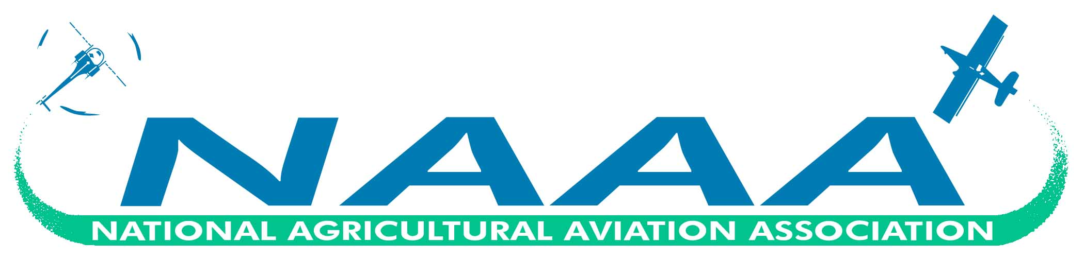

The 2008 General Aviation and Part 135 Activity Survey

What does the FAA do with this detailed information?
The information collected in this survey helps the FAA to understand more about general aviation activities, assess the impact of general aviation activities on the National Airspace System, and determine the need for increased traffic facilities and services. Federal, state, and local governments; general aviation associations; and private industry and individuals use the summary data for safety analyses, planning, forecasting, and research and development.

Will my name be associated with my survey responses?
ABSOLUTELY NOT! The information provided will be used only for statistical purposes and will not be published or released in any form that would reveal specific information reported by an individually identifiable respondent. Names of individuals are never associated with responses. There is an identification number on your letter only so PA Consulting Group knows who should receive the letter.

Why was I selected for this survey?
Your aircraft were randomly selected from the Civil Aviation Registry. The Registry shows you as a registrant of these aircraft as of December 31, 2008.

In order to better understand general aviation activity of high-use groups, several groups were sampled at 100 percent for the 2008 survey. These groups include: FAR Part 135 aircraft, rotorcraft, turbine aircraft, aircraft five years old or newer, and Alaska-based aircraft.

What if I completed a survey last year?
Even if you were sampled last year, it is very important that you respond to this survey this year. Owners/operators of multiple aircraft represent a key portion of the general aviation population. The newly designed summary form is aimed at reducing the burden of reporting for multiple aircraft, thus encouraging maximum participation.

What should I do if I have a question about how to fill out the survey or have a question we haven’t answered?
Please call Ms. Theresa Tennant of PA Consulting Group, at 1 (800) 826-1797.

Has this survey been cleared by the Office of Management and Budget Paperwork Reduction Project?
Yes. The OMB control number is 2120-0060, with an expiration date of xx-xxx-xxxx.

