Attachment 5: Instructions to Respondents
OMB No.: 0925-0557
Expiration Date: 01/31/2009

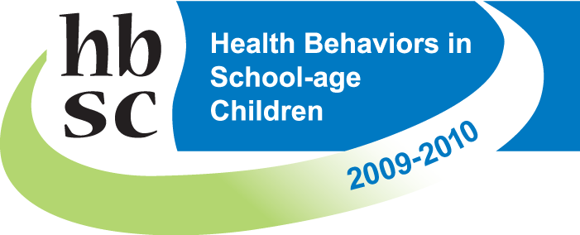
STUDENT SURVEY INSTRUCTIONS

STEP 1: USING CHECKLIST, VERIFY THAT ALL ASSEMBLED STUDENTS HAVE COMPLETED APPROPRIATE PERMISSION FORM PROCESS REQUIRED BY SCHOOL.

STEP 2: AFTER STUDENTS ARE SEATED AND THEIR DESKS ARE CLEAR OF OTHER PAPERS, DISTRIBUTE PENCILS AND ENVELOPES. DO NOT DISTRIBUTE SURVEY BOOKLETS.

STEP 3: INTRODUCE THE SURVEY TO THE CLASS.

Good (morning/afternoon). As you know, your class is participating in a survey that asks about your health. This survey is being done for the National Institute of Child Health and Human Development, which is a part of the National Institutes of Health. It is being given to young people throughout the United States and in many other countries.

First, I’d like to thank each of you for participating in this survey today. Participating in this survey is voluntary, and your grade in any class will not be affected, whether or not you answer the questions. However, only a limited number of students like you are participating in this survey in about 400 schools all over the country, so your answers are very important. Please read each item carefully and answer it based on what you really know or do. I would like to emphasize that this is not a test of you or your school. You are not required to answer any questions that make you feel uncomfortable.

STEP 4: DISTRIUTE SURVEY BOOKLETS. EMPHASIZE PRIVACY/ANONYMITY

Throughout the entire survey process, I will maintain strict procedures to protect your privacy and allow for your anonymous participation. Please do NOT write your name on the survey booklet or envelope. Your answers are private. We will never share your individual answers with your teachers, your principal, your parents, or anyone. Results of the survey will never be reported by name, class, or school.

STEP 5: INSTRUCT THE CLASS IN FILLING OUT THE SURVEY BOOKLET

Now, let’s look at the survey booklet. Use the No. 2 pencil I gave you to fill out this survey. Do not use a pen or some other pencil. Notice that for each question on the survey there are a series of squares. For each question that you answer on the survey, choose the ONE answer (unless is says you may pick more than one) that best fits what you know, feel, or do, then fill in the corresponding square. Don’t pick a response just because you think that’s what someone wants you to say. Please be sure to read every question and answer honestly. Remember, do not write your name anywhere on the booklet or the envelope. When you are finished, look over your survey booklet to make sure that you haven’t skipped any questions. Then bring your survey booklet and the envelope to me at the front of the room. We will then ask you to place your survey booklet in the envelope, seal it, and place it in the box. All surveys will be sent back to our main office where they will be processed by a computer optical scanner. Any questions before we begin? Alright, you may begin. Raise your hand if you have any questions.

