U.S. Department of Labor | Bureau of Labor Statistics  Data Collection Center  dccaddress  dcccity, dccst dcczip | 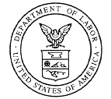

July 30, 2026

Attn: Payroll Manager
Con_Firm
Con_Address
Con_City, Con_State Con_Zipcode

Dear Payroll Manager:

You recently indicated an interest in reporting your Current Employment Statistics (CES) data each month using our Internet system. To begin reporting through the Internet, please go to the BLS Internet Data Collection System site at https://cesdata.bls.gov. Please note the 's' in the 'https'. It is required. Once you've reached our site, enter your 9-digit CES report number and the letters displayed above the box and then click the "I Accept" button.

Each month we will send you an Advance Notice message by E-mail, letting you know that we will soon be collecting data for a new month. If we do not hear from you as our deadline approaches, we may also send you a reminder message by E-mail.

You may report as soon as your data are available. We ask that you continue to provide this information monthly, for the pay period that includes the 12th of the month. The BLS will use the information you provide for statistical purposes only and will hold the information in confidence to the full extent permitted by law. In accordance with the Confidential Information Protection and Statistical Efficiency Act (Title 5 of Public Law 107-347), the information you provide to the BLS will not be disclosed in identifiable form without your informed consent.

If you have any questions or concerns, please feel free to contact us at 1-800-827-2005 or by e-mail at ceswebhelp@bls.gov.

Thank you for your cooperation.

Sincerely yours,

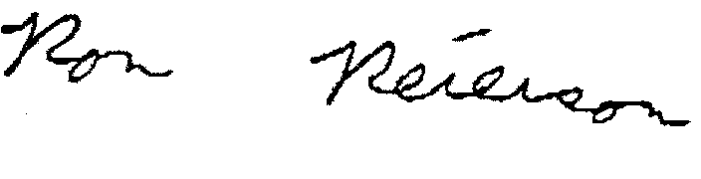

Data Collection Center Manager
Enclosure

