CATI Screens

Enrollment Screen

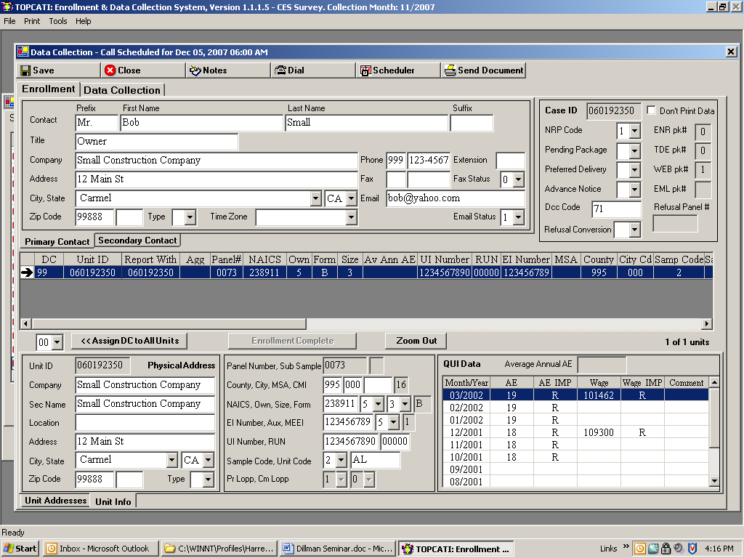

Data Collection Screen (note script at bottom of page)

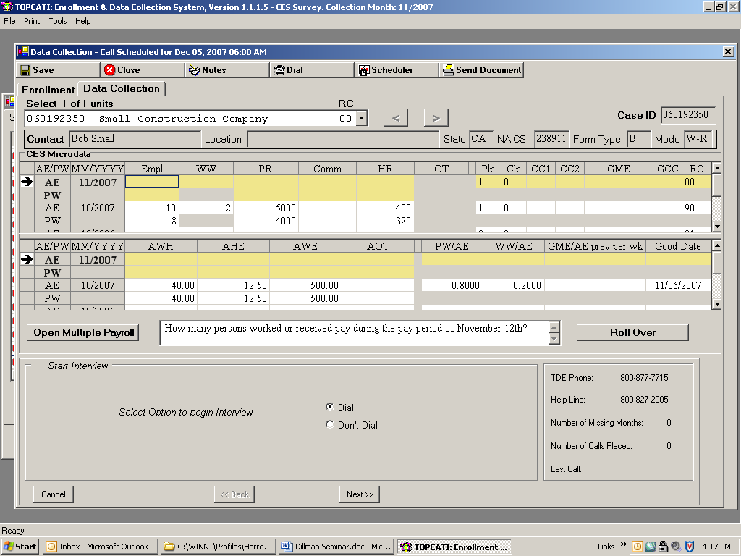

Other questions:
How many of them were women?
What was the total Payroll for All Employees?
What were the total Commissions paid to All Employees?
What were the total number of Hours worked by All Employees?
How often were all employees paid? (1=Weekly 2=Biweekly 3=Semimonthly 4=Monthly)
How often are commissions paid? (1=Weekly 2=Biweekly 3=Semimonthly 4=Monthly)
What was the Gross Monthly Earnings for the previous month?
How many were Construction Workers?
What was the total Payroll for Construction Workers?
What were the total number of Hours worked by Construction Workers?

Rollover to Web

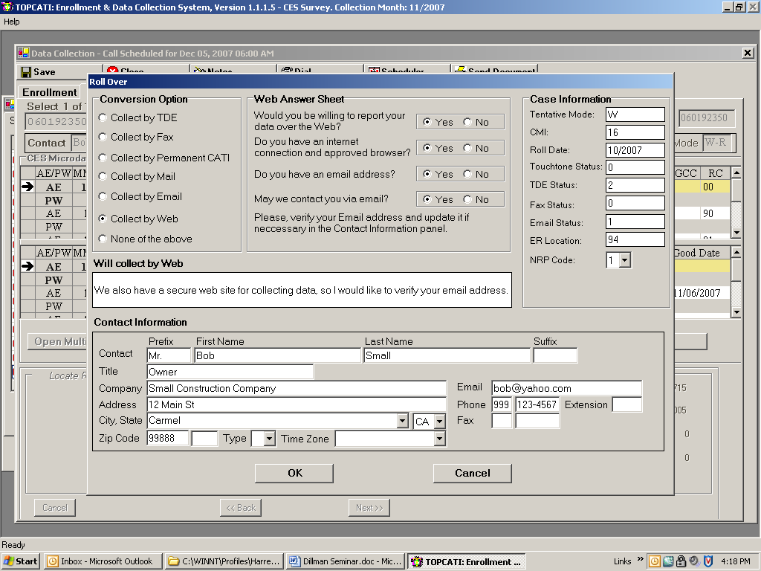

Web Rollover Letter

Dear Mr. ****:

Your recently indicated an interest in reporting your Current Employment Statistics (CES) data each month using our Internet system. To begin reporting through the Internet, please got to the BLS Internet Data Collection System site at https://cesdata.bls.gov. Please note the ‘s’ in the ‘https’. It is required. Once you’ve reached our site, enter your 9-digit CES report number and the letters displayed above the box and then click the “I Accept” button.

Each month we will send you an Advance Notice message by E-mail, letting you know that we will soon be collecting data for a enw month. If we do not hear from you as our deadline approaches, we may also send a reminder message by E-mail.

We look forward to receiving your data by the Internet.

If you have any questions or concerns, please feel free to contact us at 1-800-827-2005 or by e-mail at ceswebhelp@bls.gov.

Thank you for your cooperation.

Sincerely yours,

Emails used in Web collection:

Welcome to CES Web Reporting

From: CESMail
Sent: Wednesday, November 07, 2007 12:54 PM
To: CESWeb
Subject: Welcome to CES Internet Reporting

CES Report: 660000001

Dear Respondent:

You recently indicated an interest in reporting your Current Employment Statistics (CES) data each month using our Internet system. To begin reporting through the Internet, please go to the BLS Internet Data Collection System site at <https://cesdata.bls.gov>. Please note the 's' in the 'https'. It is required. Once you've reached our site, enter your 9-digit CES report number and the letters displayed above the box and then click the "I Accept" button.
Each month we will send you an Advance Notice message by E-mail, letting you know that we will soon be collecting data for a new month. If we do not hear from you as our deadline approaches, we may also send you a reminder message by E-mail.

We look forward to receiving your data by the Internet.

If you have any questions or concerns, please feel free to contact us at 1-800-827-2005 or by e-mail at ceswebhelp@bls.gov.

Thank you for your cooperation.

Advance Notice Message

From: cesmail@bls.gov
Sent: Thursday, October 25, 2007 12:00 PM
To: ****************
Subject: October Employment Report - US Bureau of Labor Statistics

CES Report: 660000001

The data reported to the Current Employment Statistics program last month were included in the estimates reported by the Bureau of Labor Statistics on Friday, October 05, 2007, and publicized by major media organizations such as The Wall Street Journal.

Please report your November employment, payroll, and hours data by Friday, October 26, 2007, if possible. Our web address is <https://idcf.bls.gov>. If you have any questions, please contact cesmail@bls.gov or call our Help Desk at 1-800-827-2005.

Thank you for your cooperation.

Nonresponse Prompt Message

From: cesmail@bls.gov
Sent: Thursday, October 25, 2007 12:00 PM
To: ****************
Subject: October Employment Report - US Bureau of Labor Statistics

CES Report: 660000001

As of today, our records show that we have not received your employment, payroll, and hours data for October. Please report these figures by Friday, October 26, 2007, if possible. If you have reported your information by some method other than web, please send a note to ceswebhelp@bls.gov.
Please report your data to <https://cesdata.bls.gov>.
If you have any questions, please contact ceswebhelp@bls.gov or call our Help Desk at 1-800-827-2005.

Last Chance Message

From: cesmail@bls.gov
Sent: Friday, October 26, 2007 10:20 AM
To: *********************
Subject: Urgent request for October employment data

CES Report: 660000004

This is your last chance to report your October employment, payroll,
and hours data in order for it to be included in our preliminary
estimates of October employment. The Bureau of Labor Statistics will
publish the October Employment Situation report on Friday, November
02, 2007. The Employment Situation report is a monthly news release
that highlights the previous month's employment estimates. Your
figures help to make these estimates possible.

Please report your data to <https://cesdata.bls.gov>.

If you have any comments or concerns, please call our helpdesk,
toll-free, at 1-800-827-2005.

Web Data Entry Screen

