Background
The Office of Examination and Insurance is working with the Office of the Chief Information Officer on the development of a web-based program that will capture and display credit union data. Upon completion, information we currently collect through the software-based 5300 Call Report and Report of Officials programs will be captured through this online program. Credit unions will login to a system via the Internet and enter their data quarterly.
The effective date of these changes is September 1, 2009.
Credit Union Profile
The online system includes an area called the credit union profile. The profile contains information about the credit union that infrequently changes. This area includes some read-only chartering information as well as some data we currently collect on the 5300 Call Report and Report of Officials. Once the initial data is entered into the profile, input is only required for additions, deletions, and changes. The areas from the 5300 Call Report that moved to the profile include:
- US Patriot Act Contact Information (Page 1)
- Emergency Contact Information (Page 2)
- Vital Records Center (Page 2)
- Disaster Recovery Information (Page 2)
- Audit and Verification Information (Page 8)
- Programs and Member Services (Page 8)
- Federal Home Loan Bank and Federal Reserve Bank Information (Page 11)
- Information Systems and Technology (Page 12)
- CUSO Information (Page 18)
The information currently collected on the Report of Officials that will be inputted into the profile includes:

- Main and Branch offices
- Name of Manager/CEO
- Board of Directors
- Annual Meeting Date Information

5300 Call Report
We will continue to collect credit union financial data through the 5300 Call Report quarterly. The call report will be completed and submitted from within a credit union’s profile.

Manual Credit Unions vs. Online Filers
Although majority of credit unions have the capability to use the online system, there are a small number of credit unions that do not have Internet access and will be unable to input their information. These credit unions will be identified as manual filers and will receive a Profile Form and a 5300 Call Report Form each quarter. Both forms will be completed by the credit union and sent to the NCUA or State Supervisory Authority representative for input into the online system. After the initial input of profile information, the examiner will only have to update this information with any changes. Online filing credit unions will only receive a letter from NCUA each cycle. We estimate less than 10% of credit unions will file manually each cycle.
Screen Prints from Online Program
When developing the new Profile and 5300 Call Report forms, we tried to make the form match the online system; however, in some instances, we could not. The Contacts and Sites areas in the online system capture the all the information formerly on the Report of Officials as well as the Emergency Contact, Patriot Act Contacts, Hot Site and Vital Records Center. Please see the following:
Login Screen
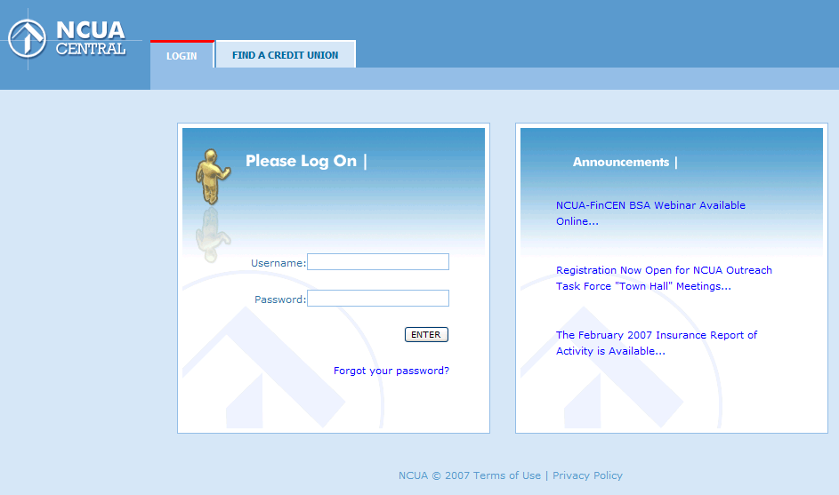

Credit Union Profile
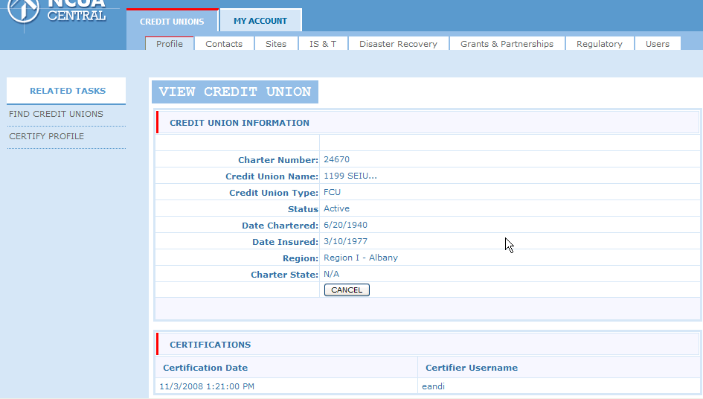
Contacts (people associated with the credit union- Board of Directors, Committee Members, Emergency Contact, Patriot Act Contact, etc.)– View List of Contacts
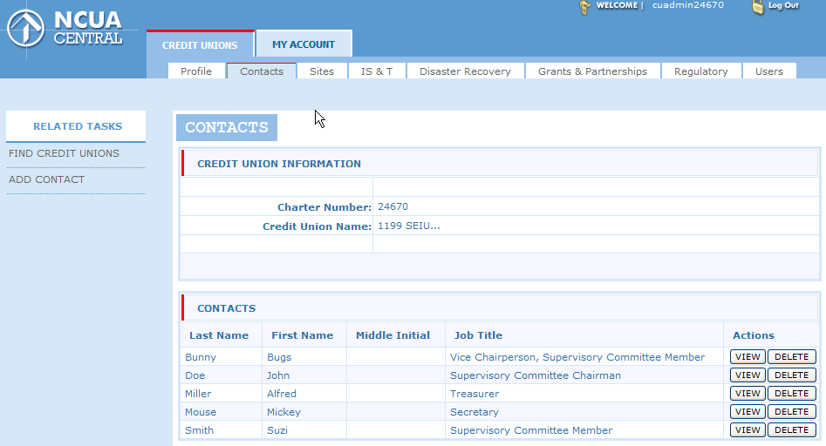

Contacts – Add/Edit – The Job Title and Role fields are multi-select. Mandatory fields are based on the job title and role. In the online instructions, NCUA clarifies what fields are mandatory.
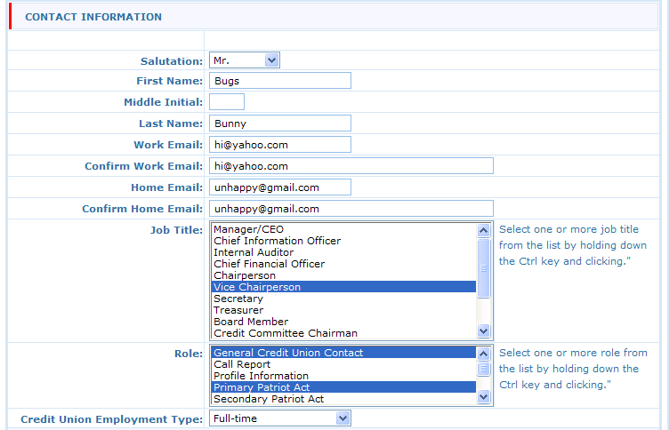
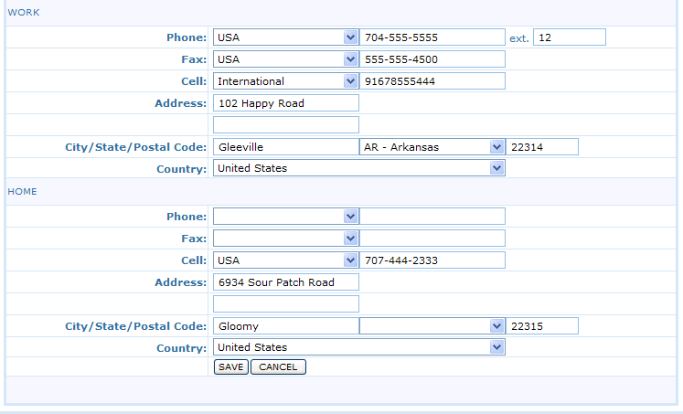
Sites – View list of locations
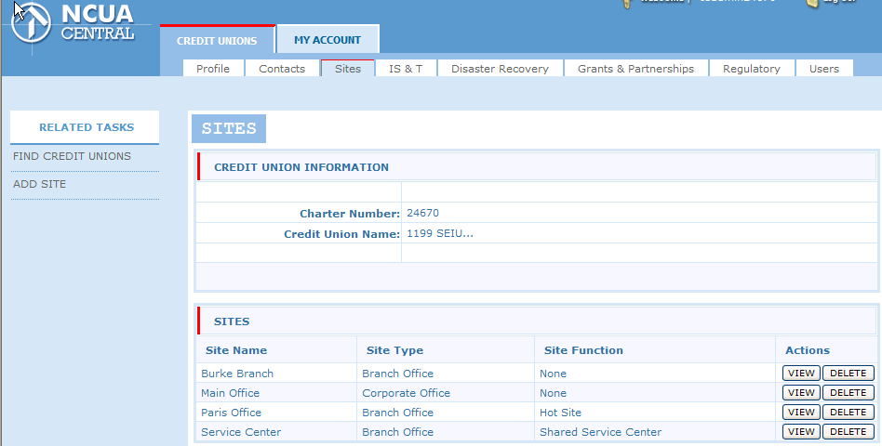
Site – Add/Edit a location – Site Type options include: Corporate Office, Branch Office, Other. Site functions not listed: ATM, Location of Records (Note: Credit unions are not required to report the ATM locations; however, they have the option).
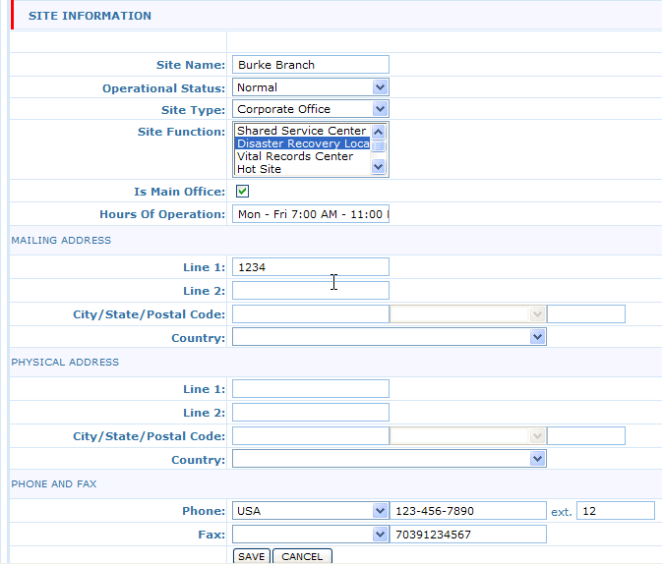

IS&T – Majority of the questions from Page 12 of the Call Report.
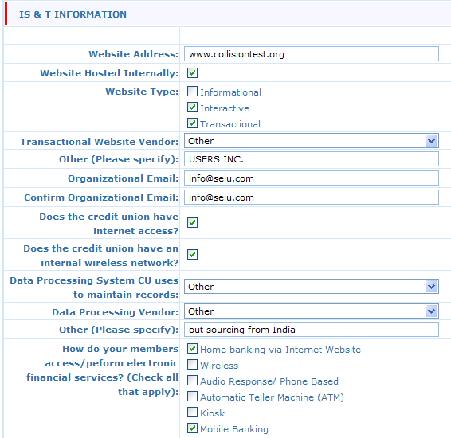

Data Processing Conversion – View Dates
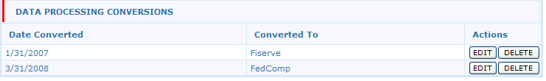

Data Processing Conversion – Add/Edit a conversion
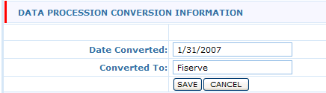
Disaster Recovery Information and Test
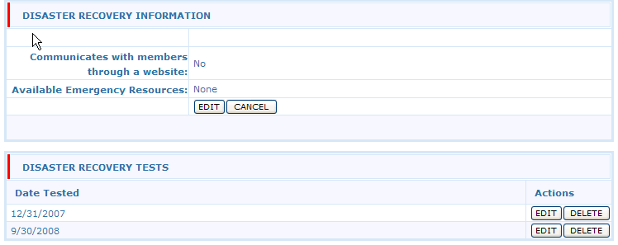
Grants and Partnerships – This tab is optional for credit unions.
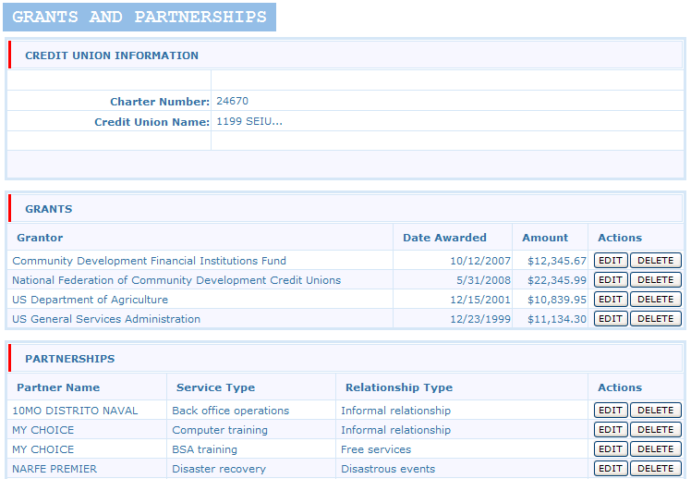
Regulatory – This is where we will capture Annual Meeting, Financial Statement Audit, and Member Account Verification Information
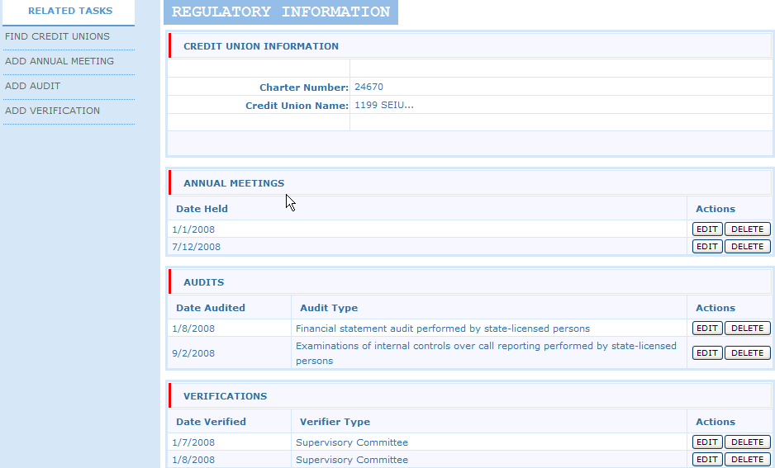
To Be Programmed – Credit Union Service Organization (CUSO) and Programs and Services. The CUSO section will be similar to Sites and Contacts and will contain all the fields on Page 18 of the Call Report. Programs and Services are being moved from Page 8 – 9 of the Call Report. This page will be checkboxes.
The 5300 portion is in process of being programmed; however, the format is not changing significantly. We plan to the form pages broken in smaller parts in the online program; however, when printed from the online system the forms will look similar. For example, page 3 of the Call Report will be broken into 2 web pages – Cash will be on one web page and Investments on the next. When printed, these two web pages will print on one page, similar to the paper form.

