Global Self-Assessments (Parallels DDx560) Reading

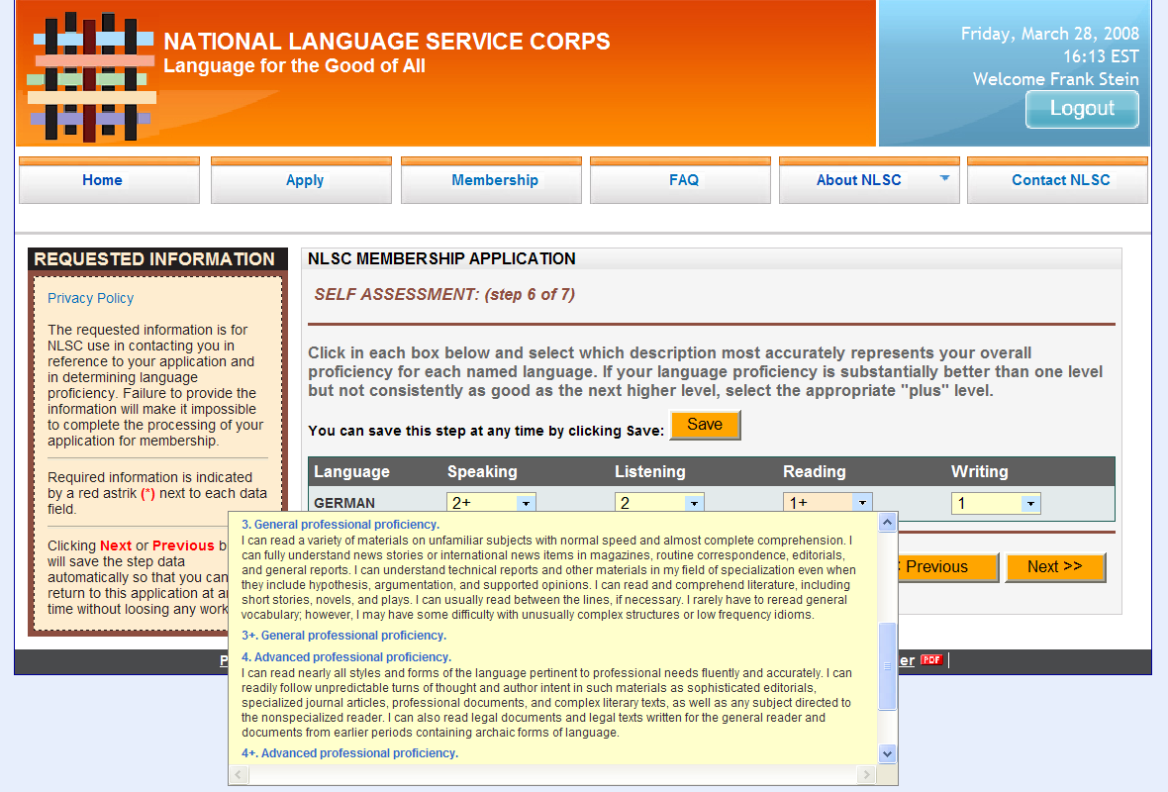

Detailed Skilled Self-Assessments (Parallels DDx559) Reading

