i3368PRO
AB003:
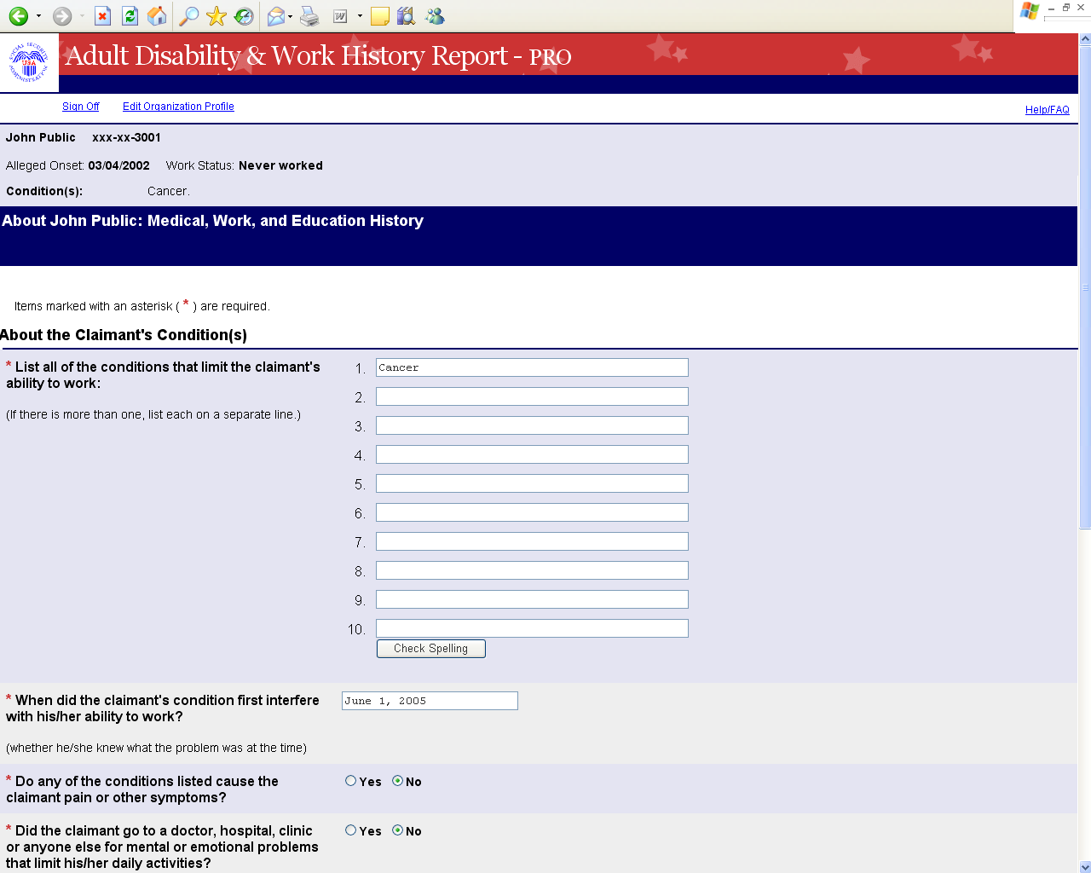

Current screenshot on SNAPP:
http://eis.ba.ssa.gov/snapp/screenshots/i3368PRO/i3368PROPages/ab003.html
AB004:
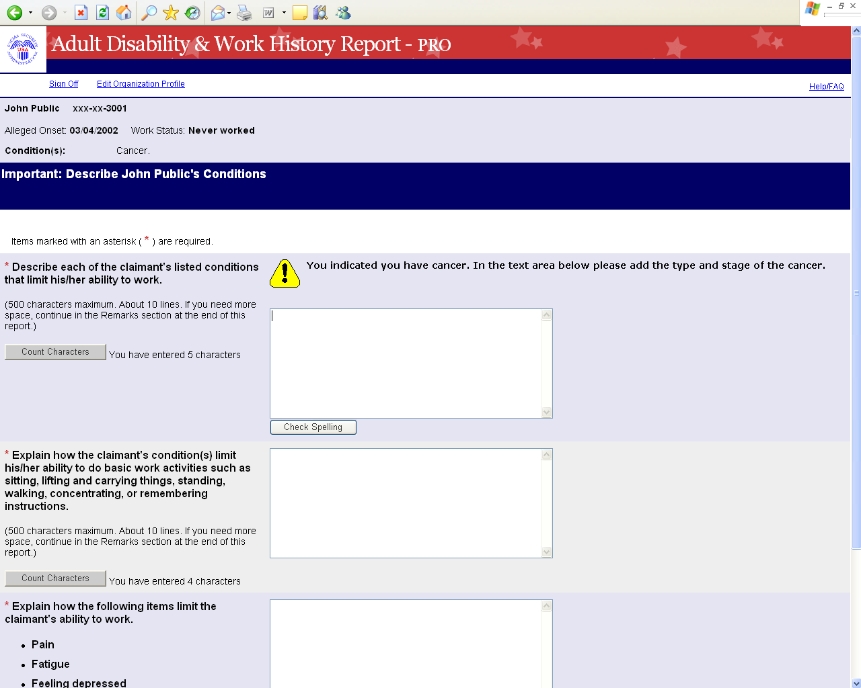

Current screenshot on SNAPP:
http://eis.ba.ssa.gov/snapp/screenshots/i3368PRO/i3368PROPages/ab004.html
i3369:

AY005-SWCW
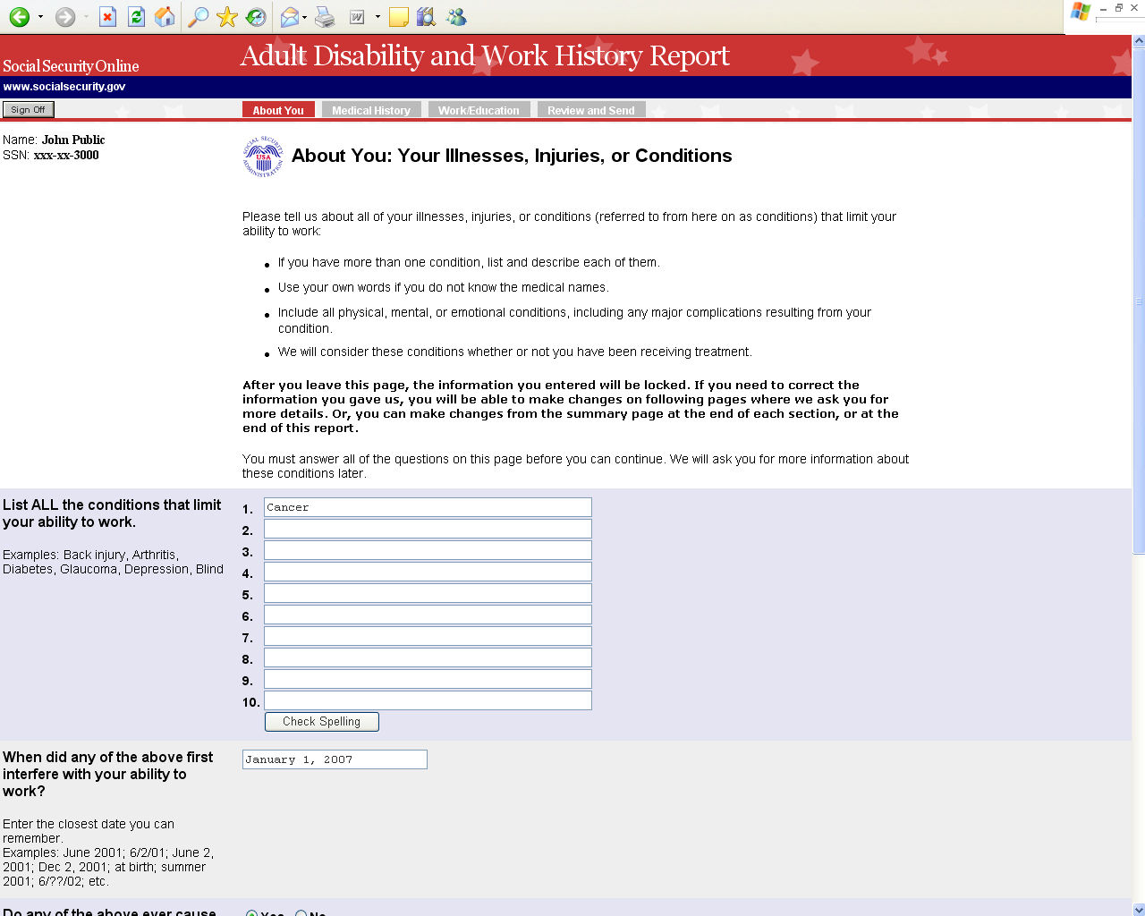

Current screenshot on SNAPP:
http://eis.ba.ssa.gov/snapp/screenshots/i3369/i3369Pages/ay005-swcw.html
AY006-SWCW
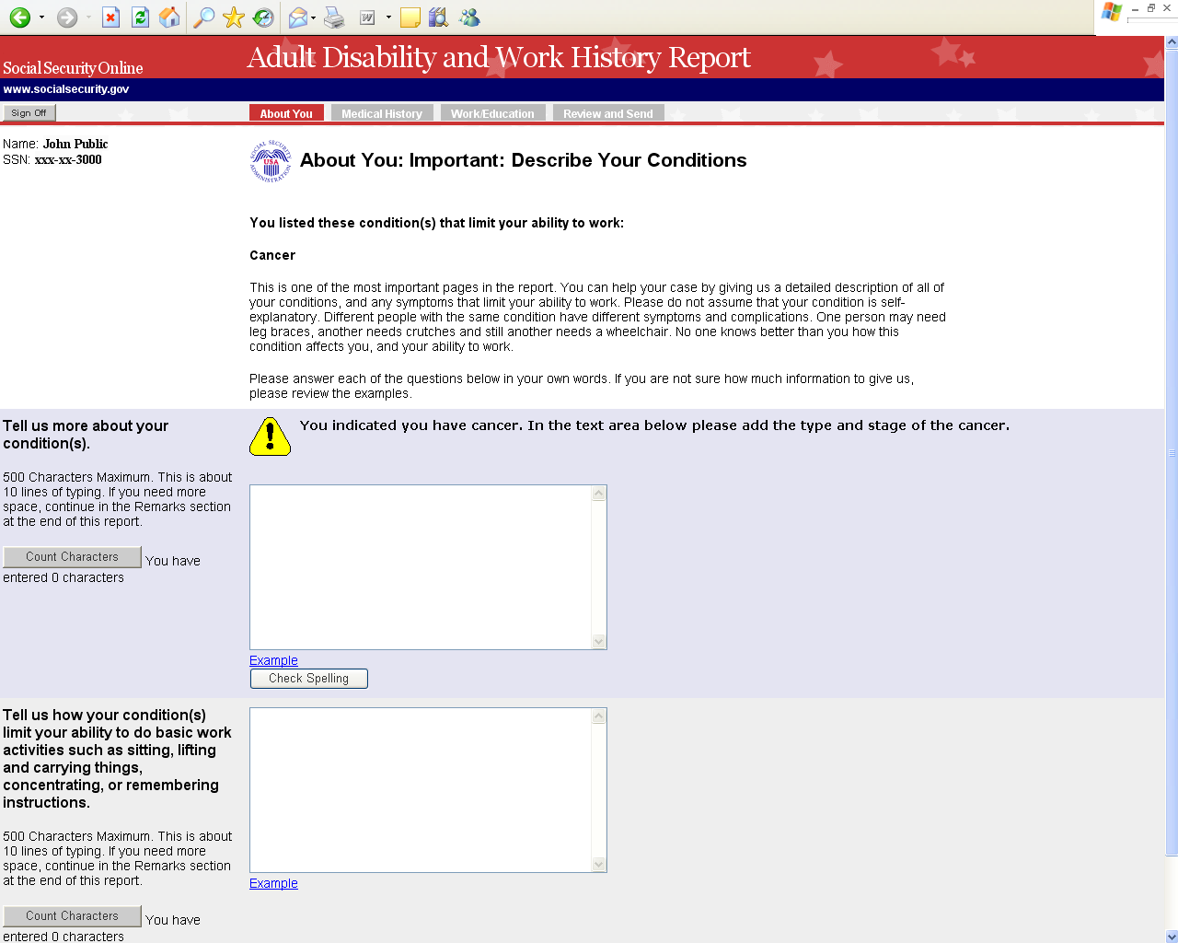

Current screenshot on SNAPP:
http://eis.ba.ssa.gov/snapp/screenshots/i3369/i3369Pages/ay006-swcw.html
i3820:

AC008:
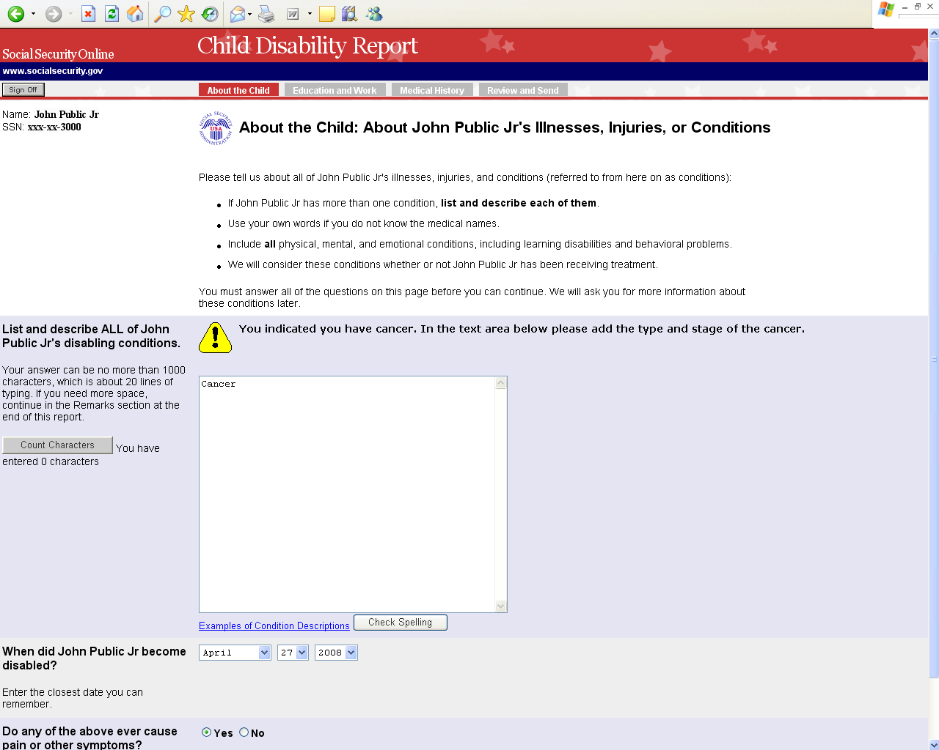

Current screenshot on SNAPP:
http://eis.ba.ssa.gov/snapp/screenshots/i3820/i3820Pages/ac008.html

