OMB Control No: XXXX-XXXX

Expiration date: XX/XX/XX

Children’s Bureau

Administration for Children and Families

Regional Partnership Grant

ACF Number: ACYF-0155
OMB Number: 0970-New

September 3, 2008

Instructions to Grantees for Uploading Data to the RPG Data System:

This correspondence is to instruct you on the process for submitting performance indicator data to the RPG Data System through the Collaborative Project Management (CPM) web portal. A web-based RPG Data Collection and Reporting System (the RPG Data System) has been developed to 1) collect and store indicator data on specific children, adults and families; 2) provide a standardized format to report and process data; and 3) provide a format and reporting system for grantees’ Semi-Annual Progress Report information on activities and progress toward goal achievement. Overall, the RPG Data System will provide the data for analysis by the RPG Support Contract (RPG SC) Project Team to generate the indicator data reports and assessment of RPGs’ performance that will be used by the Administration for Children and Families to report to Congress.

The number of data elements collected by each grantee will vary depending on the final list of Federal Project Officer (FPO)-approved indicators (i.e., not all grantees will be reporting on all 23 indicators and therefore are not required to collect and report all data elements).Thus, you will have a customized data plan created according to your FPO-approved final set of indicators. A data element will not be included in your data plan if you are not collecting case level data for the indicator(s) that use that data element. The data plan will instruct the RPG Data System as to which indicators and data elements you are planning to submit. If you are serving different populations, either through multiple sites or the implementation of multiple program strategies, and applying different indicators to these different populations (e.g. families with children in out-of-home care versus children residing at home), the data plan will also clarify which indicators apply to which populations. In addition, a separate data plan will be created for comparison group data.

The RPG SC Project Team has designed an XML Schema to standardize the data being uploaded to the RPG Data System. The XML Schema file acts as a guide to help you assemble your data in a form that can be validated prior to submission. The XML Schema file will be customized to your specific data plan so as to require only data called for by that plan. For variables that may repeat over time (e.g., maltreatment cases, substance abuse treatment admissions), you will need to have the capacity to record multiple incidents in the database you are using to collect and store your project information prior to converting and uploading it to the RPG Data System. Mainstream data tools (SQL, Oracle, Access, Excel, etc.) generally have some ability to export your relational data in an XML format. You may need to do some additional formatting from these tools to convert your data into your XML Schema. Macro staff is available to assist you with that process.

Beginning in Fiscal Year 2009, you will submit a data file every six months with your required data elements, based on the FPO-approved final set of indicators. The submission of the data is aligned with the required Grantee Semi-Annual Progress Reports, which are due April 30 and October 31 of each year. You may submit your data the same time as the Semi-Annual Progress Reports, but no later than six weeks after the Semi-Annual Progress Reports are due (i.e., no later than June 15 and December 15 of each year). These twice-yearly data submissions will include the entire current record for all of a grantee’s cases to date.

Data Submission
The next major development of the RPG Data System will be completion and availability of the “Data Submission” function. This is where your data will be uploaded in XML format as specified by individual data plans. Subsequent to OMB approval of the data submission process for the RPGs, Macro will work with a group of grantees to pilot test data uploading, and then initiate field testing and user training for all grantees.

Access to the RPG Data System is available through CPM for those with either Read-only or Read/Write access, as specified in the grantee data plans. (If you need to add someone or change user rights, please click the CPM “Support” link and enter your request.) These users will find a new left menu option labeled “Data Collection.” The Data System will recognize your login and automatically display your grant’s information.

Submitting your data to the RPG Data System is a simple and straightforward process. The following screen shots illustrate the steps you will follow showing the actual system interface:

Slide 1 shows the “Data Submission” area of the RPG Data System. You must first have created one or more data plans that are entered in the “Data Plan” area. Your plan or plans will be listed with their corresponding numbers as shown on the slide. To submit data first use the “Reporting Date” dropdown to select the proper reporting period, then click the “Add Data” link to open the next screen. Note that you can also click the “Previous Uploads” link to check your previous data submissions record.

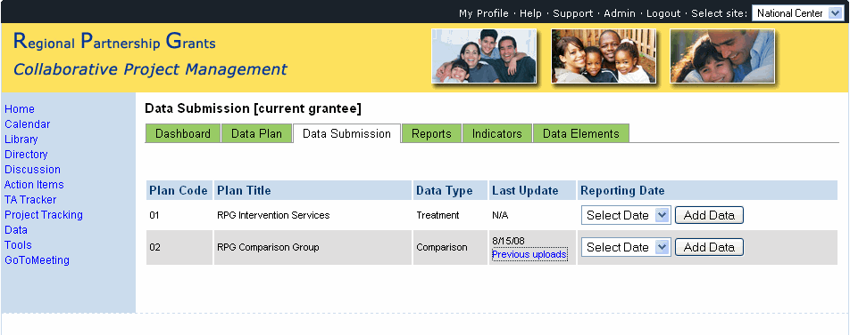
Slide 2 shows the page where you will enter your data for a selected data plan. Case level data is submitted using the “Upload Case Level Data” prompt. Use the browse button to locate the file on your local drive. The file will be an XML file as specified by the Data Dictionary. You should be very sure that you are uploading the data for the corresponding data plan. The plan code, plan title, and reporting period will all be shown for reference. We have attached a sample data plan. If aggregate data is called for in your data plan, enter the data into the corresponding fields then click “Upload/Save Data.” This page will also allow you to view your previous data submissions.
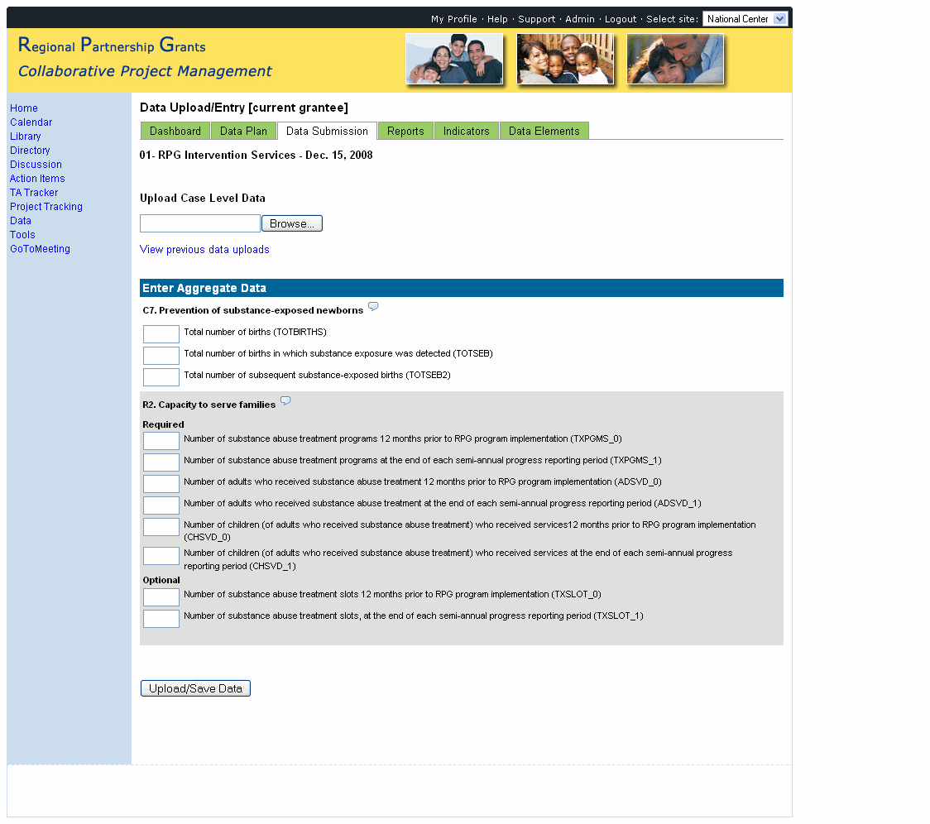

Slide 3 shows a record of your previous data submissions, including the dates added, name of the person who submitted, the status of the submission, and the number of records included.
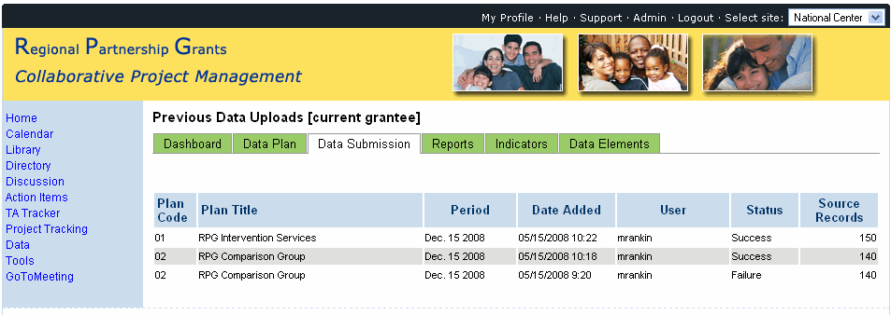

THE PAPERWORK REDUCTION ACT OF 1995 (Pub. L. 104-13)
Public reporting burden for this collection of information is estimated to average 175.5 hours per response, including the time for reviewing instructions, gathering and maintaining the data needed, and reviewing the collection of information.
An agency may not conduct or sponsor, and a person is not required to respond to, a collection of information unless it displays a currently valid OMB control number.
If you have questions or need assistance click the “Support” link at the top of any page. Please remember that technical assistance is available to help you work through any problems you may encounter. Do not hesitate to contact to your PML or the RPG SC Project Team as needed during this process.

