Institute of Museum and Library Services
The Impact of Free Access to Computers and the Internet in Public Libraries
Response to Questions from OMB
ICR Reference No. 200808-3137-001

Question 1: Please provide the specific research questions IMLS anticipates that this study will answer.
Answer: The original IMLS RFP sought to answer the following questions about public access computer use in public libraries:

- What are the demographics of people who use computers, the Internet, and related services in public libraries?
- What information and resources provided by free access to computers, the Internet, and related services in public libraries are people using, across the spectrum of on‐site and off‐site use?
- How do individuals, families, and communities benefit (with a focus on social, economic, personal, and professional well‐being) from free access to computers, the Internet, and related services at public libraries?
- What reliable indicators can measure the social, economic, personal, and/or professional wellbeing of individuals, families, and communities that result from access to computers, the Internet, and related services at public libraries?
- What correlations can be made between the benefits obtained through access to computers and the Internet and a range of demographic variables?
- What computer and Internet services and resources are lacking at public libraries that, if provided, could bring about greater benefit?
- What indicators of negative impact can be identified where free access to computers and the Internet is weak or absent?

Question 2: Please provide a discussion of alternative research designs that IMLS considered to answer these questions as well as why they were not chosen and how they were inferior to the chosen design.
Answer: Our original design was predicated on three research methods: a random digit dial telephone survey of library public access computer users, a universal web survey of PAC users offered through all public library public access computers in the country, and qualitative field work to probe further into the use of public access computing in selected communities.

While the overall design continues to include these three methods, we have considerably tightened the telephone survey sampling methodology to make sure that we comply with current best practices in this area, and have included a cell phone sample as well to broaden the coverage. The web survey has been restructured to be a random sample of the universe of library systems in the country rather than a universal survey, and redesigned to provide early input on results to validate the design during the sampling period. The methodology for selecting the qualitative study sites has been refined from our original approach.

We have also added non‐response follow up surveys to both the telephone and web surveys to provide better information on the actual populations using the services, and allow us to verify the results we are getting in the broader surveys. This was an important addition to the methodology developed in cooperation with the Urban Institute.

Figure 1: Mixed Method Triangulation

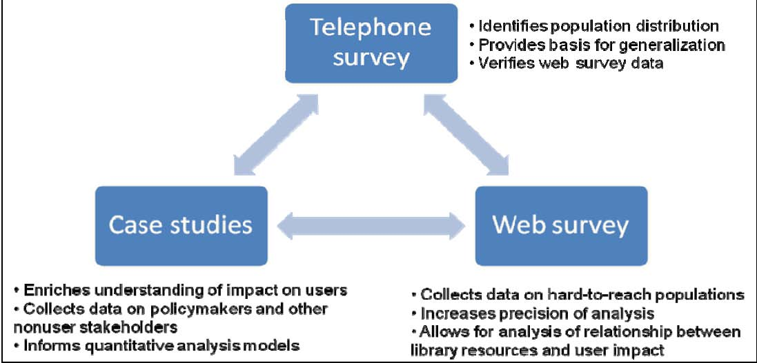

As seen in Figure 1, the strength of this research design is the triangulation of data from the three research methods. The telephone survey data will provide a representative picture of the prevalence of different types of people using public access computers and how it benefits them. The web survey data, along with NCES data on the selected libraries’ resources will allow for the analysis of the relationship between available public access computing resources and user results; the web survey is also better suited to collecting data from hard to reach populations such as youth and homeless persons. The case study data will provide a richer understanding of how users use public access computing and the role it fills in their everyday information environment and will inform the models we develop for analyzing the telephone and web survey data.

Question 3: Please provide a crosswalk between specific hypotheses and each set of questions IMLS proposes to ask (e.g., does IMLS believe that individuals’ type of home affects propensity to own a home computer).
Answer: Table 1 presents the five working hypotheses that informed the development of our research methods and survey instruments.

Table 1: Hypotheses Crosswalk
# | Hypothesis | Survey questions
1 | There are demographic characteristics that define users of computers, the Internet, and related services in public libraries. These demographic characteristics may be used to better understand how computers, the Internet, and related services impact populations of users and to inform the development of services in libraries. | Demographic questions Q13 through Q26
2 | Individuals, families, and communities are impacted socially, economically, personally and professionally by the availability of free access to computers, the Internet, and related services at public libraries. | Domain questions M1 through D6
3 | The social, economic, personal, and/or professional impact of services related to providing free access to computers, the Internet, and related services at public libraries can be measured at the individual, family, and community levels. | Domain questions M1 through D6
4 | Correlations can be made between the impact of access to computers and the Internet and a range of demographic variables. Correlations can be made to type, level, or volume of related services to measured impact. | Demographic questions Q13 through Q26, Domain questions M1 through D6
5 | Computer and Internet services and resources are lacking at PLs that, if available, could bring about greater benefit. Indicators of negative impact can be identified where free access to computers and the Internet is weak or absent. | Case study results, plus analysis of correlations between demographic questions Q13 through Q26 and domain questions M1 through D6

Question 4: Please cite the literature supporting each of these hypotheses (e.g., what is the basis for the belief that home type affects propensity to own a home computer).
Answer: Table 2 shows literature supporting the hypotheses presented in question 3.

Table 2: Citations In Support of Hypotheses
Hypothesis | Citations
1 | Glander, M., Dam, T., & Chute, A. (2007). Households' use of public and other types of libraries: 2002. Washington, DC: National Center for Education Statistics (NCES). U.S. Department of Education.  Griffiths, J.‐M., & King, D. W. (2008). InterConnections: A National Study of Users and Potential Users of Online Information: IMLS.  Morrill, J. H. (2007). The Wisconsin Library User (and Non‐User) II: Outcomes of a Second Statewide Survey (2003 – 2007 comparisons): Wisconsin Public Library Consortium.  Zweizig, D., & Dervin, B. (1977). Public library use, users, uses: Advances in knowledge of the characteristics and needs of the adult clientele of American public libraries. Advances in Librarianship, 7, 231‐255.
2 | American Library Association, Information Institute, & College of Information, F.S.U. (2007). Libraries Connect Communities: American Libraries Association.  Bertot, J. C., Jaeger, P. T., Langa, L. A., & McClure, C. (2006). Public Access Computing and Internet Access in Public Libraries: The Role of Public Libraries in Egovernment and Emergency Situations. First Monday, 11(9).  Boatman, W., Van Fleet, C., & Wallace, D. P. (2003). Public libraries as a bridge for college‐bound young adults. Reference & User Services Quarterly, 42(3), 229‐234.  Burnham, E., & Peterson, E. (2005). Health information literacy: A library case study. Library Trends, 53(3), 422‐433.  Chobot, M. C. (2002). The Challenge of Providing Consumer Health Information in Public Libraries. Washington, DC: American Association for the Advancement of Science.  Estabrook, L., Witt, E., & Raine, L. (2007). Information that solves problems: How people use the internet, libraries, and government agencies when they need help. Washington, DC: Pew/Internet & American Life Project.  Gordon, M. T., Moore, E. J., Gordon, A. C., & Heuertz, L. (2003). Kids have access, enjoy computers: Libraries key for many, especially the disadvantaged. Seattle, WA: Evans School of Public Affairs, University of Washington.  Heuertz, L., Gordon, A. C., Moore, E. J., & Gordon, M. T. (2002). Public libraries and the digital divide: How libraries help. Seattle, WA: University of Washington.  Morales, M. (2007). Public libraries are sole source of online employment and education information for millions of Americans. Retrieved July 15, 2008, from http://www.ala.org/ala/pressreleases2007/september2007/ALA_print_layout_1_436373_436373.cfm  Stone, E. (1999). The impact of public library use on the educational attainment of primary school children. Unpublished Dissertation.  Suaiden, E. J. (2003). The social impact of public libraries. Library Review, 52(8), 379‐387.  Walker, C., & Manjarrez, C. A. (2003). Partnerships for free choice learning: Public libraries, museums and public broadcasters working together: Institute for Museum and Library Studies
3 | Abend, J., & McClure, C. R. (1999). Recent views on identifying impacts from public libraries. Public Library Quarterly, 17(3), 361‐390.  Berk & Associates, Inc. (2005). The Seattle Public Library Central Library: Economic Benefits Assessment. Seattle, WA: The Seattle Public Library Foundation & City of Seattle Office of Economic Development.  Bertot, J. C., McClure, C. R., & Jaeger, P. T. (2008). The impacts of free public Internet access on public library patrons and communities. Library Quarterly, 78(3), 285‐301.  Durrance, J. C., & Fisher‐Pettigrew, K. E. (2002). Toward Developing Measures of the Impact of Library and Information Services. Reference & User Services Quarterly, 42(1), 43‐53.  Elliott, D., Holt, G., Hayden, S., & Holt, L. E. (2007). Measuring your library’s value: How to do a cost‐benefit analysis for your public library. Chicago: American Library Association.  Fraser, B. T., Nelson, T. W., & McClure, C. (2002). Describing the economic impacts and benefits of Florida public libraries: Findings and methodological applications for future work. Library & Information Science Research, 24(3), 211‐233.  Holt, G. E., & Elliott, D. (2003). Measuring outcomes: Applying cost‐benefit analysis to middle‐sized and smaller public libraries. Library Trends, 51(3), 424‐440.  Kelley School of Business. (2007). The Economic Impact of Libraries in Indiana. Indianapolis, IN: Indiana State Library.  Manjarrez, C. A., Cigna, J., & Bajaj, B. (2007). Making Cities Stronger: Public library contributions to local economic development. Washington, DC: The Urban Institute.  Pifalo, V., Hollander, S., Henderson, C., DeSalvo, P., & Gill, G. P. (1997). The impact of consumer health information provided by libraries: the Delaware experience. Bulletin of the Medical Library Association, 85(1), 16‐22.  Poll, R. (2003). Measuring impact and outcome of libraries. Performance Measurement and Metrics, 4(1), 5‐12.
4 | Bertot, J. C., McClure, C. R., Thomas, S., Barton, K. M., & McGilvray, J. (2007). Public Libraries and the Internet 2007: Report to the American Library Association. Tallahassee, FL: College of Information, Florida State University.  Flythe, F. H. (2001). Identification of the information needs of the newly arrived Hispanic/Latino immigrants in Durham county, North Carolina, and how the public library may address these needs. Unpublished Master's paper. University of North Carolina at Chapel Hill.  Gordon, M. T., Moore, E. J., & Gordon, A. C. (2003). Public Access Computers, Libraries, and the Poor: Do Neighborhood Factors Make a Difference? Seattle, WA: Evans School of Public Affairs of University of Washington.  Gordon, M. T., Moore, E. J., Gordon, A. C., & Heuertz, L. (2003). Kids have access, enjoy computers: Libraries key for many, especially the disadvantaged. Seattle, WA: Evans School of Public Affairs, University of Washington.  Heuertz, L., Gordon, A. C., Gordon, M. T., & Moore, E. J. (2003). The Impact of Public Access Computing on Rural and Small Town Libraries. Rural Libraries, 23(1), 51‐79.  Holt, G. E. (2006). Fitting library services into the lives of the poor. The Bottom Line: Managing library finances, 19(4).  National Center for Education Statistics (NCES). (2007). Public libraries in the United States: Fiscal year 2005. Washington, DC.  Koontz, C. M., Jue, D. K., & Lance, K. C. (2005). Neighborhood‐based in‐library use performance measures for public libraries: A nationwide study of majority‐minority and majority white/low income markets using personal digital data collectors. Library & Information Science Research, 27(1), 28‐50.  Moore, E. J., Gordon, A. C., Gordon, M. T., & Heuertz, L. (2002). It's working: People from low‐income families disproportionately use library computers. Seattle, WA: Evans School of Public Affairs, University of Washington.  Velasquez, D. (2007). Public access computing in 14 Midwestern public libraries. Paper presented at the eChicago 2007, River Forest, Illinois.
5 | Heuertz, L., Gordon, A. C., Moore, E. J., & Gordon, M. T. (2002). Public libraries and the digital divide: How libraries help. Seattle, WA: University of Washington.  Jaeger, P. T., Bertot, J. C., & McClure, C. (2007). Public libraries and the Internet 2006: Issues, funding and challenges. Public Libraries, 46(5), 71‐78.  Parker, R., & Kreps, G. (2005). Library outreach: Overcoming health literacy challenges. Journal of the Medical Library Association, 93(4), 81‐85.  Pew Internet. (2004). Toward Equality of Access: The Role of Public Libraries in Addressing the Digital Divide: Bill & Melinda Gates Foundation.

Question 5: Please explain specifically how the survey results will be used to generate indicators. Examples may be useful.
Answer: In reviewing indicators used to describe individual, community and societal impacts for our study of PAC in community technology centers (Crandall & Fisher, 2007), we found very few indicators that relate directly to the effects of technology. Most indicators examine broader changes in behavior that may be a result of technology interventions; few studies address the relation of technology to changes in these indicators.

Six sets of indicators were identified as potentially valuable for the current study (Table 3). These indicators were initially selected because of their applicability to the research questions guiding this project. We grouped these indicators into a number of major areas of influence, related to Civic Engagement, eCommerce, Education, eGovernment, Health, Employment, and Social Inclusion. Our expert committee (see Question #9) was engaged in the review and revision of these original indicator sets and domains based upon their policy expertise, and throughout the course of the instrument design have had multiple opportunities to review and comment on the survey instruments developed from this baseline set of indicators.

Table 3: Initial Indicator Sets Used to Develop Survey Instruments
Source | Year | URL
1. Urban Institute  National Neighborhood  Indicators Project | 1996 | http://www2.urban.org/nnip/
2. – 3. World Bank –  Social Capital Initiative and World Values Survey | 1997‐2005 | http://web.worldbank.org/WBSITE/EXTERNAL/TOPICS/EXTSOCIALDEVELOPMENT/EXTTSOCIALCAPITAL/0,,contentMDK:20193049~menuPK:994384~pagePK:148956~piPK:216618~theSitePK:401015,00.html,  http://www.worldvaluessurvey.org/
4. Search Institute | 2007 | http://www.search‐institute.org/assets/
5. Childstats.gov | 2007 | www.childstats.gov
6. City of Seattle –  Information Technology Indicators Project | 2004 | http://www.seattle.gov/tech/indicators/

To link these indicators closely to the work conducted to‐date on PAC in libraries, we have designed our instruments to allow cross‐correlation with data collection provided in such work as the PEW Internet & American Life Studies (2007), NCES data (Croe, 2007), and that conducted at Florida State University (Bertot, et. al, 2006). We believe that this integration will provide the missing link in the current picture, and allow more direct exploration of the true impacts of PAC in libraries and the communities and populations they serve.

Using the area of economic development, the following examples demonstrate how the project will develop additional indicators using the mixed methods of data collection and analysis. Table 4 presents a list of certain indicators related to the concept of economic development derived from projects conducted by the Urban Institute, the World Bank, Gates Foundation CAT programs, Casey Family Programs, and the City of Seattle. Table 5 shows how two of those indicators can be expressed as variables on multiple instruments. This is the process used to move from the existing indicator sets to the survey instruments that will be used in the three data collection methods of the study.

Table 4: List of Indicators Related to Economic Development
- Opportunities to upgrade job skills
- Learn software programs
- Employment and finding work
- Learn how to write a resume
- Career planning skills
- Work life skills
- New business creation
- Marketing opportunities for small business
- Increased bandwidth and infrastructure for low‐income business
- Government services available to employers/employees
- Money management skills

Table 5: Examples of Potential Variables for Economic Development Indicators
Study Method | Opportunities to Upgrade Job Skills | Employment & Finding Work
1. Telephone Survey  and  2. Online PL Survey | Have you ever attended a class or workshop at the library to learn computer skills for work related activities? YES / NO  [If YES]  Did you learn any of the following skills?  - How to create a resume  - How to create a spreadsheet  - How to create a webpage  - Other: | Have you ever used a computer at the library to search for job openings?  Have you ever filled out a job application online at the library?  Have you ever used a computer at the library to create a resume?
3. Case Study  ‐ User Interviews & Focus Groups | Tell me an example of something you have learned about computers or the Internet from being here at the Library.  How did this help you at work? (or, how do you think it will help?) | Have any of you used computers in the library to help you find a job?  Tell us about how you used the computer during that job search.  How did it help you? What else could have helped?
‐ PL staff interviews & focus groups | What types of computer training or instruction to assist in development of work‐related skills do you offer?  How do you publicize these opportunities? | How have you assisted people who were looking for work?  What barriers do people encounter when using PAC to find jobs?
‐ Local agency & government staff interviews | Do you refer people to the library to learn computer skills to enhance their job skills? Under what circumstances? How often? How does this affect your workload? What kind of feedback do you receive from the people you have referred? | Do you refer people to the library to use the computers or get access to the Internet when they are looking for work? How often? What has been their experience?  Do you offer services through the library that help people to find work?

Question 6: Please clarify how the generated indicators will be validated.
Answer: We intend to validate indicators developed through the study by re‐examining their relationship to the larger context of the policy issues identified in our initial work described above. In previous work, we have developed an approach to situating indicators within a policy arena for this validation, and will apply this model for the current study. Our expert committee and the Urban Institute will serve as external reviewers of our findings, and provide valuable confirmation of their validity as well.

Our approach is based on the use of what we are calling a “situated logic model”, which places the indicators related to public access computing impact in the larger policy context surrounding the activity (Naumer, 2008).

The situated approach is demonstrated in Figure 2. This diagram shows how public access computing is situated within the context of workforce development. This approach recognizes that public access computing outputs, such as providing access to technology, are the basis for activities within a workforce development program. In this example, online job training is an activity that workforce development programs use to train workers. This activity is enabled by access and technology skills provided through public access computing. Therefore, an output of public access computing is to provide access and the skills necessary to benefit from online job training. The result of this activity may be that participants in the program qualify for a new set of jobs. The workforce development output may then be considered an outcome for public access computing centers. The workforce development program outcome of placing a participant in a new job may be considered an impact indicator for the use of public access computing. Additionally, aggregated results of placing more qualified workers in the workforce to create an improved workforce may, by proxy, be considered an impact of public access computing.

Figure 2: Situated Logic Model
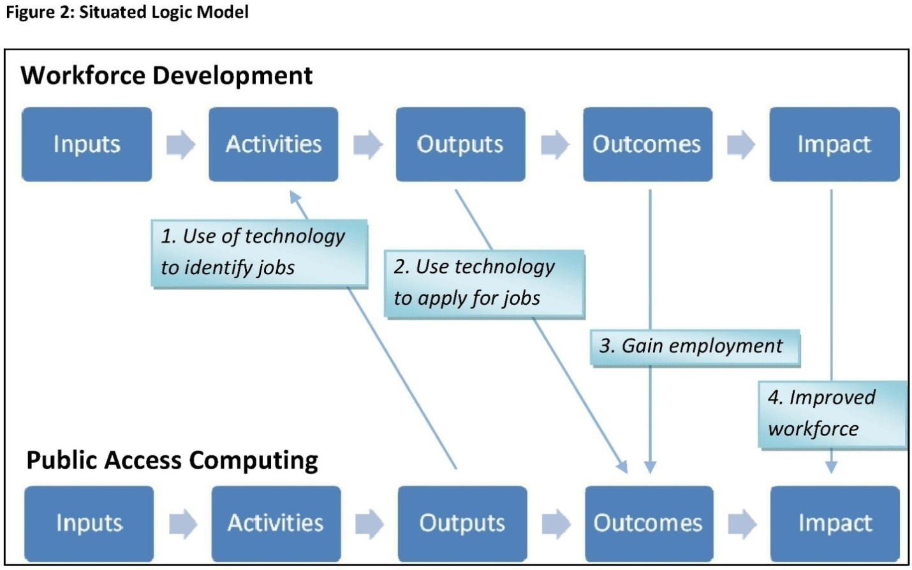

Question 7: Please explain how existing data from the Census Bureau’s Current Population Survey supplements on library use and Internet use informed this study.
Answer: The October 2002 CPS (Glander, 2006) study was used to estimate the possible universe of public library computer users and to help us develop the sampling frame for the telephone and web surveys. According to this study, 8.9% of households used a public library to use a computer or the Internet. There has been no subsequent CPS survey that specifically addressed public library computer and Internet use.

Question 8: Please explain how the 2007 IMLS study on individuals’ use of the Internet and library use informed this study.
Answer: The IMLS funded 2007 Pew/Internet & American Life Project (Estabrook, Witt, et al., 2007) looked at how people use the Internet, libraries, and government agencies to solve 10 common problems, all of which had a potential connection to the government or government‐provided information. Several of the key findings from this study helped inform our research design and survey, including:

- For help with a variety of common problems, more people turn to the Internet than consult experts or family members to provide information and resources.
- Persons 18‐30 years‐old are leading users of libraries for help in solving problems and are also most likely to say they will use libraries in the future when they encounter problems.
- There was some variance in where people turned for help depending on the type of problem that people confronted.
- People with low‐access to the Internet are poorer, older, and less well‐educated than those with broadband access at home or work.

The first finding identified the importance of Internet access for solving problems and determining why people might use public access computing resources for their needs. We developed our questions regarding impact to explore this area more thoroughly across multiple domains, and to probe into some of the specific areas where people might be using public access computing services to seek help.

The second finding informed our decision to specifically seek‐out young people for our study and to ensure that we were also able to capture those 14‐18. Reaching young people, as well as the homeless, was a major driver behind our decision to develop a web survey for this study.

The variance in where people turn for help depending on the type of problem with which they are confronted helped to inform the structure of our surveys and interview guides and specifically led us to ask about Lay Information Mediator Behavior (LIMB). LIMB occurs when a friend or family member finds information for another person and is important to understanding the boundaries of impact beyond the direct use of public access computing; questions about this type of behavior are asked in several places in both survey instruments and will also be a focus of case study interviews.

The fourth finding is the driver behind the inclusion of demographic questions drawn from the census data, which will allow us to correlate population characteristics with impact, and informed our inclusion of questions related to other access means available to individuals using public access services in libraries.

Question 9: Please describe how IMLS involved federal and non‐federal subject matters experts in the design of the research questions (e.g., a technical working group), as well as a list of those experts.
Answer: Library experts, as well as those from the educational, health, nonprofit, governmental, and business sectors were consulted in the development of indicator focus areas and the survey instruments. We convened our expert committee early in the development of our instruments, and used their direct feedback to develop and refine the policy domains selected for inclusion in the surveys, as well as for review of the individual questions in the survey over a 6 month period. In addition, we used the expertise of Glen and Leslie Holt, both well‐respected practitioners and researchers in the library community, as consultants to review our work to make sure it was meaningful within the library context. Members of the expert committee include:

• Rick Ashton, Chief Operating Officer, Urban Libraries Council
• Michael Barndt, Data Center Analyst, Nonprofit Center of Milwaukee
• Susan Benton, Strategic Partners Executive, City/County Management Association (ICMA)
• John Carlo Bertot, Professor and Associate Director, Information Use Management & Policy Institute, Florida State University
• Cathy Burroughs, Associate Director, National Network of Libraries of Medicine
• Sarah Earl, Acting Director, International Development Research Center Evaluation Unit
• Wilma Goldstein, Senior Advisor for Women’s Issues, Small Business Association
• Jaime Greene, Program Officer, Bill & Melinda Gates Foundation
• Carla Hayden, Executive Director, Enoch Pratt Free Library
• Peggy Rudd, Director and Librarian, Texas State Library and Archives Commission
• Ross Todd, Associate Professor and Director, Center for International Scholarship in School Libraries, Rutgers University
• Bernard Vavrek, Director, Center for the Study of Rural Librarianship, Clarion University of Pennsylvania

Question 10: Please provide a clear explanation of the power analysis used to determine sample sizes for each type of proposed data collection.
Answer: Because our research objectives are mostly descriptive, we used a precision analysis to estimate the sample sizes for the telephone and web surveys. We aimed to achieve a 95% confidence interval while minimizing the margin of error within generally accepted ranges. We estimated the standard error based on an 8.9% response rate to Q3 (Have you used a computer in a public library in the last year?). For the web survey, we estimated an average of 200 responses per library system based on the number of annual users of electronic resources as reported in the 2005 NCES dataset divided by the 14 day fielding period.

We calculated sample sizes for a range of margins of error (Table 6) and then factored in design and clustering effects (Table 7). For the phone survey, we determined the optimal point to be +/‐4.5%; further decreasing the margin of error would disproportionally increase the effective sample size and associated costs. However, because the incremental costs of increasing the precision of the web survey are minimal, we were able to reduce the estimated margin of error for this method to approximately +/‐2.5%, estimating approximately 80% of library systems selected for hosting the web survey would actually participate.

Table 6: Precision Analysis
Telephone survey |  |  |  | Web survey
Margin of Error at 95% Confidence | SRS sample size |  | Margin of Error at 95% Confidence |  | SRS sample size
2.5% | 1537 |  | 2.5% |  | 1537
3% | 1067 |  | 3% |  | 1067
3.5% | 784 |  | 3.5% |  | 784
4% | 600 |  | 4% |  | 600
4.5% | 474 |  | 4.5% |  | 474
5% | 384 |  | 5% |  | 384
7% |  | 196
9% |  | 119

Table 7: Survey Design Effects
Telephone survey |  | DEFF
Effective N |  |  |  | 400 |  | 600 | 800 | 1,000 | 1,500 | 2,000
SRS Estimate |  |  | 1.5 | 267 |  | 400 | 533 | 667 | 1,000 | 1,333
Web survey
Effective N | Roh |  | DEFF | 10,000 |  | 25,000 | 50,000 | 75,000 | 100,000 | 200,000
SRS estimate | 0.15 |  | 38.6 | 259 |  | 648 | 1,297 | 1,945 | 2,593 | 5,186
# Library systems |  |  |  | 50 |  | 125 | 250 | 375 | 500 | 1000

This more robust sampling frame for the web survey also attempts to account for the vagaries of sampling at the library system level to achieve a certain number of responses at the user level. We believe this is justified as one of the goals of our overall mixed method approach is to validate the use of web surveys in library research.

Question 11: Please provide more specifics on how the desired indicators to be developed from this study will inform IMLS policies.
Answer: The study indicators are designed to help the public library community better understand the size and scope of public access use in United States. They are not are intended to affect or alter IMLS grant making policies or priorities. This use of a cooperative agreement is consistent with the Section 9162 of the IMLS authorizing legislation [20 USC Chapter 72] which states: “From the amounts reserved under section 9131(a)(1)(B) of this title for any fiscal year the Director shall establish and carry out a program of awarding grants or entering into contracts or cooperative agreements to enhance the quality of library services nationwide and to provide coordination between libraries and museums. Such grants, contracts, and cooperative agreements shall be used for activities that may include: … (2) research and demonstration projects related to the improvement of libraries, education in library and information science, enhancement of library services through effective and efficient use of new technologies, and dissemination of information derived from such projects.”

Citations
Bertot, J., McClure, C. R., Jaeger, P. T., & Ryan, J. (2006). Public libraries and the Internet 2006: Results and Findings. Information Use Management and Policy Institute, College of Information, Florida State University.

Crandall, M. D. & Fisher, K. E. (2007). Baseline Data Collection and Analysis for CT Support (work in progress). Funded by Bill & Melinda Gates Foundation under Grant # 42646.

Estabrook, L., E. Witt, et al. (2007). Information that solves problems: How people use the internet, libraries, and government agencies when they need help. Washington, DC, Pew/Internet & American Life Project

Glander, M., and Dam, T. (2006). Households’ Use of Public and Other Types of Libraries: 2002 (NCES 2007‐327). U.S. Department of Education. Washington, DC: National Center for Education Statistics. Retrieved from http://nces.ed.gov/pubsearch.

Kroe, P.E. (2007). Data File, Public Use: Public Libraries Survey: Fiscal Year 2005 (NCES 2008–303). National Center for Education Statistics, Institute of Education Sciences, U.S. Department of Education. Washington, DC.

Naumer, C., Situated Logic Model: Using the Model in the Real World (forthcoming), in Information and Community Technology: Identifying Local and Global Impact, M. Crandall and K.E. Fisher, Editors. 2008, Information Today: Medford, N.J.

PEW Internet and American Life Project – Reports. (2007). http://www.pewinternet.org/reports.asp

N=SE*z/T2

