This is an update to the letter sent on September 14, 2009 regarding usability interviews for the online version of the National Survey of College Graduates (NSCG), sponsored by the National Science Foundation.

In that letter we requested approval to conduct 30 usability interviews—15 interviews with each of two versions of the instrument.

At this time we are conducting a second round of interviews, involving an additional 30 participants during February and March, 2010. These interviews will be conducted with two new versions of the questionnaire. While the initial versions included the placement of the job categories in two columns and tested the sequence of the ‘Next’ and ‘Previous’ buttons, the new versions include a single column of job categories. This will result in the following four versions of the form:

1 column,  ‘next’ button first | 2 columns,  ‘next’ button  first
1 column,  ‘previous’  button first | 2 columns,  ‘previous’ button first

These interviews will be conducted by staff from the Census Bureau’s Usability Lab and will involve the same types of respondents, recruited from the same sources, as described in the September 14, 2009 letter. Also as described in that letter, we will provide a $40 stipend for expenses to each participant who completes a session.

Copies of screens from the two new versions of the questionnaire are attached.

The estimated time for completion of each usability session is one hour. Thus, the total estimated burden time for testing is a maximum of 30 hours.

The contact person for questions regarding data collection or statistical aspects for this project is:
Jennifer C. Romano
Statistical Research Division
Room 5K102D
U.S. Census Bureau
Washington, D.C. 20233
(301) 763- 3577

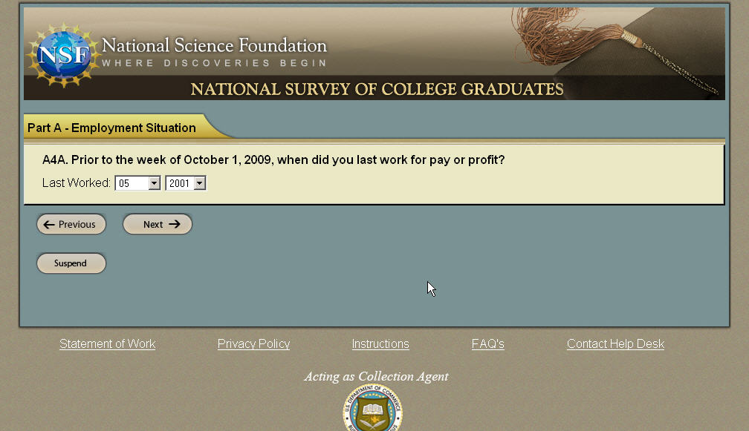
Version with Previous on the left

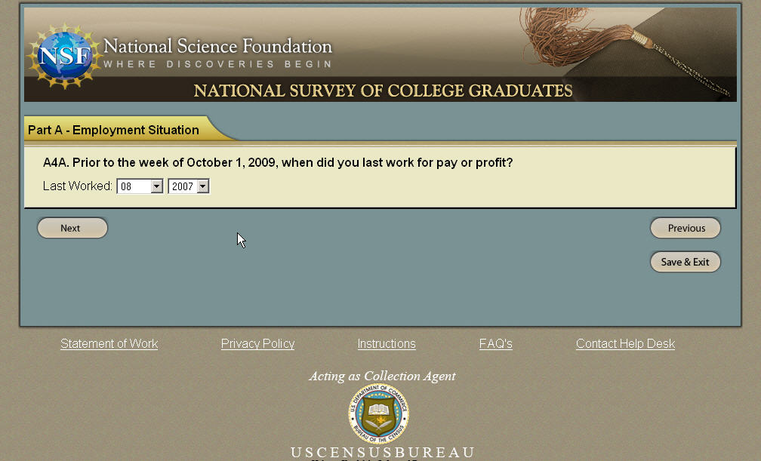
Version with Next on the left

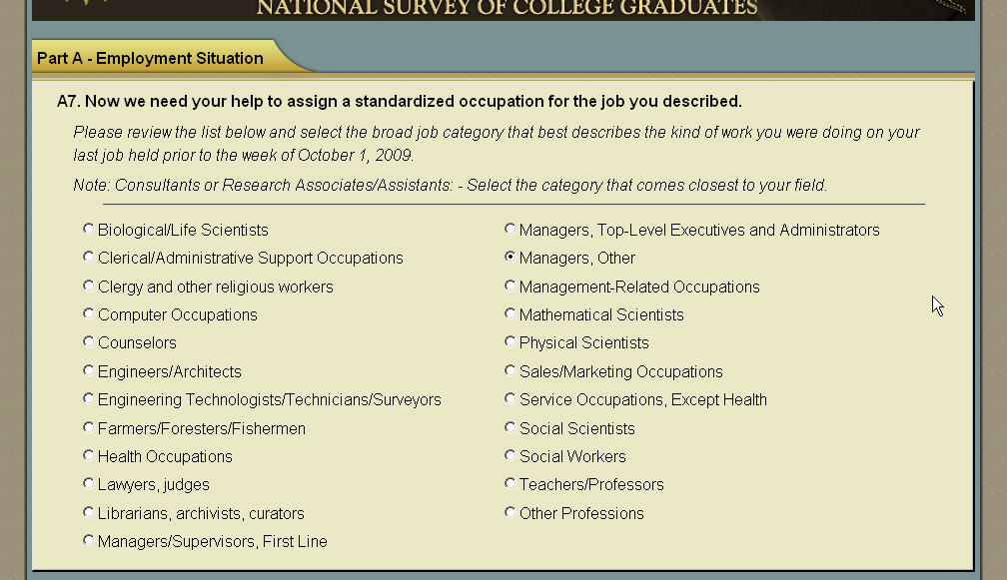
Version with 2 columns
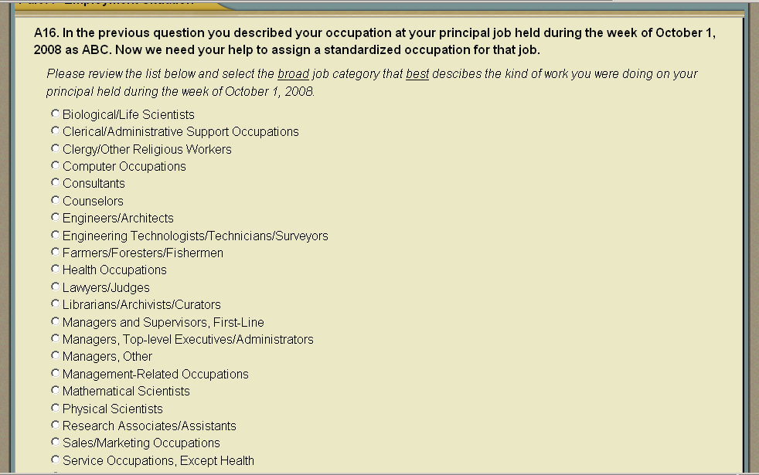
Version with 1 column

