Attachment 1a – Forms to be used as starting points in evaluating the collection of birth certificate data using focus group and cognitive interview techniques.

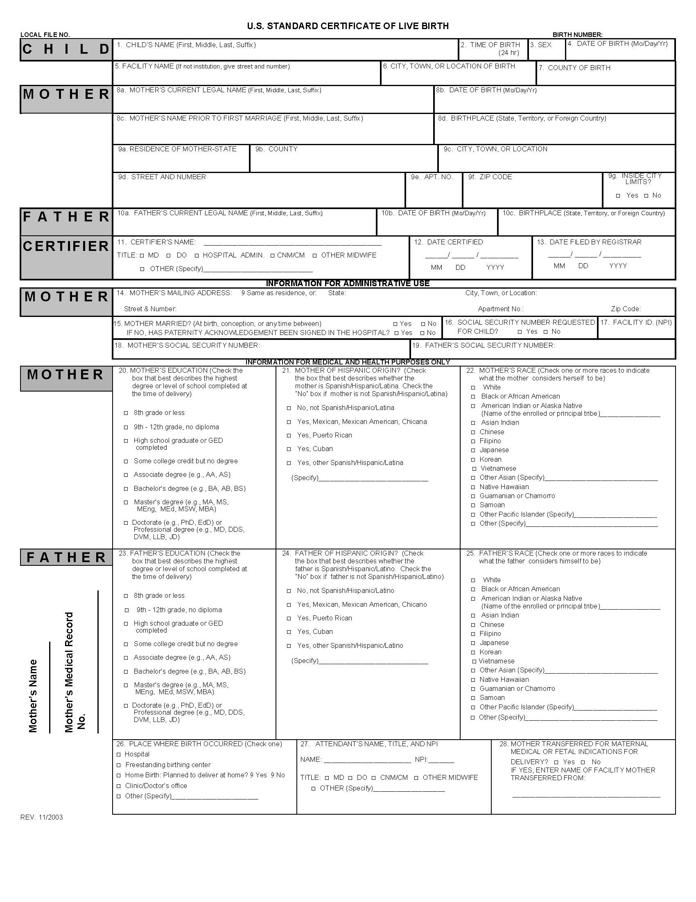
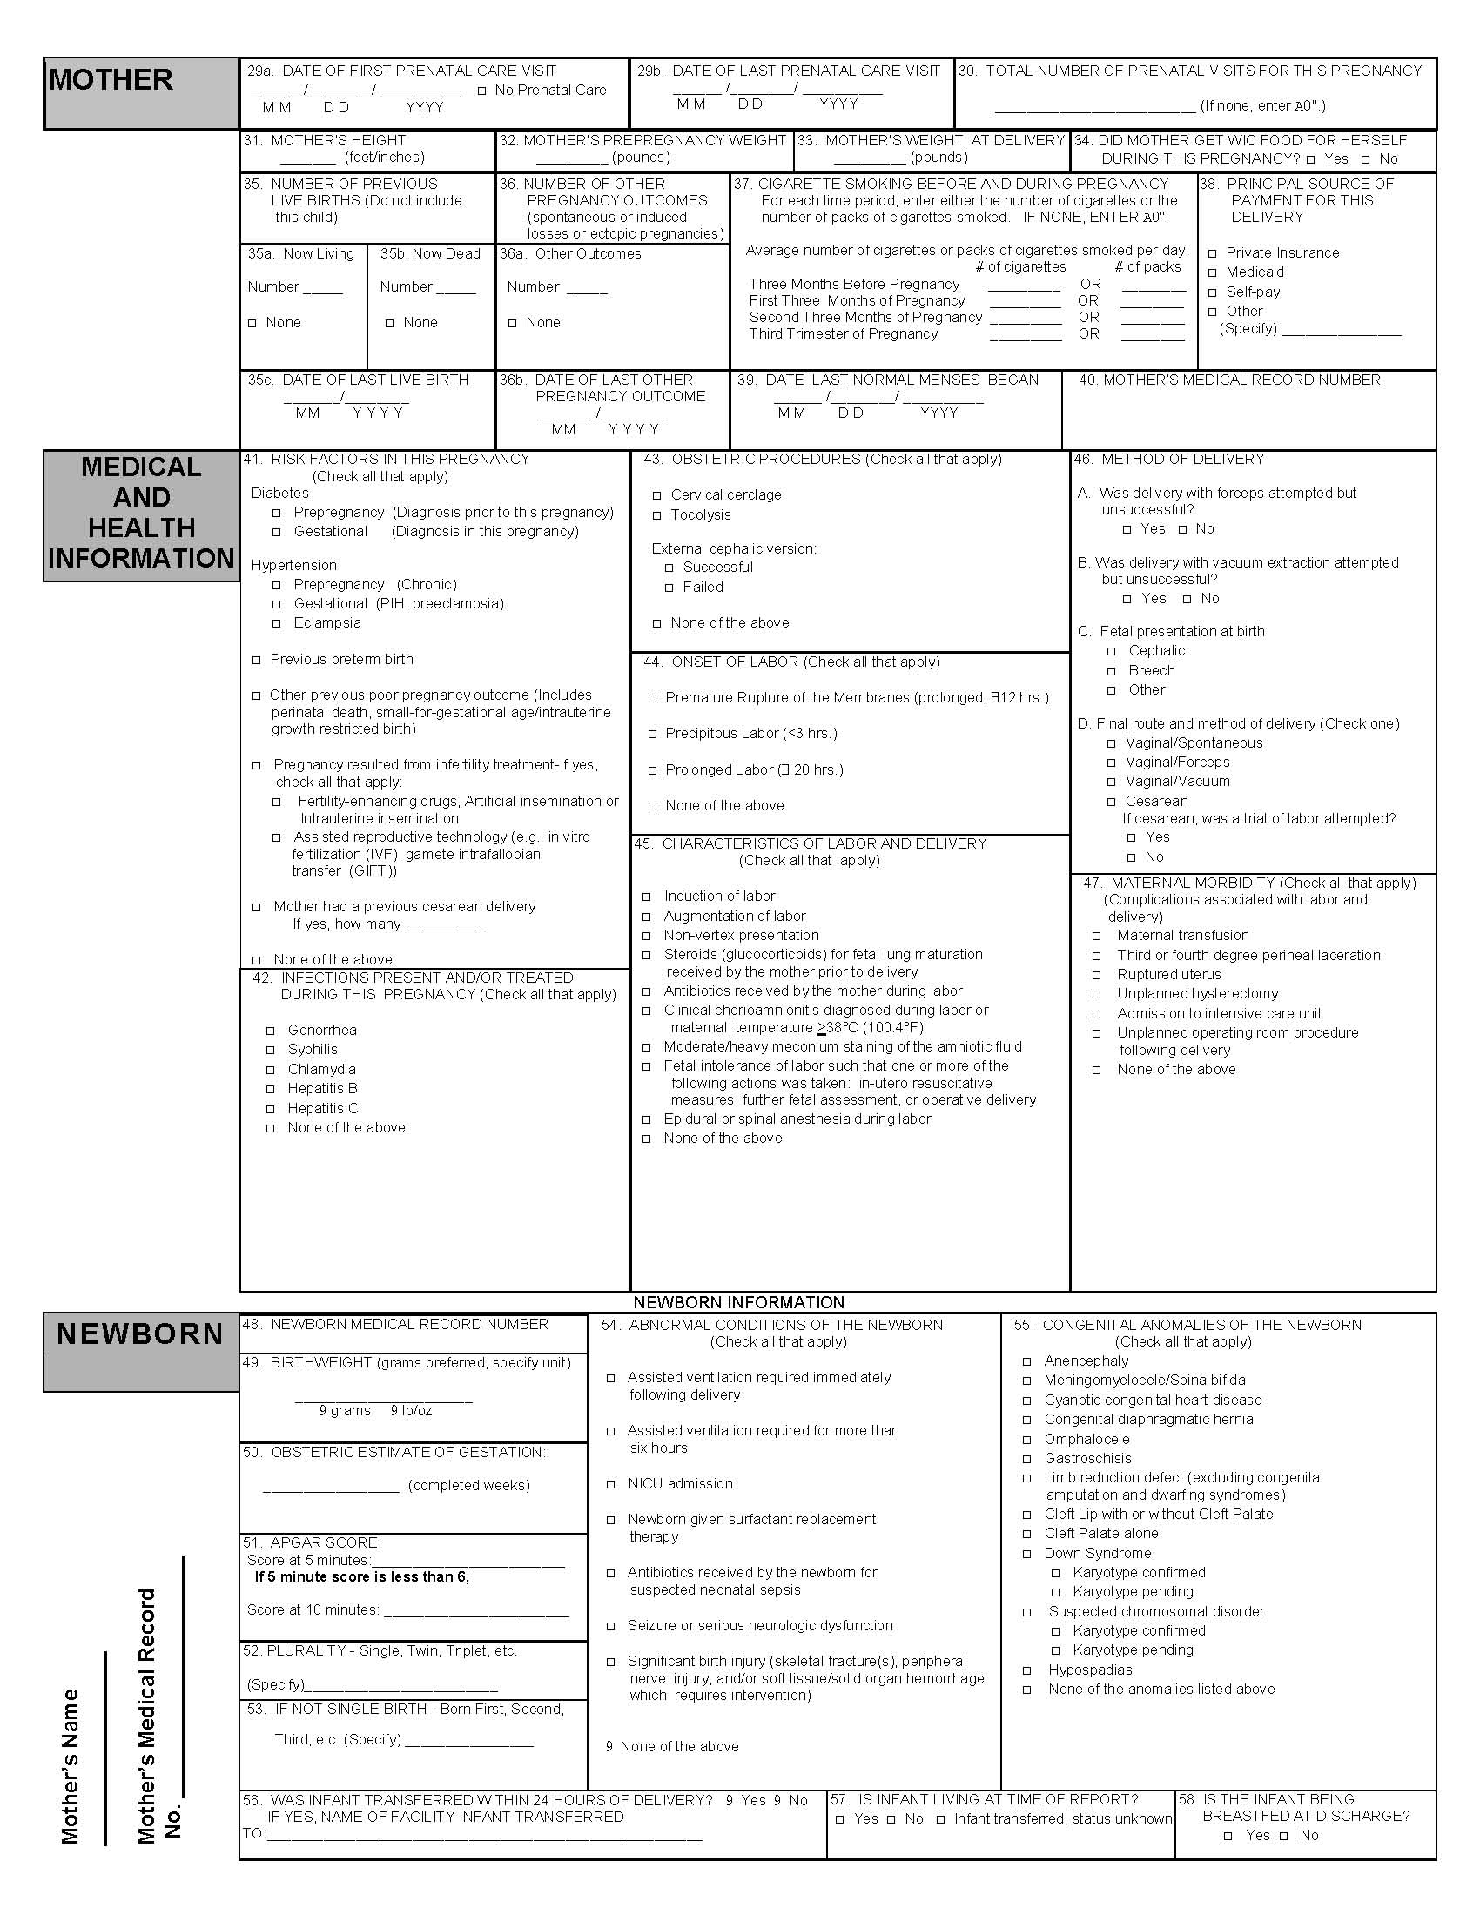

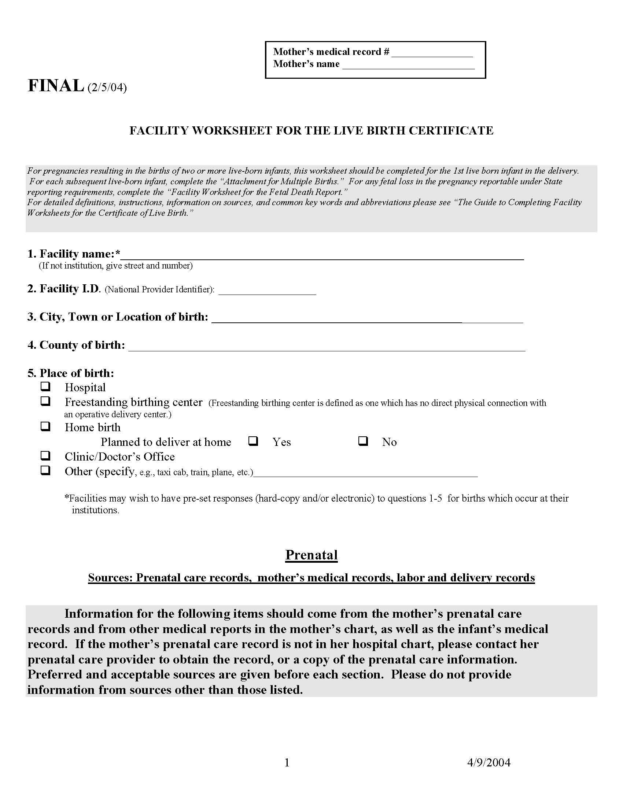
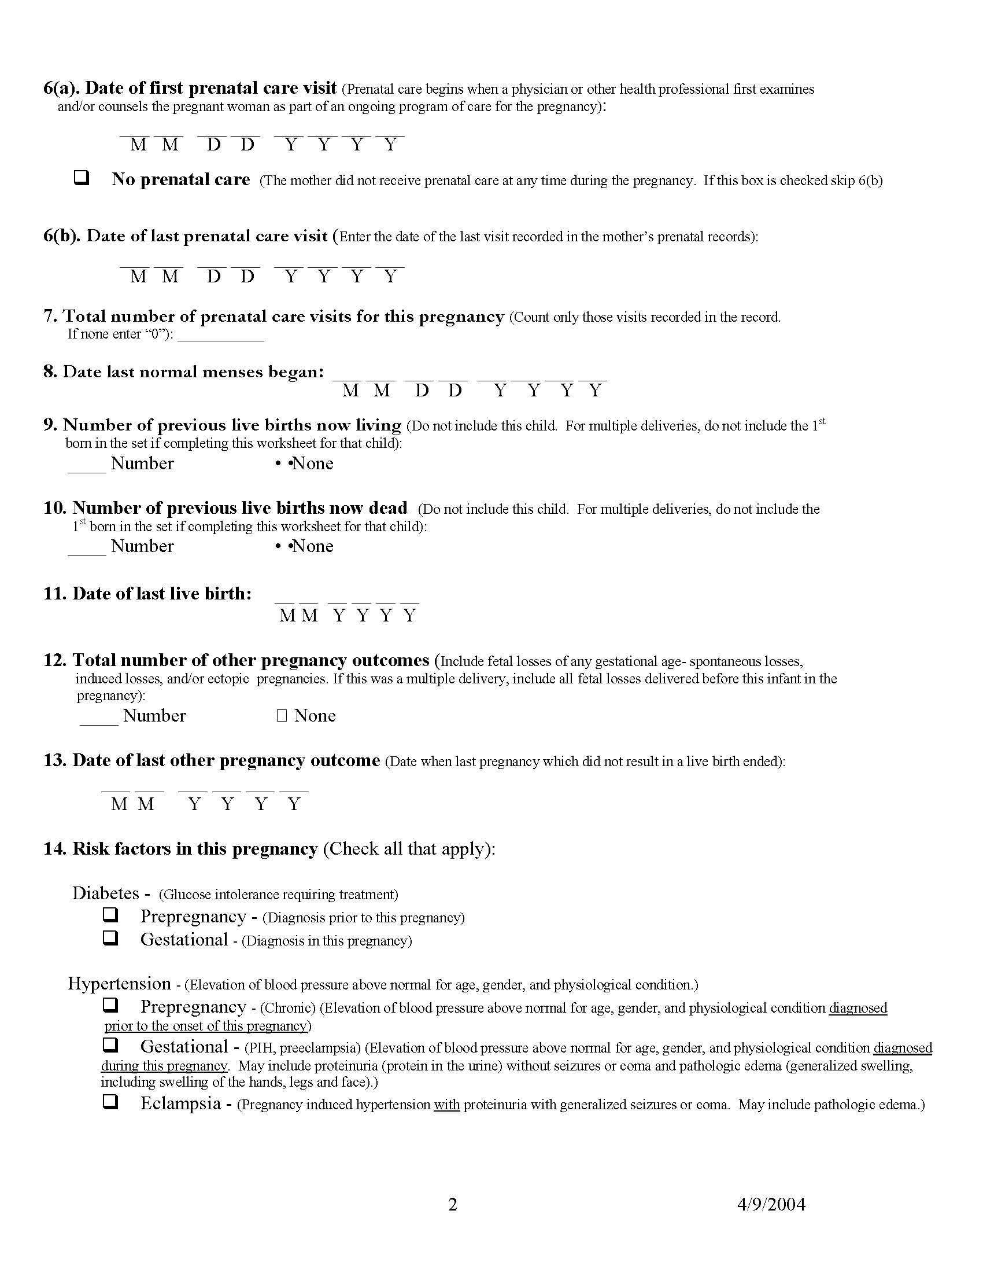
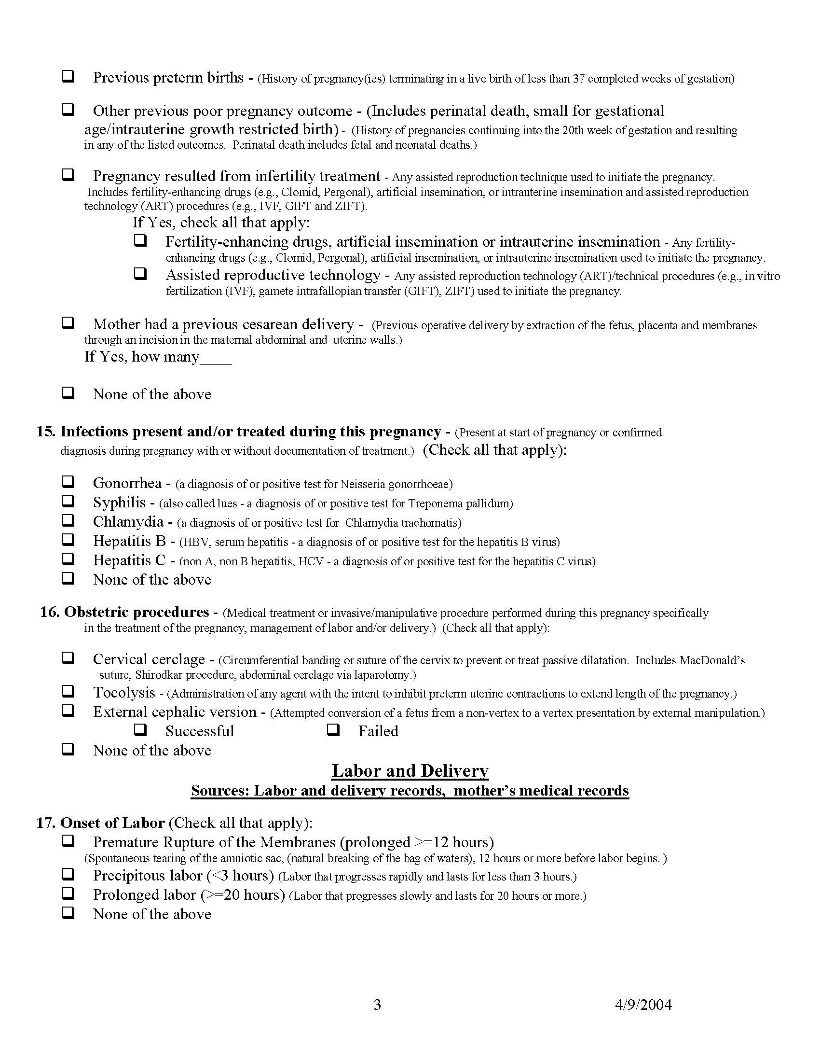
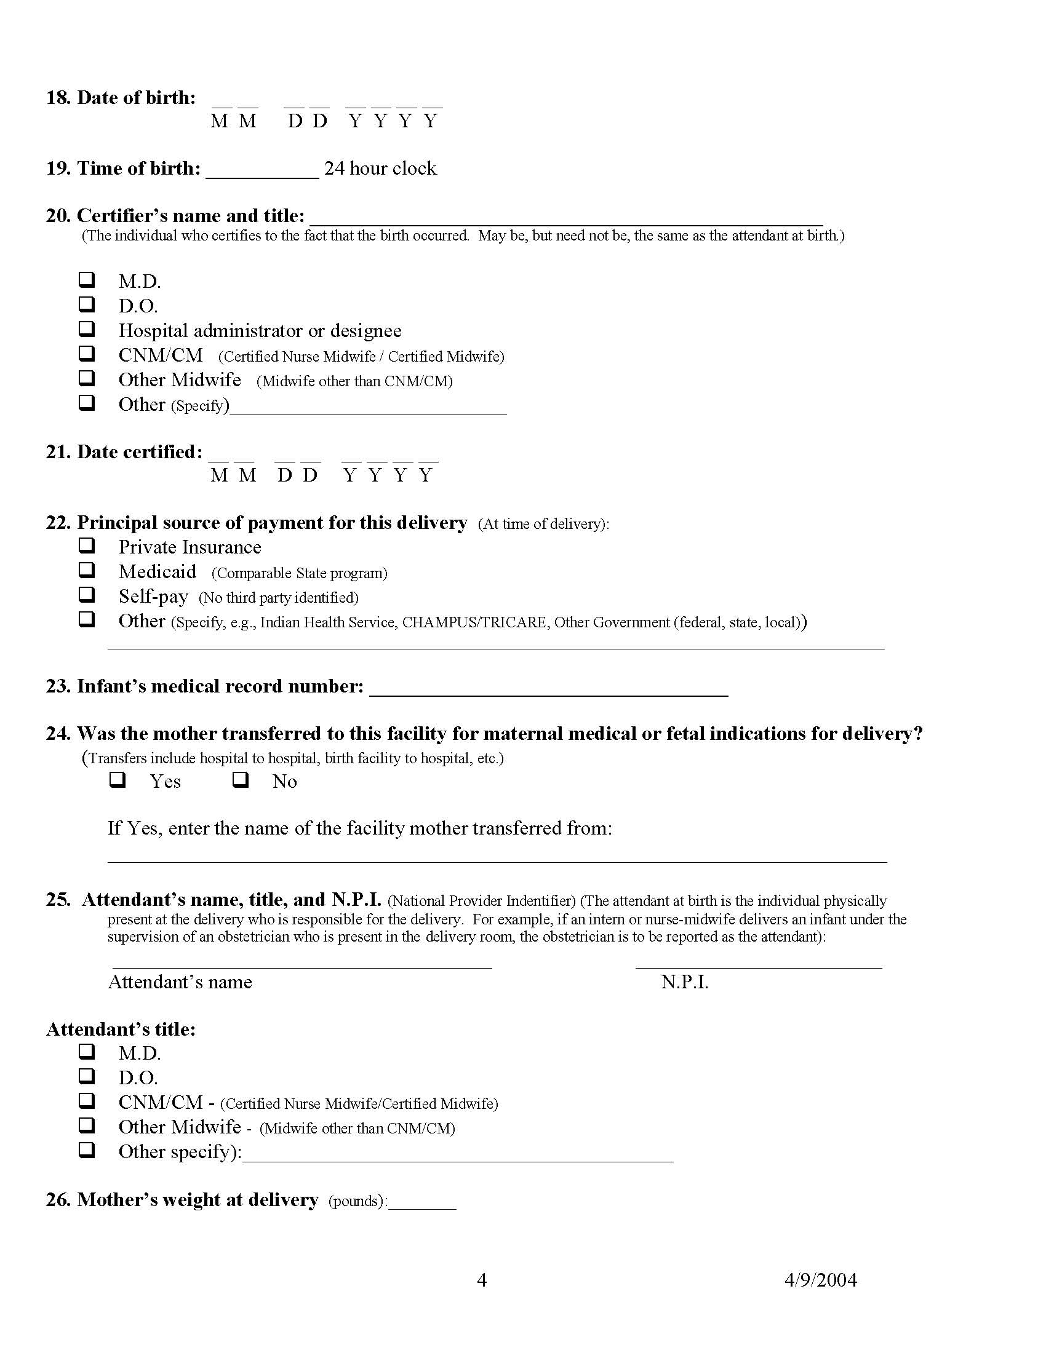
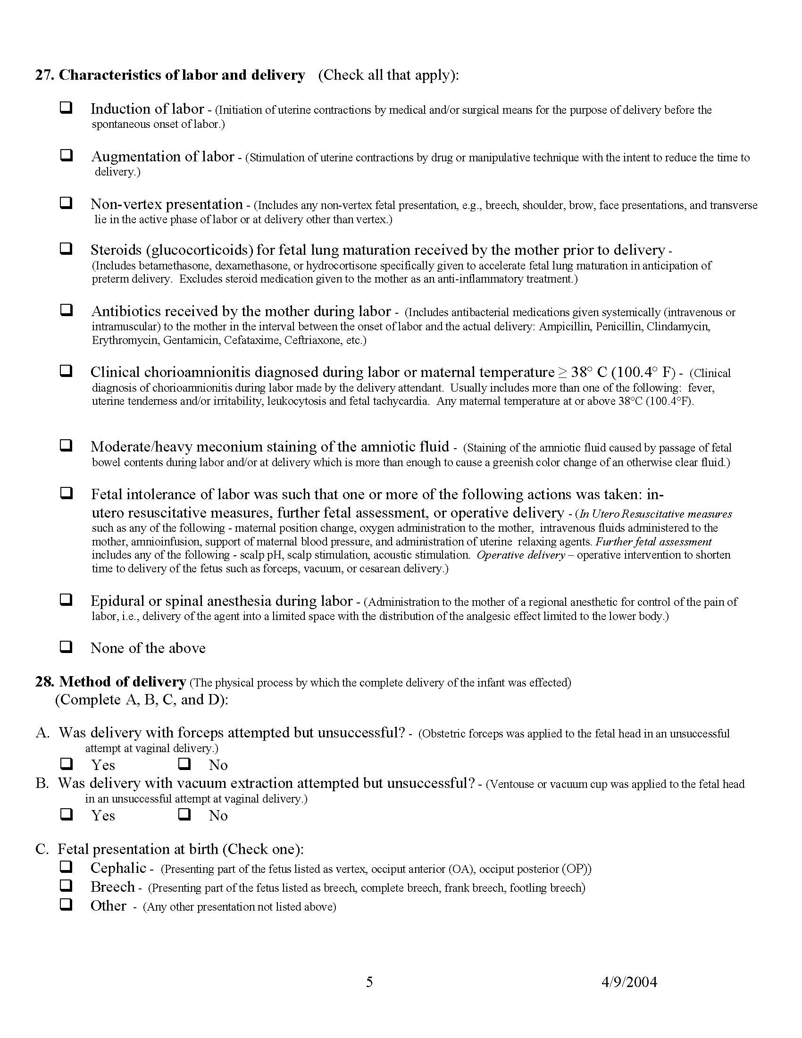
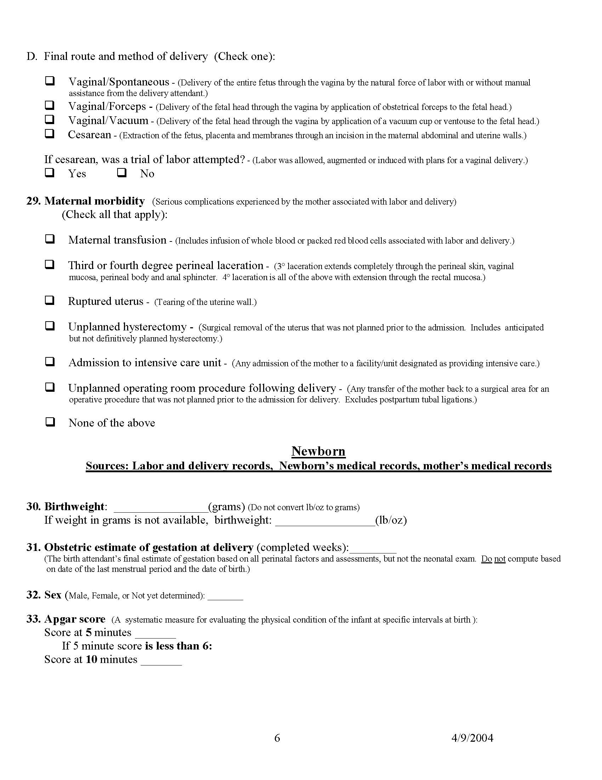
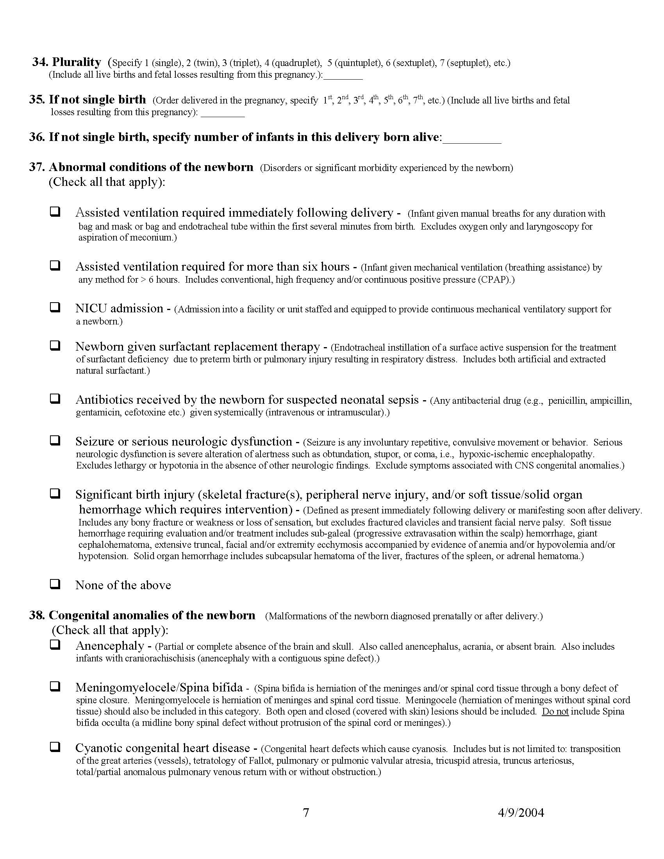
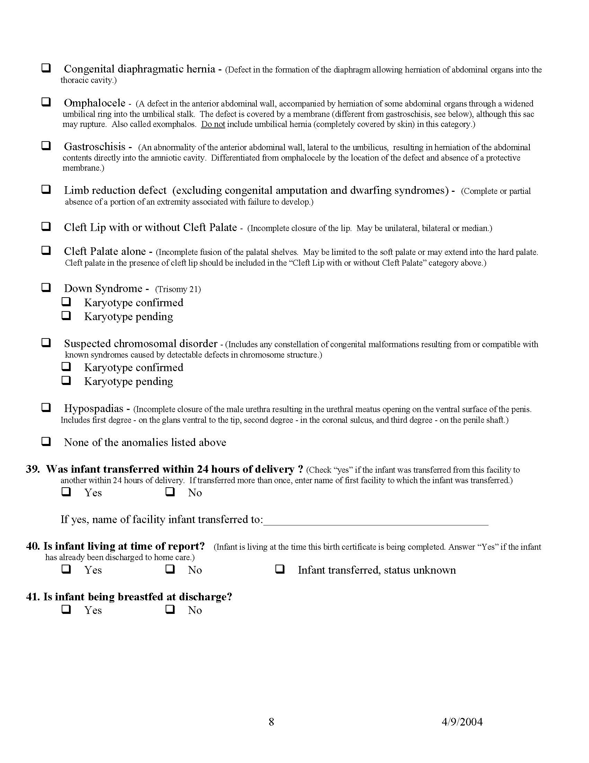
Appendix 1b – Discussion Guide For Focus Groups

OMB #0920-0222; Expiration Date: 02/28/10
Notice - Public reporting burden for this collection of information is estimated to average 90 minutes per response, including time for reviewing instructions, searching existing data sources, gathering and maintaining the data needed, and completing and reviewing the collection of information. An agency may not conduct or sponsor, and a person is not required to respond to, a collection of information unless it displays a currently valid OMB control number. Send comments regarding this burden estimate or any other aspect of this collection of information, including suggestions for reducing burden to: CDC/ATSDR Reports Clearance Officer; 1600 Clifton Road, MS D-24, Atlanta, GA 30333, ATTN: PRA (0920-0222).

Assurances of Confidentiality – All information which would permit identification of any individual, a practice, or an establishment will be held confidential, will be used only by NCHS staff, contractors, and agents only when required and with necessary controls, and will not be disclosed or released to other persons without the consent of the individual or the establishment in accordance with section 308(d) of the Public Health Service Act (42 USC 242m) and the Confidential Information Protection and Statistical Efficiency Act (PL-107-347).

Introduction
Welcome. My name is ____________. Before we start, I want to make sure that you understand who we are and why you’re here. The National Center for Health Statistics, a federal government statistical agency, is part of the Centers for Disease Control and Prevention (CDC). One of CDC’s key missions is to monitor the health of people in the United States.

Birth certificate data are used to monitor the health of women giving birth and their infants, as well as to determine public policy and funding for maternal and child health at the local, state and national level.

Since the 2003 Revised U.S. Standard Certificate of Live Birth includes changes in the data items and in how these data are collected, it is crucial to ascertain how the data are collected and what problems if any are encountered along the way.

Today we will be discussing how you collect birth certificate data. For example, what sources are available to you? How easy/difficult is it to find a specific data item? What do you do if you cannot find a data item? We’ll be using the 2003 Revised U.S. Standard Certificate of Live Birth and the facility worksheet as starting points for our interview, with the understanding that they may differ somewhat from those used in your hospital.

Overview and Ground Rules
Before we continue, I’d like to go over some general information—we’d like to establish some ground rules for our discussion, and tell you about the confidentiality procedures we have in place.

I would like you to know that in the whole discussion today, you don’t have to reveal anything that you are not comfortable revealing.

For purposes of the group discussion, we’d like you to pick a name that you would like to be called– a first name is fine, it doesn’t even have to be your real name. [ASK THEM TO FILL OUT NAME CARDS.]

The consent form you just signed assures you that we will keep your information confidential. We would also like to ask everyone to treat this discussion as confidential. That is, if you learn anything private about another member of the group, we would like to ask you not to discuss that with anyone outside of this room. Although we are required by federal law to keep information private, we cannot guarantee that everyone else will honor your privacy. All we can do is ask that people please agree to that. And again, you should never feel obligated to share any information that you are not comfortable sharing.

We are planning to audio tape this focus group. This is for note-taking purposes in case we miss anything that was said. We will use the tape to double-check our notes and make sure they are complete.

One of the great things about this discussion is “group dynamic” – ideas that one person raises will remind someone else of a related issue. That’s great, feel free to speak up. But also don’t interrupt each other. We ask that there be only one speaker at a time so that responses can be accurately recorded. You may have more to say about some topics than others, and that’s OK too.

Don’t feel like you have to agree or disagree with anyone in this room. We want to hear about your personal experiences and thoughts and it’s OK to disagree with someone else. But please be respectful of the opinions or experiences of others in the room.

Sometimes groups start talking about subjects that are off the main topic. That’s natural; but please don’t be offended if we steer the conversation back to the material we most need to cover.

As a courtesy to everyone, please turn off your beepers and cell phones. The discussion will last 90 minutes. We will not have breaks built into it, but should you need to go to the restroom during the discussion, please feel free to leave. However, I would appreciate it if you would go one at a time.

Does anyone have any questions before we get started? [If yes, answer questions]. [If no, okay then, let’s proceed].

Moderator talking-points

1. What sources are available to you to complete the information on the Facility Worksheet?

2. If a source that you need is not available, what do you do?

3. Is there Information you are asked to collect that you cannot find?

4. Are there instances when you are not sure what information you are being asked to collect?

Wrap-Up (5 minutes)
OK. We are pretty much out of time. Does anyone have any last thoughts or questions?

I want to thank all of you for coming today and sharing your opinions. The information you’ve shared today will be very useful in helping to improve the collection of birth certificate data. [Stop audio taping].
Appendix 1c – Introduction to cognitive interview

OMB #0920-0222; Expiration Date: 02/28/10
Notice - Public reporting burden for this collection of information is estimated to average 60 minutes per response, including time for reviewing instructions, searching existing data sources, gathering and maintaining the data needed, and completing and reviewing the collection of information. An agency may not conduct or sponsor, and a person is not required to respond to, a collection of information unless it displays a currently valid OMB control number. Send comments regarding this burden estimate or any other aspect of this collection of information, including suggestions for reducing burden to: CDC/ATSDR Reports Clearance Officer; 1600 Clifton Road, MS D-24, Atlanta, GA 30333, ATTN: PRA (0920-0222).

Assurances of Confidentiality – All information which would permit identification of any individual, a practice, or an establishment will be held confidential, will be used only by NCHS staff, contractors, and agents only when required and with necessary controls, and will not be disclosed or released to other persons without the consent of the individual or the establishment in accordance with section 308(d) of the Public Health Service Act (42 USC 242m) and the Confidential Information Protection and Statistical Efficiency Act (PL-107-347).

Introduction
Thank you for agreeing to participate in this interview today. You have read the Informed Consent form and you agree to take part in this research study. Is that correct? [Interviewer waits for verbal acknowledgment]. You have given your permission for me to tape record your interview today and, if needed, to play it to other people working on this study. Is that correct? [Interviewer waits for verbal acknowledgment].

Before we start, I want to make sure that you understand who we are and why you’re here. The National Center for Health Statistics, a federal government statistical agency, is part of the Centers for Disease Control and Prevention (CDC). One of CDC’s key missions is to monitor the health of people in the United States.

Birth certificate data are used to monitor the health of women giving birth and their infants, as well as to determine public policy and funding for maternal and child health at the local, state and national level.

Since use of the 2003 Revised U.S. Standard Certificate of Live Birth includes changes in data items and in how these data are collected, it is crucial to ascertain how the data are collected and what problems if any are encountered along the way.

Today we will be discussing how you collect birth certificate data. For example, what sources are available to you? How easy/difficult is it to find a specific data item? What do you do if you cannot find a data item? We’ll be using the 2003 Revised U.S. Standard Certificate of Live Birth and the facility worksheets as starting points for our interview, with the understanding that these may differ somewhat form those used in your hospital.

I want to remind you that this interview is strictly confidential. Confidential means that your name will never be linked to the answers you give.

Do you have any questions you want to ask me before we begin?

