Summer Reading Program Study
OMB Clearance Request—Appendix A
Supporting Materials
February 2009
Prepared For:
Institute of Education Sciences
United States Department of Education
Contract No. ED-06-CO-0017
Prepared By:
Regional Educational Laboratory—Southwest
Edvance Research, Inc.
9901 IH-10 West, Suite 700
San Antonio, Texas 78230
(210) 558-1902
(210) 558-1075 (fax)

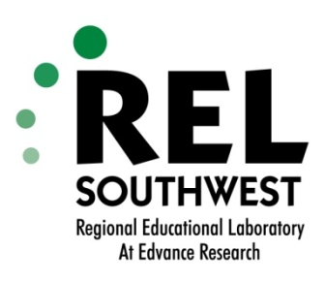

April 2009

Dear Parent or Guardian,

We are happy to tell you that your child’s school district is participating in a Voluntary Summer Reading Program. If you agree to participate your child will get eight free books to keep and read either this summer or next summer. The program is funded by the U.S. Department of Education and conducted by the Regional Educational Laboratory – Southwest (REL Southwest). Our goal is to help students read better and enjoy reading more. Our results will help schools and teachers improve future summer reading programs.

What does my child get from being in this program?
Your child will get eight free books to keep and read either this summer or next summer. Reading over the summer may improve your child’s reading. The program will help school districts plan summer reading programs in the future as a way to help improve students reading.

How does my child participate in this program?
With your permission, your child will be mailed eight free books to keep and read. The books will be provided at either the end of this school year or at the end of the next school year. To sign up for the program, simply sign this form and have your child select his or her six favorite things to read about (like animals or history).

What other information about my child will be collected?
With your permission, we will ask your school district to provide us with records about your child’s background and reading achievement. Every school district maintains this type of information about students.

Will information about my child stay private?
Yes. We will not share your child’s information with anyone outside the program team. Your child’s test results and school district-provided information will only be used to evaluate the effectiveness of the Summer Reading Program. Final reports about this program will summarize findings, and will not identify you or your child to anyone outside the program team, except as required by law.

No child’s name will be used or appear in any written work. In addition, your child’s participation in the program will not affect his or her treatment at school. Please note that you may withdraw your child from data collection at any time without penalty.

We hope you will see the value of this program and agree to consent to your child’s participation. Please sign the Parent/Guardian Informed Consent Form and have your child complete the Student Interest Survey. Please return both forms to your child’s teacher.

If you have questions about this program, please contact Anna Baldwin, the Project Coordinator, by email at abaldwin@edvanceresearch.com or by telephone at (210) 558-4114.

Sincerely,

REL Southwest
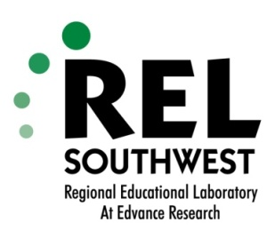

Voluntary Summer Reading Program
Parent/Guardian Informed Consent Form

I understand that my consent for my child’s participation in the Voluntary Summer Reading Program conducted by the Regional Educational Laboratory – Southwest (REL Southwest) means that:

- My child will be mailed eight free books to keep and read during the summer of either 2009 or 2010.
- My child’s school district will provide background and academic achievement information about my child to the summer reading program team.
Additionally, I understand the following statements about my child’s rights as a participant in the program:

- Any information obtained during the program that could identify my child will not be provided to anyone outside the summer reading program team.
- Responses to this data collection will be used for statistical purposes only. The reports prepared for this program will summarize findings and will not associate responses with a specific individual. The study team will not provide information that identifies me or my child to anyone outside the summer reading program team, except as required by law.
- My consent for a) my child’s participation in the Voluntary Summer Reading Program and b) the district’s sharing of my child’s background and academic achievement information with the summer reading program team is voluntary. I can revoke my consent at any time.
- If I have questions about this program, I can contact Anna Baldwin, the Project Coordinator, by email at abaldwin@edvanceresearch.com or by telephone at (210) 558-4114.

Please check the appropriate box and fill in the information below. Please return this form to your child’s teacher. THANK YOU!

 YES, my child can participate in this Summer Reading Program My school district can share my child’s background and academic achievement information with the Summer Reading Program team.

 NO, my child may NOT participate in this Summer Reading Program My school district may NOT share my child’s background and academic achievement information with the Summer Reading Program team.

Parent or Legal Guardian Name (please print) __________________________________________

Child’s Name (please print) ____________________________________________________________________

Address (Summer 2009): ___________________________________________________________

Parent or Legal Guardian Signature __________________________________Date_____________

