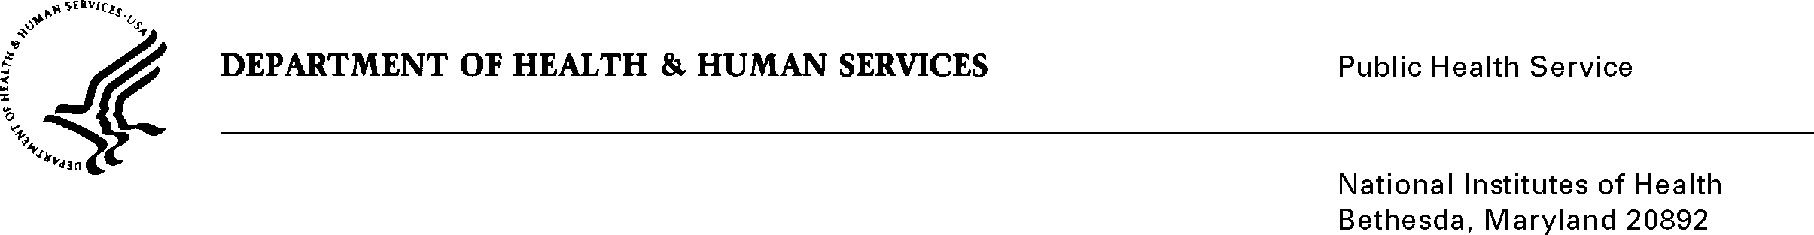

DATE: November 21, 2008

TO: Cathrine Sasek, Ph.D.
Health Science Administrator
Office of Science Policy
Office of Science Policy & Communications, NIDA

FROM: NIH Privacy Act Officer

SUBJECT: Applicability of the Privacy Act: Simulations for Drug Related Science Education

I have reviewed the NIDA submission to OMB entitled “Simulations for Drug Related Science Education” and have determined that the Privacy Act will not apply to this data collection.

Although students will be asked to provide personally identifiable information (birth date, grade, gender, race and personal opinions), they will not be asked to provide their name and the system is not designed to retrieve the survey information by a personal identifier linked to them.

The data collection is covered by NIH Privacy Act Systems of Record 09-25-0156, “Records of Participants in Programs and Respondents in Surveys Used to Evaluate Programs of the Public Health Service, HHS/PHS/NIH/OD”.

If you have any questions, please contact my office at (301) 496-2832.

Karen M. Plá

Attachment

