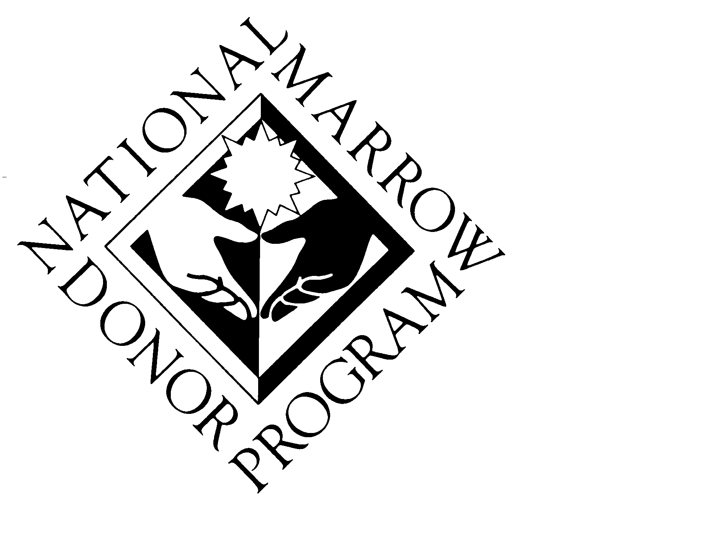
National Marrow Donor Program®

Example of Customer Survey

OFFICE OF PATIENT ADVOCACY
Customer Satisfaction Survey

Public Burden Statement: An agency may not conduct or sponsor, and a person is not required to respond to, a collection of information unless it displays a currently valid OMB control number. The OMB control number for this project is 0915-0212. Public reporting burden for this collection of information is estimated to average xx hours per response, including the time for reviewing instructions, searching existing data sources, and completing and reviewing the collection of information. Send comments regarding this burden estimate or any other aspect of this collection of information, including suggestions for reducing this burden, to HRSA Reports Clearance Officer, 5600 Fishers Lane, Room 10-33, Rockville, Maryland, 20857.

OPA SURVEY

1. How did you learn about OPA? (Check as many as you need.)
❒ Mail
❒ Phone call from OPA
❒ NMDP Web site (www.marrow.org)
❒ My doctor or nurse
❒ Other (Please describe)

2. Were you satisfied with the information or services from OPA? (Check one.)
❒ Yes ❒ Somewhat ❒ No ❒ Does not apply

3. What information or services did you ask for? (Check as many as you need.)
❒ Disease information
❒ Treatment information
❒ Stem cell transplant information
❒ How to find a volunteer unrelated donor
❒ Transplant Centers and doctors
❒ Understanding my insurance
❒ Financial help during treatment
❒ Help with travel and places to stay during transplant
❒ Tests of new treatments for my disease (clinical trials)
❒ I did not ask for information or services
❒ Other: (please describe) ________________________________________________

4. Did you understand the information? (Check one.)
❒ Yes ❒ Somewhat ❒ Did not understand ❒ Does not apply
Comments:

5. Did you learn more about stem cell transplants after the phone call? (Check one.)
❒ Yes ❒ Somewhat ❒ Not at all ❒ Does not apply
Comments:

6. Was the OPA person you spoke with friendly and polite? (Check one.)
❒ Yes ❒ Somewhat ❒ No ❒ Does not apply
Comments:

7. Do you (or the person you called about) think you will need a stem cell transplant now or in the future?
❒ Yes (If yes, what kind?)
❒ Using my own cells (autologous transplant)
❒ Using cells from a relative (related transplant)
❒ Using cells from someone who is not related to me (matched unrelated transplant)
❒ Using cells from an umbilical cord (cord blood unit)
❒ No (If no, why not?)
❒ I am on another therapy and doing well
❒ I don’t have insurance or money to pay
❒ Other
❒ I don’t know

8. If you have more comments or ideas for us, please include them here.

THANK YOU!

Please return the survey in the enclosed pre-paid envelope or mail to:

Office of Patient Advocacy
National Marrow Donor Program
3001 Broadway Street NE, Suite 500
Minneapolis, MN 55413

