Attachment 2B

Summary of Public Comments and CDC Response

Exploratory Research with People Living with Lung Cancer

Federal Register Notice: A 60-day Notice was published in the Federal Register on Monday, August 4, 2008, Vol. 73, No. 150, pp. 45224-45225

Public Comment #1

From: Janine Chambers [mailto:JChambers@lungusadc.org]
Sent: Tuesday, August 26, 2008 10:21 AM
To: OMB-Comments (CDC)
Subject: Request for document
Please send a copy of the data collection plans for Exploratory Research with People Living with Lung cancer-New-Division of Cancer Prevention and Control, National Center for Chronic Disease Prevention and Health Promotion, Centers for Disease Control and Prevention (CDC).
[FR Doc. E8-17767 Filed 8-1-08}

Thank you,

Janine L. Chambers
Director, Adult Lung Disease Programs
American Lung Association
1301 Pennsylvania Avenue NW, Suite 800
Washington, DC 20004-1725

telephone: (202) 785-3355
Fax: (202) 452-1805
jchambers@lungusadc.org

CDC Response to Public Comment #1

CDC provided copies of the draft information collection instruments and the draft study methodology to the requestor at the American Lung Association.

Public Comment #2

The American Lung Association provided a Letter of Support for the project (see next page).
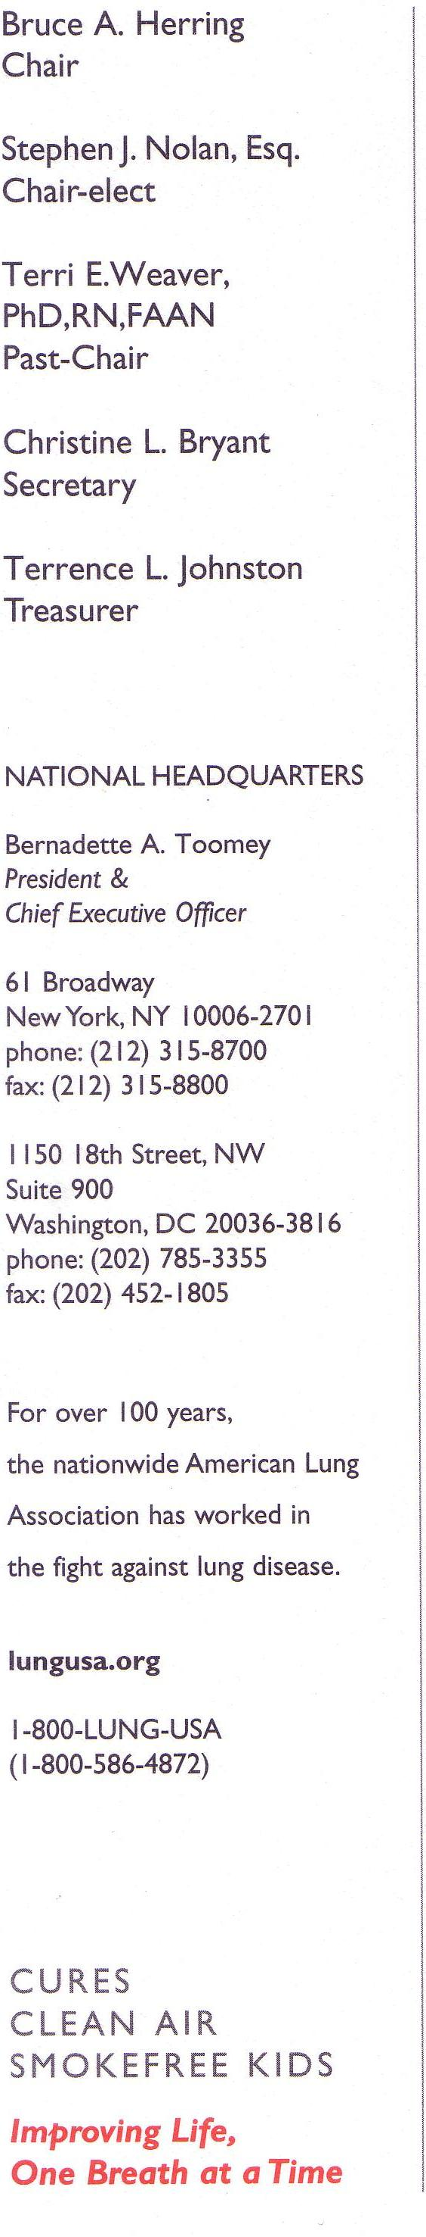


September 30, 2008

Maryann I. Daneshvar
CDC Acting Reports Clearance Officer
1600 Clifton Road
MS-D74
Atlanta, GA 30333

RE: FR Doc. E8-17767

Dear Ms. Daneshvar:

The American Lung Association is one of the nation’s oldest voluntary health organizations. Founded in 1904 to combat tuberculosis, our mission continues to prevent lung disease and promote lung health. Through research, education and advocacy, the American Lung Association works to fight all lung diseases.

The incidence and mortality attributed to lung cancer has been rising steadily since the 1930’s, primarily due to the popularity of cigarette smoking pre and post World Wars I and II. Lung cancer has been the leading cause of cancer deaths among men since the early 1950’s and, in 1987, surpassed breast cancer to become the leading cause of cancer deaths among women in the United States. Lung cancer is expected to cause an estimated 161,840 deaths in 2008, accounting for 29 percent of all cancer deaths. In 2005, 360,081 Americans were living with lung cancer. Five-year survival rates are low compared to other common cancers at 15.2 percent.

The American Lung Association strongly supports the Centers for Disease Control and Prevention (CDC) proposed project of Exploratory Research with People Living with Lung Cancer. The intent to improve the understanding of the challenges and needs of individuals living with lung cancer is critically important in order to help close the knowledge gap that currently exists compared to the information currently available about the needs of people living with other cancers.

We urge the CDC to consider the disparities of populations with lung cancer and encourage the CDC to make every effort to uncover what may be unique challenges and needs of those populations, in particular African Americans and women. The rationale for our concern is as follows:

Over the past 32 years, the lung cancer age-adjusted incidence rate has decreased 14.8 percent in males compared to an increase of 149.8 percent in females. Between 1973 and 2005, the age-adjusted lung cancer incidence rate in white males decreased. Between 1973 and 2005, the age-adjusted lung cancer incidence rate in white males decreased 14.0 percent while the incidence rate in black males decreased 23.9 percent.

However, the 2005 incidence rate in black men was 29 percent higher than that of white men (94.2 vs. 73.0 per 100,000, respectively). Lung cancer in both white and black women has more than doubled since 1973.

Again, the American Lung Association supports the CDC’s efforts to inform future research activities and the development of health-related information and services for the benefit of individuals living with lung cancer.

Sincerely,


Charles Connor
Executive Vice President and Chief Operating Officer

CDC Response to Public Comment #2

On behalf of the program, the project officer wishes to thank the American Lung Association for expressing its support of the proposed activity.

Amy DeGroff

