Department of Veteran Affairs
A. JUSTIFICATION

1. Explain the circumstances that make the collection of information necessary. Identify legal or administrative requirements that necessitate the collection. Attach a copy of the appropriate section of each statute and regulation mandating or authorizing the collection of information.
The rise in the number of disabled veterans, many of which are severely disabled, is increasing the potential need for rehabilitation services. Veterans who have service-connected disabilities are eligible to receive assistance services and compensation through a series of Veterans Benefit Administration programs. The Vocational Rehabilitation and Employment (VR&E) program provides vocational rehabilitation services to assist veterans to obtain and keep suitable employment consistent with their capabilities and interests or to achieve independence in their activities of daily living.
There are many challenges associated with vocational rehabilitation and employment and no program achieves a 100 percent success rate. Nationally, some of the most acute challenges occur in the area of mental health disabilities (Noble et al, 1997) and program participation and retention issues are common problems. Although there is debate on how to best track program outcomes data, the percentage VR&E program participants that are rehabilitated annually has ranged between 17 and 23 between 2002 and 2006. The effectiveness of the VR&E program is impacted by the application process, the entitlement rules determining who is accepted, and the retention rate over potentially long periods of training, and ultimately veteran’s outcomes in terms of being able to reach their goals of getting and maintaining suitable employment or living independently. Challenges that affect participation and retention include institutional barriers as well as personal circumstance barriers.
The specific purpose of the study for which this data request is being submitted is to:
- Determine whether the VR&E program is meeting the needs of severely disabled veterans in terms of offering a program they want to partake in, achieving high retention, and finding suitable long-term employment for participants.
- Determine whether these rehabilitation services are as effective as they can be by identifying the factors that hinder and facilitate achieving long-term career employment for severely disabled veterans.
The study will support VA’s fulfillment of the requirements of Title 38, §527, Evaluation and Data Collection.
We are seeking approval for the following information collection:
- Telephone and/or face-to-face interviews to be conducted with veterans with severe injuries who have participated in the VR&E program.
- Telephone interviews to be conducted with persons who work in State Vocational Rehabilitation Programs and those who work in private organizations that provide Vocational Rehabilitation services
These data collections are necessary for the VBA to:
- Effectively plan for and provide effective rehabilitation and benefit delivery services.
- Effectively plan for future staff and resource allocation.

2. Indicate how, by whom, and for what purpose the information is to be used. Except for a new collection, indicate the actual use the agency has made of the information received from current collection.
The VBA will use the information obtained during this study to improve the administration of employment focused services under the VR&E program.
This is a request for a new, one-time only, information collection. No prior collection has been obtained.

3. Describe whether, and to what extent, the collection of information involves the use of automated, electronic, mechanical, or other technological collection techniques or other forms of information technology, e.g. permitting electronic submission of responses, and the basis for the decision for adopting this means of collection. Also describe any consideration of using information technology to reduce burden.
For veterans who consent to being interviewed, depending on the circumstances specific to each respondent, the interviews will take place face-to-face or via telephone. In both instances, the interviewers will ask the participants whether they will agree to recording the audio portion of the interview. If permission is given, recording will take place; otherwise, it will not.
For State and private sector personnel, interviews will take place via the telephone. Permission will be secured from these individuals to record the audio portion before recording will be done. If permission is not granted, no recording will take place.

4. Describe efforts to identify duplication. Show specifically why any similar information already available cannot be used or modified for use for the purposes described in Item 2 above.
A thorough review of the literature revealed no duplication of effort. None of the studies contained the information required by VBA to conduct the study. However, in order to minimize response burden, this study will use a great deal of administrative data available and maintained by VBA.

5. If the collection of information impacts small businesses or other small entities, describe any methods used to minimize burden.
No small businesses or other small entities are impacted by this information collection.

6. Describe the consequences to Federal program or policy activities if the collection is not conducted or is conducted less frequently as well as any technical or legal obstacles to reducing burden.
VA will not be able to serve veterans with disabilities in ways that are desired by veterans. Ultimately, this will result in a serious disservice to the men and women who have sacrificed so much for this country.

7. Explain any special circumstances that would cause an information collection to be conducted more often than quarterly or require respondents to prepare written responses to a collection of information in fewer than 30 days after receipt of it; submit more than an original and two copies of any document; retain records, other than health, medical, government contract, grant-in-aid, or tax records for more than three years; in connection with a statistical survey that is not designed to produce valid and reliable results that can be generalized to the universe of study and require the use of a statistical data classification that has not been reviewed and approved by OMB.
There are no such special circumstances. This is a one-time data collection.

8. If applicable, provide a copy and identify the date and page number of publication in the Federal Register of the agency's notice, required by 5 CFR 1320.8(d), soliciting comments on the information collection prior to submission to OMB.

The Department notice was published in the Federal Register on May 11, 2008 at pages 21854-21855. There were no comments received in response to this notice.

9. Explain any decision to provide any payment or gift to respondents, other than remuneration of contractors or grantees.
No payment or gift is provided to respondents.

10. Describe any assurance of confidentiality provided to respondents and the basis for the assurance in statue, regulation, or agency policy.
Respondents are assured that answers given will be kept confidential and be used for research and statistical purposes only. The information that respondents supply is protected by law (the Privacy Act of 1974, 5 U.S.C. 522a and section 5701 of Title 38 of the United States Code).

11. Provide additional justification for any questions of a sensitive nature, such as sexual behavior and attitudes, religious beliefs, and other matters that are commonly considered private; include specific uses to be made of the information, the explanation to be given to persons from whom the information is requested, and any steps to be taken to obtain their consent.
There are no questions of a sensitive nature in the interview instrument for representatives of successful vocational rehabilitation programs or in the interview instrument for veterans with severe injuries. Participants will be briefed on the purpose of the data collection and informed consent will be obtained from participants prior to the interviews.
The study report will not include information that can be used to identify respondents. The report will include statistical data and other aggregated data for improving the VR&E program. The VBA will use the report primarily for planning, projections, and to improve the program.

12. Estimate of the hour burden of the collection of information.
The total response burden for interviews is provided in the exhibit below.
Estimated Respondent Burden for Data Collection Activities
Data Collection Activity | Number of Respondents | Average Burden Hours Per Respondent | Burden Hours
Interviews with Veterans with Severe Injuries | 100 | 60 | 100
Interviews with State and Private Sector Vocational Rehabilitation program personnel | 100 | 60 | 100
TOTALS | 200 |  | 200

13. Provide an estimate of the total annual cost burden to respondents or record keepers resulting from the collection of information. (Do not include the cost of any hour burden shown in Items 12 and 14).
The burden estimate for interview respondents is based on interviewing 100 veterans with severe injuries. The estimate of time needed to complete the interview is 60 minutes. The calculation of the total response burden and the cost to the respondent is provided in the exhibit below.
Estimated Response Burden for Representatives from Successful Vocational Rehabilitation Programs and Veterans with Severe Injuries Interview Protocols
Interview Type | Number of Respondents | Average Burden Hours Per Respondent | Total Burden Hours | Hourly Rate | Tot. cost
Interviews with Veterans with Severe Injuries | 100 | 60 | 100 | $17.68 | $1,768
Interviews with State and Private Sector vocational rehabilitation program personnel | 100 | 60 | 100 | $26.22 | 2,622
Totals | 200 |  | 200 |  | $4,390
a. There is no capital, start-up, operation, or maintenance costs.
b. Cost estimates are not expected to vary widely. The only cost is that for the time of the respondent (average of 60 minutes per respondent).
c. There are no anticipated capital start-up cost components or requests to provide information.

14. Provide estimates of annual cost to the Federal Government. Also, provide a description of the method used to estimate cost, which should include quantification of hours, operation expenses (such as equipment, overhead, printing, and support staff), and any other expense that would not have been incurred without this collection of information. Agencies also may aggregate cost estimates from Items 12, 13, and 14 in a single table.
The total cost to the Federal Government is estimated at $727,165. The exhibit below presents the labor and contracting costs for conducting a literature review, conducting an archival state-by-state inventory of vocational rehabilitation programs for which veterans are eligible, and for conducting the surveys.

Estimated Cost to the Federal Government
Cost Item | Hours | Cost
VA-Labor | 120 | $6,917
Contractor |  | 720,248
Total |  | $727,165

The VA Labor cost was estimated using a composite average salary and benefits figure of $57.64 per hour. It is estimated that the amount paid to the contractor, ICF for the survey of veterans and the interviews will be $727,165. These costs include defining the scope and focus of the study, conducting a literature review, developing interview protocols, Preparing PRA Clearance Package, Assisting VR&E in addressing any modifications required by OMB, conducting interviews, analyzing data, and writing a comprehensive overview report.

15. Explain the reason for any changes reported in Items 13 or 14 above.
There are no changes. The interview protocols discussed in this supporting statement is a new one-time data collection.

16. For collections of information whose results will be published, outline plans for tabulation and publication. Address any complex analytical techniques that will be used. Provide the time schedule for the entire project, including beginning and ending dates of the collection of information, completion of report, publication dates, and other actions.
The major activities and project timeline, are provided below.

Exhibit 1: Gantt Chart
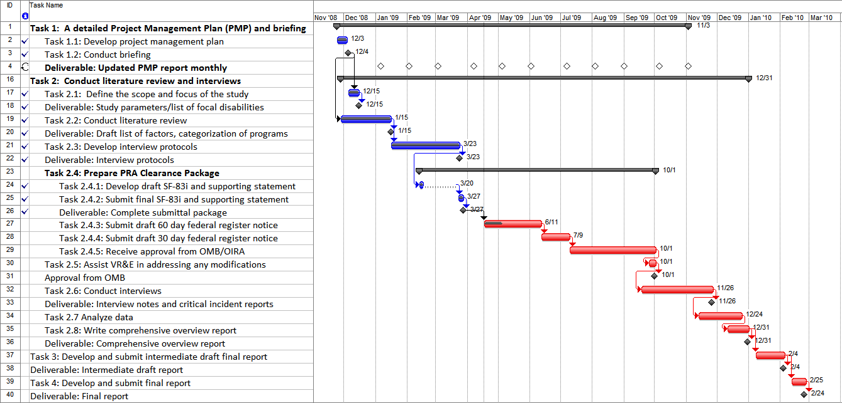

Attachment A: Interview Protocol for Veterans with Severe Injuries

Source: Department of Veterans Affairs (2008). 2007 Veterans Employability Survey, Washington, DC
Source: O*NET Online (http://online.onetcenter.org), accessed on 17-Apr-09, for position: 11-9151.00 - Social and Community Service Managers.

