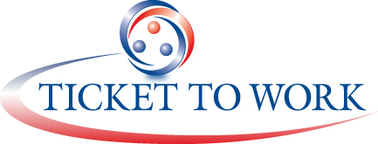


Advance Letter to Beneficiaries Participating in the EN Customer Satisfaction Survey

MAXIMUS Ticket to Work
P.O. Box 1433
Alexandria, Virginia 22313
Insert Date

Dear (Insert Name),

With the help of an organization called uSPEQ, the Social Security Administration (SSA) is conducting a survey of some individuals in the Ticket to Work program who have an Employment Network (EN) in California.

Within the next week, you will receive a survey in the mail asking about the services you have received from your EN, (Insert name of EN), and how satisfied you are with those services. Your name will not be on the survey and your EN will not see your personal responses. We will use the responses to test a new EN report card to let future beneficiaries know how satisfied other beneficiaries are with a particular EN.

It is a short survey that will take about 10 minutes to read, complete and mail back to us. We will send you a postage paid envelope in which you may return the completed survey. We hope you will take the time to complete the survey and return it. Your opinions are very important to us. Thank you in advance for your help.

If you have any questions about this survey, you may contact (Insert Name of MAXIMUS account representative for CA) of MAXIMUS at (Insert phone number). MAXIMUS is SSA’s Operations Support Manager for the Ticket to Work program.

Sincerely,

Name
Title
Office

