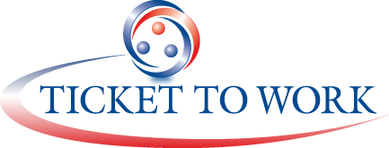


Reminder Letter to Beneficiaries Participating in the EN Customer Satisfaction Survey

MAXIMUS Ticket to Work
P.O. Box 1433
Alexandria, Virginia 22313
Insert Date

Dear (Insert Name),

About two weeks ago, we mailed you a Consumer Experience Questionnaire asking about the services you have received from your Employment Network, (Insert Name), under the Social Security Administration’s Ticket to Work program.

If you have already completed and returned the questionnaire, thank you very much for participating. If you have already told us that you do not want to participate, you will not be contacted again.

If you have not completed the questionnaire, please do so today. We value your opinion.

If you did not receive the questionnaire, or if you need another copy, please call MAXIMUS Ticket to Work at 1-866-968-7842 and we will mail another questionnaire to you today.

Sincerely,

Name
Title
Office

