Science, Service, Stewardship

NOAA
FISHERIES
SERVICE

Southwest Fisheries Science Center
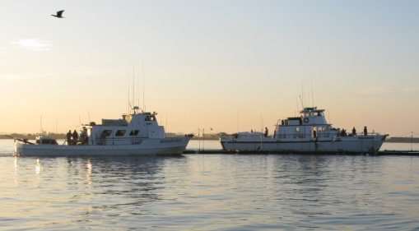
Fisheries Resource Division
The Fisheries Resource Division develops the scientific foundation for the conservation and management of marine resources in the California Current and Pan-Pacific Pelagic Ecosystems. We serve the public and contribute information to management organizations and the scientific community.

California CPFV
(Commercial Passenger Fishing Vessel)
2012 Calender Year
Cost and Earnings Survey

Frequently Asked Questions

Why is this survey being conducted?
This survey is being conducted to collect information needed to increase the understanding of the important economic contributions of the California CPFV fishery, and the impacts of federal actions on the fishery. The data you provide will be of great value toward developing this understanding.

How long will the survey take?
The survey will take approximately one hour to complete.

What do I need to bring to my scheduled interview?
You should bring with you your accounting books containing your cost and earnings data from the 2012 calendar year, and information on the number and type of trips you took during 2012 (including cost/earnings data for each trip type). If you publish a rate-sheet or brochure outlining trips and prices, please bring a copy to your scheduled interview.

How do I benefit from participating?
Your participation is voluntary, however, through participation you will increase the understanding of the CPFV industry in California. Sharing your experience in the fishery will help provide information needed to estimate the economic impact and number of jobs supported by the CPFV fishery in California. Information will also be used to understand the impact that changes in environmental, economic, and management conditions have had on the fishery. The results of the survey will be available online.

How will I be sure my data is confidential?
Data collected will be kept confidential as required by section 402(b) of the Magnuson-Stevens Act and NOAA Administrative Order 216-100, Confidentiality of Fisheries Statistics, and will not be released for public use except in aggregate statistical form without identification as to its source. Particpation or lack of participation in the survey will remain condiential. All economic data will be aggregated into statistical form for all reports. It will not be possible to identify your individual business in any publication

How will my data be used?
Your data, combined with data from all the other respondents, will form a critical component of a research study evaluating the economic contributions of the California CPFV fishery, and the effects that changes in environmental, economic, and management conditions may have on the industy. Your data will help to produce an accurate understanding of the economic health of the California CPFV fishery that will inform resource managers and the public.

If you have any further questions or concerns pertaining to this survey, please contact James Hilger, by telephone at 858-546-7140 or by email at james.hilger@noaa.gov.

