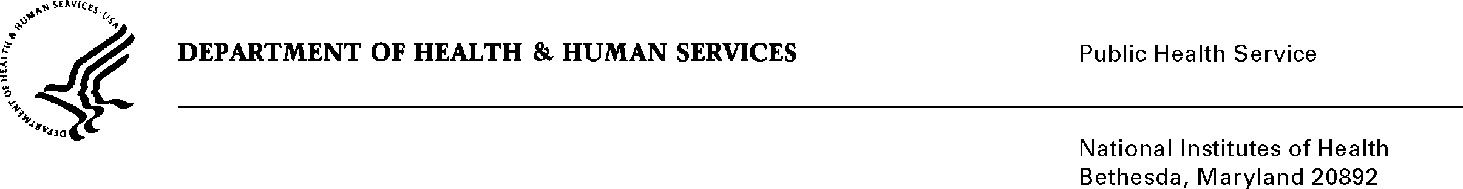

DATE: February 27, 2009

TO: Ann M. Taubenheim, Ph.D., M.S.N.
Division for the Application of Research Discoveries, NHLBI

FROM: NIH Privacy Act Officer

SUBJECT: Applicability of the Privacy Act: Survey of NHLBI Constituents’ Health Information Needs and Preferred Formats

I have reviewed the NHLBI submission to OMB requesting approval for the use of the “Survey of NHLBI Constituents’ Health Information Needs and Preferred Formats”.

I have determined that the Privacy Act will apply to this data collection which involves the collection of personally identifiable records that are designed to be retrieved by a personal identifier, such as name, age, gender and email address which will be stored temporarily in a database.

The data collection is covered by NIH Privacy Act Systems of Record 09-25-0156, “Records of Participants in Programs and Respondents in Surveys Used to Evaluate Programs of the Public Health Service, HHS/PHS/NIH/OD”.

If you have any questions, please contact my office at (301) 496-2832.

Attachment

Karen M. Plá

