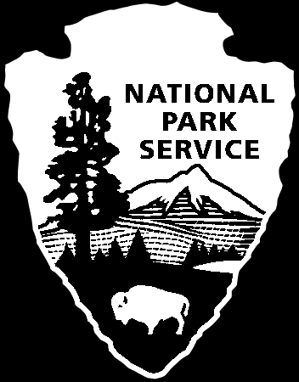
Rivers, Trails, and Conservation Assistance Program
National Park Service
U.S. Department of the Interior

Page 1 - Introduction and Information

This is a government-mandated satisfaction survey for the National Park Service Rivers, Trails and Conservation Assistance Program (RTCA). We are contacting you because you received assistance for RTCA in fiscal year 2010 (October 1, 2009-September 30, 2010).

The Government Performance and Results Act (GPRA) of 1993 calls on every federal agency to seek feedback and evaluate how effectively it is performing its job. We have created a short survey to evaluate the effectiveness of the FLP program and encourage you to provide us with your feedback.

We estimate completing the survey will take ten minutes. If you have any difficulties accessing the electronic survey, please contact _____, Survey manager at (202) 354-69## or via e-mail at ______@nps.gov.

Participation in this survey is voluntary and all answers will remain anonymous. We appreciate your time in providing us feedback.

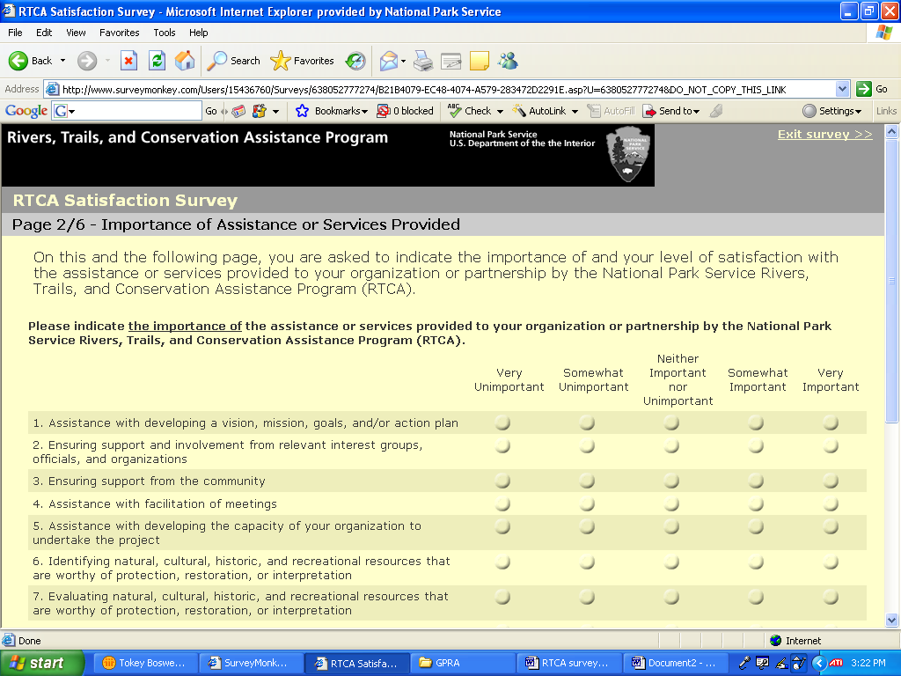
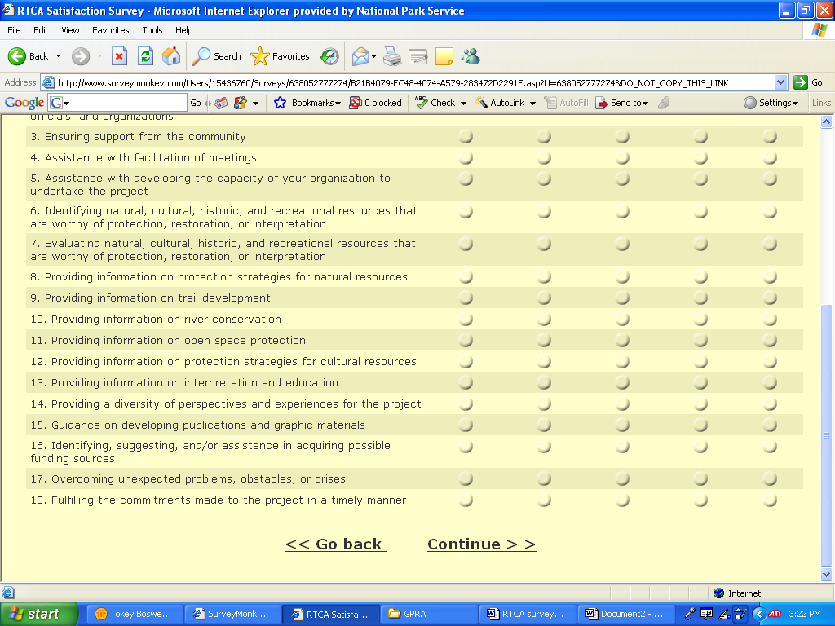
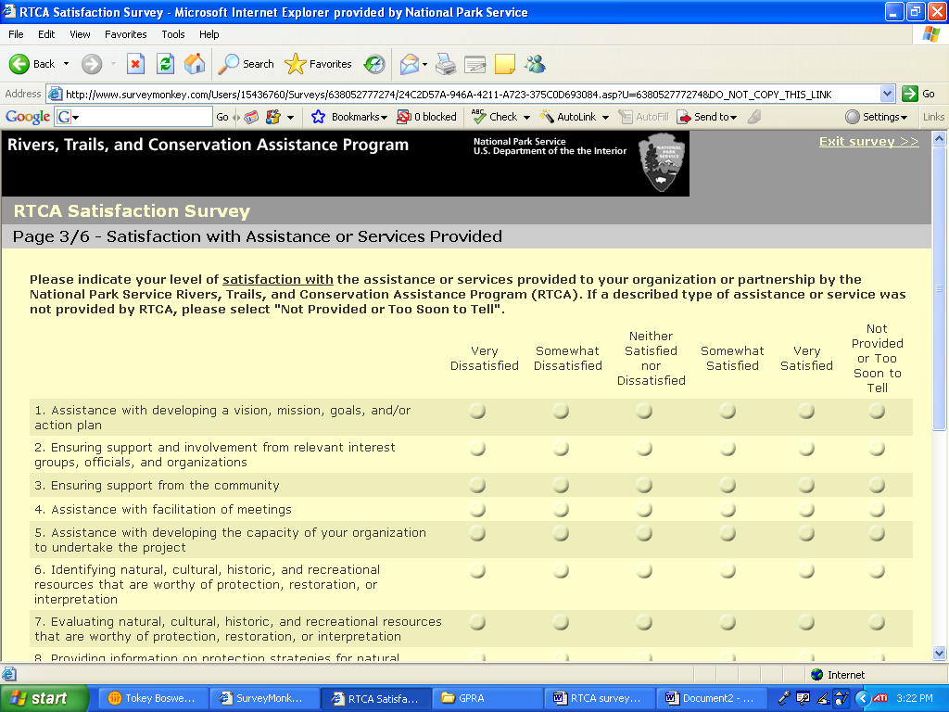
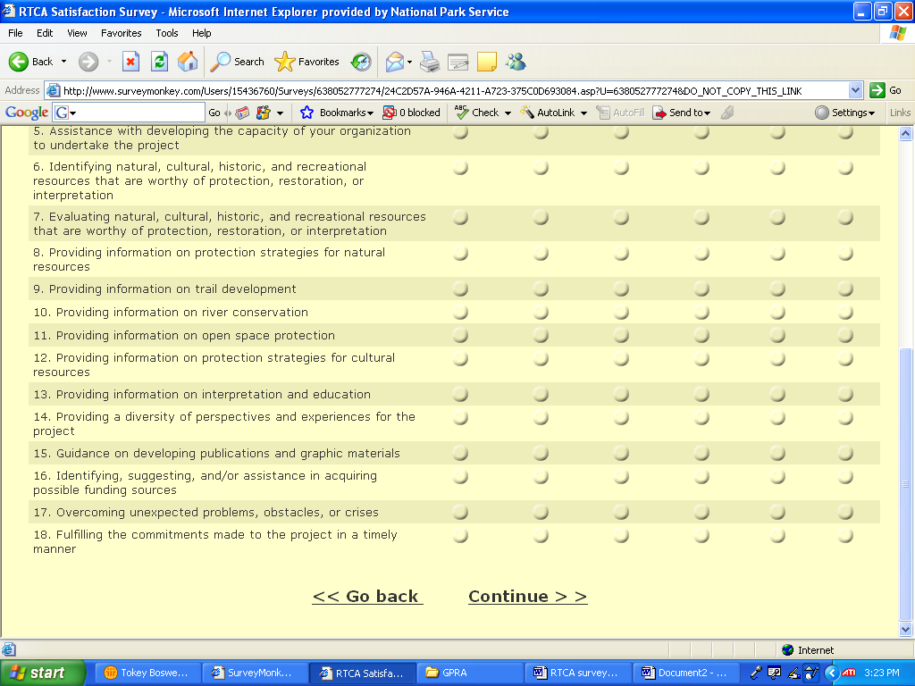
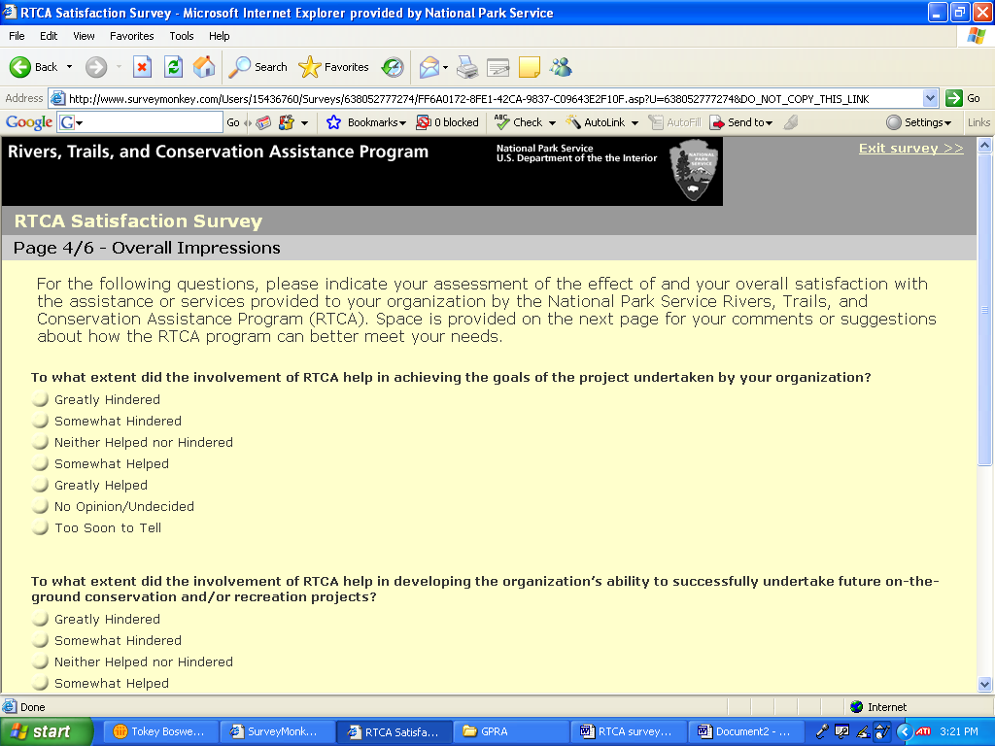
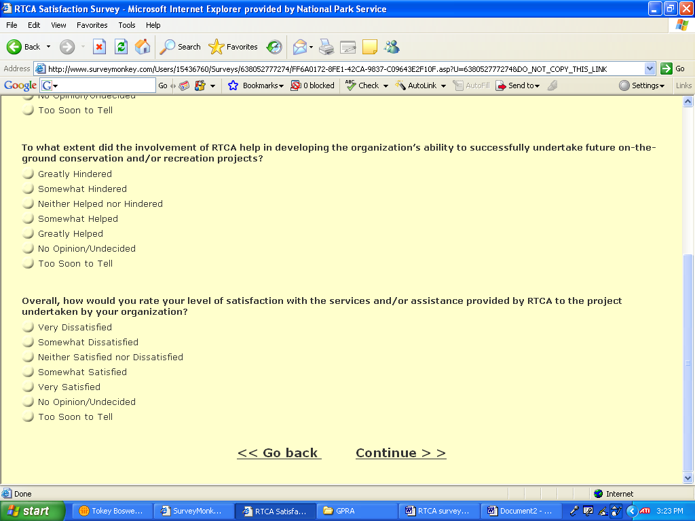
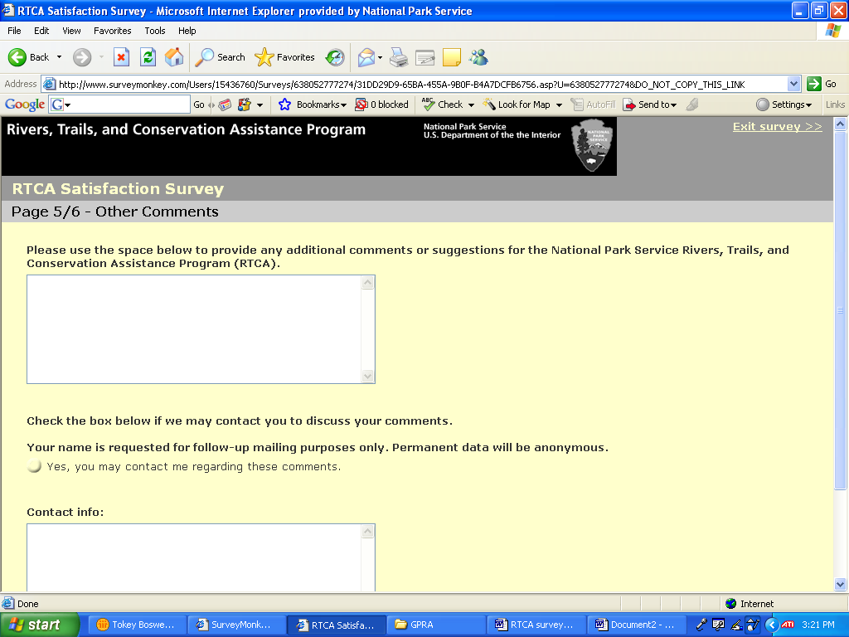

Rivers, Trails, and Conservation Assistance Program
National Park Service
U.S. Department of the Interior

Page 6/6 – Exit Page

Thank you for completing this survey. By clicking on “Finish,” below, you will be directed to the National Park Service Rivers, Trails and Conservation Assistance Program’s web page.

PRIVACY ACT and PAPERWORK REDUCTION ACT Statement:
16 U.S.C. 1a-7 authorizes collection of this information. This information will be used by site/area managers to better serve the public. Response to this survey is voluntary. No action may be taken against you for refusing to supply the information requested. Your name is requested for follow-up mailing purposes only. Thus permanent data will be anonymous. A Federal agency may not conduct or sponsor, and a person is not required to respond to, a collection of information unless it displays a currently valid OMB control number. The OMB Control Number for this survey is 1024-0226 which expires xx-xx-xxxx.

Burden Estimate Statement:
Public reporting for this form is estimated to average 10 minutes per response. Direct comments regarding the burden estimate or any other aspect of this form to the Information Collection Clearance Officer, WASO Administrative Program Center, National Park Service, 1201 Eye Street, 12th floor, Washington DC 20005.

Finish – thank you!

