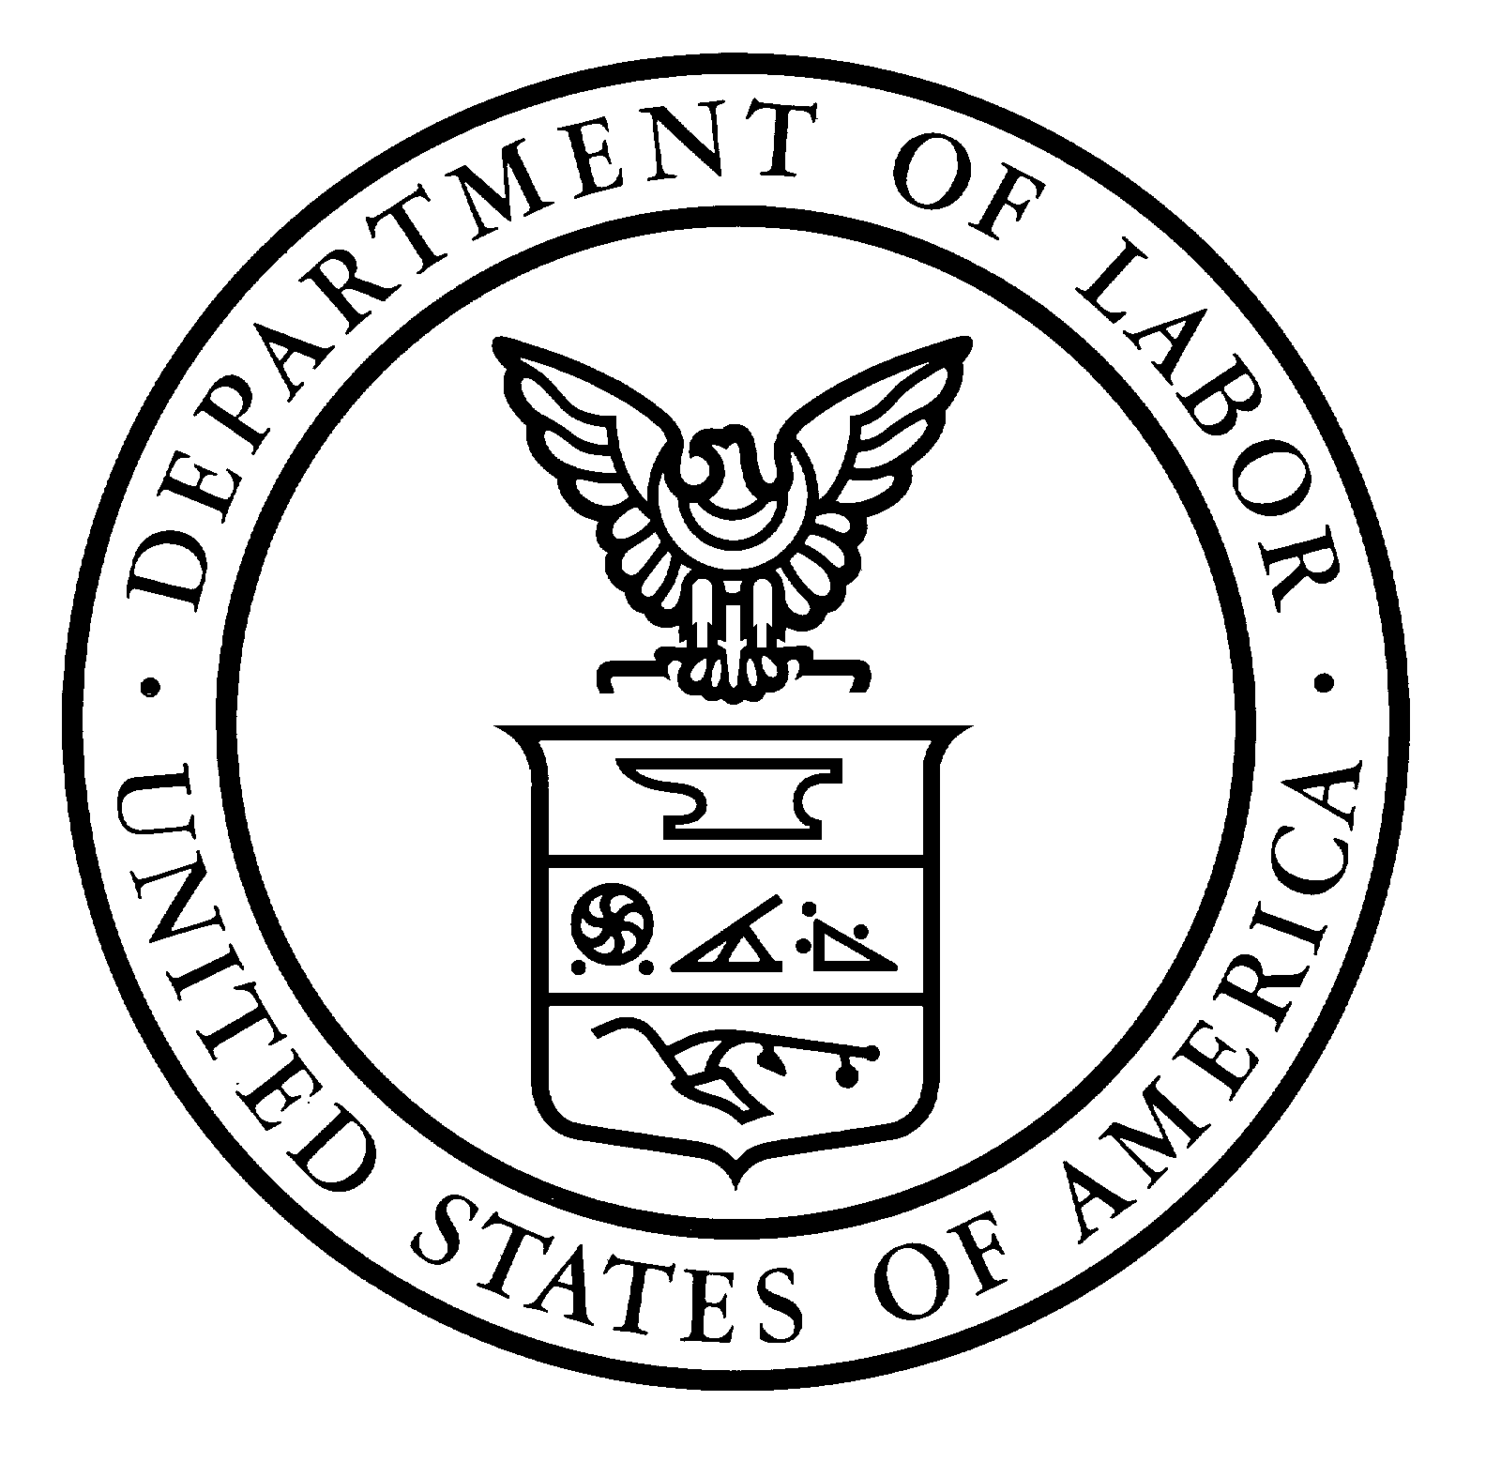 | United States Department of Labor  Bureau of Labor Statistics

Did you mail back your response to the U.S. Department of Labor?

If so, thank you very much for your response. If not, please answer the short survey you received a few days ago that asked if your home is owned or rented, and return it to the Strategic Research Group in the next five days. Your response is important and will help us to reduce the cost of the upcoming Housing Survey. Although your participation is voluntary, this information is very important and will be kept confidential.

Again, thank you for your participation.

