Form NMB-6 OMB No. 3140-0006 (Expiration Date 08/31/2009)

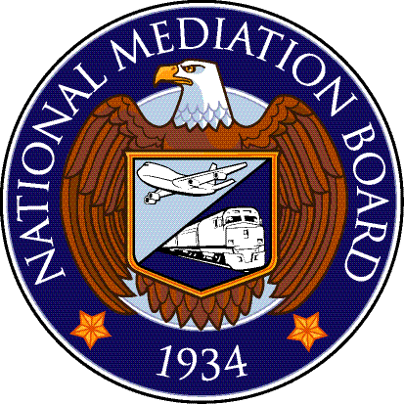
Authorization Number

Arbitration Services - Official Travel/Referee Compensation Authorization

Before completing this form, please read instructions on page 2

Referee’s Name |  |  |  |  | Address |  |  |  |  |  |  | Date
Referee’s Signature |  |  |  |  | City, State, Zip |  |  |  |  |  |  | Telephone
Part 1 Official Travel Authorization and Caseload
Board Number(s)  and Case(s) | Travel Date  FROM: |  |  | Travel Date  TO: |  |  | Carrier |  |  | Travel  FROM: |  |  | Travel  TO:
Part 2 Travel Estimate
Estimated cost to Government |  |  |  |  |  |  | $ |  |  |  | ← Check for Car Rental Approval.  To be used for trip – in and around designated area only. No other vehicle can be hired.  Approved by:

Transportation: (Using Government Travel Agency)
Total per diem and miscellaneous items:  (Rental Car Approval required in writing) |  |  |  |  |  |  | $ |  | Signature
TOTAL Estimated Cost: |  |  |  |  |  |  | $ |  |  |  | ← Check for Other and explain below:
Part 3 Compensable Service
Compensable service days to be rendered during the month of: |  |  |  |  |  |  |  | Show number of cases heard and not decided as of previous month:
Month |  |  | Number of days to be rendered
List all board(s) and/or case(s) you will work on this month:

Part 4 For National Mediation Board Use Only
To the Referee, you are authorized to perform compensable service as follows: |  |  |  |  |  | Compensation obligated:  $ |  |  |  |  | Approved by:
 |  |  |  |  |  |  |  |  |  |  | Signature
For the Month of: |  | # of days authorized |  |  |  | Travel obligated: (this month only)  $  Travel is not transferable |  |  |  |  | Your pay voucher, for this month must be submitted to Finance and Administration by:  If not submitted by this date, the money will be de-obligated.
Form Number Changed: This form was previously NMB – 14

Page 1 of 2
Form NMB – 6

Arbitration Services - Official Travel/Referee Compensation Authorization

Instructions for Completing NMB-6 Form

Purpose of Form:
NMB - 6 was created to assure adequate funding of obligations required by the Budget and Accounting Act of 1921, as amended, and the Federal Managers’ Financial Integrity Act.

Time Frame for Submission of Form:
Referees holding official appointments by the National Mediation Board, who desire to work or travel must submit an NMB–6 Form ten days prior to the month covered by the authorization request.
- Note: Failure to submit NMB Form -6, ten days prior to the month covered by the request will result in non-authorization by the National Mediation Board. No additional travel or work days will be authorized until a voucher for all travel and days authorized has been submitted or you have advised that your allotted days not claimed on a voucher may be released.

E-Mail Form to: ARB@NMB.GOV

Completing Part 1
Referees must list all travel scheduled for month requesting work and all board/cases pertaining to that travel. (i.e. NRAB Division, Public Law Boards, Special Boards of Adjustment, etc.)

Completing Part 2
Car Rental – if required for travel, please submit a letter of justification with the form.

Completing Part 3
(1) Referees must list all boards and cases that he/she will work on that month (i.e. NRAB Division, Public Law Boards, Special Boards of Adjustment, etc.); (2) List number of days requested; and (3) Indicate number of cases heard and not decided. It is important that this information is furnished. Failure to furnish this information will result in non-authorization.

Do NOT Complete Part 4 – Completed by the NMB
When authorization requests are approved, the NMB will complete part 4. An authorization Number will be assigned and a copy of the form will be forwarded to you.

Revising Travel or Work Schedule
If changes in travel or work schedule occur after the NMB - 6 form has been submitted, please submit another NMB - 6 marked “AMENDED”.

Instructions:
- Read information above
- Complete page 1 – Parts 1, 2, and 3
- Attach letter of justification if rental car is requested
- E-Mail to ARB@NMB.GOV

Questions:
Please address questions to Arbitration Services at (202) 692-5055.

Form Number Changed: This form was previously NMB – 14

Page 2 of 2

