Form NMB-8 OMB No. 3140-0008 (Expiration Date 08/31/2009)

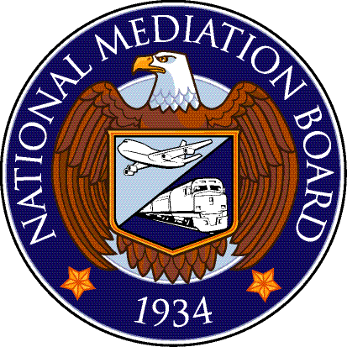

Neutral’s Report of Activity
Name (type or print) | Date

Board Number (PLB, SBA, Arb.): |  |  |  |  | Carrier:
Division Number (1st, 2nd, 3rd, 4th ): |  |  |  |  | Organization:
Activity Days Claimed (In multiples of 1/8)
Month | Day | Year | NMB Case Number | Award Number | Decision Code | Travel | Hearings |  | Decision Writing | Total
Reminder: No more than one day’s pay will be paid for any one date. |  |  |  |  |  |  |  | TOTAL

I certify that I worked the actual days, or parts thereof, listed above and copies of the awards in the cases listed have been forwarded to the parties:
Signature: | Date

DECISION ACTION CODES: ST= Sustained; DN = Denied; PS = Partially Sustained; RM = Remanded; H=Hearing; DS = Dismissed; IN = Interpretation; ES = Executive Session* * Prior approval must be requested.
FALSE, FICTITIOUS OR FRAUDULENT CLAIMS: Whoever makes or presents to any person or officer in the civil, military, or naval service of the United States, or to any department or agency thereof, any claim upon or against the United States or any department or agency thereof, knowing such claims to be false, fictitious or fraudulent, shall be fined not more than $10,000 or imprisoned not more than five years and shall be subject to a fine in the amount provided by law. 18 U.S.C. Section 287.

