«Date»

«FirstName» «LastName»
«Dept_Name»
«Institution_Name»
«Address1» «Address2»
«City», «State» «ZipCode»

Dear «FirstName» «LastName»,

This is an invitation to join other early career researchers in completing a new survey from the National Science Foundation (NSF), Division of Science Resources Statistics (SRS) – the Survey of Early Career Researchers.

The NSF/SRS needs your help to understand the careers of scientists and engineers, and the factors that affect them. The Survey Sciences Group (SSG) is conducting this survey on NSF’s behalf. The survey gathers information from early career researchers with doctorates or equivalent degrees, including postdoctoral researchers (postdocs), about their education and career goals and experiences.

Your perspective is important. The survey will take between 25-30 minutes. Please follow the instructions below to complete the survey:

1. Go to the survey website: www.ssgresearch.com/nsf-researchers
2. In the ID field of the login box, enter the following ID: «CustomID»
3. Click the START SURVEY button on the screen to proceed with the survey.

This survey is voluntary. The information that you provide will be used for statistical purposes only and your responses will be kept confidential under the authority of the National Science Foundation Act of 1950, as amended, and the Confidential Information Protection and Statistical Efficiency Act of 2002. A decision to not provide some or all of the requested information will not in any way adversely affect you.

If you have questions or require technical assistance, please contact the SSG Support Desk by sending an email to nsf-researchers@ssgresearch.com or by calling toll free at 1-800-774-0142, ext. 409. When you contact them, please refer to the NSF Survey of Early Career Researchers and provide your Study ID: «CustomID».

Thank you, in advance, for your time and cooperation.

Sincerely,
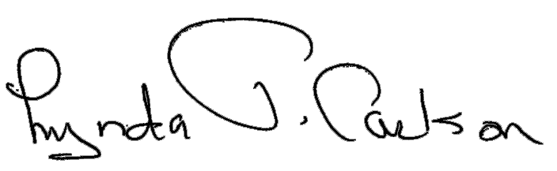
Lynda T. Carlson, Ph.D.
Director, Division of Science Resources Statistics
National Science Foundation
4201 Wilson Boulevard, Suite 965
Arlington, VA 22230
Tel: 703-292-7766
Email: lcarlson@nsf.gov

