ORA Mockups
Login
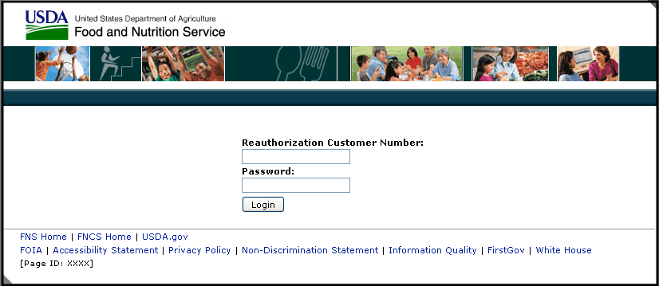

View Documents and Eligibility Information
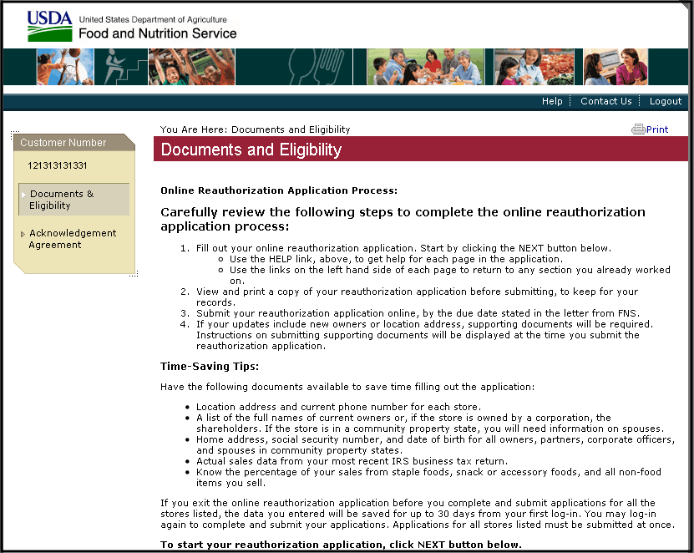
View Documents and Eligibility Information (Con’t)
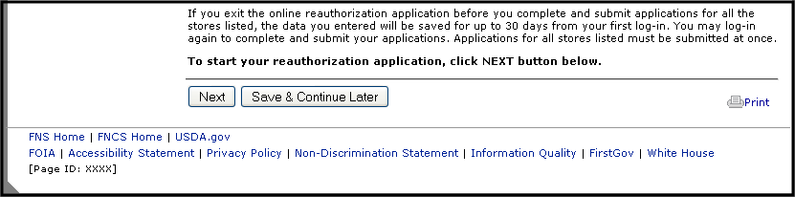

View and Accept/Decline Acknowledgement Agreement
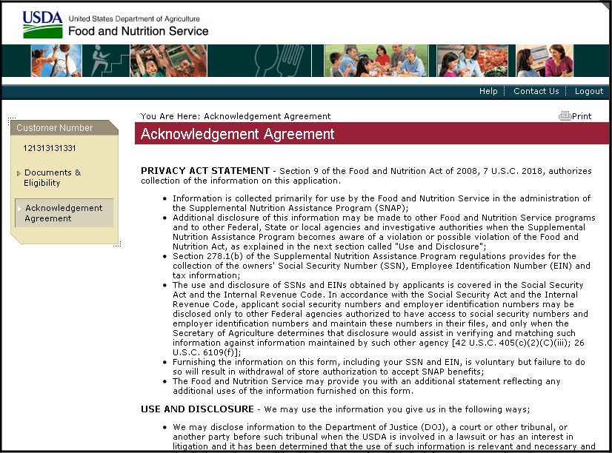

View and Accept/Decline Acknowledgement Agreement (Con’t)
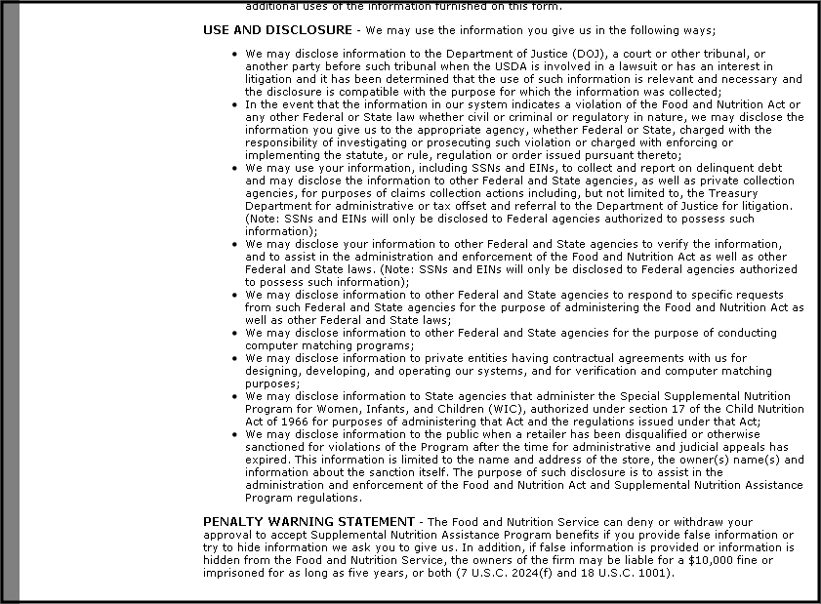

View and Accept/Decline Acknowledgement Agreement (Con’t)
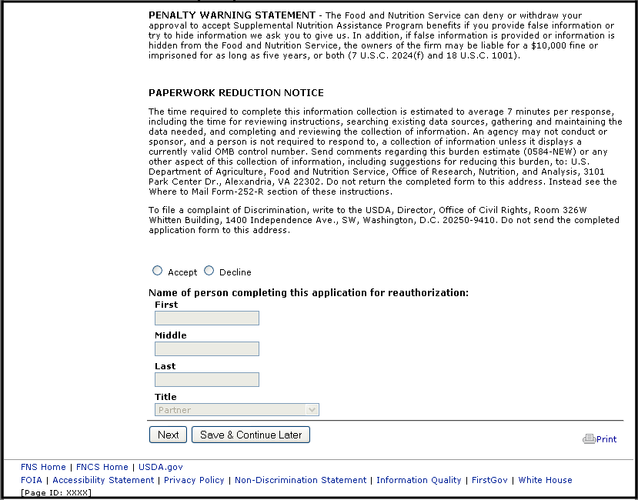

View Corporation Store List (Corporation User Only)
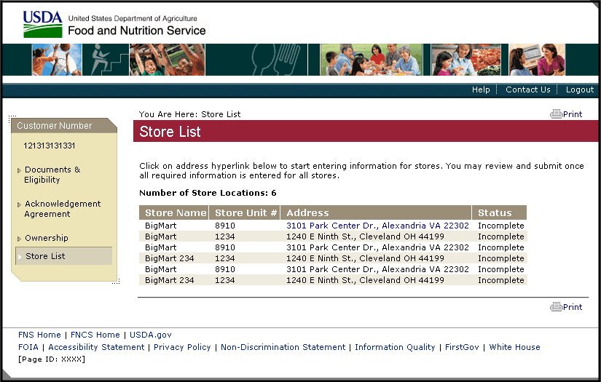

View and Enter Basic Store Information
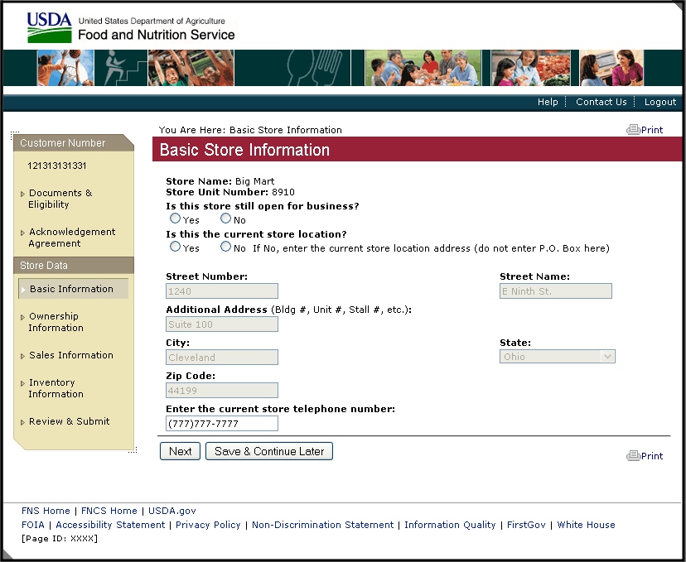

View and Enter Ownership Information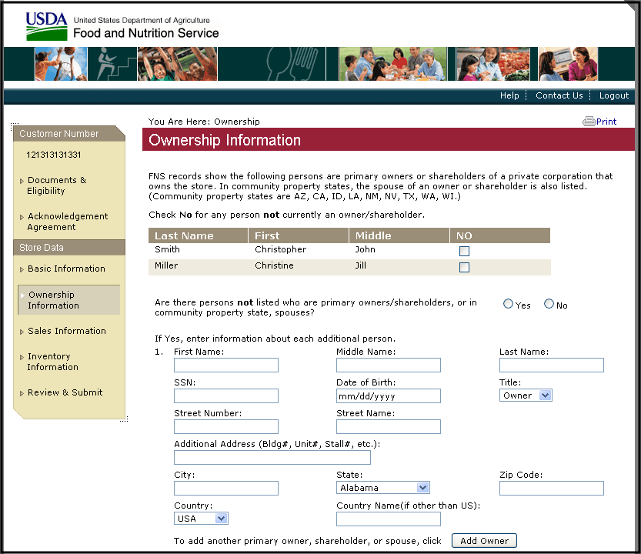

View and Enter Ownership Information (Con’t)
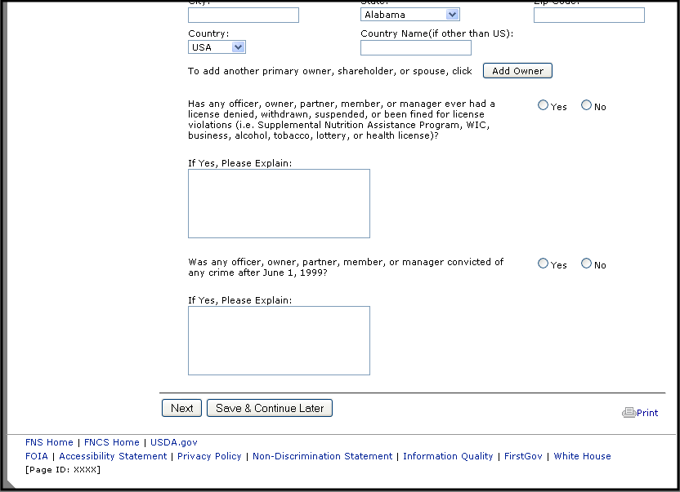

Enter Sales Information
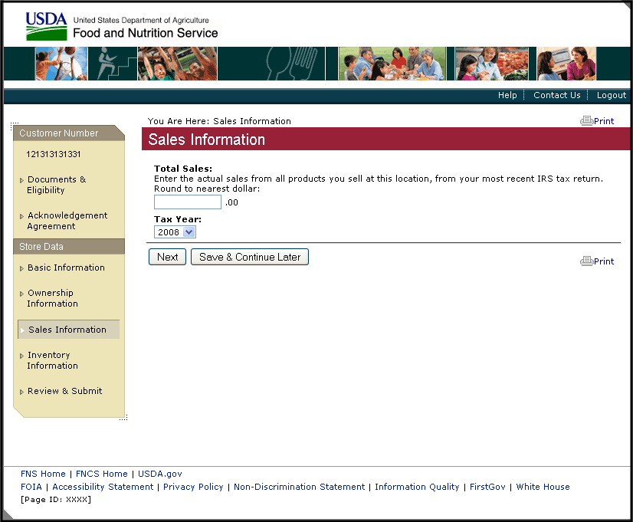

Enter Inventory Information
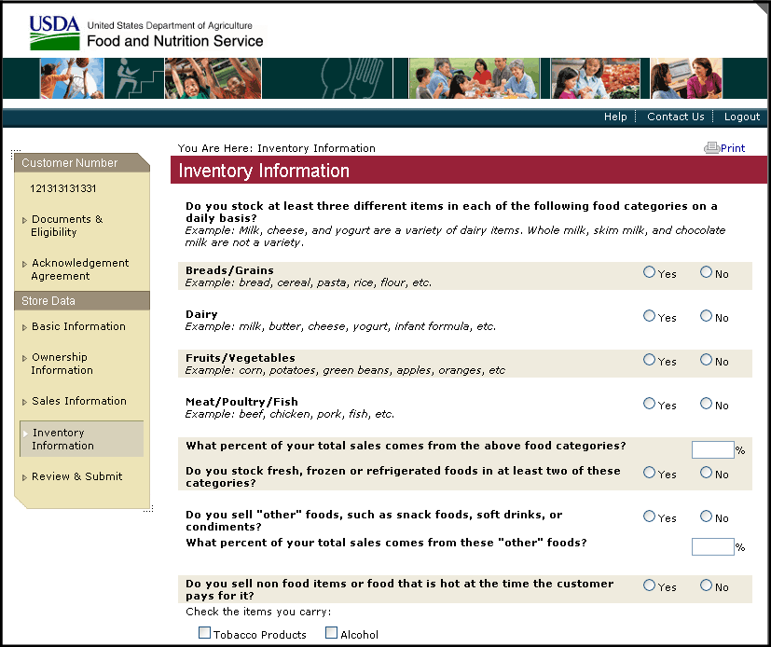
Enter Inventory Information (Con’t)
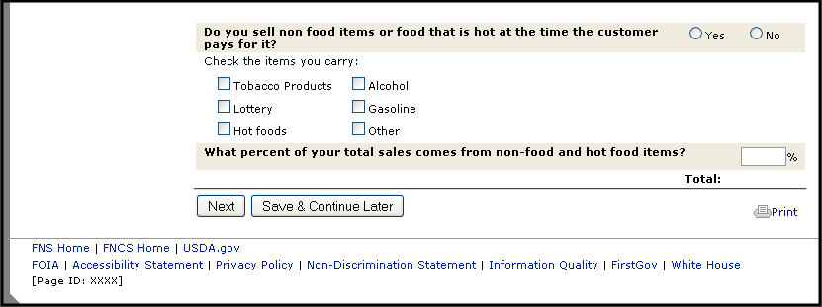
Review and Submit (Single Store)
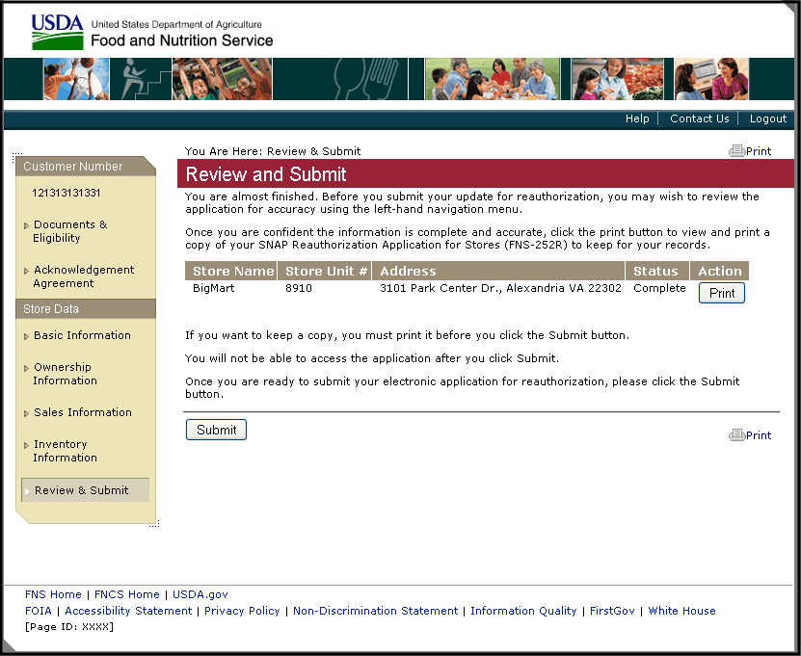

Review and Submit (Multiple Stores)
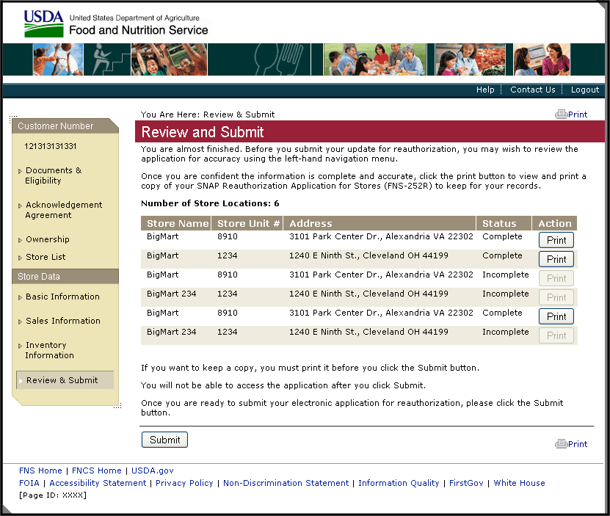

Confirmation 1
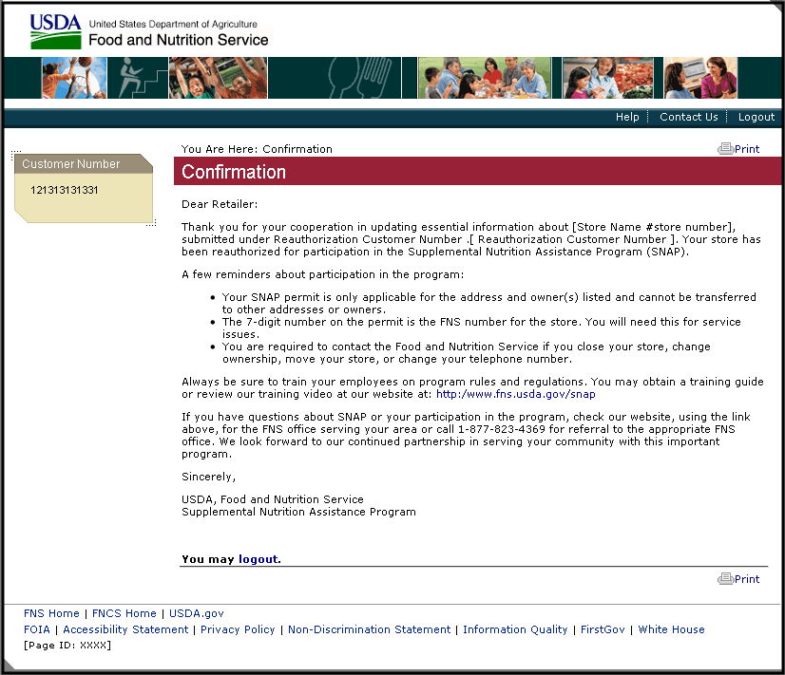

Confirmation 2
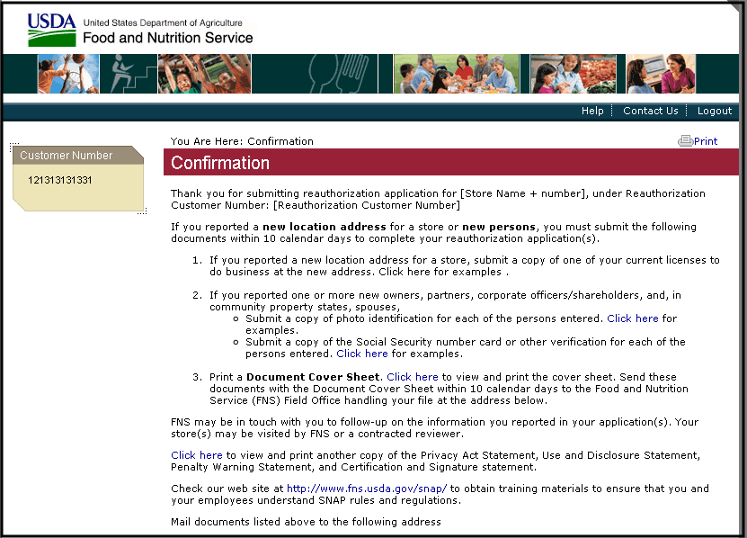
Confirmation 2 (Con’t)
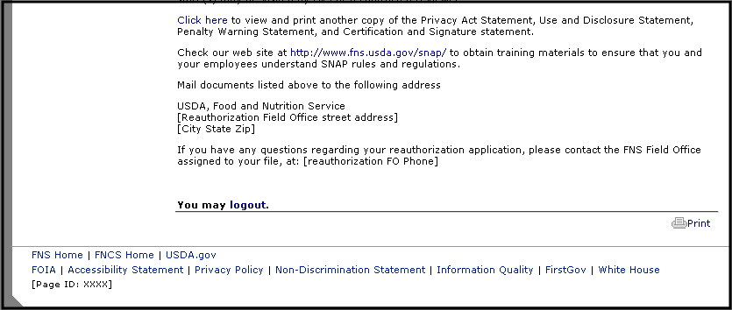
Confirmation 3:
