ATTACHMENT C3.

PRE-IMPLANTATION GENETIC DIAGNOSIS (PGD) NATIONAL ART SURVEILLANCE SYSTEM SCREENS
NASS screen shot for the PGD question before modification:

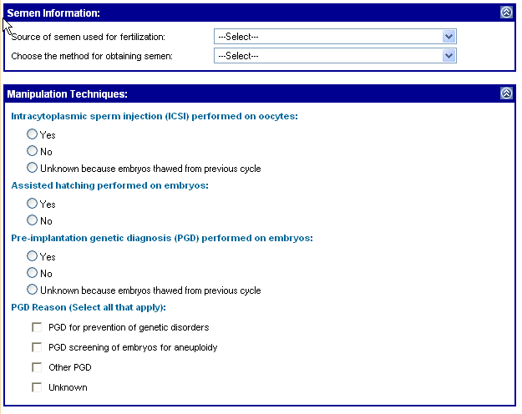

NASS screen shot for the PGD question after modification:

