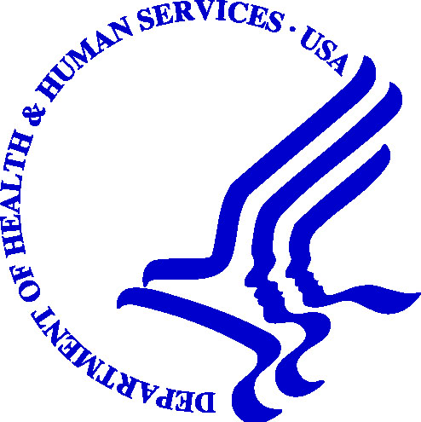

DEPARTMENT OF HEALTH & HUMAN SERVICES Centers for Medicare
and Medicaid Services

Region VII
Federal Office Building
601 East 12th Street, Room 235
Kansas City, Missouri 64106

RE: Women’s Health Cancer Rights Act (WHCRA) Compliance

Dear Sir or Madam:

It has come to our attention that -------------------------- issues and/or renews health insurance in one or more of the following States: Colorado, Massachusetts and Wisconsin.

The Women’s Health and Cancer Rights Act (WHCRA) provides protections to patients who choose to have breast reconstruction in connection with a mastectomy, pursuant to the requirements found at sections 2706 and 2752 of the Public Health Service Act (42 USC sections 300gg-6 and 300gg-52). WHCRA envisions that states will enact and enforce laws embodying the requirements of WHCRA. At this time, the States of Colorado, Massachusetts and Wisconsin have not fully incorporated WHCRA’s provisions into state law. As a result, pursuant to sections 2722 and 2761 of the Public Health Service Act (42 USC sections 300gg-22 and 300gg-61), the enforcement of all or part of WHCRA in these states is currently the responsibility of this office. Policy form reviews are one of the enforcement tools used by CMS in these States to confirm health insurance issuers’ compliance with WHCRA.

The purpose of this letter is to request that your organization submit all policy forms, riders, applications as well as any other material (i.e. marketing materials, etc.) pertinent to WHCRA, to this office for review. When responding to this request, please provide all policy forms and related materials offered in the group and/or individual markets segregated by the applicable State(s) (i.e. Colorado, Massachusetts and/or Wisconsin) and by applicable market (i.e. group or individual). If you are not the correct individual to address this request, please route this correspondence to the correct individual(s) or department. Please submit all material to:

Associate Regional Administrator for Medicaid and Children’s Health Operations

Centers for Medicare & Medicaid Services

Attn: Insurance Reform Team

Richard Bolling Federal Building

601 East 12th Street, Room 235

Kansas City, MO 64106

Please note that we are requesting the materials be sent to CMS within 30 days of the date of this letter. In circumstances in which you cannot prepare the requested materials within this time period, you may contact our office so we may discuss a reasonable extension.

Presently there is no fee imposed by CMS in the course of meeting its responsibility to review policy forms. After completing our review, we will provide you with any comments and/or recommendations. If necessary, we may arrange to meet with you and your staff to further discuss our findings and other WHCRA issues.

If discussion or clarification is desired please contact Evan Doran of this office at (816) 426-6314. Thank you for your attention to this matter.

Sincerely,

James G. Scott
Associate Regional Administrator for Medicaid
and Children’s Health Operations

