National Emergency Family Registry Locator System (NEFRLS)
Guidelines for Database Usage and Suggested Scripts
To Register Displaced Persons

“Good morning/afternoon Disaster Assistance Family Locator. My name is ______________my PIN is____. Would you like to register, update your registration, or search for a family member?”

PAPERWORK BURDEN DISCLOSURE NOTICE Public reporting burden for this form is estimated to average 19 minutes (.32 hour) per response. The burden estimate includes the time for reviewing instructions, searching existing data sources, gathering and maintaining the data needed, and completing and submitting the form. You are not required to respond to this collection of information unless it displays a valid OMB control number. Send comments regarding the accuracy of this burden estimate and any suggestions for reducing the burden to: Information Collections Management, Department of Homeland Security, Federal Emergency Management Agency, 500 C Street, SW, Washington, D.C. 20472, Paperwork Reduction Project (1660-NEW). NOTE: Do not send your completed form to this address.

“I would be happy to assist you with that. Before we begin, what State are you calling from?

[Service Rep: If the caller is from an area other than the area for which NEFRLS was activated do not register the caller]

Inform the caller “NEFRLS has not been activated for your state” and refer them to their local authorities and/or the ARC safe and well site.

If caller needs to search for missing child or a person under the age of 21,
Refer callers from the state for which NEFRLS was activated to the National Emergency Child Locator Center (NECLC), (866) 908-9570 or www.NECLC.org;

Callers from other areas should be referred to the National Missing and Exploited Children’s Hotline or 1-800-THE LOST (1-800-843-5678)

To register callers from a State for which NEFRLS is Activated

⇨[Access the NEFRLS Home Page: https://asd.fema.net/inter/nefrls/home.htm]
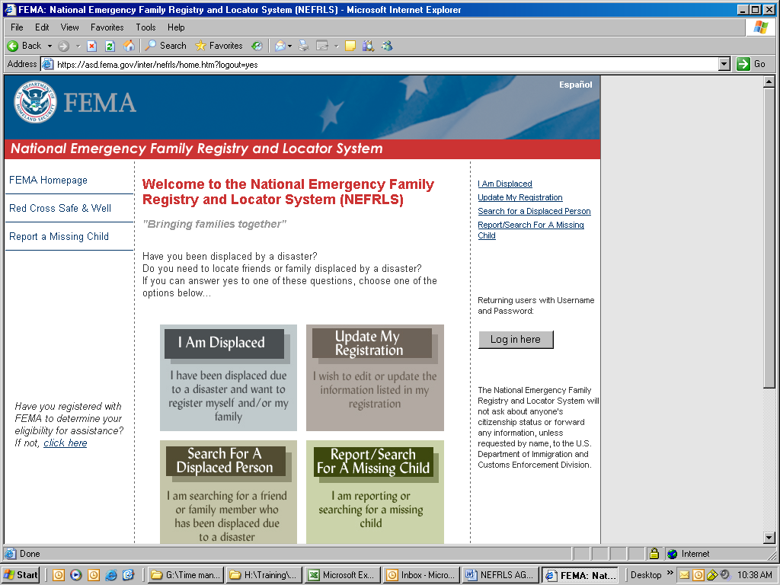

⇨[Log into the database as an agent by clicking the log-in button on the right side of the screen.]

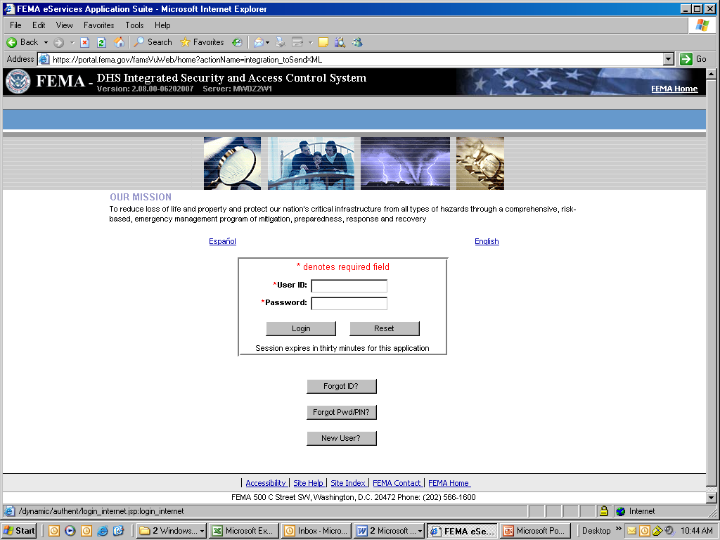

⇨ [Complete log-in page with userid and password created during access/approval set-up. Then click “Login” button.]

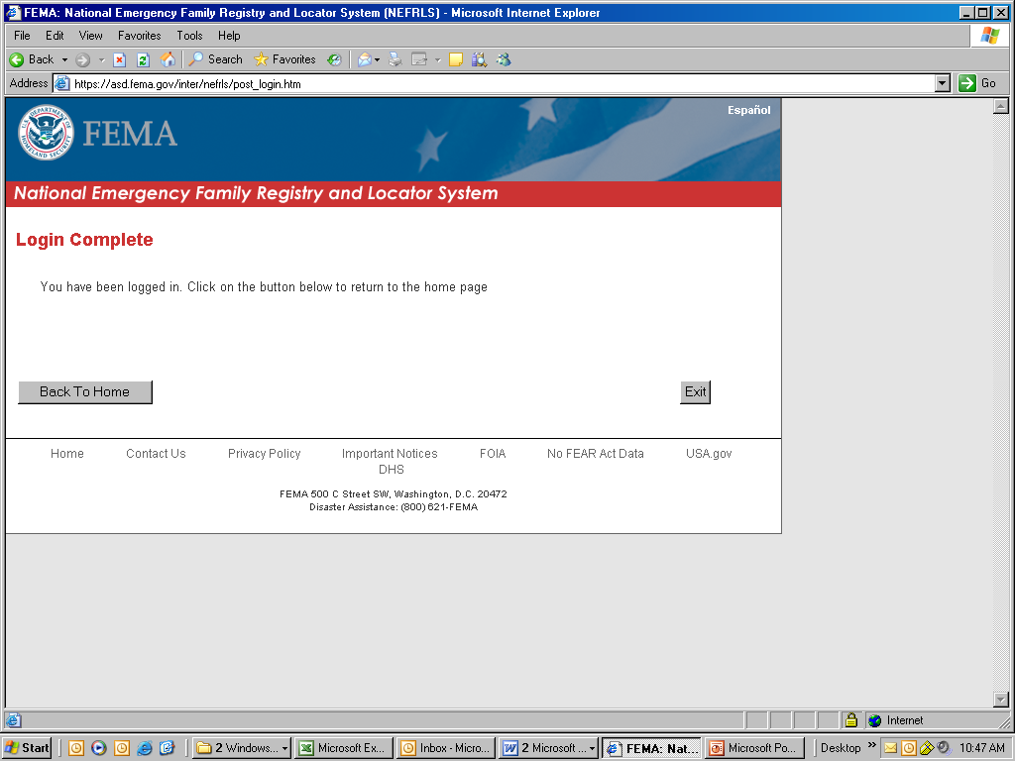
⇨ [Click the “Back to Home” button.]

⇨ [The home page should now show a “Log Out” button. If so, continue the call. If not, try to log in again.]

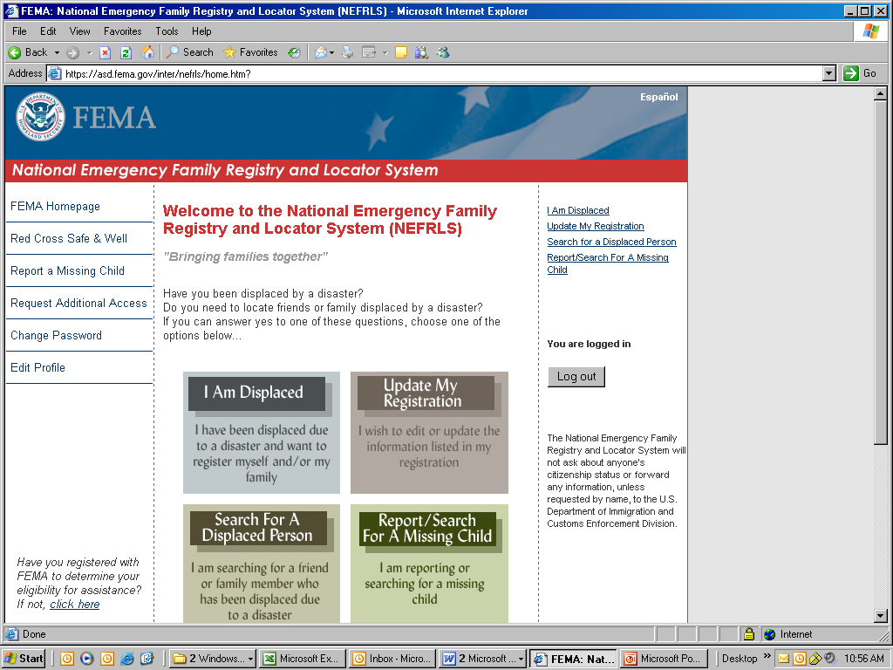

⇨ [Click icon I AM DISPLACED]

The following page will display. Click the “Next Button at the bottom of the page to retrieve the Privacy Act.

[Adult Caller] I would like to register

“ I am required by law to read the Privacy Act.”

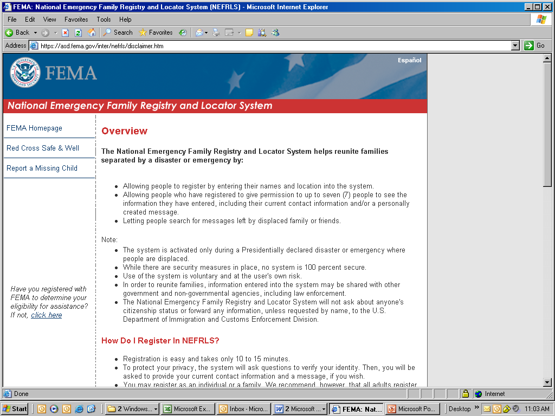

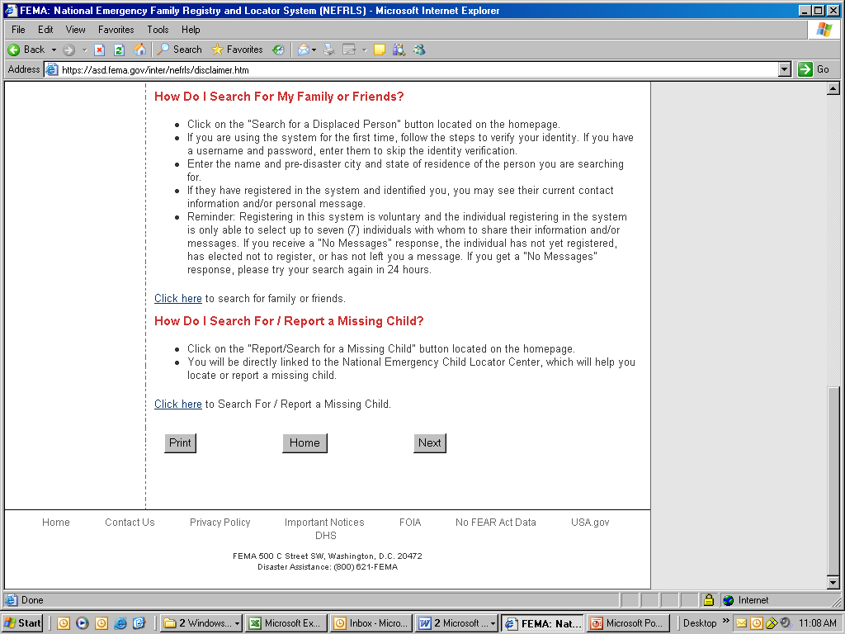

[Service Rep: Proceed with reading Privacy Act to caller --
- DO NOT log in as the caller (you cannot ask for or use their password if they already registered)
- DO NOT create a password for the caller

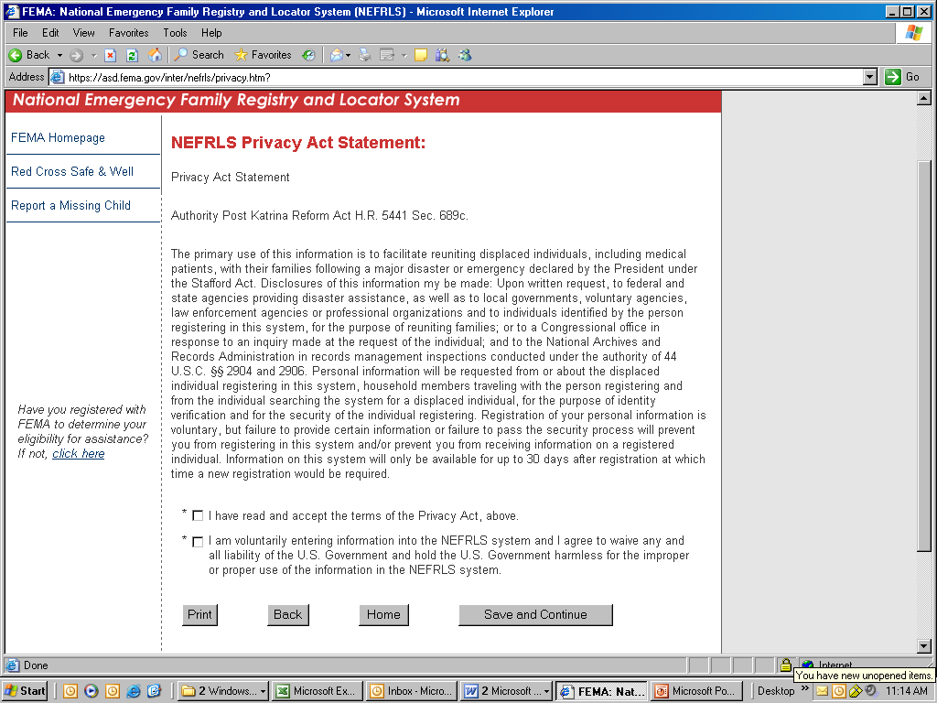
Privacy Act Page:

⇨ [Check both boxes at the bottom of the privacy act and select the “Save and Continue” button.]

“To safeguard your privacy, you will be asked a series of questions to verify your identity. Let’s begin with the registration process.”

⇨ [Click “Next” at the bottom of the page Registration, Step 1 of 9 page that appears. This will allow you to proceed to the Personal Information Contact information.]

“Would you like to register yourself and/or your family?”

[Caller] “I’d like to register myself.”

[Service Rep: Proceed with completing required fields for Personal Information and Pre-Evacuation Contact Information.]
- The registrant’s “Primary Pre-Evacuation Phone” number must be valid to pass IDV. Ask for a land line to their primary residence/pre-evacuation residence. If they do not have one, then list their cell phone.

“I need to confirm the information just entered.”

[Service Rep: Read and spell back all lines containing information. If information contains errors, click EDIT. If there are no errors, click CONFIRM]

“The information you provided is being routed for identity match.”

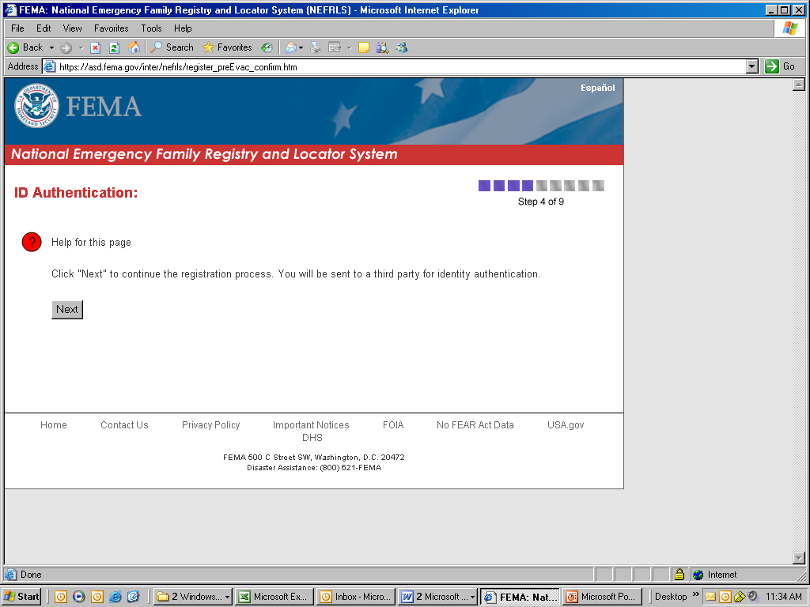

[Service Rep: If information does not match, advise caller, “We are not able to verify your information.” Refer the caller to their local authorities and/or the ARC Safe and Well site.]
If the information does match, the following screen will display allowing the registration process to continue. Click “Continue Without Password”

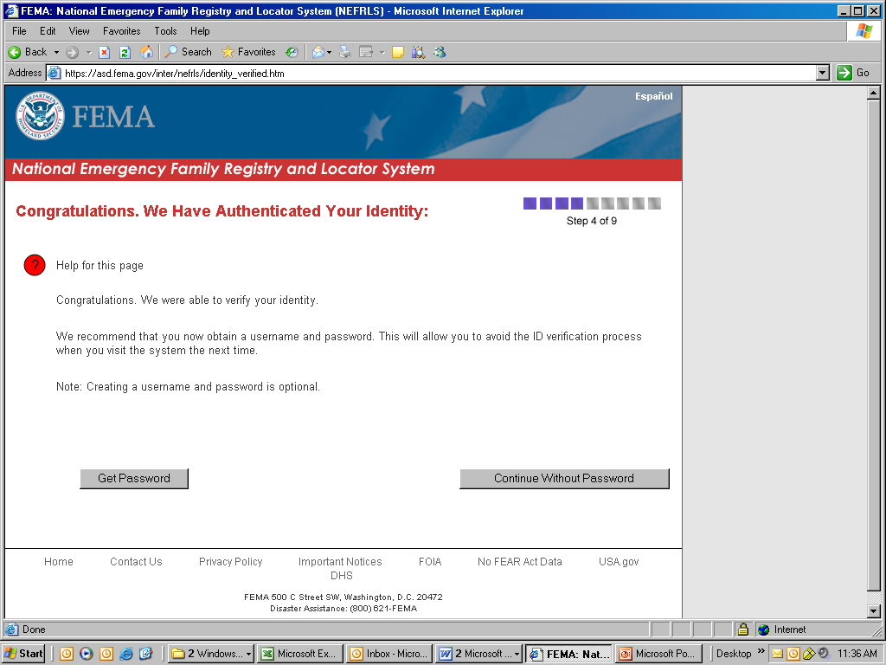

“Would you like to include you current contact information?”

[Caller] “Yes.”

[Service Rep: Proceed with completing optional fields for Current Contact Information]

“Would you like to list members of your household that are traveling with you?”

[Caller] “Yes.”

[Service Rep: Proceed with completing optional fields for My Family/Household Members That Are Traveling With Me. You may enter up to four members by clicking ENTER MORE FAMILY/HOUSEHOLD MEMBER. If caller wishes not to enter this information or is traveling alone, click I HAVE COMPLETED MY FAMILY/HOUSEHOLD MEMBER LIST]

[Service Rep: On the “Message for Family and Friends” ask the applicant if they would like to leave a message for friends & family. Message should contain helpful information such as a contact person, location, or if they are okay, etc. After writing the note, click “Save and Continue”]

“Would you like to have me leave a short note for family and friends who may wish to locate you?

[Caller] “Yes.”
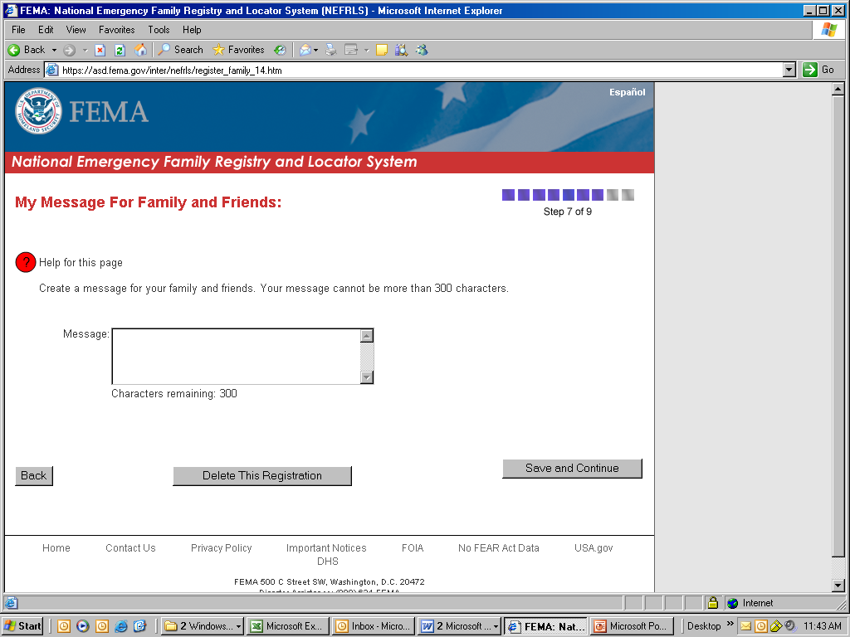

[Service Rep: On the “Who Do You Want to View Your Information?” screen, the registrant can give 7 people access to some of their information. Ask the applicant how much information they want each person to have and select the appropriate radio button. After completing this page, click “I have completed my list of authorized individuals” or “Authorize More Individuals” to display additional spaces.]

“Is there anyone that you would like to have access to your information such as a parent, friend, or other relative?”

[Caller] “Yes.”

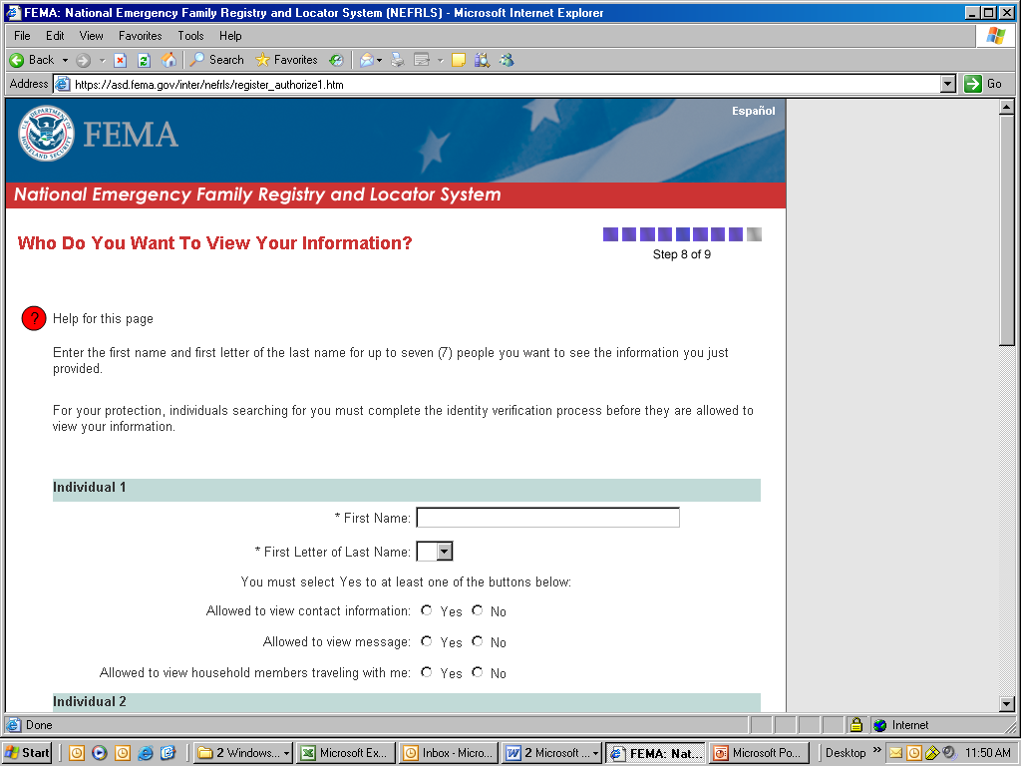

⇨ [A page will appear displaying information on authorized individuals as entered. Verify that the information is correct. Then click “Save and Continue”]

[Service Rep: The Registration Complete page will appear. ]

“You have completed your registration process. The information you have entered will be available for 60 days from today or until the system has been de-activated.”
[Service Rep: Thank the caller for registering]

“Thank you for calling the Disaster Family Locator service. My PIN # is ________. Do you have any further questions for me at this time?

[Caller] “No, not at this time.”

[Service Rep: If no further questions/concerns]

“Okay. Thank you and I hope everything works out for you.

⇨ [Click the “Home” button at the bottom of the page]

⇨ [Click the “Log Out” button on the right side of the page.

⇨ [Close the Netscape browser (This is a very important step. If not done, the NEFRLS program will not operate correctly.]

⇨ [Reopen the browser and proceed to the NEFRLS Home Page: https://asd.fema.net/inter/nefrls/home.htm to take the next registration. Follow the same steps outlined in this document.

