Fall 2009

«P_FName»«P_LName»
«CurHHAddr1»
«CurHHAddr2»«CurHHAddr2»
«CurHHCity», «CurHHState» «CurHHZip»

Dear «P_FName»«P_LName»,

Your child is being asked to take part in Phase I of an important study, the Early Childhood Longitudinal Study, Kindergarten Class of 2010-11 (ECLS-K:2011). The ECLS-K:2011 is sponsored by the National Center for Education Statistics (NCES) of the U.S. Department of Education’s Institute of Education Sciences and is being conducted on behalf of NCES by Westat. This study is the third in a series of longitudinal studies of young children sponsored by NCES and is described in more detail in the enclosed summary sheet.

In your school and in other schools across the nation, we are asking Spanish-speaking kindergartners to take an assessment that will help us develop the English and Spanish reading skills assessment for the second phase of the study. The assessment will be administered individually to each child by trained assessors.

All information collected will be protected from disclosure to the fullest extent allowable by law. Information from multiple individuals will be combined to produce statistical reports; no information that identifies you or your child (e.g., name or address) will be included in any reports. Your child’s school will not receive any of the information collected by our assessors about your child; participation will not affect your child’s grades or progress in school.

(Active consent): [A consent form is enclosed. Before we can proceed with the study, we need your permission to conduct the assessment with your child. Please complete and return the enclosed form to your child’s school by the date shown on the form.]
(Passive consent): [A consent form is enclosed. If you will allow your child to participate in this study, you do not need to return this form. We thank you for your support of the ECLS-K:2011. If you do not want your child to take part in this study, please fill out the enclosed form and return it to the school by the date shown on the form.]

Thank you for your time and consideration of the ECLS-K:2011. If you have questions about the study, please feel free to call Westat toll free at 1-888-204-4864 or send an email to ECLSKHELP@westat.com. Also, more information about ECLS-K:2011 is available on the NCES website at http://nces.ed.gov/ecls/.

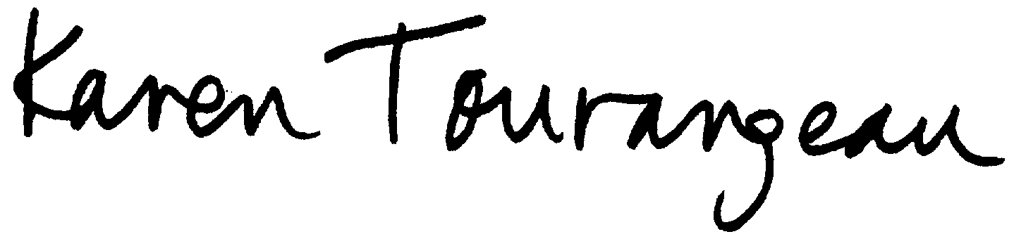
Sincerely,
Karen Tourangeau
Project Director

Enclosures

