Appendix C
(LOCAL LEVEL)

SURVEY INSTRUMENT

LOCAL PROGRAM DIRECTORS
OF CAREER AND TECHNICAL EDUCATION AT THE SECONDARY LEVEL (DISTRICT SURVEY)

OMB # xxxx-xxxx

Survey of

Secondary School Districts

Offering Career-Technical Education

State:
District Name:
Respondent Name:
Telephone Number: E-mail Address:
NCES ID Number:

Note: If you do not know your NCES District ID, please click on the link below and enter your state name and zip code to locate your district. The NCES District ID is a 7-digit number that will appear in the lower left-hand corner of your district descriptor.
http://nces.ed.gov/ccd/schoolsearch/
If you need assistance finding your NCES District ID, please call Jamie Isaac at RTI: (919) 541-6342

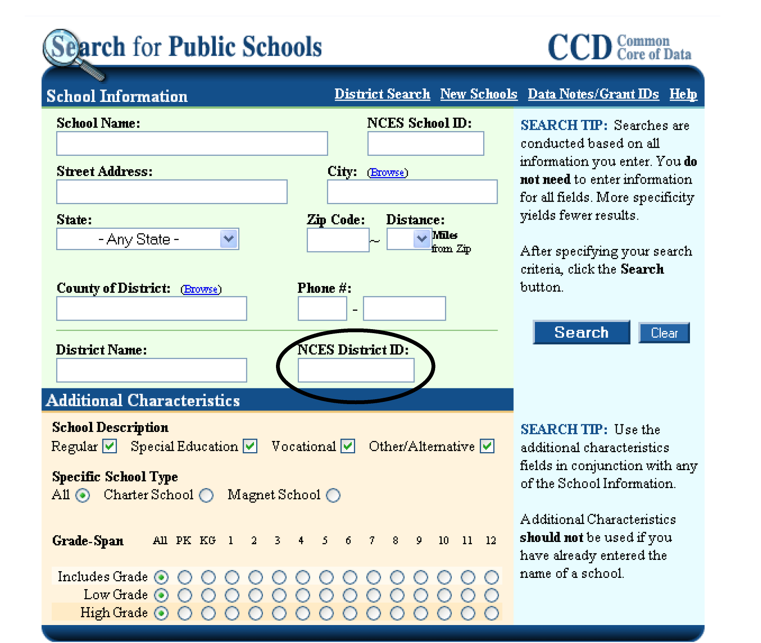

Uses of the Data
This survey is part of an overall evaluation of career and technical education in the United States mandated by Congress in the Carl D. Perkins Career and Technical Education Act of 2006 (Perkins IV) and is sponsored by the U.S. Department of Education. The information from this survey is to assess the status of career and technical education and the implementation of Perkins IV. Reports based on the survey will be available to Congress, state and local educators and the general public. The survey will provide data on a range of important issues in career and technical education, including the extent to which states and local education agencies have developed, implemented, or improved career and technical education programs; the educational and employment outcomes of students participating in career and technical education programs, and the effect of state and local accountability requirements in improving the provision of program services.

Data Collection
As a matter of policy, the U.S. Department of Education is concerned with protecting the privacy of participants in voluntary surveys. We want to let you know that:
- Your responses will be merged with those of other respondents and will not be identified as the agency you represent, except as required by law.
- You may skip questions you do not wish to answer; however, we encourage you to answer as many questions as possible, because incomplete data will reduce the value of the information provided to Congress.

The public reporting burden for this collection of information is estimated to average 75 minutes per response, including the time for reviewing instructions, searching existing data sources, gathering the data needed, and completing and reviewing the collection of information. Send comments regarding this burden estimate, or any other aspect of this collection of information, to: U.S. Department of Education Information Management and Compliance Division, Washington, D.C. 20202 and to the Office of Management and Budget Paperwork Reduction Project 1850-0664, Washington, D.C. 20505

If you have questions about this survey, please call:

For Technical Questions: James Isaac, RTI 919-541-6342
For Questions about the Study: Steven Klein, MPR 503-963-3757
Background

A. Did your district receive a federal Perkins Title I and/or Title II grant in the 2008-09 program year?
Yes 1
No 2 (END)
Don’t know 3 (END)

B. Did your district receive its Perkins Title I funding through participation in a consortium in 2008-09?
Yes 1
No 2
Don’t know 3

C. Where are secondary career technical education (CTE) services delivered in your district? (Mark all that apply)
Comprehensive high school(s) 1
Regional or area CTE center(s) 2
Full-time technical high school(s) 3
Co-location of programs with a postsecondary institution 4
Other (Specify) 5

D. In the 2008-09 program year, what was your district’s total—
Number
Secondary enrollment, defined as grades 9–12, (include all students
regardless of CTE participation)
Number of CTE participants in Perkins-eligible programs
Number of CTE concentrators in Perkins-eligible programs
Topic Area 1: Programs of Study (POS)

- How many Programs of Study (POS) offered in your district in the 2008-09 program year were developed at the state or local level? (Mark “Don’t Know” if you do not have this information)
Enter Don’t
Number Know
State developed POS □
Locally developed POS, using state template or guidance and …
State approval required and obtained □
State approval required and not yet obtained □
State approval not required □
Locally developed POS without state guidance and …
State approval required and obtained □
State approval required and not yet obtained □
State approval not required □
TOTAL □

- Are any of the POS offered in your district described on a Web site?
Yes 1
No 2

If yes, what is the web address for an example?______________________________
- In the following table, please list the five (5) POS with the highest enrollments in your district in the 2008-09 program year and the number of students in each POS. If you have less than five POS then please list them all. Please do not include any POS that did not receive state approval.

Name of state-approved POS  NOTE: Please crosswalk your POS to the appropriate cluster using the pull-down menu provided | Number of students enrolled in coursework in the POS in the 2008-2009 program year
1
2
3
4
5

- How many of the five POS with the highest enrollments (listed in Question 3) incorporated each of the following characteristics of a POS? (Mark “Don’t Know” if you do not have this information)

Program(s) of Study Characteristics | Number of POS Among the Five Listed in Question 3 that Incorporate this Characteristic | Don’t Know
STANDARDS
Aligned with state secondary academic standards | 0 1 2 3 4 5
Aligned with state postsecondary standards or requirements for program completion | 0 1 2 3 4 5
Aligned with technical standards that were…
a. state-developed | 0 1 2 3 4 5
b. industry-developed | 0 1 2 3 4 5
c. national based on 16 career clusters | 0 1 2 3 4 5
d. locally developed | 0 1 2 3 4 5
e. other (specify) | 0 1 2 3 4 5
Aligned with state college-ready standard | 0 1 2 3 4 5
Aligned with state work-ready standard | 0 1 2 3 4 5
CURRICULUM
Uses a curriculum that is…
a. state-developed | 0 1 2 3 4 5
b. industry-developed | 0 1 2 3 4 5
c. third-party (e.g., vendor) developed | 0 1 2 3 4 5
d. locally developed | 0 1 2 3 4 5
e. other (specify) | 0 1 2 3 4 5
Uses a curriculum that the spans secondary and postsecondary levels | 0 1 2 3 4 5
Uses a curriculum that is non-duplicative across secondary and postsecondary levels | 0 1 2 3 4 5
Is part of an articulation agreement with ONLY one local postsecondary institution | 0 1 2 3 4 5
Is part of an articulation agreement with TWO or more postsecondary institutions (in-state or out-of-state) | 0 1 2 3 4 5
Is covered by a state-wide articulation agreement | 0 1 2 3 4 5
Offers secondary CTE courses that earn academic credit toward HS diploma | 0 1 2 3 4 5
Offers secondary CTE courses that earn postsecondary credit (dual or concurrent credit at secondary and postsecondary levels) | 0 1 2 3 4 5

Question 4: Continued

Program(s) of Study Characteristics | Number of POS Among the Five Listed in Question 3 that Incorporate this Characteristic | Don’t Know
ASSESSMENTS
Assesses technical skill attainment through…
a. state-developed exams aligned with technical standards | 0 1 2 3 4 5
b. industry-developed exams | 0 1 2 3 4 5
c. national licensing or credentialing exams | 0 1 2 3 4 5
d. state licensing or credentialing exams | 0 1 2 3 4 5
e. locally developed exams that are…
(i) aligned with state standards | 0 1 2 3 4 5
(ii) aligned with national 16 career cluster standards | 0 1 2 3 4 5
(iii) aligned with industry standards | 0 1 2 3 4 5
(iv) other (specify) | 0 1 2 3 4 5
f. G.P.A. instead of exam | 0 1 2 3 4 5
g. course or program completion | 0 1 2 3 4 5
h. other (specify) | 0 1 2 3 4 5
CREDENTIALS
Leads to a credential---
a. with special recognition on high school diploma or transcript | 0 1 2 3 4 5
b. that is Industry-recognized or sponsored | 0 1 2 3 4 5
c. at Postsecondary level, including… | 0 1 2 3 4 5
(i) certificate | 0 1 2 3 4 5
(ii) associate degree | 0 1 2 3 4 5
(iii) bachelor’s degree | 0 1 2 3 4 5
OTHER FEATURES
Responds to local high skill, high demand, high pay occupational area | 0 1 2 3 4 5
Career guidance must be, or is available | 0 1 2 3 4 5
All secondary CTE students required to select a POS | 0 1 2 3 4 5
Was previously part of Tech Prep program | 0 1 2 3 4 5

- On which of the following topics did your state offer technical assistance to help you in developing POS for state approval, and in which areas did your district staff participate during the 2007-08 or 2008-09 program years? (Mark all that apply in each column)
State District Staff
Offered Participated
POS templates or guidelines □ □
Career clusters □ □
CTE content standards □ □
CTE curriculum development guidelines □ □
Academic and CTE curriculum integration □ □
Secondary and postsecondary curriculum alignment □ □
Technical skill assessments □ □
Career guidance and counseling □ □
Tech Prep □ □
Implementation of Perkins accountability measures □ □
Data systems for monitoring student progress □ □
Aligning standards and assessments □ □
Other (specify) □ □

- What types of professional development does your state offer AND what did district staff participate in to support the development and implementation of POS? (Mark all that apply for each group)
 | State/ regional conferences | Local workshops | Online electronic workshop/ webinars | One-on-one support | Other  Specify  ______  ______ | None | Don’t Know
Teachers
--State offered | □ | □ | □ | □ | □ | □ | □
--Locals participated | □ | □ | □ | □ | □ | □ | □
Administrators
--State offered | □ | □ | □ | □ | □ | □ | □
--Locals participated | □ | □ | □ | □ | □ | □ | □
Counselors
--State offered | □ | □ | □ | □ | □ | □ | □
--Locals participated | □ | □ | □ | □ | □ | □ | □

- To what extent did each of the following stakeholder groups participate in your district’s efforts to develop and implement POS?
Involvement in POS | Develop |  |  |  | Implement
 | Not at all | Some | A lot | Don’t know | Not at all | Some | A lot | Don’t know
Secondary academic teachers | 1 | 2 | 3 | 4 | 1 | 2 | 3 | 4
Secondary CTE teachers | 1 | 2 | 3 | 4 | 1 | 2 | 3 | 4
Counselors | 1 | 2 | 3 | 4 | 1 | 2 | 3 | 4
School district administrators | 1 | 2 | 3 | 4 | 1 | 2 | 3 | 4
Postsecondary academic instructors | 1 | 2 | 3 | 4 | 1 | 2 | 3 | 4
Postsecondary CTE instructors | 1 | 2 | 3 | 4 | 1 | 2 | 3 | 4
Postsecondary administrators | 1 | 2 | 3 | 4 | 1 | 2 | 3 | 4
National industry/union groups or professional associations | 1 | 2 | 3 | 4 | 1 | 2 | 3 | 4
Local business and/or unions | 1 | 2 | 3 | 4 | 1 | 2 | 3 | 4
Local chamber of commerce | 1 | 2 | 3 | 4 | 1 | 2 | 3 | 4

- To what extent has each of the following barriers limited your district’s efforts to develop and implement state-approved POS?
Barriers to POS | Develop |  |  |  | Implement
 | Not at all | Some | A lot | Don’t know | Not at all | Some | A lot | Don’t know
Shortage of district CTE staff | 1 | 2 | 3 | 4 | 1 | 2 | 3 | 4
Shortage of state CTE staff | 1 | 2 | 3 | 4 | 1 | 2 | 3 | 4
Lack of CTE technical content standards | 1 | 2 | 3 | 4 | 1 | 2 | 3 | 4
Lack of curricular materials | 1 | 2 | 3 | 4 | 1 | 2 | 3 | 4
Lack of CTE state assessment instruments | 1 | 2 | 3 | 4 | 1 | 2 | 3 | 4
Lack of technical expertise | 1 | 2 | 3 | 4 | 1 | 2 | 3 | 4
Lack of cooperation by secondary CTE  faculty | 1 | 2 | 3 | 4 | 1 | 2 | 3 | 4
Lack of cooperation by secondary  academic faculty | 1 | 2 | 3 | 4 | 1 | 2 | 3 | 4
Lack of cooperation by secondary  administrators | 1 | 2 | 3 | 4 | 1 | 2 | 3 | 4
Lack of cooperation from postsecondary  faculty or administrators | 1 | 2 | 3 | 4 | 1 | 2 | 3 | 4
Lack of cooperation by state level staff | 1 | 2 | 3 | 4 | 1 | 2 | 3 | 4
Resistance to state influence at local level | 1 | 2 | 3 | 4 | 1 | 2 | 3 | 4
Shortage of funds | 1 | 2 | 3 | 4 | 1 | 2 | 3 | 4
Shortage of time | 1 | 2 | 3 | 4 | 1 | 2 | 3 | 4
Conflicts between relevant individuals | 1 | 2 | 3 |  | 1 | 2 | 3 | 4
Cannot find or hire qualified instructors | 1 | 2 | 3 | 4 | 1 | 2 | 3 | 4
Lack of assistance from the state | 1 | 2 | 3 | 4 | 1 | 2 | 3 | 4
Lack of state leadership | 1 | 2 | 3 | 4 | 1 | 2 | 3 | 4

- Please mark the earliest grade level at which each of the following types of career guidance is offered to students participating in state-approved POS in your district and indicate whether the activity is required of students at any point in their program.
Type of Career Guidance | < 7 | 8 | 9 | 10 | 11 | 12 | Is it Required? | Not Offered | Don’t Know
Career days (with guest speakers) |  |  |  |  |  |  | □ Yes  □ No
Career fairs (with local business represented) |  |  |  |  |  |  | □ Yes  □ No
Job shadowing |  |  |  |  |  |  | □ Yes  □ No
Internships/ Co-ops |  |  |  |  |  |  | □ Yes  □ No
Counselor meetings with individual students and parents to discuss career preparation and course selection |  |  |  |  |  |  | □ Yes  □ No
Student development of a written plan of courses (e.g., an individual graduation plan) |  |  |  |  |  |  | □ Yes  □ No
Student written selection of a POS |  |  |  |  |  |  | □ Yes  □ No
Student completion of a career interest assessment |  |  |  |  |  |  | □ Yes  □ No

Topic Area 2: Accountability
THE QUESTIONS IN THE REMAINDER OF THIS SURVEY ADDRESS ALL OF THE CTE PROGRAMS OFFERED IN YOUR DISTRICT IRRESPECTIVE OF WHETHER OR NOT THEY QUALIFY AS A STATE-APPROVED POS.

- How difficult was it for your district to reach agreement with your state agency on performance benchmarks and targets for each of your Perkins accountability measures?
Not Somewhat Very Don’t
Difficult Difficult Difficult Know
Academic attainment (1S1, 1S2) 1 2 3 4 5 6
Technical skill attainment (2S1) 1 2 3 4 5 6
Secondary school completion (3S1) 1 2 3 4 5 6
Student graduation rates (4S1) 1 2 3 4 5 6
Placement in employment, higher education,
or the military (5S1) 1 2 3 4 5 6
Non-traditional participation (6S1) 1 2 3 4 5 6
Non-traditional completion (6S2) 1 2 3 4 5 6

[If answered ‘3’ or above for any response category go to Q11, else Q12]

- When negotiating with your state education agency to establish annual performance benchmarks and targets for your district, what were the reasons for encountering difficulty? (Mark all that apply)
Insufficient baseline data upon which to negotiate targets 1
Lack of clear guidance from the state on what
constitutes continuous improvement 2
Anticipated difficulty in gathering and submitting required data 3
Anticipated difficulty in being able to meet proposed performance targets 4
Concern over the repercussions of your district failing to meet performance targets 5
Other (specify) 6

- How do you identify students meeting the CTE concentrator threshold for Perkins accountability purposes?
Students self-report concentrator status 1
Teachers identify students based on course taking 2
Administrators identify students using local management information system 3
State identifies students using statewide database; no action at district level 4
Other (Specify) 5
Don’t know 6

- How do you ensure that the accountability data you collect for the Perkins accountability measures are valid and reliable? (Mark all that apply)
Follow state guidance on measure development 1
Provide technical assistance to teachers 2
Require teachers or administrators to review or spot-check data submissions 3
Administrators or program chairs conduct an internal review of data 4
Use a software program that automatically flags errors 5
Other 6
No steps taken to ensure data accuracy 7
Don’t know 8

- How confident are you that the data you are collecting for each of the following Perkins core indicators of performance provides an accurate measure of your district’s actual performance?
Not Somewhat Very Don’t
Confident Confident Confident Know
CTE Populations
CTE participants 1 2 3 4 5 6
CTE concentrators 1 2 3 4 5 6

Core Indicator 1
Academic attainment 1 2 3 4 5 6
Core Indicator 2
Technical skill attainment 1 2 3 4 5 6
Core Indicator 3
Secondary school diploma 1 2 3 4 5 6
GED 1 2 3 4 5 6
Other state-recognized equivalent 1 2 3 4 5 6
Proficiency credential/certificate/degree 1 2 3 4 5 6
Core Indicator 4
Student NCLB graduation rate 1 2 3 4 5 6
Core Indicator 5
Placement in postsecondary education
or advanced training 1 2 3 4 5 6
Placement in the military 1 2 3 4 5 6
Placement in employment 1 2 3 4 5 6
Core Indicator 6
Non-traditional participation 1 2 3 4 5 6
Non-traditional completion 1 2 3 4 5 6

- How confident are you that the data you are collecting for each of the Perkins special population categories provides an accurate measure of the actual performance of these populations?
Not Somewhat Very Don’t
Confident Confident Confident Know
Individuals with disabilities 1 2 3 4 5 6
Individuals from economically disadvantaged
families, including foster children 1 2 3 4 5 6
Individuals preparing for nontraditional fields 1 2 3 4 5 6
Single parents, including single pregnant women 1 2 3 4 5 6
Displaced homemakers 1 2 3 4 5 6
Individuals with limited English proficiency 1 2 3 4 5 6
Migrant students 1 2 3 4 5 6

- In what ways and to what extent did your district use its prior year Perkins accountability data in the 2008-09 program year? (In the first column, please Mark a number from 1 to 5 for each use.) For any items to which you respond “Not at all,” are there plans to use the data for any of these purposes in the next 2 years? (In the second column, please Mark the code for “Yes” or “No” for each use.)
Local use of performance data | Used not at all | Used not very much | Used some-what | Used quite a bit | Used to a great extent | If “Not at all,” do you expect to use data for these purposes in the next two years?
 |  |  |  |  |  | Yes | No | Don’t know
a. To identify programs in need of improvement | 1 | 2 | 3 | 4 | 5 | 1 | 2 | 3
b. To make program funding decisions | 1 | 2 | 3 | 4 | 5 | 1 | 2 | 3
c. To provide targeted technical assistance | 1 | 2 | 3 | 4 | 5 | 1 | 2 | 3
d. To identify special population students not being adequately served | 1 | 2 | 3 | 4 | 5 | 1 | 2 | 3
e. Other (specify) | 1 | 2 | 3 | 4 | 5 | 1 | 2 | 3
f. Overall, how useful are the Perkins data you collect for your local program improvement efforts? | 1 | 2 | 3 | 4 | 5 | 1 | 2 | 3

- Does your state agency provide you with feedback on your LEA’s performance on the Perkins accountability measures to permit you to assess your performance with others in the state, and if so, what type of information is shared? (Mark all that apply)
No data on my LEA performance is shared 1
Statewide average performance outcomes for all LEAs are shared 2
Performance outcomes are shared for LEA with characteristics
similar to my own 3
Performance outcomes are shared for all individual LEA 4

- If your district were to fail to meet its Perkins performance targets, does your state have a policy for the type of corrective action you might take to address the accountability deficiencies? (Mark all that apply)
Not applicable, no state policy exists (skip to next question) 1
Develop a program improvement plan 2
Provide professional development to staff of underperforming programs 3
Consult with state or local business or industry experts in the field 4
Eliminate underperforming programs 5
Restrict student access to programs 6
Restructure or redesign existing CTE programs 7
Other (Specify) 8
Don’t know 9
- What proportion of the students participating in state-approved CTE programs within your district were assessed using one of the following methods to measure their technical skill attainment in the 2008-09 program year?
Don’t
None Some Most All know
State-developed secondary CTE skill exam 1 2 3 4 5
Locally developed exams 1 2 3 4 5
Industry-developed, employer validated exams 1 2 3 4 5
National licensing or credentialing exams 1 2 3 4 5
State licensing or credentialing exams 1 2 3 4 5
Commercially developed exams (e.g., NOCTI) 1 2 3 4 5
Grade point average (GPA) 1 2 3 4 5
Course or program completion 1 2 3 4 5
Other (specify) 1 2 3 4 5

- Does your district offer Tech Prep programs funded with Perkins Title II resources?
Yes 1
No 2 (Go to Q22)

- The 2006 Perkins Act introduced a new set of accountability requirements for Tech Prep students. Indicate your level of agreement or disagreement with each of the following statements:
Strongly No Strongly Don’t
Disagree Opinion Agree Know
New measures impose a substantial data burden 1 2 3 4 5 6
The new measures will support program improvement
efforts at the State level 1 2 3 4 5 6
The new measures will support program improvement
efforts at the local level 1 2 3 4 5 6
Data collected for the measures are of high quality 1 2 3 4 5 6
The advantages of the new measures outweigh their
disadvantages 1 2 3 4 5 6
My district is able to collect data on all measures 1 2 3 4 5 6
My district would benefit from obtaining state
guidance on collecting data for the Tech Prep measures 1 2 3 4 5 6
Other (specify) ______________ 1 2 3 4 5 6
Topic Area 3: Finance
- How much of the total budget for CTE offered in your district in the 2008–09 program year came from each of the following sources? (If none, enter “0”.)

Amount Don’t Know
Local funds: $______ □

State funds:
Formula (must be spent on CTE) $______ □
Discretionary $______ □

Federal funds:
Perkins Title I $______ □
Perkins Reserve Fund $______ □
Tech Prep Title II $______ □
Other federal funds $______ □

- For which of the following permissible uses referenced in Section 135(c) of the 2006 Perkins Act did you use your 2008–09 Title I basic grant funds?

Yes No
Involving business and labor in designing, implementing, and
evaluating CTE programs covered by the Act □ □
Providing career guidance and academic counseling □ □
Promoting work-related experiences for students □ □
Promoting industry experiences for teachers □ □
Providing programs for special populations □ □
Assisting CTE student organizations □ □
Offering mentoring and related support services □ □
Leasing, purchasing, upgrading, or adapting equipment □ □
Supporting teacher preparation programs □ □
Entrepreneurship education and training □ □
Developing new CTE courses □ □
Offering continuing education or job referral services □ □
Supporting nontraditional training and activities □ □
Providing training programs in automotive technologies □ □
Improving accountability data collection and reporting □ □
Implementing CTE programs of study □ □
Other □ □

- What impact has each of the following changes introduced in the 2006 Perkins Act had on the administration and implementation of CTE programs in your district?
Very Negative No Very Positive
Impact Impact Impact
Requirement to adopt at least one statewide POS
to obtain funds 1 2 3 4 5
Requirement to develop at least one POS to obtain funds 1 2 3 4 5
Requirement to dedicate funds to support special
populations in preparing for high wage/skill/demand jobs 1 2 3 4 5
New allowable use of funds to support auto technologies 1 2 3 4 5
New allowable use of funds to form consortia to
maximize investment and encourage innovation 1 2 3 4 5
Requirement to report disaggregated performance
outcomes for populations referenced in NCLB Act 1 2 3 4 5
Requirement to negotiate performance benchmarks
with the State agency to qualify for funds 1 2 3 4 5
Sanctions for failing to meet state negotiated
performance benchmarks 1 2 3 4 5

- If your district was unable to enter into a consortium and received a state waiver for the minimum allocation rule ($15,000 per substate grantee) in 2008-09, why was it granted? [Reference: Section 131 (c) (1) and (2)]
Not applicable, no waiver granted 1
Rural, sparsely populated area 2
Public charter school 3
Other 4
Don’t know 5

