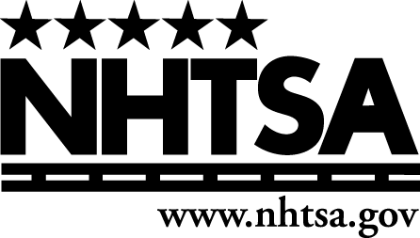
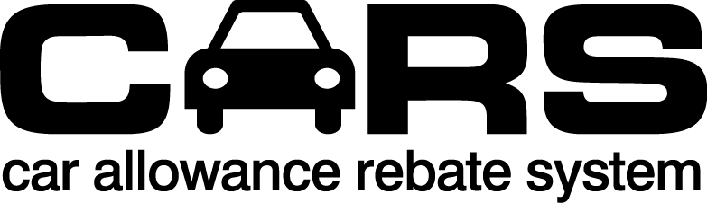
Salvage Auction Certification Form

Salvage Auction Information

CARS Invoice No. (if available)
Legal Business Name
Doing Business As (DBA)/Common Name (if different from Legal Business Name)
Address (including Street, City, State, ZIP Code)
Trade-In Vehicle Information
Make |  |  |  |  |  |  |  |  |  | Model |  |  |  |  |  |  |  |  |  |  | Model Year
Trade-In Vehicle VIN |  |  |  |  |  |  |  |  |  |  |  |  |  |  |  |  |  |  | Odometer Mileage
Dealer Transferring Trade-In Vehicle Information
Legal Business Name
Doing Business As (DBA)/Common Name (if different from Legal Business Name)
Address (including Street, City, State, ZIP Code)
Contact Name and Title |  |  |  |  |  |  |  |  |  |  |  |  |  |  |  | Contact Phone and Email
Address (including Street, City, State, ZIP Code) |  |  |  |  |  |  |  |  |  |  |  |  |  |  |  | Date this Salvage Auction Received the Trade-In Vehicle from Dealer

WARNING
This is a legal document that contains certifications under penalty of law. There are significant civil and criminal penalties for submitting false information. Please read each certification and ensure that the information that you are certifying by signing this document is, to the best of your knowledge and belief, true, accurate, and complete.

The person signing this document certifies under penalty of law that:

- This facility meets all applicable Federal and State laws.
- This facility has a currently active State license to conduct business as a salvage auction in the State where it is located.
- This facility received the trade-in vehicle bearing the above listed Vehicle Identification Number (VIN) on the date listed above from the dealer listed above.
- I, or an employee of this facility under my direction or supervision, will report to the National Motor Vehicle Title Information System (NMVTIS) the status of the trade-in vehicle within three (3) days after the date the dealer consigns the trade-in vehicle, or prior to auction (whichever is earlier).
- This facility will limit any auction sale of the trade-in vehicle solely to disposal facilities that appear on the CARS program Disposal Facility List.
- The trade-in vehicle has not been, and will not be, sold, leased, exchanged or otherwise disposed of for use as an automobile in the United States or in any other country.
- This facility will not remove any parts from the trade-in vehicle.
- This facility will not transfer the trade-in vehicle at any time prior to its sale at auction, and then only to a disposal facility that appears on the CARS program Disposal Facility List.

I certify under penalty of law that:
- I have authority to execute this document,
- I have read each of the foregoing certifications,
- This document, and any attachments, were either prepared by me or prepared under my direction or supervision,
- The information set forth in this document, and any attachments, is, to the best of my knowledge and belief, true, accurate, and complete,
- I am aware that there are significant penalties for submitting false information, including the possibility of civil penalties under the CARS program, suspension or revocation of continued participation in the CARS program, as well as fines and/or imprisonment.

DATE: ______, 2009 SALVAGE AUCTION
___________________________________
(signature)
___________________________________
(print name)
___________________________________
(title)
___________________________________
(contact phone and e-mail)

Privacy Act Statement

This notice is provided pursuant to the Privacy Act of 1974, 5 USC § 552a: This information is solicited under the authority of Public Law 111-32, 123 Stat. 1859. Furnishing the information is voluntary, but failure to provide all or part of the information may result in disapproval of a request for a credit on this purchase or lease transaction under the Cars Program. The principal purposes for collecting the information are to ensure proper disposal of trade-in vehicles, to prevent, identify and penalize fraud in connection with the Program, and to update an existing government database of Vehicle Identification Numbers. Other routine uses are published in the Federal Register at 65 F.R. 19476 (April 11, 2000), available at: www.dot.gov/privacy.

Paperwork Reduction Act Burden Statement

A federal agency may not conduct or sponsor, and a person is not required to respond to, nor shall a person be subject to a penalty for failure to comply with a collection of information subject to the requirements of the Paperwork Reduction Act unless that collection of information displays a current valid OMB Control Number. The OMB Control Number for this information collection is 2127-XXXX. Public reporting for this collection of information is estimated to be approximately XX minutes per response, including the time for reviewing instructions, completing and reviewing the collection of information. All responses to this collection of information are mandatory. Send comments regarding this burden estimate or any other aspect of this collection of information, including suggestions for reducing this burden to: Information Collection Clearance Officer, National Highway Traffic Safety Administration, 1200 New Jersey Ave, S.E., Washington, DC, 20590.

