OMB Control No. 3095-0054
Expires 08-31-2009

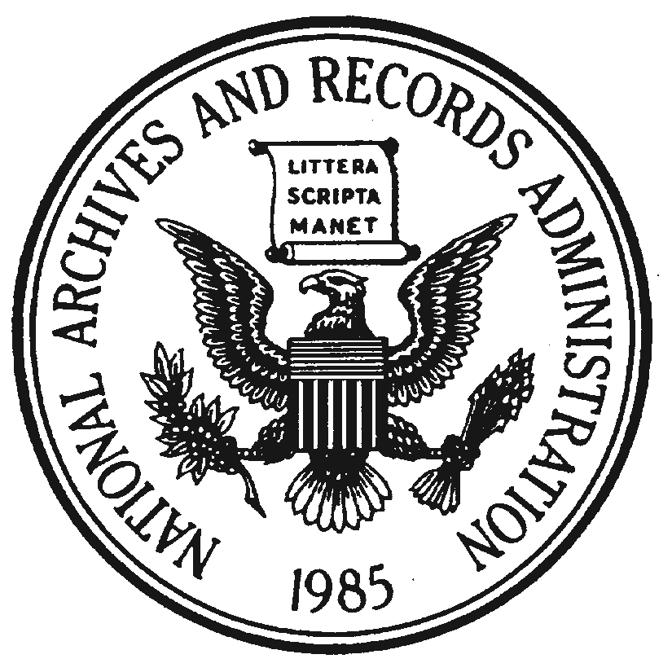 | National Archives and Records Administration  Independent Researcher Listing Application Form  For Use at Regional Records Services and Washington, DC area facilities  Please See Paperwork Reduction Act Public Burden Statement on the back
New Application |  | Update to Current Listing
* Researcher or Company Name: |  |  | *Denotes Required Field
* Street and/or Post Office Box:
* City: |  |  | * State:
*Zip Code + Zip Four: |  |  | Public Orders Telephone Number:
Customer Service Telephone Number: |  |  | Fax Number:
Electronic Mailing Address: |  |  | Web Page Address:
* Contact Person:
*Research Specialty (may list specific record groups, records media, series, subjects, topics, etc.):
* NARA facilities in which you perform research (please mark all that apply):
Northeast Region (Boston) |  |  | Pacific Alaska Region (Anchorage)
Northeast Region (New York City) |  |  | Pacific Alaska Region (Seattle)
Northeast Region (Pittsfield) |  |  | Pacific Alaska Region (Laguna Niguel)
Mid Atlantic Region (Center City Philadelphia) |  |  | Pacific Region (San Francisco)
Mid Atlantic Region (Northeast Philadelphia) |  |  | Pacific Region (Perris)
Southeast Region (Atlanta) |  |  | National Personnel Records Center (St. Louis-Civilian)
Great Lakes Region (Chicago) |  |  | National Personnel Records Center (St. Louis-Military)
Great Lakes Region (Dayton) |  |  | Washington National Records Center (Suitland)
Central Plains Region (Kansas City) |  |  | National Archives at College Park, MD
Southwest Region (Forth Worth)  Rocky Mountain Region (Denver) |  |  | National Archives Building, DC  Other (Presidential Library or affiliated archive)
* I hereby authorize NARA to release to the public the information contained in this form for the purpose of providing
a listing of independent researchers under the conditions described on the back of this form.
* Signature |  |  |  | * Date
Completed questionnaires may be faxed to 301-837-0459; or sent via postal mail to the National Archives at College Park, NWCCA, Room 2380, RE: Independent Researcher Listing, 8601 Adelphi Road, College Park, MD 20740-6001; for questions and comments, please feel free to telephone 301-837-2002 or email alic@nara.gov.

PAPERWORK REDUCTION ACT PUBLIC BURDEN STATEMENT
A Federal agency may not conduct or sponsor, and a person is not required to respond to a collection of information unless it displays a current valid OMB control number. The OMB Control No. for this information collection is 3095-0054. The information requested on this form is being collected and disseminated by the National Archives and Records Administration as a courtesy to the public. Public burden reporting for this collection of information is estimated to be ten minutes per response, including time for reviewing instructions, and completing and reviewing the collection of information. Send comments regarding the burden estimate or any other aspect of the collection of information, including suggestions for reducing this burden, to the National Archives and Records Administration (NHP), 8601 Adelphi Road, College Park, MD 20740-6001. DO NOT SEND COMPLETED FORMS TO THIS ADDRESS. PLEASE SEND COMPLETED FORMS TO THE ADDRESS SHOWN BELOW.
Procedures and Conditions for Inclusion in the Independent Researcher Listing for NARA's Washington, DC, area and Regional Records Services Facilities
1. Any independent researcher who performs work at any NARA facility or NARA-affiliated archives may complete the Independent Researcher Listing Application Form.
2. The National Archives and Records Administration (NARA) does not require a fee for inclusion on the list. However, all required fields noted on the form must be completed for inclusion on the listing.
3. The listing is compiled and disseminated as a service to the public. Copies of the listing will be available on NARA's web site and at all archival reference units at the Washington, DC; College Park, MD; and Regional Records Services facilities; and Presidential libraries.
4. Any change in an individual's listed information requires a resubmission of the form by the affected independent researcher. Updates will be made whenever new information is submitted.
5. All independent researchers who wish to remain on the listing are required to certify annually that the information we publish is current and accurate. Replies to our annual email notices must be received within 30 days. Those independent researchers who do not reply will be stricken from the listing without further notification.
6. All independent researchers using NARA facilities and NARA-affiliated archives are expected to comply with established research room procedures. Those found to be in violation of such procedures will be stricken from the listing. Severe or repeated violations may also result in suspension of research room privileges in accordance with 36 CFR 1254, subpart B.
7. Soliciting, vending, and debt collection are prohibited on NARA property.
8. Any comments or complaints received by NARA regarding any individual independent researcher on the listing will be forwarded to that researcher for resolution. However, complaints received on a regular basis regarding the business practices of any independent researcher can result in removal from the listing.
9. NARA will not be responsible for any research and/or reproduction arrangements made between the independent researcher and his/her clientele.
10. Inclusion on the list may not be viewed or advertised as an endorsement by NARA.
11. This listing is not considered part of the separate Vendor System used predominantly by NARA's Special Media Archives Services Division at College Park, MD, nor is it part of any other contractual agreement.
12. This application form is available on NARA's web site at www.archives.gov or by mail from: National Archives at College Park, Archives Library Information Center (NWCCA), Room 2380, RE: Independent Researcher Listing, 8601 Adelphi Road, College Park, MD 20740-6001; or you may fax your request for a form to 301-837-0459.
13. Submit your completed application form and updates to: National Archives at College Park, Archives Library Information Center (NWCCA), Room 2380, RE: Independent Researcher Listing, 8601 Adelphi Road, College Park, MD 20740-6001; or use our fax number: 301-837-0459.
If you have further questions, you may contact us by telephone at 301-837-2002; or by electronic mail at alic@nara.gov.

