HUBZone Electronic Application and Authorization
Screenshots

Advisory 14
Links and Pop-Ups 16
Map Advisory 22
Start Application Process 24
Links and Pop-Ups 25
Apply For HUBZone Certification 30
Links and Pop-Ups 30
Application Step One 30
Links and Pop-Ups 30
Application Step One (Part II) 30
Links and Pop-Ups Error! Bookmark not defined.
Application Step Two 30
Application Step Three 30
Links and Pop-Ups 30
Application Step Four 30
Links and Pop-Ups 30
Application Step Four (Part II) 30
Links and Pop-Ups 30
Application Step Five 30
Links and Pop-Ups 30
Application Step Five (Part II) 30
Links and Pop-Ups 30
Application Step Five (Part III) 30
Links and Pop-Ups 30
Application Step Six 30
Links and Pop-Ups 30
Application Step Seven 30
Links and Pop-Ups 30
Application Step Seven (Part II) 30
Application Step Seven (Part III) 30
Application Step Seven (Part IV) 30
Application Step Seven (Part V) 30
Application Step Eight 30
Application Step Nine 30
Application Step Ten 30
Links and Pop-Ups 30
Application Step Ten (Disputing Map Findings) 30
Application Step Ten (Part Two) 30
Debarment Information 30
Links and Pop-Ups 30
Application Step Eleven 30
Interest in Other Business Information 30
Links and Pop-Ups 30
Application Step Twelve 30
Links and Pop-Ups 30
Application Step Thirteen 30
After Adding a Affiliate 30
Links and Pop-Ups 30
Application Step Fourteen 30
Application Step Fifteen 30
Application Step Sixteen 30
Display My Application 30
Application Step Seventeen 30
Links and Pop-Ups 30
Login for Authorization of Application 30
Submitting the Application 30
Links and Pop-Ups 30
Authorization and Verification End 30
Appendix 30
Regulatory Links for the Application 30
Application Programming Guide 30

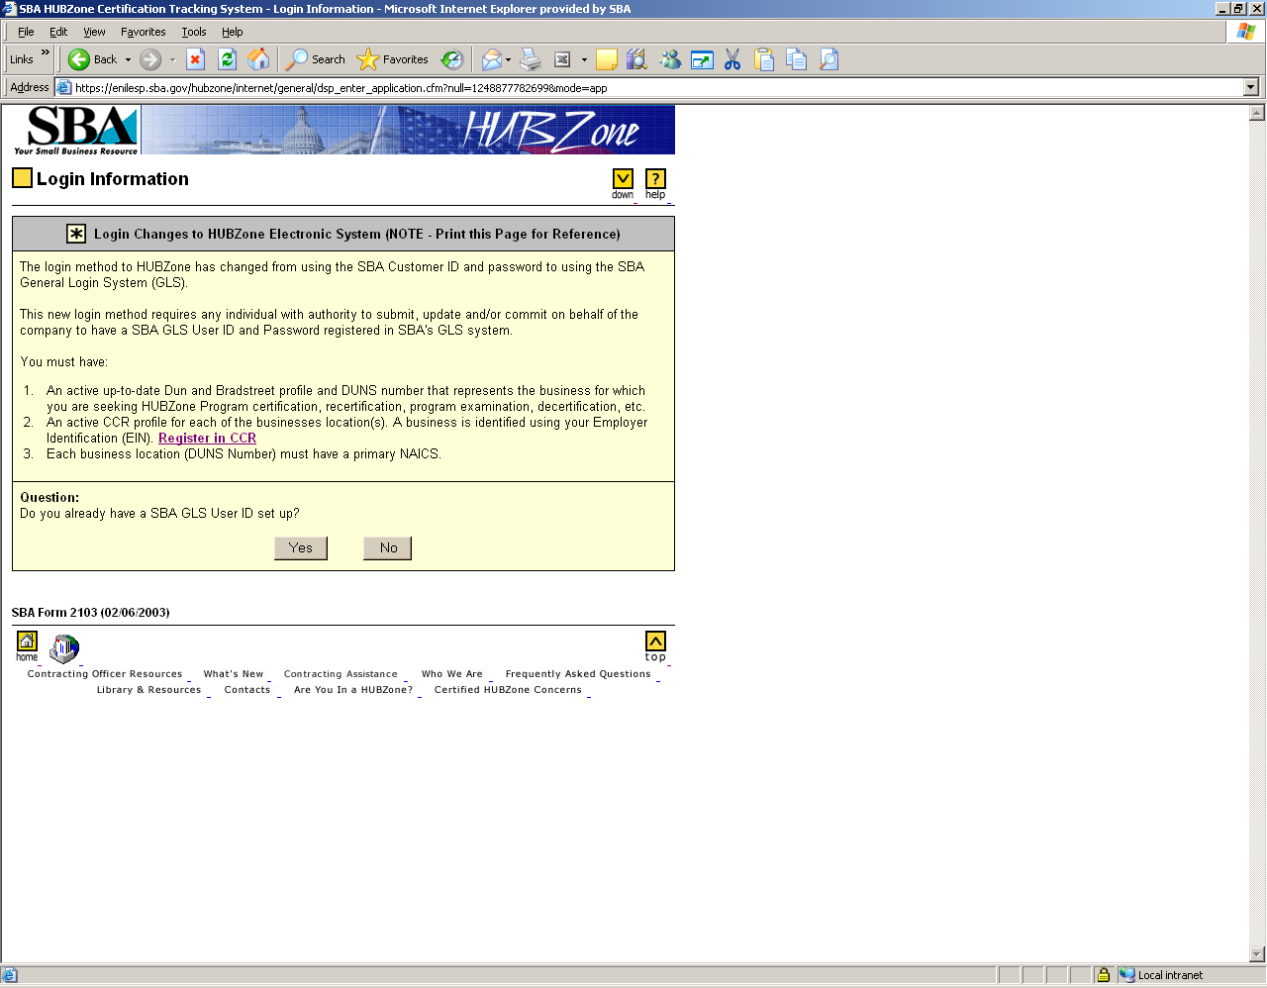
1. Delete “Decertification” in the first sentence.
2. Change the expiration date to 7/31/2009 on all pages.
3. ADD OMB Disclosure Statement below under the last sentence.
PLEASE NOTE: The estimated burden for completing this form is 3 hours per response. You are not required
to respond to any collection of information unless it displays a currently valid OMB approval number.
Comments on the burden should be sent to U.S. Small Business Administration, Chief, AIB, 409 3rd St., S.W.,
Washington D.C. 20416 and Desk Officer for the Small Business Administration, Officer of Management and
Budget, New Executive Office Building, Room 10202, Washington, D.C. 20503. OMB Approval (3245-0320). PLEASE DO NOT SEND FORMS TO OMB.
4. Add “SBA Form 2103” to each page in the application.

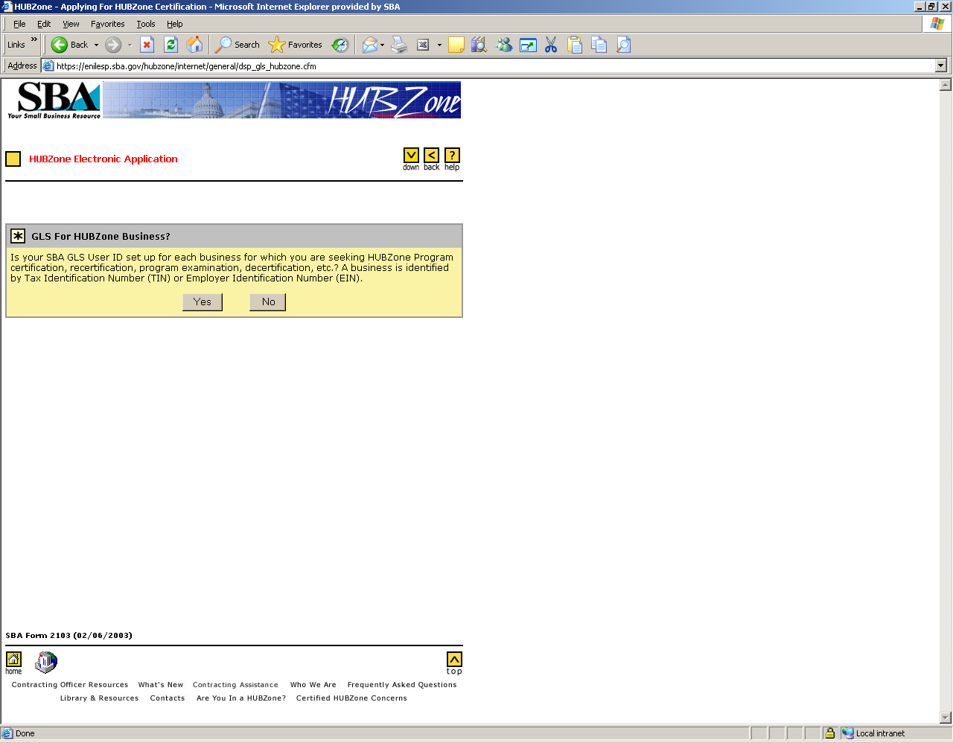

Remove the word “decertification” and change the expiration date to 7/31/2009 on all pages.
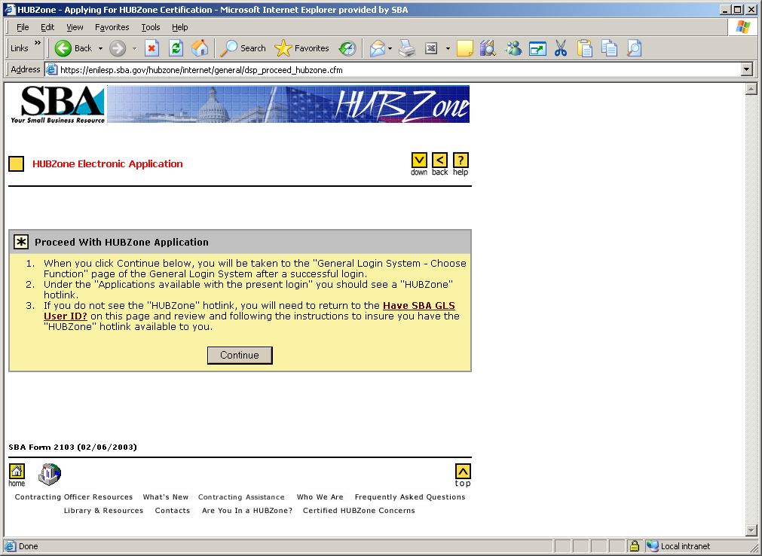

Change “insure” to “ensure” in the 3rd sentence.

Instructions to register an SBA GLS User ID (NOTE - Print this Page for Reference)
You will need to set up an SBA GLS User ID for any individual with authority to submit, update and/or commit on behalf of the company. In your SBA GLS profile, you will need to identify each business for which you are seeking HUBZone Program certification, recertification, program examination, decertification, etc. A business is identified using its Tax Identification Number (TIN) or Employer Identification Number (EIN).
Follow these steps to set up your SBA GLS User ID profile:
- You will first establish or modify your SBA GLS User profile that identifies you to associate your SBA GLS User profile to one or more of your business for which you will be seeking or maintaining HUBZone Certification.
- You will establish or modify your SBA GLS User profile using your 'SBA GLS User ID' of your choice which must be between 8 and 15 characters.
- You will complete the information in the SBA GLS User profile and submit the profile.
- You will receive an e-mail that will provide you with a temporary SBA GLS User Password. Use that password to log back into GLS. Once in GLS, you will be required to change the password using the guidelines below:
  - Must be minimum of 8 characters.
  - Must contain at least three of the following four properties
    - At least one upper case letter A, B, C, ... Z
    - Lower case letters a, b, c, ... z
    - Numerals 0, 1, 2, ... 9
    - Special characters { } [ ] < > : ? | \ ` ~ ! @ $ % ^ & * _ - + =

- Next, associate your SBA GLS User ID to each business for which you are seeking HUBZone Program certification, recertification, program examination, decertification, etc. To accomplished this you will need to:
A. Select the 'Profile' tab or select 'Update Profile.'
B. Scroll to the bottom of page and below the Business Information line select Yes for the Add New Business.
C. Enter the EIN (TIN) and DUNS for each business. NOTE: For a HUBZone Business, both are required.
D. Select "Submit" after entering both.
E. Continue this process until all businesses have been entered for your profile.
- You will need to associate your SBA User ID to the HUBZone Certification Program by doing the following: A. Select the 'Access' tab
B. Scroll down to the "Historically Underutilized Business Zones" line
C. Click on the folder icon
D. Check the box by "Firm applying for HUBZone certification"
E. In the drop down box, select the EIN and DUNS that represents the business for which you are seeking HUBZone Program Certification.
F. The "HUBZone Certification Application" option will now appear on your Choose Function page.
G. You will also receive an e-mail stating that you have successfully updated your profile.
- You are now ready to start the HUBZone Action or Inquiry.
- Click "Start Registration" link below to open the SBA GLS profile information page.
Start Registration

Remove the word “decertification” in the first paragraph and in sentence number 5..
SBA Form 2103 (02/06/2003)

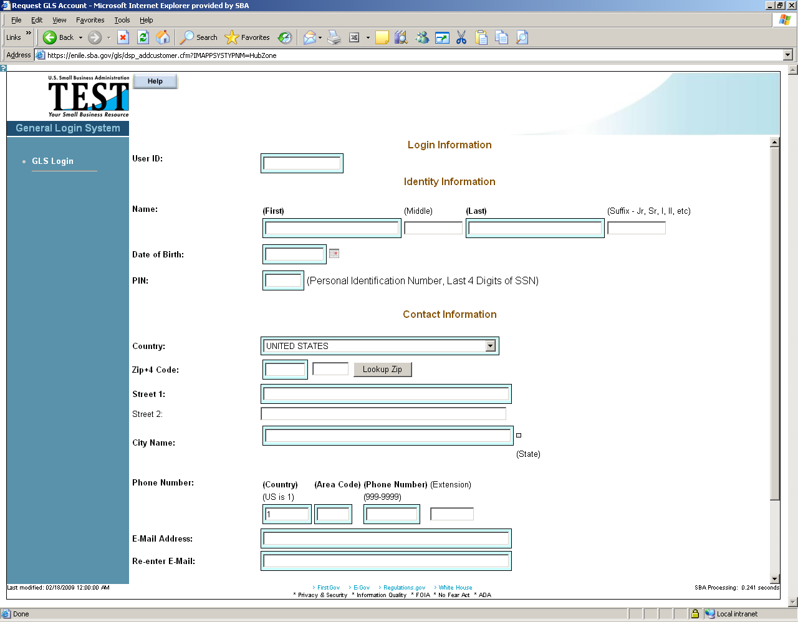

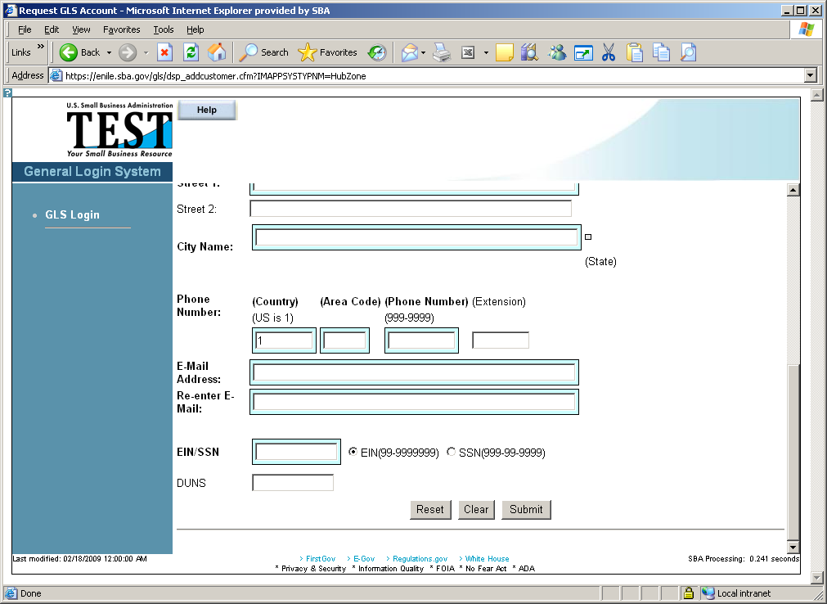

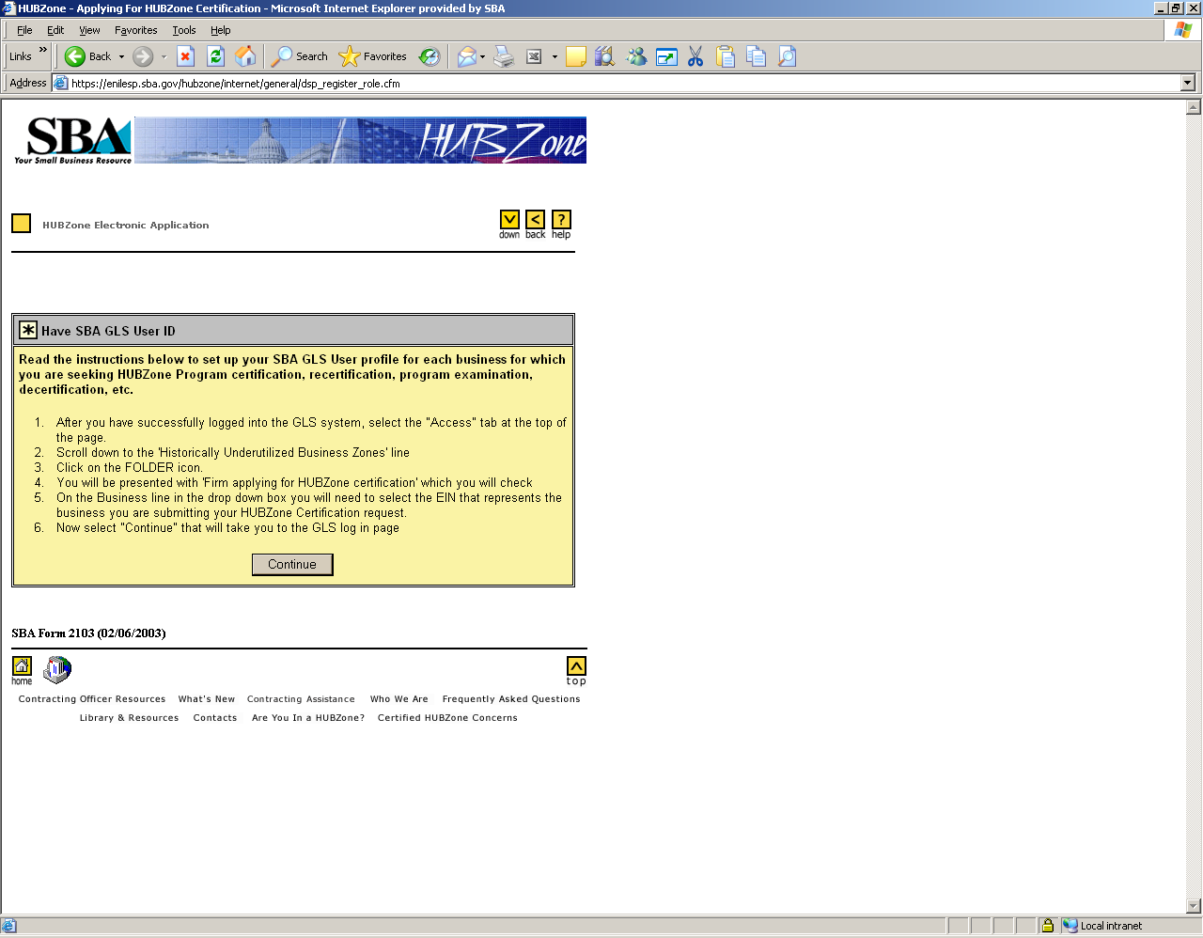

Remove the word “decertification” from the first paragraph.

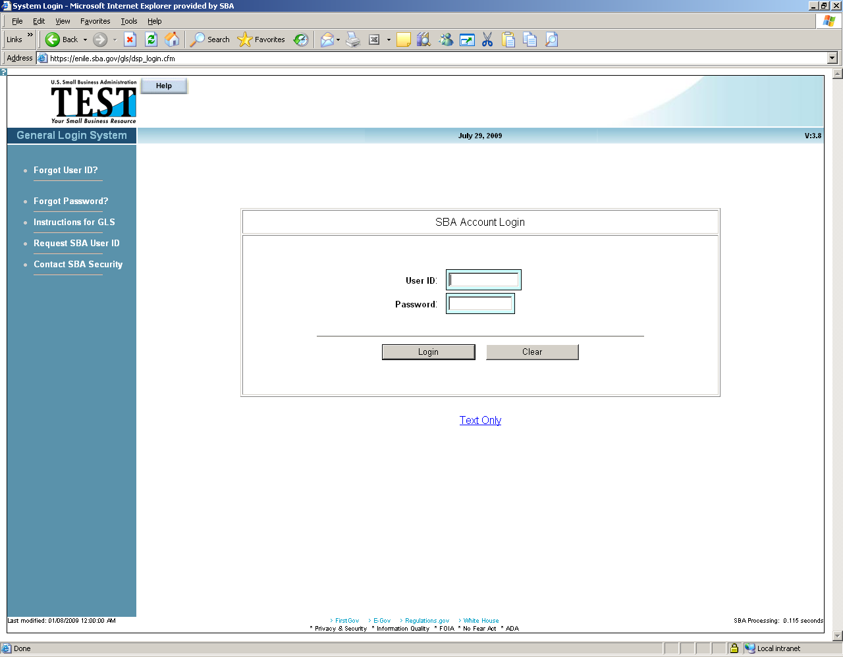

Advisory
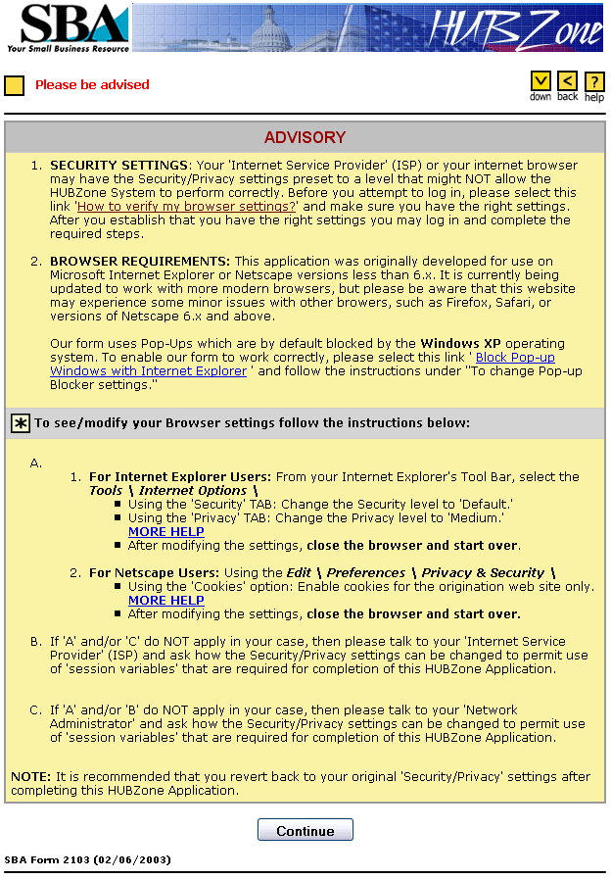
Change date from 7/31/2009

Links and Pop-Ups
The More Help link for Internet Explorer Users
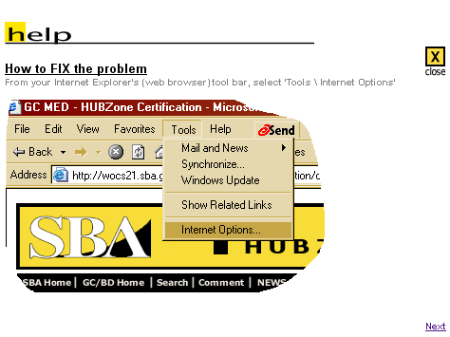
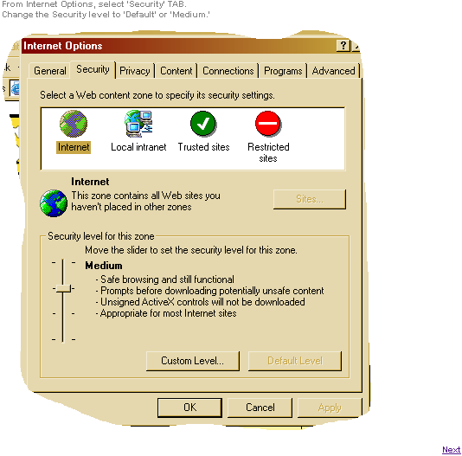
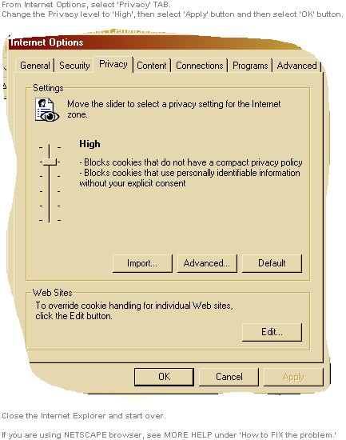

The More Help link for Netscape Users
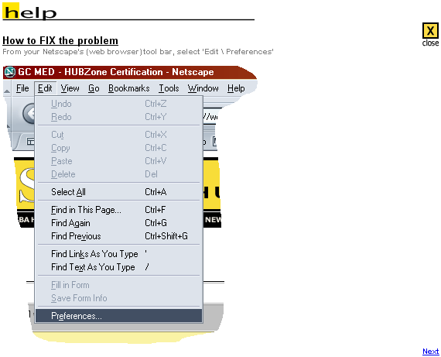
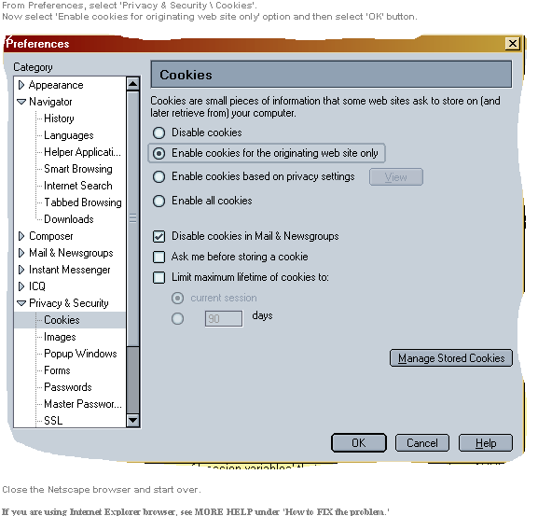

Map Advisory
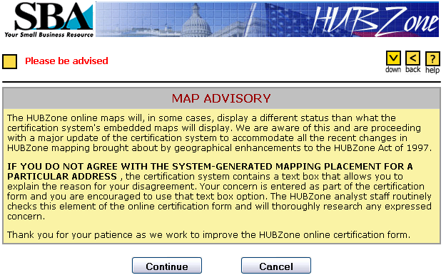

Start Application Process
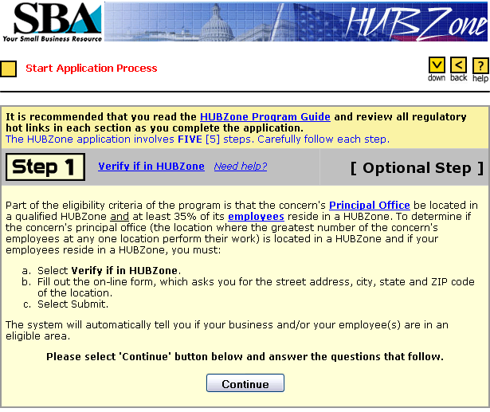
1. Add “(except for tribally owned concerns)” “after part of the eligibility criteria”.
2. Add a “period” and remove the parenthesis after “work)” and two spaces.
3. Add “However, for those concerns whose “primary industry” (see 13 CFR 121.107) is service or construction (see 13 CFR 121.201), the determination of principal office excludes the concern's employees who perform the majority of their work at job-site locations to fulfill specific contract obligations.)” After “work”.
4. Both the Principal Office and employees link should be directed to http://ecfr.gpoaccess.gov/cgi/t/text/text-idx?c=ecfr&sid=09c8010ea4b7e47866b2e23bffcbfacb&rgn=div5&view=text&node=13:1.0.1.1.20&idno=13 .

Links and Pop-Ups
The employees Link will take you to the Electronic Code of Federal Regulations site.

The Principal Office Link
This is the section linked to in the Application Program Guide. The Guide can be found in full in the appendix.
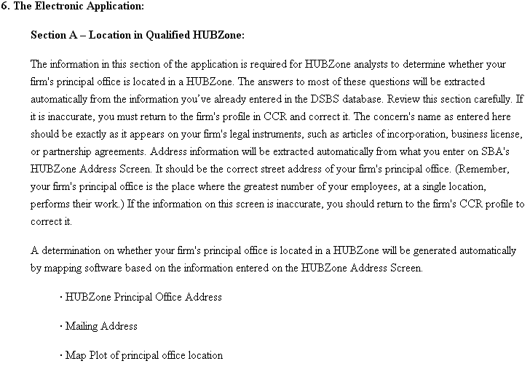

The Need Help? Link
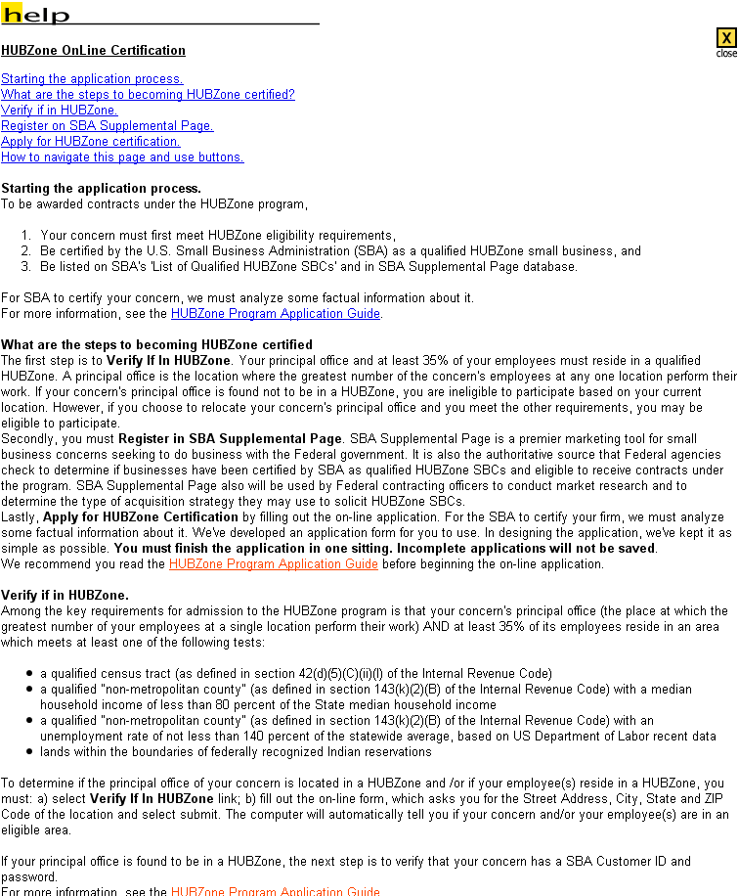
1. Remove all reference of “SBA supplemental page” and replace with “the Dynamic Small Business” on this and all subsequent pages.
2. Add “However, for those concerns whose “primary industry” (see 13 CFR 121.107) is service or construction (see 13 CFR 121.201), the determination of principal office excludes the concern's employees who perform the majority of their work at job-site locations to fulfill specific contract obligations.” After the 2nd sentence in the 2nd paragraph.
3. Add “one of” after “It is also” in the 3rd sentence in the 2nd paragraph.
4. Add “or the United states, whichever is less” after “statewide average”.
5. Add: a bullet for Qualified base closure area; and Redesignated area after “lands within ………..

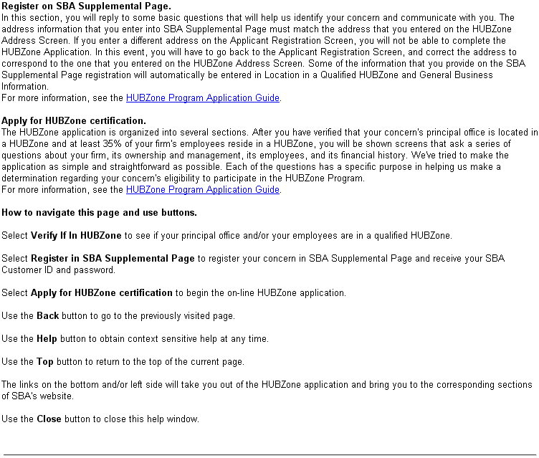
1. Remove all reference of “SBA supplemental page” and replace with “the Dynamic Small Business” on this and all subsequent pages.

The Verify if in HUBZone Link
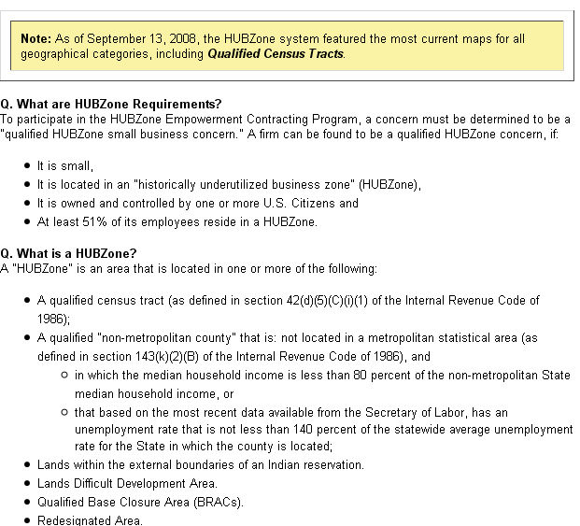
1. Remove the word “Empowerment Contracting” and change 51% to 35% under What are HUBZone requirements.
2. Remove answers under “What is a HUBZone” and create a hotlink under See 126.103 and remove all bullets.
3. Change the 3rd bullet to read “(a) it is at least 51% owned and controlled by U.S. citizens; (b) it is wholly owned by one or more Indian Tribal Governments or owned in part by one or more Indian Tribal Governments provided all other owners are either U.S. citizens or small business concerns.; it is wholly owned by a CDC or in part by one or more CDCs provided all other owners are either U.S. citizens or small business concerns.; (c) it is wholly owned by one or more small agricultural cooperatives organized or incorporated in the U.S. or owned in part by one or more small agricultural cooperatives organized or incorporated in the U.S, provided all other owners are either U.S. citizens or small business concerns.
4. Add, “or the united States which ever is less;” after the unemployment bullet.
5. Remove “lands difficult development area.”

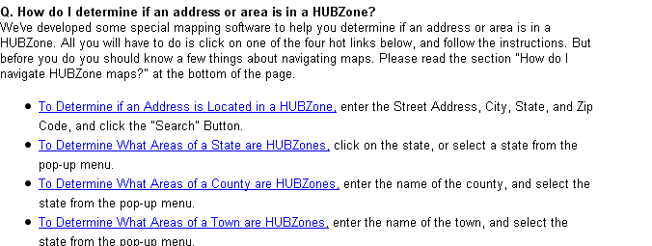

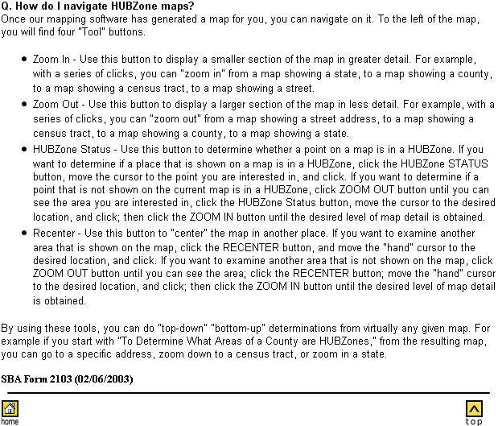
Change expiration date to 7/31/2009

The HUBZone Program Guide Link
(The entire program guide can be found in the Appendix)
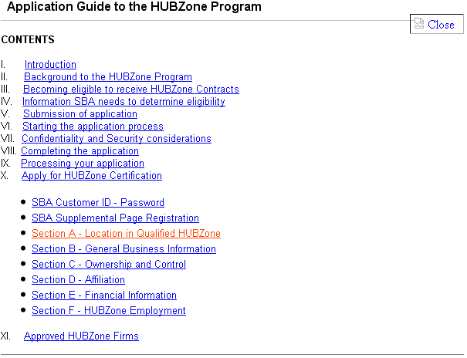

Apply For HUBZone Certification
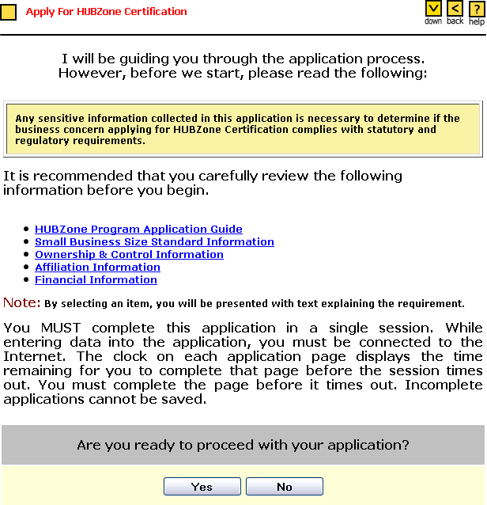

I

Links and Pop-Ups
All of the links link to the respective sections in the Program Application Guide. The Program Application Guide can be found in full in the appendix.

Application Step One

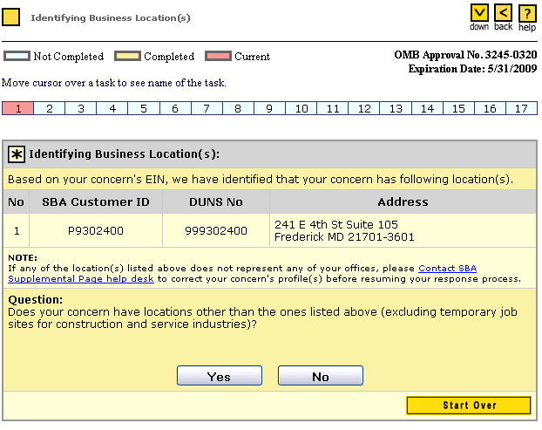
1. Add “the” between “has following”.
2. Remove ( ) around the “s” in location; change “does” to “do”
3. Change “SBA Supplemental Page” help desk to “pronet@sba.gov”.
4. Change the Expiration Date from 5/31/2009 to 7/31/2009 in the entire application.

Links and Pop-Ups
The Contact SBA Supplemental Page help desk Link
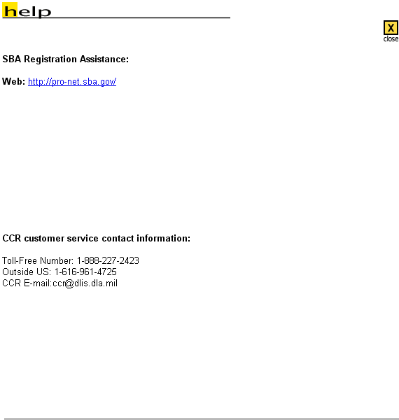
Laura, the link automatically sends the firm to CCR after explaining the purpose of pronet and its integration with CCR.
1. Change the link to go directly to pronet@sba.gov (which is the current email address).
2. Change the toll free number to 1 866 606 8220.

Application Step One (Part II)
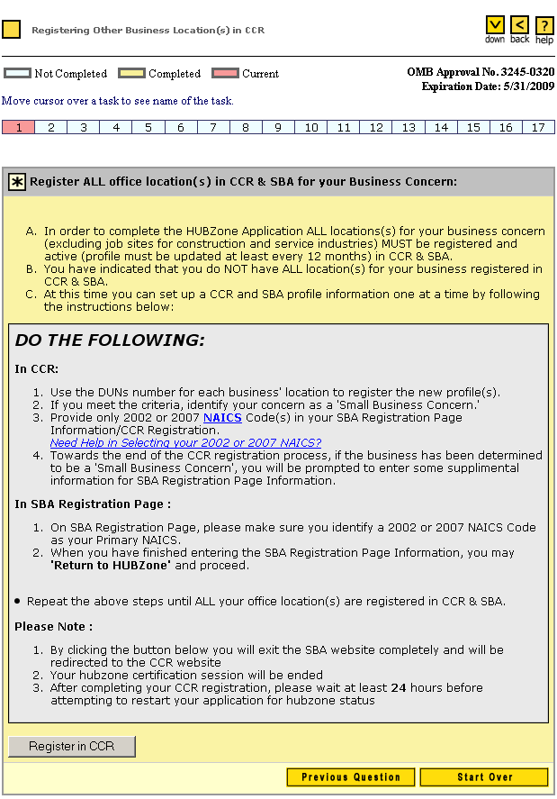
Appears after answering Yes to the question in Application Section One Part I

1. On the previous page, Number 4 above, correct the spelling of “supplemental.”
2. Under the Please note, change “hubzone” to “HUBZone”.
******************************************************************************

The NAICS Link
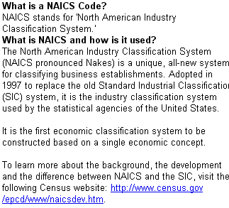

The Need Help in Selecting your 2002 or 2007 NAICS? Link
This link will take you to the census.gov site.

Application Step Two
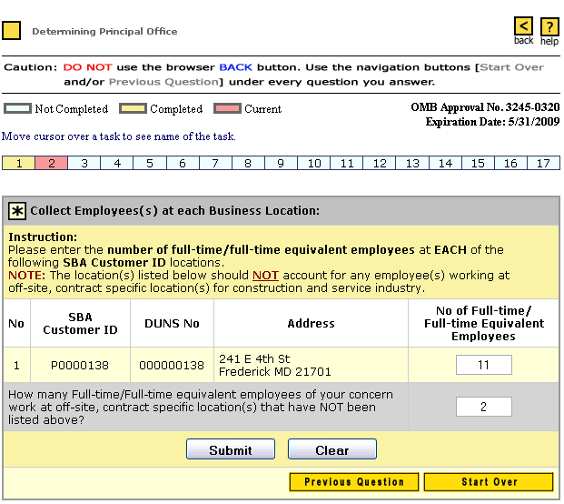

1. Under the NOTE: Remove “working at off-site, ……………” and replace with “that perform the majority of their work a jobsite locations to fulfill specific contract obligations.”
2. Remove “work at off-site contract ……….NOT been listed above” and replace with “perform the majority of their work at jobsite locations”.

Application Step Three
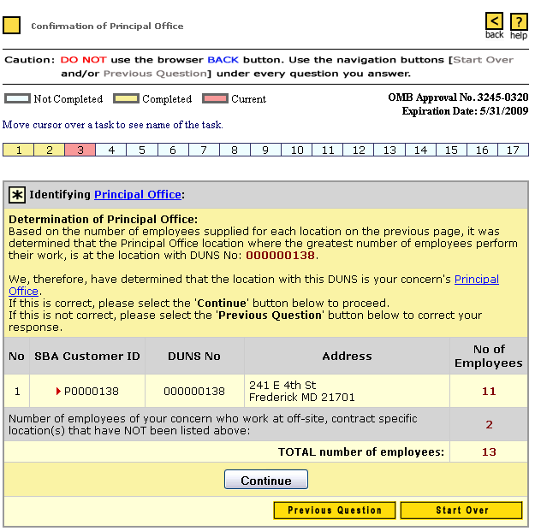

1. Remove “We, therefore, have determined that”. Capitalize the “T” to read “The location with this DUNS………”
2. Prinicpal Office link should be directed to http://ecfr.gpoaccess.gov/cgi/t/text/text-idx?c=ecfr&sid=09c8010ea4b7e47866b2e23bffcbfacb&rgn=div5&view=text&node=13:1.0.1.1.20&idno=13
3. Remove “work at off-site, contract specific locations………….above:” and replace with “who perform the majority of their work at jobsite locations”.

Links and Pop-Ups
The two Principal Office links link to their respective sections in the Application Program Guide. The Guide can be found in full in the appendix.

Application Step Four
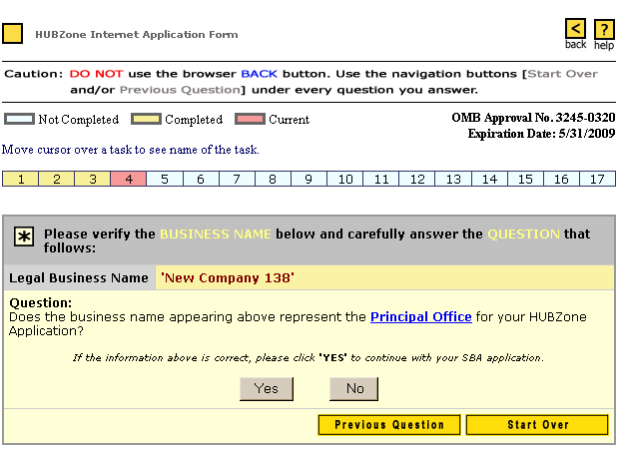

1. Does the business name appearing above operate out of the Principal************
2. Principal Office link should be directed to http://ecfr.gpoaccess.gov/cgi/t/text/text-idx?c=ecfr&sid=09c8010ea4b7e47866b2e23bffcbfacb&rgn=div5&view=text&node=13:1.0.1.1.20&idno=13
3. Add “Only the firm’s” in front of “Legal Business Name” and add “may be used to apply for HUBZone certification. SBA will not accept applications submitted using DBAs”.

Links and Pop-Ups
The Principal Office link links to its’ respective section in the Application Program Guide. The Guide can be found in full in the appendix.

Application Step Four (Part II)
Screen appears after clicking No in Application Section Four.
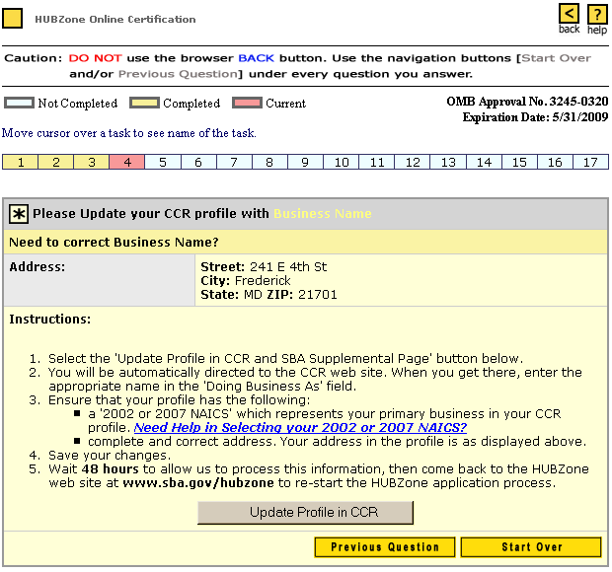

1. Remove reference to “SBA supplemental Page” and replace with “Dynamic Small Business Search Page”.
2. Change “48 hours” to “24 hours”

Links and Pop-Ups
The Need Help in Selecting your 2002 or 2007 NAICS? link links to the census.gov site. The Update Profile in CCR button links to the ccr.gov site.

Application Step Five
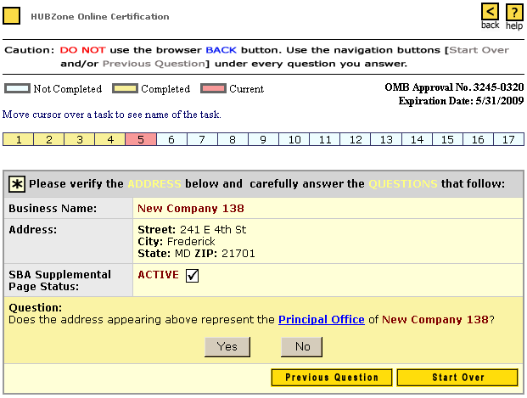
1. Change “SBA Supplemental Page Status” to “Dynamic Small Business Search (DSBS) Status”.
2. Prinicpal Office link should be directed to http://ecfr.gpoaccess.gov/cgi/t/text/text-idx?c=ecfr&sid=09c8010ea4b7e47866b2e23bffcbfacb&rgn=div5&view=text&node=13:1.0.1.1.20&idno=13

Links and Pop-Ups
The Principal Office link links to its’ respective section in the Application Program Guide. The Guide can be found in full in the appendix.

Application Step Five (Part II)
Screen appears after clicking No in Application Section Five

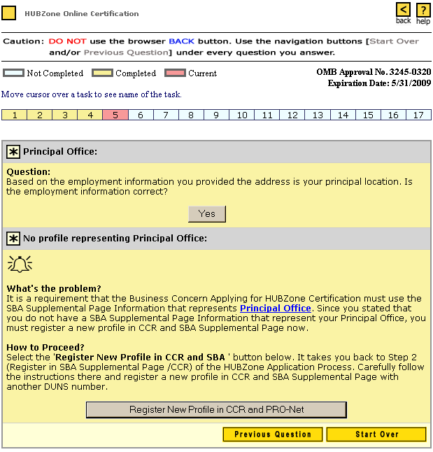

1. Under What’s the problem?, add an “s” after represent.
2. Change “SBA Supplemental Page/CCR” to “Dynamic Small Business Search (DSBS) ”.
3. Change PRO-Net to DSBS.

Links and Pop-Ups
The Principal Office link links to its’ respective section in the Application Program Guide. The Guide can be found in full in the appendix.

Application Step Five (Part III)
The screen appears after clicking Register New Profile in CCR and PRO-Net.
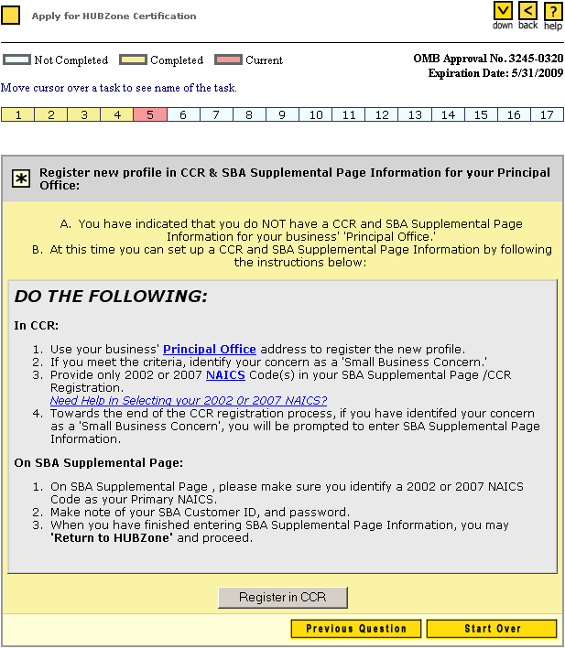
1. Remove all reference to “SBA Supplemental Page” and replace with “Dynamic Small Business Search page”

Links and Pop-Ups
See Application Step One (Part II) for information on NAICS and Need Help in Selecting your 2002 or 2007 NAICS links. The Principal Office link links to its’ respective section in the Application Program Guide which is found in full in the appendix.

Application Step Six
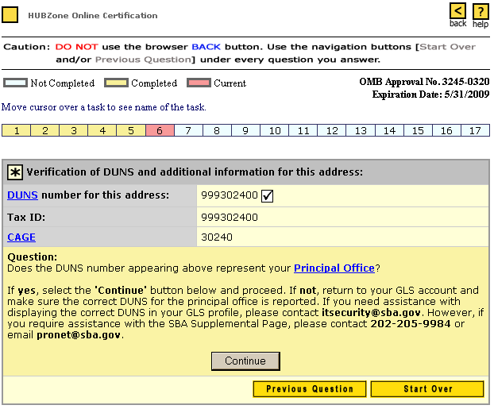

Links and Pop-Ups
The DUNS Link
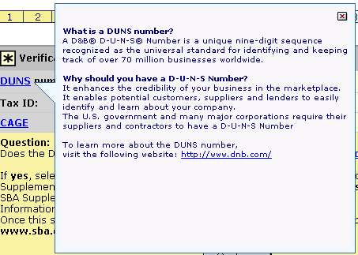

1. Under Why should you have………Remove “It enhances the credibility of your business in the marketplace It enables potential customers, suppliers and lenders to easily identify and learn about your company” in its entirety.

The CAGE Link
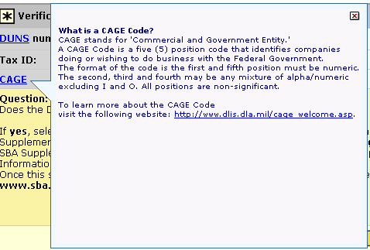

Application Step Seven
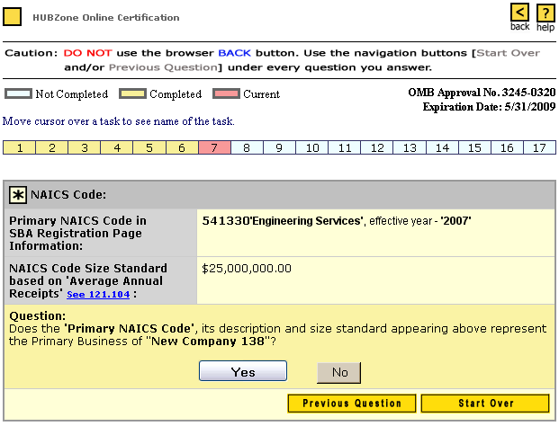
1. Remove “Business” and replace with “Industry”.
2. Add a link “See 121.107” after Industry.

Links and Pop-Ups
The see 121.104 link links to the Electronic Code of Federal Regulations site.

Application Step Seven (Part II)
Screen appears after clicking No on Application Section Seven.
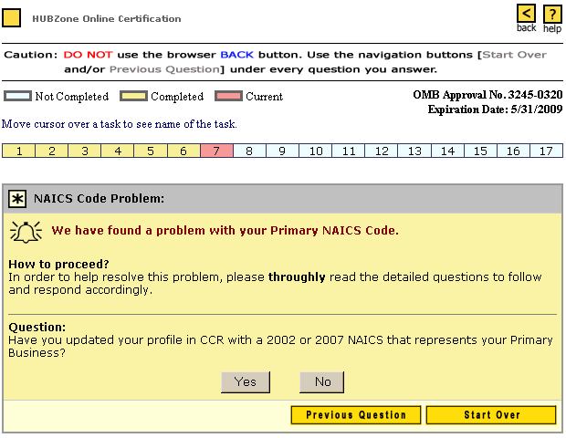

1. Remove “Business” and replace with “Industry”.
2. Add a link “See 121.107” after Industry.

Application Step Seven (Part III)
Screen appears after clicking No in Application Section Seven (Part II).
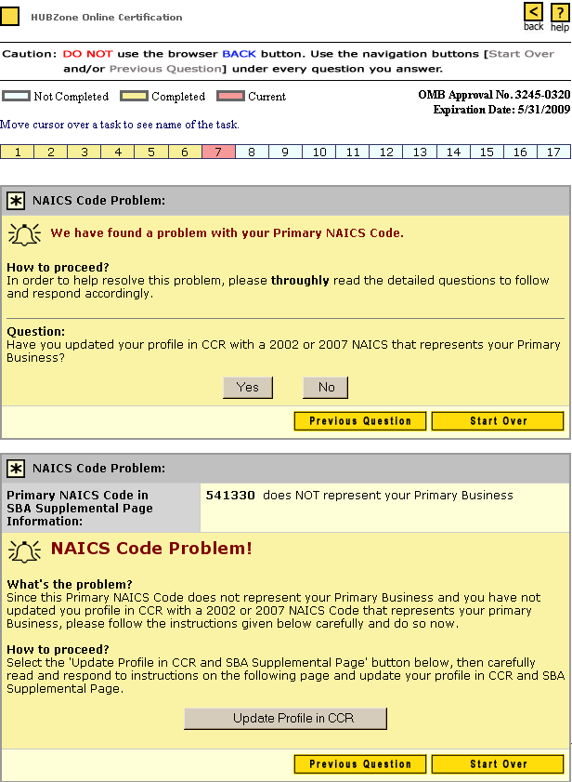
1. Correct the spelling of “thoroughly”.
2. Replace “ primary Business” with Primary “Industry”
3. Remove all reference to SBA Supplemental Page and replace with Dynamic Small Business Search page.

Application Step Seven (Part IV)
Screen appears after selecting Yes in Application Section Seven Part II.
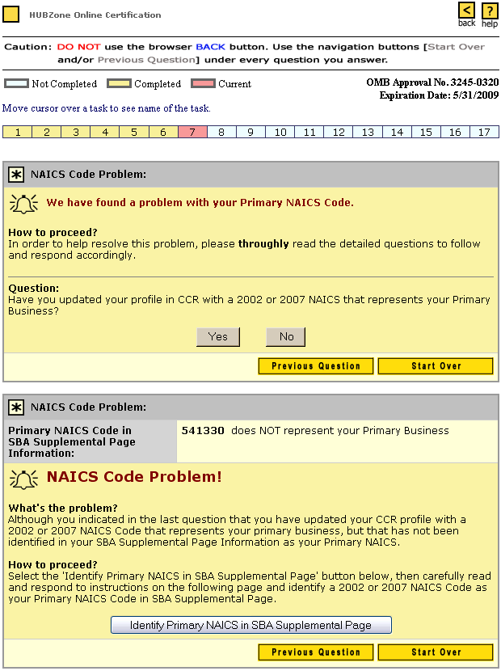
1. Correct the spelling of “thoroughly”.
2. Replace “ primary Business” with Primary “Industry”
3. Remove all reference to SBA Supplemental Page and replace with Dynamic Small Business Search page.

Application Step Seven (Part V)
Screen appears after clicking Update Profile in CCR in Application Section
Seven Part III.
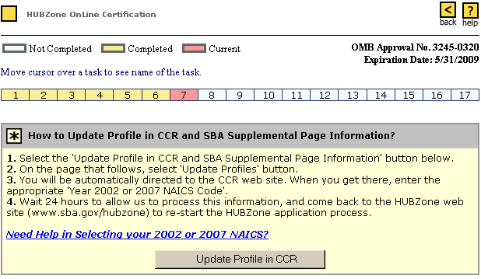

Application Step Eight
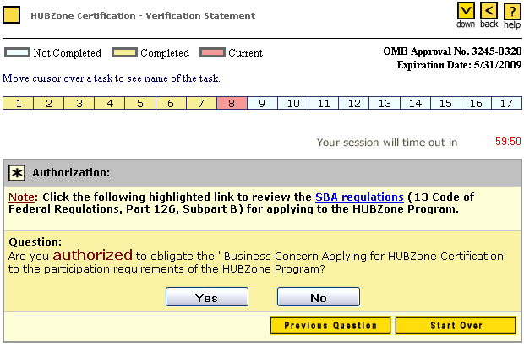

1. Change “are you authorized” to “Are you an authorized officer that can represent the”….

Application Step Nine
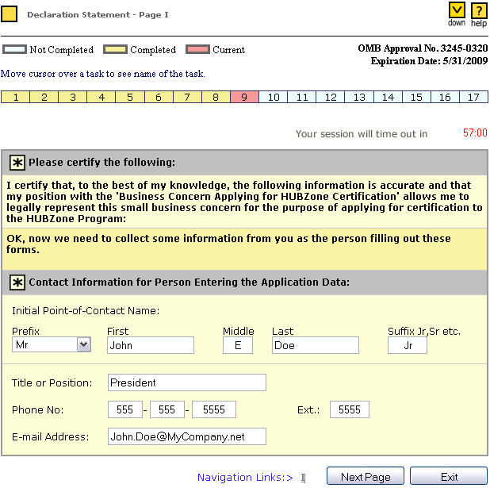

1. Add “as an officer of the applicant firm” after “my position”.

Application Step Ten
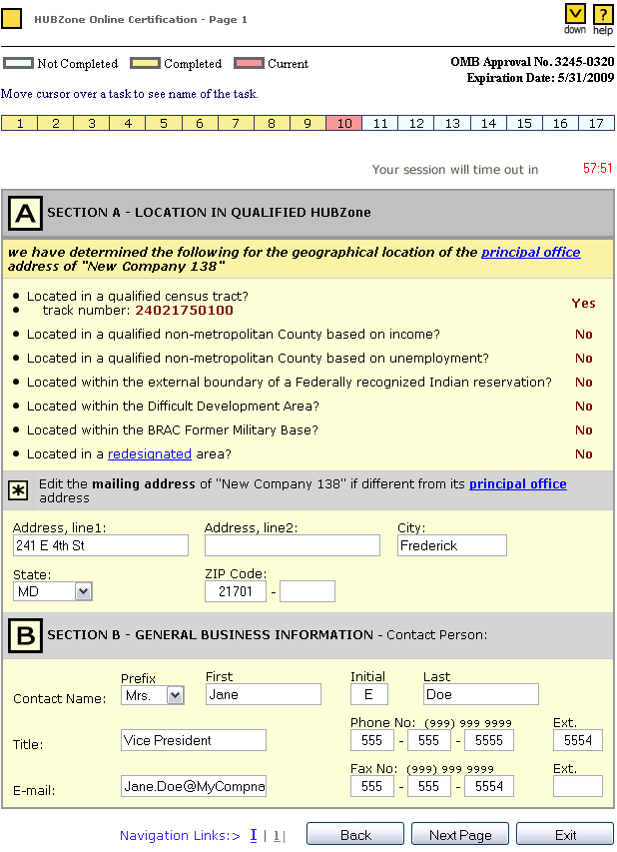
1. Remove the bullet for “Difficult development Area?

Links and Pop-Ups
The redesignated Link
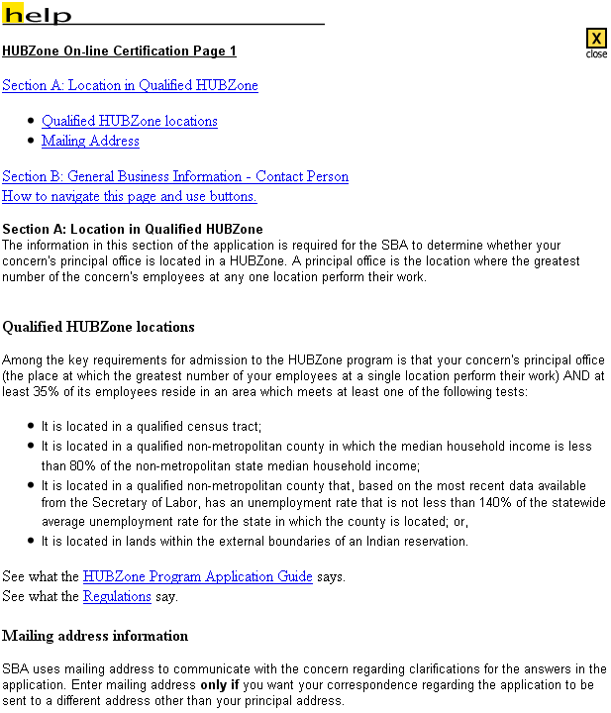

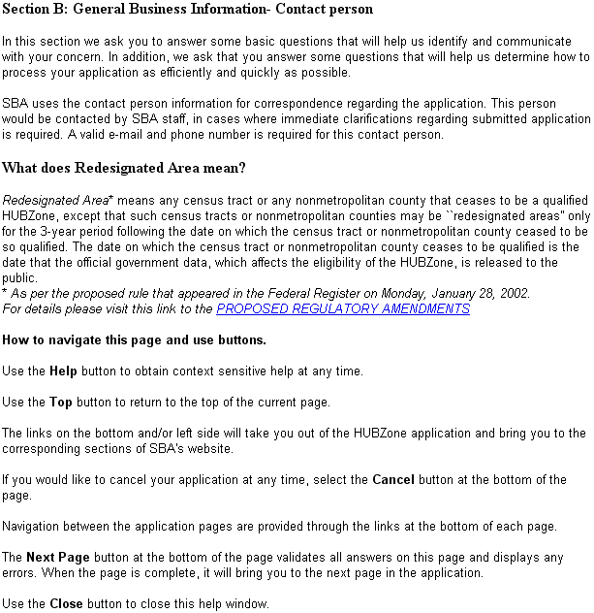

1. Add “(1) The date on which the Census Bureau publicly releases the first results from the 2010 decennial census; or (2) Three years after the date on which the census tract or non-metropolitan county ceased to be so qualified. The date on which the census tract or non-metropolitan county ceases to be qualified is the date that the official government data, which affects the eligibility of the HUBZone, is released to the public.” After “qualified in the 4th line of the first sentence under What does Redesignated mean?
2. Remove “as per the proposed rule………. And replace with the statute.

Application Step Ten (Disputing Map Findings)
This Section will appear if all the answers to questions in Section A are No.
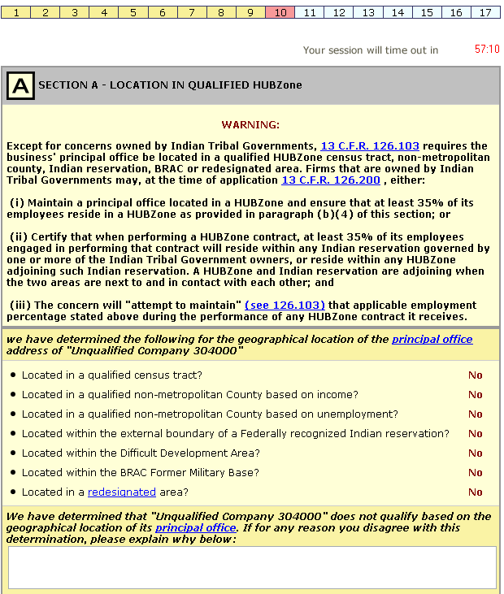

1. first para-first sentence change to read “Execpt for concerns owned by Tribal Governments, and all other owners are either U.S. citizens or small business, ………….”and all other owners are either U.S. citizens or small business(es)” after Except for concerns owned by Indian Tribal Governments”
2. first para-second sentence change to read as follows: Firms that are owned in whole or part by Indian Tribal Governments or corporations wholly owned by Indian Tribal Government may,……..
3. (i) – remove as provided in paragraph (b)(4) of this section;
4. Remove the Difficult Development bullet.

Application Step Ten (Part Two)
General Business Information Section Continued from previous page.
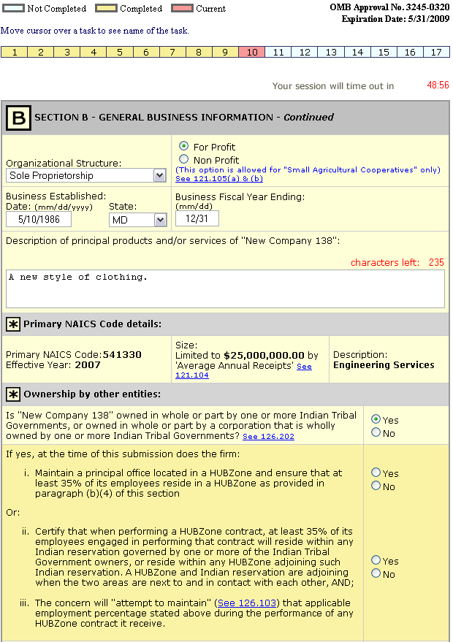
1. Under “ownership by other entities and after the word Goverments” add and all other owners are either U.S. citizens or small businesses”.
2. Change the regulatory link to “126.200(a).
3. under “I” above remove “as provided in paragraph (b)(4) of this section”.
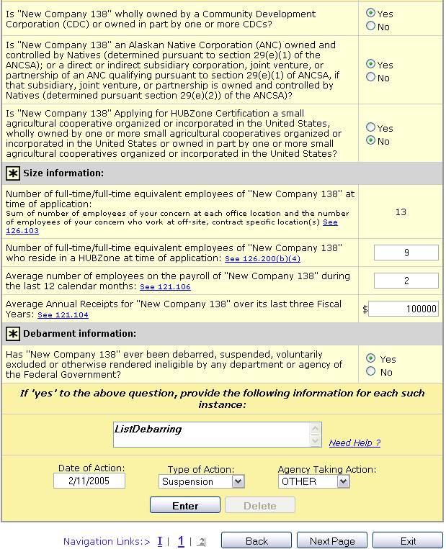

1. add “and all other owners are either U.S. citizens or small buinesses” after CDCs?
2. (a) Under the field above add “as” after HUBZone Certification; (b) add “a concern” before “wholly” and (c) add “provided all other owners are either U.S. citizens or small businesses” before the “?”.
3. Change “Size Information” to read “Size and HUBZone Residency Information”
4. Change “See 126.200(b)(4)” to “See 126.103”.
5. Under “debarment information” change the sentence to read “Is “New Company 13” debarred, suspended……….

Debarment Information
The appearance of the screen after entering Debarment information.
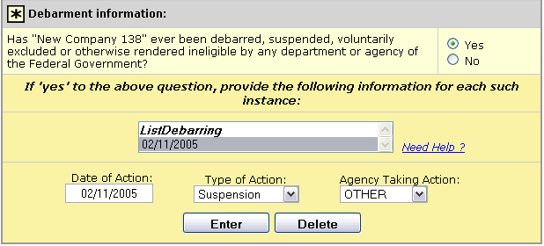

1. Under “debarment information” change the sentence to read “Is “New Company 13” debarred, suspended………

Links and Pop-Ups
Alert will appear after selecting Business type “Non Profit” in the General Business Information section.
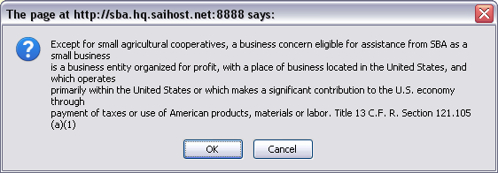

Alert will appear if current number of employees that reside in a HUBZone is less then the required 35% when entering data into the Size Information section under General Business Information
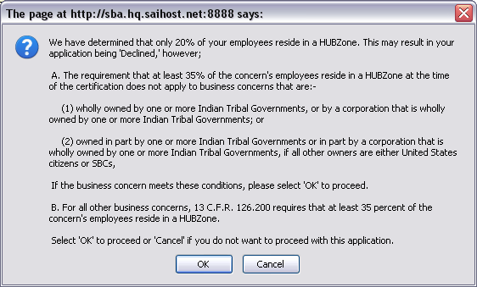

Alert may appear after enter Average Annual Receipt data in the Size Information section under General Business Information.
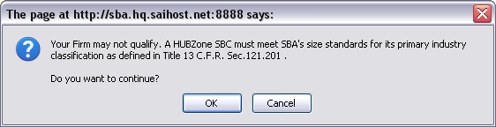

The Need Help? Link
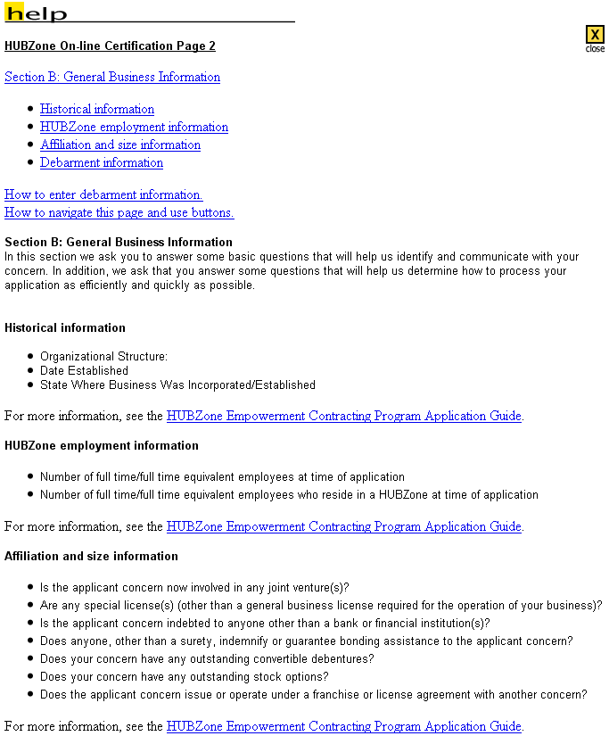
U
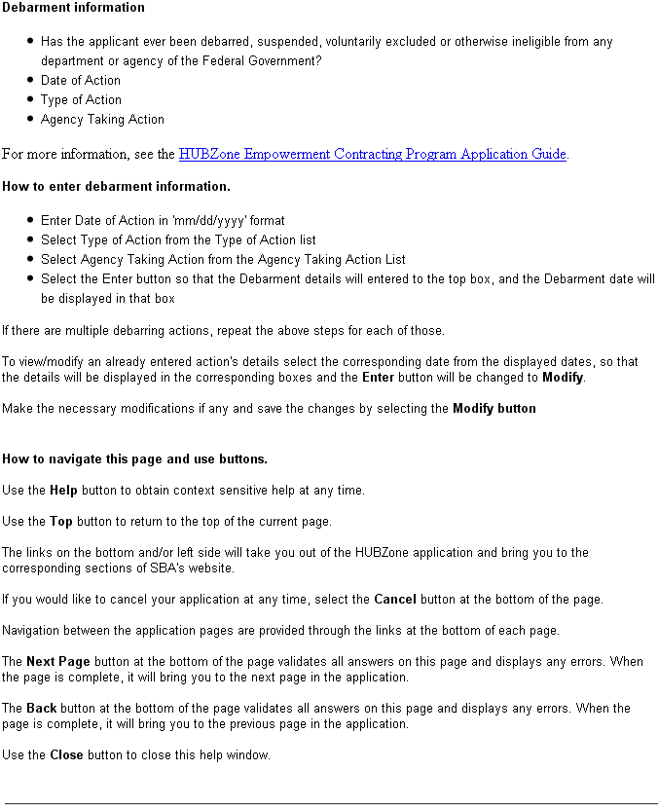
Under debarment information change the sentence to read “Is the applicant firm debarred, suspended, etc.

Application Step Eleven
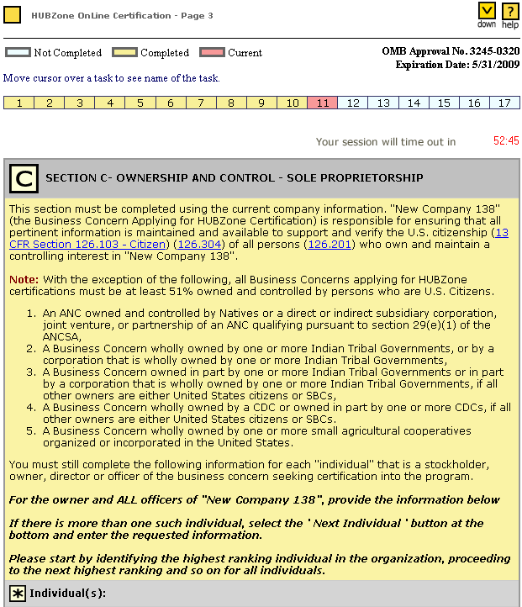
1. Remove “(126.304)”.
2. Add “126.202” after the “New Company 138” in the last sentence of the first para.
3. Under the “Note” add “All other business concerns applying for HUBZone certification must be:”
4. Change number 5 to read “A Business Concern wholly owned or owned in part by one or more small agricultural cooperatives organized or incorporated in the United States, if all other owners are either U.S. citizens or small businesses’.
5. Add “6. A small agricultural cooperative organized or incorporated in the United States”.

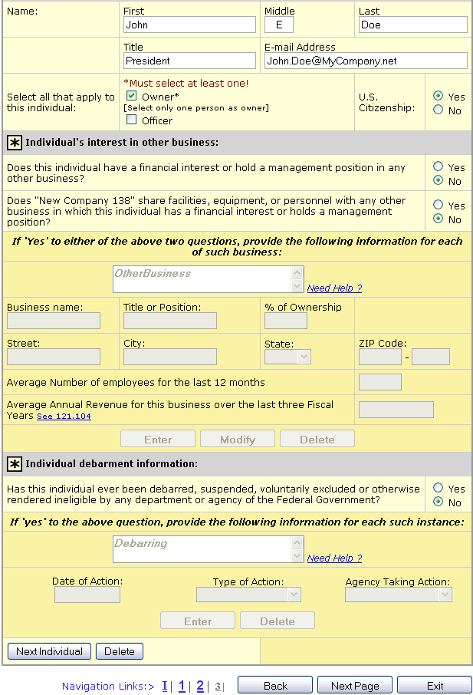

1. Under debarment information change the sentence to read “Is this individual currently debarred, suspended, voluntarily excluded or otherwise……………”

Interest in Other Business Information
The screen’s appearance after entering information into the Individual’s interest in other business section.
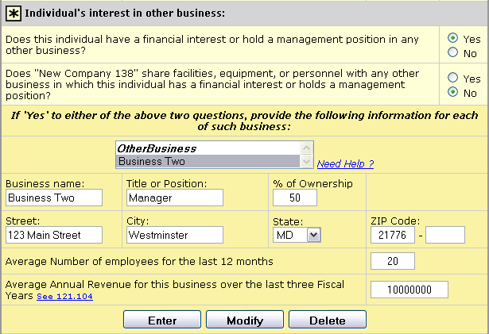

Links and Pop-Ups
This alert will appear if the individual selects No for U.S. Citizenship in Section C.
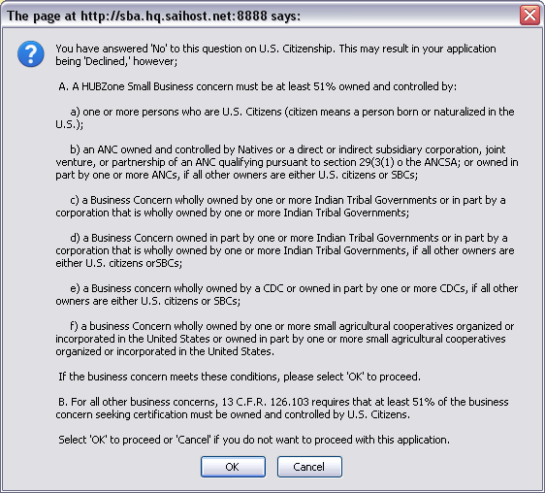
1. Change (A) to read, “A HUBZone Small Business concern can be:”
2. Change (a) to read: “at least 51% owned and controlled by individuals”
3. Remove “in part” in C above and take the “s” off of Governments on the second line.
4. change (f) to add, “a small agricultural cooperative organized or incorporated in the United States” in front of “a business Concern wholly owned……. Also, after United States on the 3rd line add “if all other owners are either U.S. citizens or small business concerns”.
5. Change 126.103 to 126.200. add “directly” after “must be” and add “individuals who are” after “controlled by”.

Application Step Twelve
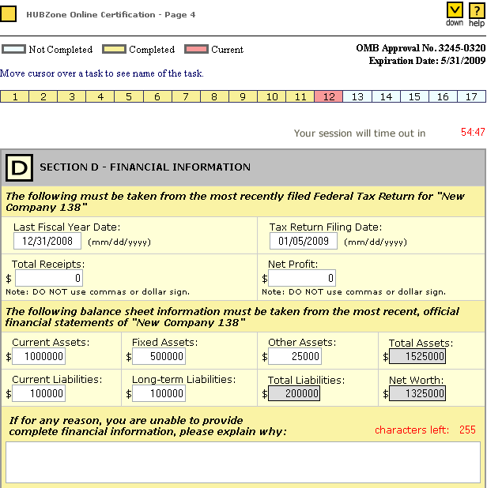

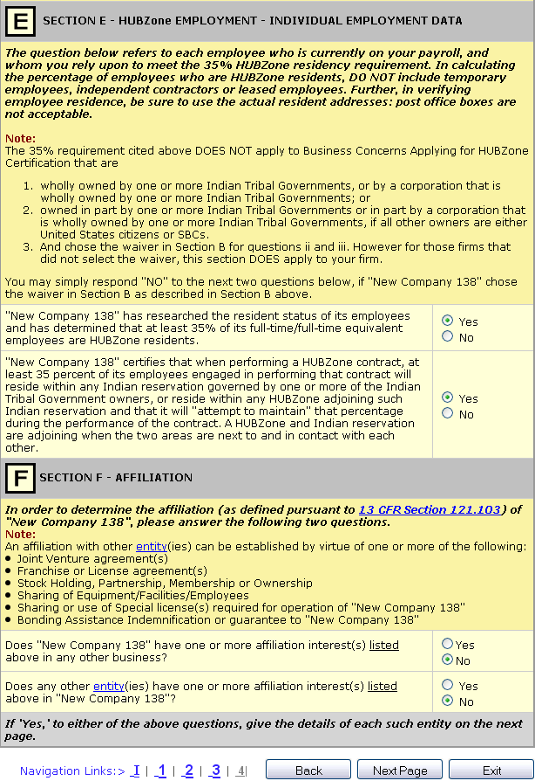
1. Change the first sentence to read “The question below refers to each individual employee wh currently works for your business.
2. The second sentence after “DO NOT include temporary employees” add “(from a temporary agency)”.
3. Under Section “F”, after the 3rd bullet, add a bullet for “Identity of Interest”
4. Add a bullet for “Other contractural relationships” after the “bonding Assistance” bullet

Links and Pop-Ups
This alert will appear when the Yes radio button is selected for the second question in Section F.
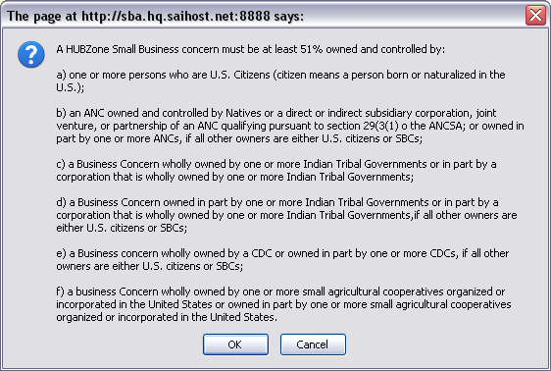
1. Change (A) to read, “A HUBZone Small Business concern can be:”
2. Change (a) to read: “at least 51% owned and controlled by individuals”
3. Change c to read, “……….more Indian Tribal Government or by a ……….” And take the “s” off of Governments on the second line.
4. change (f) to add, “a small agricultural cooperative organized or incorporated in the United States” in front of “a business Concern wholly owned……. Also, after United States on the 3rd line add “if all other owners are either U.S. citizens or small business concerns”.
5. Change 126.103 to 126.200. add “directly” after “must be” and add “individuals who are” after “controlled by”.

The entity link
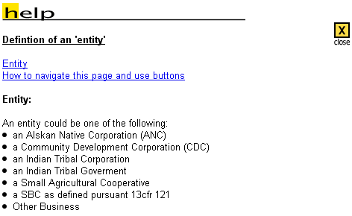
1. Correct the spelling of “Alaskan”
2. Capitalize CFR and add the word “Part” in front of 121

Application Step Thirteen
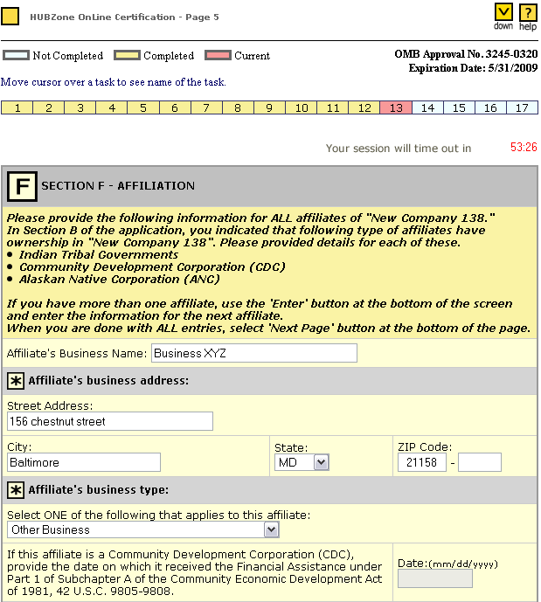
1. Add a bullet for “Agricultural cooperatives under section F.

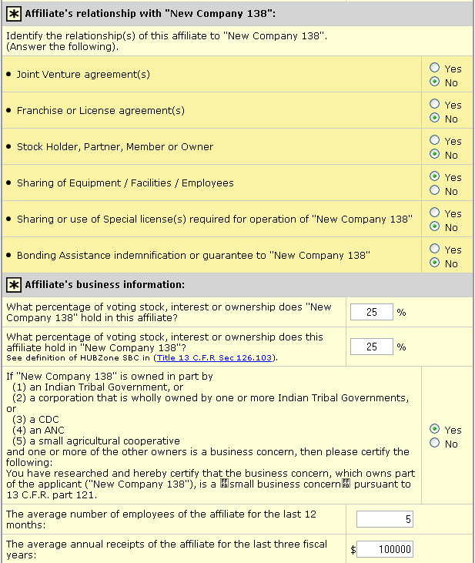
1. Under “Affiliate’s business…….remove “(4) an ANC” and change (5) to (4).

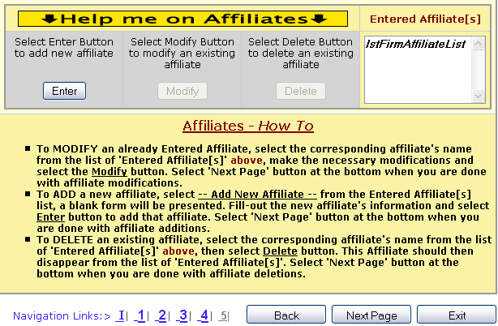

After Adding an Affiliate
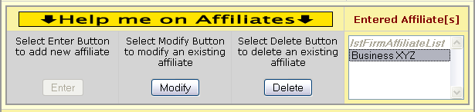

Links and Pop-Ups
This alert will appear if the No radio button is selected in the Affiliate’s business information section.
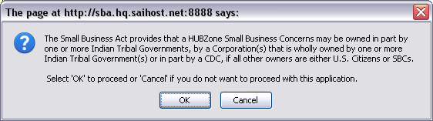

1. After “Indian Tribal Government(s) or inpart by a CDC” add a semicolon. After the semicolon add the following: “or an ANC owned and controlled by Natives; or a small agricultural cooperative organized or incorporated in the United States, wholly owned by one or more small agricultural cooperatives organized or incorporated in the United States or owned in part by one or more small agricultural cooperatives organized or incorporated in the United States; if all other owners are either United States citizens or small business concerns.

This alert will appear when clicking the Next Page button on Application Section Thirteen.
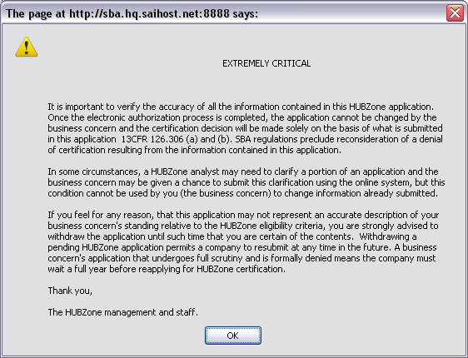

1. 1st Para. 4th line, remove the remaining sentence and replace with “as well as documents provided and other information obtained by SBA. There is no reconsideration process”.
2. 3rd Para. Remove the (,) after the word reason.
3. 3rd Para, last sentence, add the word “Again,” at the beginning of the sentence.

Application Step Fourteen
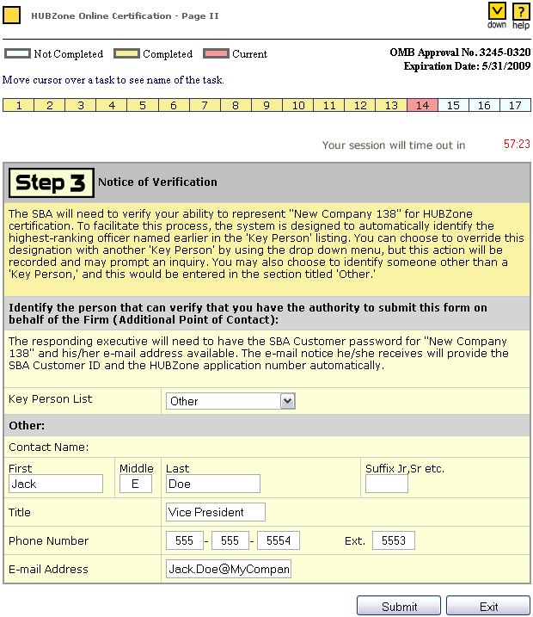

1. 2nd sentence, remove “the Key Person” and replace with “Section C of this application”.
2. 3rd sentence, add “that is an officer” after “Key Person”.
3. Remove “executive” and replace with “officer”.

Application Step Fifteen
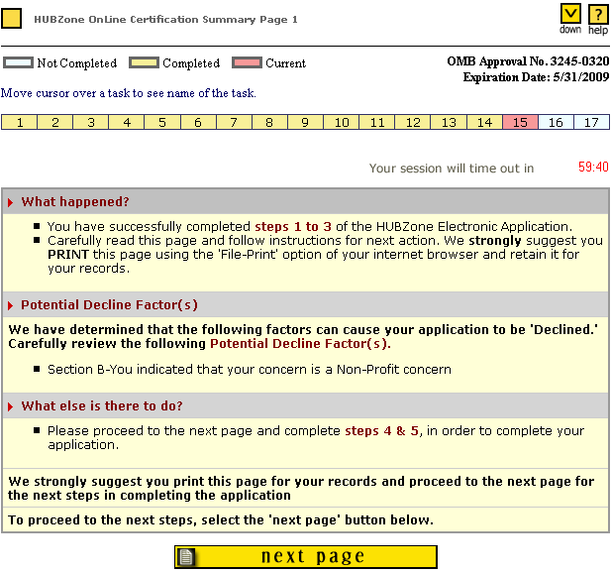

Application Step Sixteen
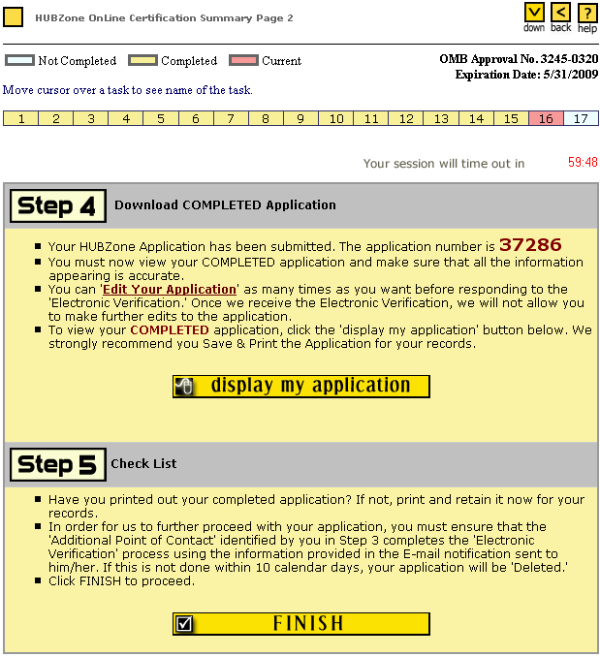

Under Step 5, remove ‘Additional Point of Contact” and replace with “An officer of the applicant firm”

Display My Application
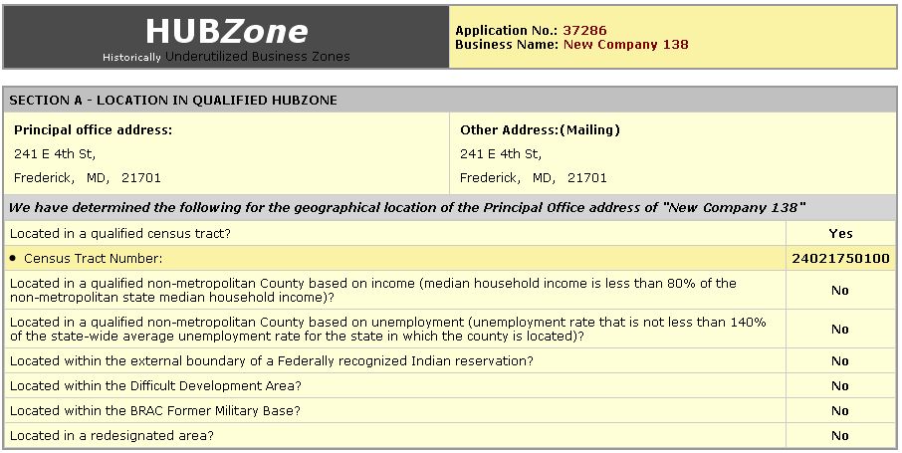
1. Remove reference to DDA.
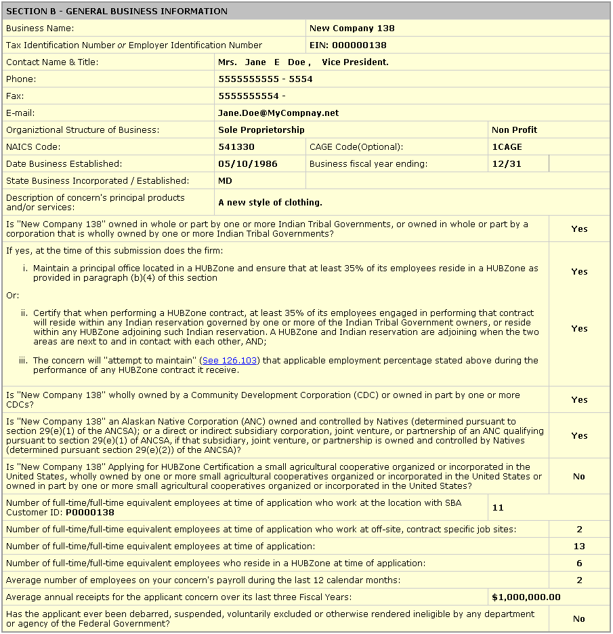

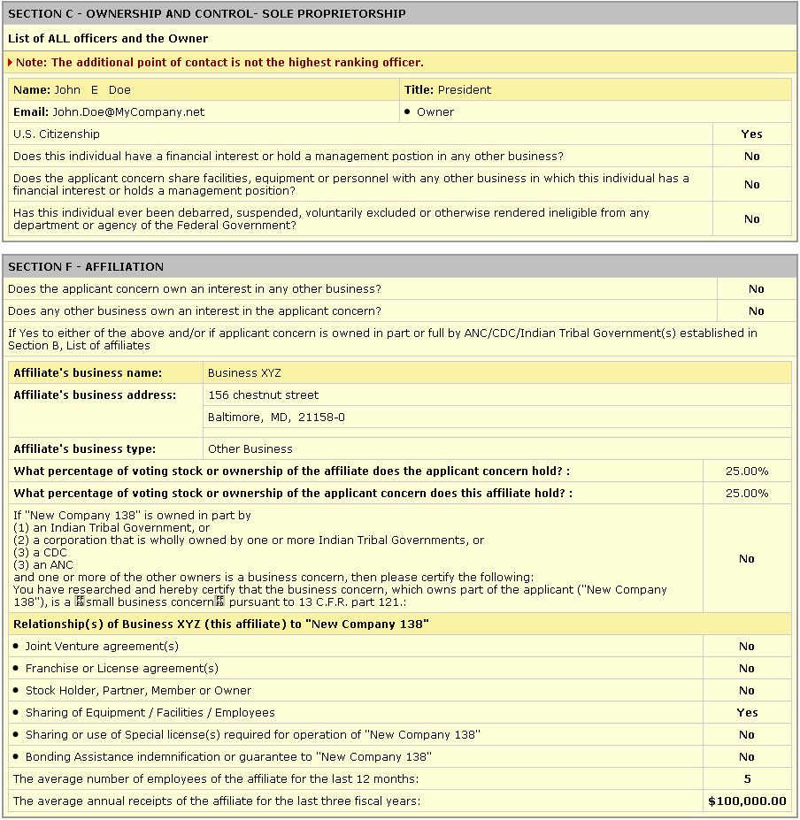

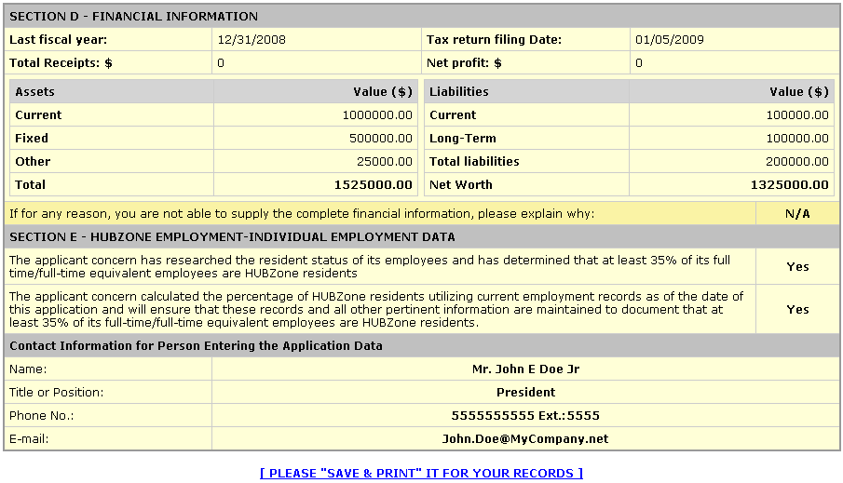

Application Step Seventeen
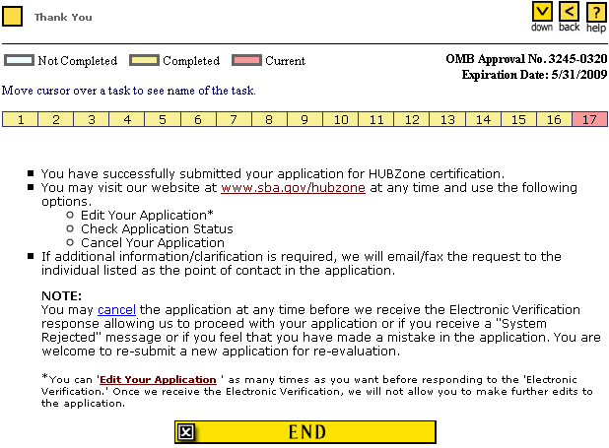

Links and Pop-Ups
The Cancel Link
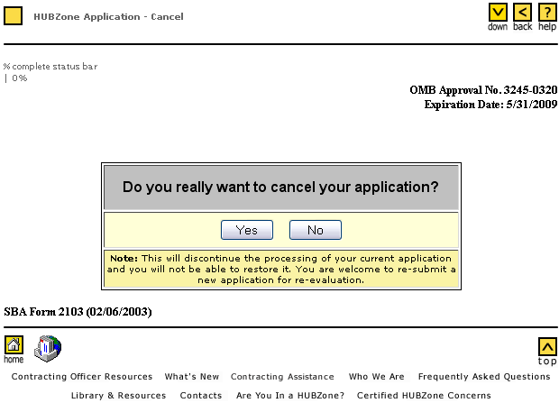

1. Change the 2003 date to 7/31/`2009

The Edit Your Application Link
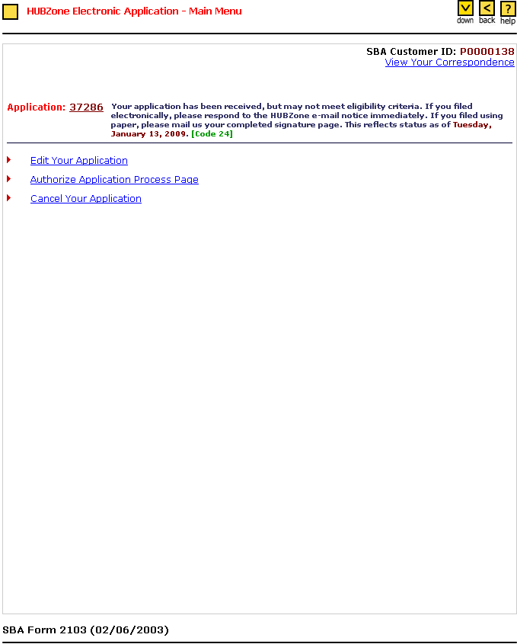

1. change expiration date to 7/31/2009.

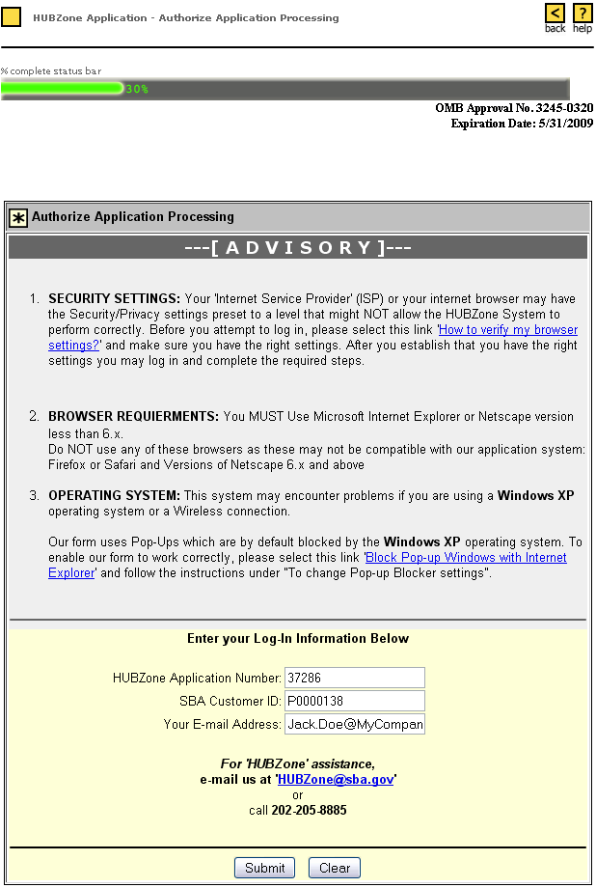
Login for Authorization of Application

Submitting the Application
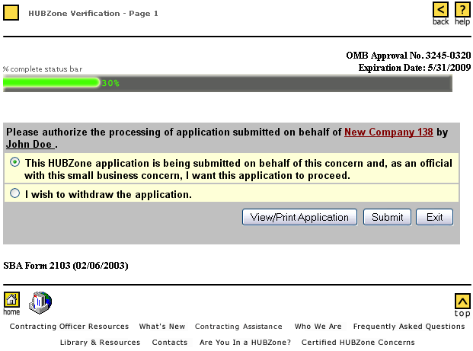

1. change expiration date to 7/31/2009
2. change “official with” to “officer of”.

Links and Pop-Ups
This message will appear once clicking the Submit button.
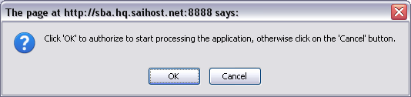

Authorization and Verification End
After clicking end, the applicant is directed back to the HUBZone homepage.
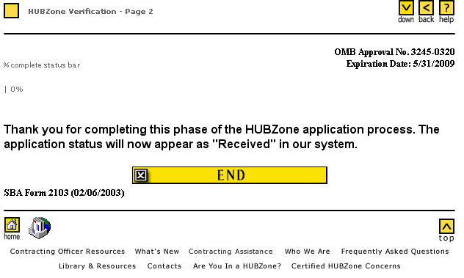
1. Change expiration date to 7/31/2009

Appendix
Contains the Regulatory Links for the Application and the Application Programming Guide in full.

Regulatory Links for the Application

See 121.104
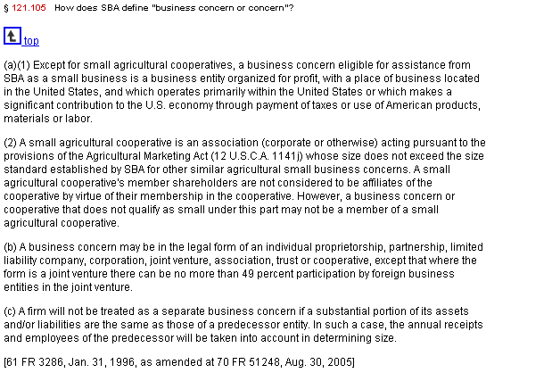

SBA Regulations
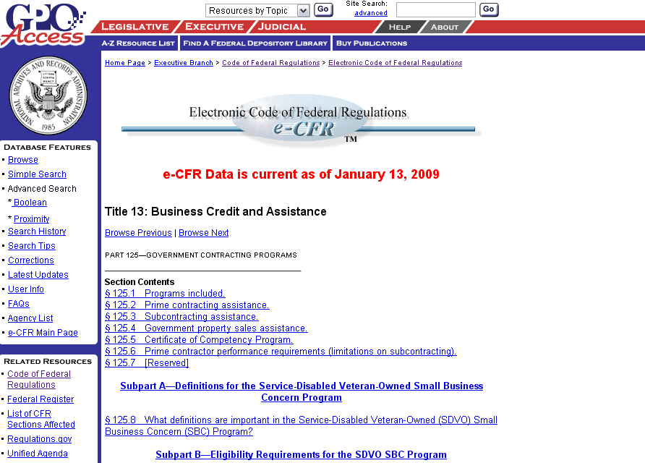

See 121.105(a) & (b)
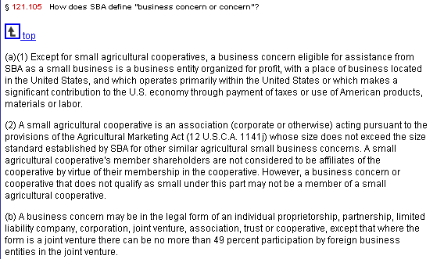

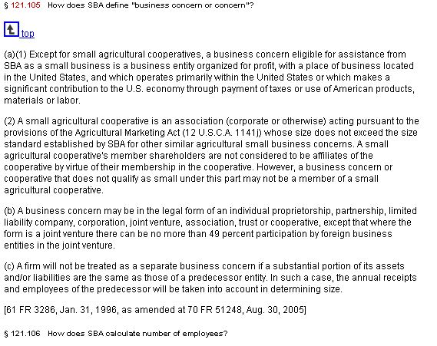
See 126.202

See 126.103
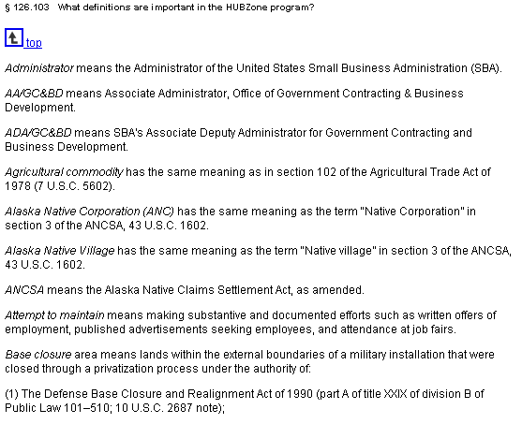

See 126.200(b)(4)
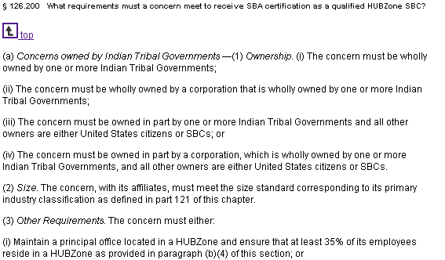

See 121.106
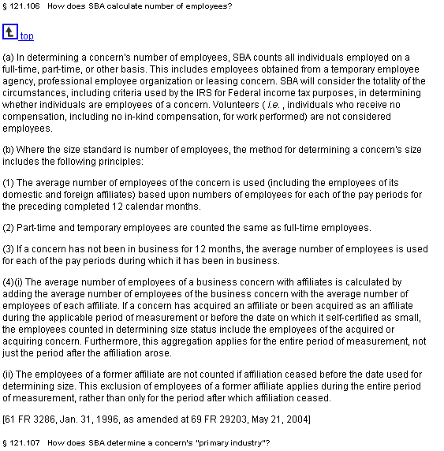

See 121.104
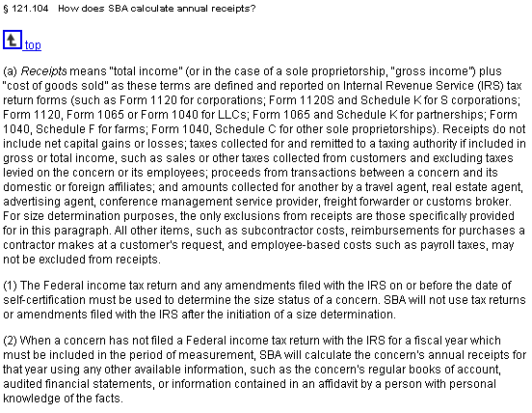

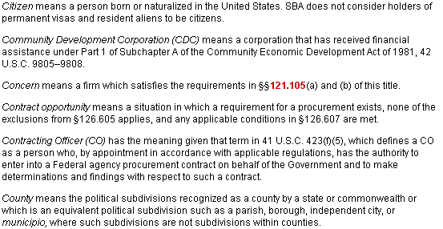
13 CFR Section 126.103 – Citizen

See 126.304
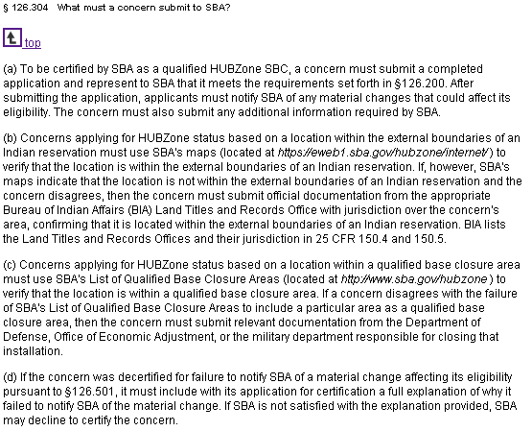

126.201
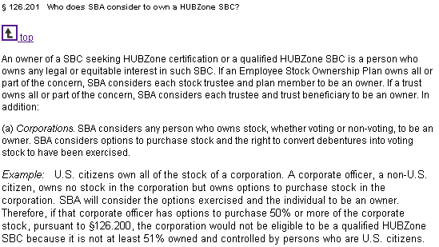

Application Programming Guide

