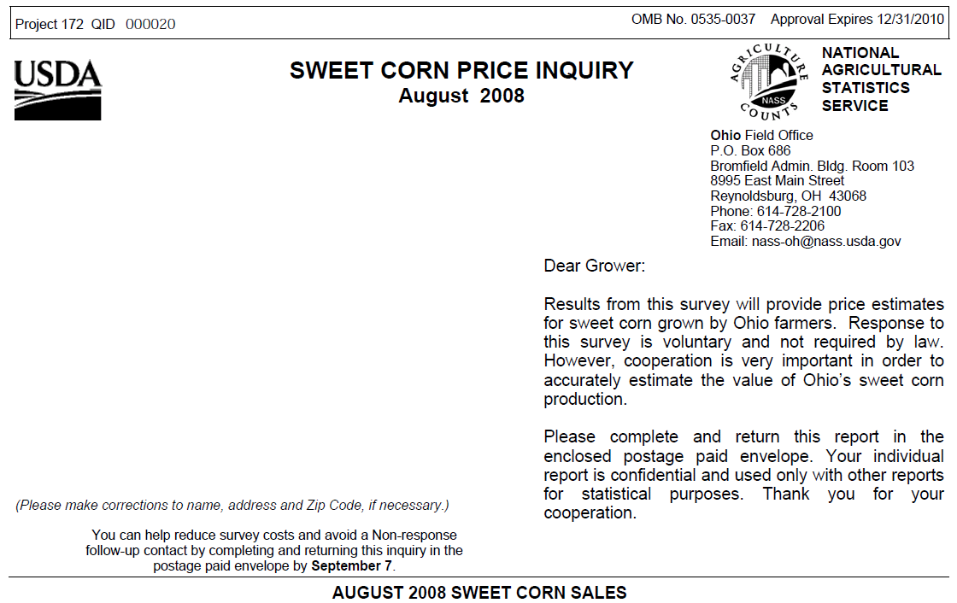
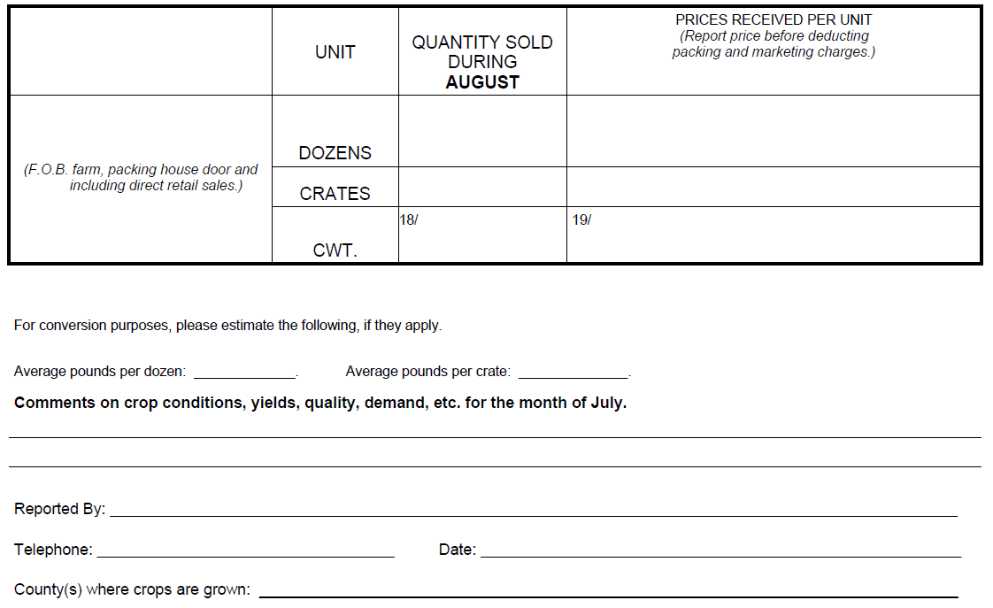

According to the Paperwork Reduction Act of 1995, an agency may not conduct or sponsor, and a person is not required to respond to, a collection of information unless it displays a valid OMB control number. The valid OMB control number for this information collection is 0535-0037. The time required to complete this information collection is estimated to average 5 minutes per response, including the time for reviewing instructions, searching existing data sources, gathering and maintaining the data needed, and completing and reviewing the collection of information.

