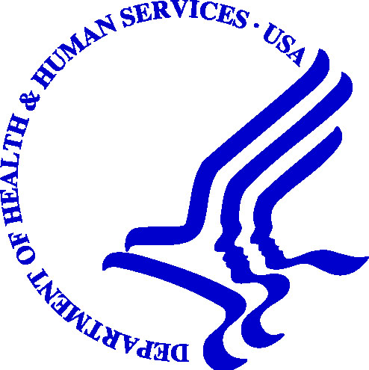

DEPARTMENT OF HEALTH & HUMAN SERVICES Centers for Medicare &
Medicaid Services

Region VII

Federal Office Building
601 East 12th Street, Room 235
Kansas City, Missouri 64106

RE: Newborns’ and Mothers’ Health Protection Act of 1996 (NMHPA) Compliance

Dear Sir or Madam:

It has come to our attention that ----------------------------- issues and/or renews health insurance in the State of Wisconsin.

The Newborns’ and Mothers’ Health Protection Act of 1996 (NMHPA) affects the amount of time a mother and newborn child are covered for a hospital stay following childbirth. The regulations regarding NMHPA may be found in the Tuesday, October 27, 1998 Federal Register at 45 CFR 146.101-130 and at 45 CFR 148.101-170. NMHPA envisions that states will enact and enforce laws embodying the requirements of NMHPA. At this time, the State of Wisconsin has not fully incorporated NMHPA’s provisions into state law. As a result, pursuant to the requirements found at sections 2722 and 2761 of the Public Health Service Act (45 USC sections 300gg-22, 300gg-61), the enforcement of all or part of NMHPA in Wisconsin is currently the responsibility of this office. Policy form reviews are one of the enforcement tools used by CMS in this state to confirm health insurance issuers’ compliance with NMHPA.

The purpose of this letter is to request that your organization submit all policy forms, riders, applications as well as any other material (i.e. marketing materials, etc.) pertinent to NMHPA, to this office for review. If you are not the correct individual to address this request, please route this correspondence to the correct individual(s) or department.

Please send all policy forms and related materials offered in the group and/or individual markets in Wisconsin. In addition, please provide a listing of all the products your company offers in the State of Wisconsin. Please submit all material to:

Associate Regional Administrator for Medicaid and Children’s Health Operations

Centers for Medicare & Medicaid Services

Attn: Insurance Reform Team

Richard Bolling Federal Building

601 East 12th Street, Room 235

Kansas City, MO 64106

Please note that we are requesting the materials be sent to CMS within 30 days of the date of this letter. In circumstances in which you cannot prepare the requested materials within this time period, you may contact our office so we may discuss a reasonable extension.

Presently there is no fee imposed by CMS in the course of meeting its responsibility to review policy forms. After completing our review, we will provide you with any comments and/or recommendations. If necessary, we may arrange to meet with you and your staff to further discuss our findings and other NMHPA issues.

If discussion or clarification is desired, please contact Evan Doran of this office at (816) 426-6314. Thank you for your attention to this matter.

Sincerely,

James G. Scott
Associate Regional Administrator
for Medicaid and Children’s Health Operations

