Weather Note: Section headers will not be included in online survey. Items in bold are programmer instructions. Response options will be randomized, except when sequential. All rated questions include a “don’t know” or “NA” option.

Introduction
The National Oceanic and Atmospheric Administration’s (NOAA) National Weather Service (NWS) is committed to serving the needs of all of its customers. The NWS is undertaking research on how satisfied users are and would appreciate your feedback. The purpose of this research, conducted in partnership with the federal government as part of the American Customer Satisfaction Index, is to help the NWS improve its services for you and others like you.

Your answers are voluntary, but your opinions are very important for this research. Your responses will be held completely confidential, and you will never be identified by name. CFI Group, a third party research and consulting firm, is administering this survey via a secure server. The time required to complete this survey will depend on how certain questions are answered, but will likely take about 20 minutes, and is authorized by Office of Management and Budget Control No. 1505-0191.

Please click on the “Next” button below to begin the survey.

Information About You

The following questions are intended to help us better understand your responses by allowing us to classify responses by geographic area and by type of users.

- From the list below, please select the continent or country in which you live or work. (drop down list of major countries)
  - United States
  - Canada
  - Mexico
  - Central America and Caribbean
  - South America
  - Europe
  - Africa
  - Asia
  - Australia
  - Other, please specify (capture)

- (If Q1=1) Please enter your zip code (capture open-end)

- (If Q1=1) What sector do you represent?
  - NOAA Employee
  - Federal Government (Non-NOAA)
  - Local Government
  - State Government
  - Government Contractor
  - Commercial Enterprise
  - Non-Profit Business
  - Private Citizen
  - Academia
  - Other (please specify) (Capture)

- What is your primary use of information provided by the National Weather Service?
  - Agriculture (skip to Q7)
  - Aviation (continue)
  - Commerce (including retail and ground & water transportation) (skip to Q6)
  - Commodities Markets (skip to Q7)
  - Communication/News Media (skip to Q7)
  - Consulting/Added Value Customer Forecast Services (skip to Q7)
  - Education (e.g., formal education or training of children and adults) (skip to Q7)
  - Emergency Response/Public Safety (skip to Q7)
  - NWS Data Provider (e.g., storm spotter, co-op observer) (skip to Q7)
  - Personal (skip to Q7)
  - Recreation (e.g., boating, flying, fishing, beachgoer, etc.) (skip to Q7)
  - Research (applied and basic) (skip to Q7)
  - Environmental Resource Management (e.g., energy, utilities, water resource) (skip to Q7)
  - Other (please specify) (skip to Q7) (Capture)

- (only if Q4=2) For what type of Aviation do you use National Weather Service information?
  - Dispatcher
  - Commercial Freight
  - Commercial Passenger
  - Private Aircraft for Business
  - Private Aircraft for Pleasure

- (only if Q4=3) For what type of Commerce do you use National Weather Service information?
  - Retail
  - Ground Transportation
  - Water Transportation

- What is the primary scope of your responsibility?
  - National
  - Regional (all or parts of multiple states)
  - Single state
  - All or parts of multiple counties, parishes or boroughs
  - Large city/urban area
  - Small city/township/suburban
  - Rural
  - Personal use
  - Other (please specify) (Capture)

- How do you receive Weather, Water, and Climate information? (Select all that apply)
  - National Weather Service Web Sources
  - Non-National Weather Service Web Sources
  - Mobile devices (e.g, PDA, Phone, Smart Phone)
NOAA Dissemination Services:
  - NOAA Weather Radio/All Hazards
  - NOAA Weather Wire
  - Family of Services (FOS)
  - Emergency Managers Weather Information Network (EMWIN)
  - NOAAPort
FAA:
  - World Area Forecast System (WAFS)
  - DUATS
  - Flight Services
Media:
  - Local or cable TV
  - Commercial Radio
  - Satellite radio
  - Satellite TV
  - Newspaper
Marine Broadcasts:
  - U.S. Coast Guard Broadcasts (HF/MF/VHF/NBDP)
  - NAVTEX receiver
  - Immarsat-C SafetyNET
  - Radiofacsimile
  - Other (please specify) (Capture)

- (If Q8=1 or 3-20) How frequently do you typically access National Weather Service information?
  - Several times per day
  - Once per day
  - Several times per month
  - Once per month
  - Once every six months
  - Once per year or less frequently
  - Don’t know

General Satisfaction with the National Weather Service

Hazardous Services

The NWS issues flood and hazardous weather watches, warnings, and advisories for the protection of life and property.

Referring specifically to hazardous weather-related warnings provided by the NWS, on a 10-point scale, where 1 means “Poor” and 10 means “Excellent,” please rate each of the hazardous weather warnings on the following.

 | Ease of Understanding | Timeliness | Accuracy
- Tornado Warnings
- Severe Thunderstorm Warnings
- Winter Storm Warnings
- Hurricane Warnings
- Flash Flood Warnings
- River Flood Warnings
- High Surf Warnings

- Please select the statement that best describes the issuance of a NWS Watch:
  - A watch is issued for less serious weather-related conditions than those that would warrant the issuance of a warning and may require immediate action to protect life and property.
  - A watch means a dangerous weather-related event is ongoing or likely to occur at any moment and immediate action is needed to protect life and property.
  - A watch means forecasters believe the threat for a hazardous weather-related event is increasing, but its occurrence, location, and/or timing is still uncertain.
  - I don’t know
  - Other (please specify)

- Please select the statement that best describes the issuance of a NWS Warning:
  - A warning means forecasters believe the threat for a hazardous weather-related event is increasing, but its occurrence, location, and/or timing is still uncertain.
  - A warning is issued for less serious weather-related conditions than those that would warrant the issuance of a watch and may require immediate action to protect life and property.
  - A warning means a dangerous weather-related event is ongoing or likely to occur at any moment and immediate action is needed to protect life and property.
  - I don’t know
  - Other (please specify)

- Please select the statement that best describes the issuance of a NWS Advisory:
  - An advisory means a dangerous weather-related event is ongoing or likely to occur at any moment and immediate action is needed to protect life and property.
  - An advisory is issued for less serious weather-related conditions than those that would warrant the issuance of a warning and may require immediate action to protect life and property.
  - An advisory means forecasters believe the threat for a hazardous weather-related event is increasing, but its occurrence, location, and/or timing is still uncertain.
  - I don’t know
  - Other (please specify)

Routine Climate, Water and Weather Services

- Which of the following routine weather, water or climate forecast elements have you used within the past year:
  - Temperature (Max/Min) forecasts
  - Chance (Probability) of Precipitation forecasts
  - Cloud Cover forecasts
  - Wind (Direction, Speed) forecasts
  - Dew Point forecasts
  - River Heights/Flow forecasts
  - Ultraviolet (UV) Index forecasts
  - Air Quality forecasts
  - Wave Height forecasts
  - 1 to 4-Week National Outlooks for Temperature and Precipitation
  - 3-Month National Outlooks for Temperature and Precipitation
  - El Niño/La Niña outlooks
  - 3-Month Drought Outlooks
  - 3-Month Local Temperature Outlooks

(Respondents will only rate elements selected in Q20) Referring specifically to elements found in routine weather, water, or climate forecasts provided by the NWS, on a 10-point scale, where 1 means Poor and 10 means Excellent, please rate each of the elements below on the following.

 | Meets my needs | Ease of Understanding
- Temperature (Max/Min) forecasts
- Chance (Probability) of Precipitation forecasts
- Cloud Cover forecasts
- Wind (Direction, Speed) forecasts
- Dew Point forecasts
- River Heights/Flow forecasts
- Ultraviolet (UV) Index forecasts
- Air Quality forecasts
- Wave Height forecasts
- 1 to 4-Week National Outlooks for Temperature and Precipitation
- 3-Month National Outlooks for Temperature and Precipitation
- El Niño/La Niña outlooks
- 3-Month Drought Outlooks
- 3-Month Local Temperature Outlooks

NWS public weather forecasts are available for up to 7 days into the future. This means that a 1-day forecast is for the weather 1 day (24 hours) from now, that a 3-day forecast is for the weather 3 days (72 hours) from now, and so on. Using a scale from 1 to 10 where 1 means Not at all Confident and 10 is Very Confident, how confident are you in max/min temperature forecasts for the times listed below?

- 1 day from now
- 3 days from now
- 7 days from now

Forecasts issued by the National Weather Service routinely include a probability of precipitation (PoP) statement, which is often expressed as the "chance of rain" or "chance of precipitation". The PoP, expressed in percent, describes the chance of measurable precipitation (at least 0.01 inch) occurring during a specified 12-hour period.

Using a scale from 1 to 10 where 1 is Not at all Confident and 10 is Very Confident, how confident are you in probability of precipitation forecasts for the times listed below?
- 1 day from now
- 3 days from now
- 7 days from now

Using a scale from 1 to 10 where 1 is Not at all Confident and 10 is Very Confident. How confident are you in amount of precipitation in forecasts for the times listed below?
- Less than 1 day from now
- 1 day from now
- 3 days from now

Decision Support Services

Value is defined here as economically beneficial or an improvement to quality of life. Using a 1 to 10 scale where 1 means Not at all Valuable and 10 means Very Valuable, please rate the value of each of the following products and services?
- Local NWS climate products and services (Include the collage of local climate products)
- NWS national climate products and services (Include the collage of national climate products)
- NWS hydrological products and services (Include the collage of hydro products)
- NWS aviation products and services
- Hazardous weather products and services

- During the last six months, approximately how many times did you contact the National Weather Service staff to discuss forecast and/or warning information?
  - 0 times (skip to Dissemination Services)
  - 1-10 times
  - 11-50 times
  - 50-100 times
  - More than 100 times

- During a typical interaction, approximately how much time did you spend discussing forecast and/or warning information with the National Weather Service staff?
  - Less than 5 minutes
  - 5 to 15 minutes
  - 16 to 30 minutes
  - More than 30 minutes

Considering your interaction with a National Weather Service office, please rate the NWS staff on each of the following using a 10 point scale on which 1 means Poor and 10 means Excellent:
- Accessibility
- Responsiveness
- Knowledge
- Professionalism

There are several reasons you may have directly contacted an NWS forecaster in the past six months about a forecast, warning, or other information. Using a 1 to 10 scale where 1 means “Not at all Valuable” and 10 means “Very Valuable,” please rate the value of each of the following possible services provided by an NWS forecaster.
- Clarification of weather-related information
- Stating forecast uncertainty (level of confidence) in weather-related information
- Providing weather-related information to help you make a decision

Dissemination Services

The National Weather Service strives to use the latest technologies available to disseminate climate, water, and weather information in gridded, graphical, image, and text form to meet the needs of its customers.

- Using a 1 to 10 scale, where 1 means Poor and 10 means Excellent, please rate the quality of satellite data available through the NWS web sites. (11=don’t use)

- Using a 1 to 10 scale, where 1 means Poor and 10 means Excellent, please rate the quality of radar data available through the NWS web sites. (11=don’t use)

- (only if Q58 and 59<>11) Please provide any suggestions on how the NWS can further improve its satellite or radar data. (capture open-ended)

Referring specifically to NWS information on the Web, on a 10-point scale, where 1 means Poor and 10 means Excellent, please rate the NWS Web pages on the following:
- Ease of locating information
- Information is up-to-date

- (If any Q61-62<7) Please explain any difficulties you had with NWS Web pages. (capture open-end)

- As technology evolves, what sources will you mostly likely use to get NWS information in the next one to five years? (Select all that apply)
  - Desk top/lap top computer
  - Mobile Device
  - Social Media (e.g., Facebook, Twitter)
  - Direct Interaction with NWS Staff (e.g., in-person, telephone, NWSChat)
  - NOAA Weather Radio All-Hazards
  - File transfer services (e.g., map services, RSS feeds, FTP)
  - Other (please specify) (Capture open-ended)

- Do you identify yourself as one who generally requires specific products for commercial or research purposes and has automated methods (e.g., NOMADS, FTPPRD, NOAAport, RSS feeds, Family of Services, EMWIN) for ingesting data?
  - Yes
  - No (skip to Outreach and Weather Education section)

Using a 1 to 10 scale where 1 means Poor and 10 means Excellent, please rate..
- The ease of locating data on NWS dissemination servers
- The ease of requesting that additional data be added to NWS dissemination streams or servers
- The ease of providing input into the decision making process for the development of new NWS products.

Outreach and Weather Education

- If you were to visit an NWS booth at an outreach event (e.g., fair, show, open house), please select from the list below your most preferred formats to obtain weather-related awareness and safety information (select all that apply):
  - Paper (e.g., brochures, bookmarks, business cards, posters, fact sheets)
  - Refrigerator magnets, key chains, and pens
  - DVDs
  - List of Internet Links
  - Other (capture open-ended response)

- What do you perceive as the top hazardous weather-related threats in your local area. Please select up to three.
  - Tornadoes
  - Severe Thunderstorms
  - Flash Floods
  - River Floods
  - Winter Storms
  - Hurricanes (including storm surge)
  - Heat Wave
  - Wildfires
  - Drought
  - Coastal Storms (high wind/storm surge)
  - Tsunamis
  - Extreme Cold
  - Air Quality
  - Other, please specify (capture open-ended response)

- How useful is NWS awareness and safety information in helping you prepare for or respond to hazardous weather-related threats? Use a 10-point scale where 1 is “Not at all Useful” and 10 is “Very Useful.”

Customer Satisfaction Index

Now, please think about your overall satisfaction with the National Weather Service.

- First, please consider all of your experiences with the National Weather Service. Using a 10-point scale on which 1 means Very Dissatisfied and 10 means Very Satisfied, how satisfied are you with the National Weather Service?

- Using a 10-point scale on which 1 now means Falls Short of your Expectations and 10 means Exceeds your Expectations, to what extent has the National Weather Service fallen short of, or exceeded your expectations?

- Now, imagine what an ideal organization providing weather information would be like. How well do you think the National Weather Service compares with that ideal organization you just imagined? Please use a 10-point scale on which 1 means Not Very Close to the Ideal, and 10 means Very Close to the Ideal.

Desired Outcomes

- Using a 10-point scale where 1 means Not at all Likely and 10 means Very Likely, how likely would you be to take action based on the information you receive from the National Weather Service?

- Using a 10-point scale, on which 1 means Not at all Likely and 10 means Very Likely, how likely are you to use the National Weather Service as a source of weather information in the future?

- Using a 10-point scale on which 1 means Not at all likely and 10 means Very likely, how likely are you to recommend the National Weather Service to a colleague or friend?

- What other revolutionary products and services could the National Weather Service offer (today or in the distant future) in order to serve you better? (capture open end)

Demographics (not required)

- What is your age? (capture)

- What is your gender?
  - Male
  - Female

- What is the highest degree or level of school you have completed?
  - Did not complete high school
  - High school diploma or equivalent
  - Some college, two-year college, or technical school (e.g., AA, AS)
  - Four year College graduate (e.g., BA, BS)
  - Master’s degree (e.g., MA, MS, MBA)
  - Professional degree or doctorate (e.g., MD, DDS, PhD, EdD)

Optional Sections

- This is the end of part one of the survey. To allow the NWS to expand and improve services we would greatly appreciate additional feedback from you on the topics identified below. If you wish to continue, please select the area you are most interested in from the following. You will be given the opportunity to stop or select other areas of interest after completion of your first selection. Thank you in advance for your thoughtful feedback!
  - Aviation Weather Services
  - Marine and Coastal Weather Services
  - Routine Forecast and Hazardous Weather Services
  - I do not wish to continue

(only if Q83=1) Aviation Weather Services

- Where do you get aviation weather from?
  - Commercial weather vendors (skip to next section)
  - Government

- Have you used NWS aviation weather products and services within the past six months for flight planning or aircraft dispatching?
  - Yes
  - No

How frequently do you use the government (FAA/NOAA) aviation weather delivery services for preflight planning, aircraft dispatching, or in-flight operations?

 | Always | More than once a week | Weekly | Once a month or less | Never
- ADDS/AWC
- DUATS/DUAT
- AFSS/FSS Flight Service Stations

- ( If Q87<>NEVER) What type of briefing do you prefer?
  - Standard (This briefing occurs when your departure is within 6 hours and/or you do not request an abbreviated briefing)
  - Abbreviated (This briefing occurs when you only request certain information, but not all available information)
  - Outlook (This briefing occurs for departure times more than 6 hours out from the time of briefing)

How often do you use the…
 | Always | Often | Sometimes | Rarely | Never
- ADD Flight Path Tool
- G-AIRMET
- CIP/FIP icing potential forecasts
- FA (Area Forecasts)
- SIGMETs
- AIRMETs
- WS Convective SIGMETs
- TAFs
- CWA (Center Weather Advisory)
- CCFP
- Miscellaneous Forecast Charts
- Radar Imagery
- Satellite Imagery
- PIREPs

(re-ask optional section question here for 2 remaining sections)
(only if optional section question=2) Marine and Coastal Weather Services

Marine and Coastal Weather Services: Storm Surge and Rip Current Questions
Marine and coastal weather products and services are designed for the U.S. Coastal (extending from the immediate coastline outward to 60 nautical miles from shore), Offshore (extending outward to 250 nautical miles), or High Seas (far offshore sections of the open Atlantic, Pacific, Gulf of Mexico, and/or Caribbean Sea) areas.

The following questions ask about your experience with NWS products and services in the storm surge and rip current programs.

Storm Surge [positive (onshore)/negative (offshore)]: Storm surge is the onshore/offshore rush of sea or lake water caused by the high winds associated with a land falling tropical or extra-tropical cyclone.

Storm Surge

- What has been your experience with storm surges?
  - I have never have been impacted by one
  - It has damaged my property
  - I or someone I know had to be rescued from one
  - It has caused severe flooding in my area
  - Don’t know
  - Other, please explain (capture)

Please indicate your level of familiarity with each of the following storm surge products on a scale of 1 to 10 where 1 means “not at all familiar” and 10 means “very familiar.”
- Coastal Flood Watch
- Coastal Flood Advisory
- Coastal Flood Warning
- Storm Surge information on Hurricane Local Statements
- Storm Surge information in Hazardous Weather Outlooks
- Storm Surge information in Tropical Cyclone Public Advisories

Of the NWS Storm Surge information you have received for tropical and extra-tropical systems, using a 1 to 10 scale where 1 means ‘Poor’ and 10 means ‘Excellent’, how would you rate the:
- Ease of understanding the storm surge products
- Usefulness of the storm surge products
- Improvements in storm surge forecasting over the past five years
- Overall quality of storm surge products and services

- Using a 1 to 10 scale, where 1 means ‘Not at All Useful’ and 10 means ‘Very Useful’, how useful would probabilistic storm surge information (e.g., the probability of a specific water level at a specific location, probability of exceeding a specific surge height) be to you?

- Should the NWS begin issuing storm surge watches and warnings?
  - Yes
  - No

- (If Q115=1) Do you think the new storm surge watch/warning for extreme coastal inundation should apply to both tropical and severe coastal storms during extra tropical storm surge events?
  - Yes
  - No

- (If Q115=1) If the NWS began issuing storm surge watches and/or warnings, in what format would you most like to see these products? (select all that apply)
  - Text
  - Graphical
  - Digital
  - Other (capture open-ended response)

- (If Q115=1) If the NWS adopts a storm surge warning, what geographical area should be included in a storm surge warning?
  - NWS Zone
  - County
  - Storm-based polygon (e.g., severe thunderstorms, flash floods, and tornadoes)
  - Other (capture open-ended response)

- At what point does negative storm surge (offshore rush of water) affect how you conduct operations?
  - -1 to -2 ft
  - -2 to -3 ft
  - -3 to -5 ft
  - > -5 ft
  - Negative storm surge does not affect how I conduct operations.
  - Not applicable
  - Other (capture open-ended response)

- Please select the time period below that would provide you with adequate amount of time to take action before a possible storm surge event.
  - <12 hours
  - 12-24 hours
  - 25-36 hours
  - 37-48 hours
  - >2-3 days
  - > 3 days

- Do you have any recommendations for improvement to the NWS storm surge program? (capture open-end)

Rip Currents

A rip current is a strong channel of water flowing seaward from near the shore, typically through the surf line, and can occur on any shore that has breaking waves. Rip currents can be identified by different/choppy wave patterns in a line moving away from shore, which may consist of dirty/muddy water and be carrying foam or debris.

- Do you feel you have enough information and knowledge to make informed decisions about rip currents?
  - Yes
  - No
  - Not sure

- From what sources have you received information about rip currents? (Select all that apply)
  - Signs
  - NWS Brochures – including “Break the Grip of the Rip”
  - Brochures other than NWS
  - Radio
  - Television
  - NWS Internet Sites - including ripcurrents.noaa.gov
  - Internet Sites other than NWS
  - Social Media Sites (Facebook, Twitter)
  - Newspaper
  - Friend/Family
  - Other. Please explain (capture)

- What do you believe is the best way to get out of a rip current?
  - Swim sideways/parallel to shore
  - Float/tread water until current slows, then swim at angle towards shore
  - Wait for a lifeguard or someone to rescue me
  - Float in rip and expect it turns you back toward shore
  - Call for help or raise hand for help
  - I don’t know

On a scale of 1 to 10 where 1 means “Not at all Useful” and 10 means “Very Useful”, please rate the usefulness of…

- The NWS Surf Zone Forecast when assessing the rip current threat
- The NWS Coastal Hazard Message when assessing the rip current threat
- The NWS Hazardous Weather Outlook when assessing the rip current threat

- On a scale of 1 to 10 where 1 means “Very Dissatisfied” and 10 means “Very Satisfied”, how satisfied you are with NWS rip current education and outreach?

The NWS uses a tiered layer of qualifiers for rip current outlooks in the Surf Zone Forecast.

- What does a high risk of rip currents mean to you?
  - Rip currents will be frequent and dangerous to anyone entering the water
  - Rip currents will be frequent, but experienced swimmers can enter the water
  - Rip currents will be frequent

- What does a low risk of rip currents mean to you?
  - There is no chance of rip currents occurring
  - Rip currents are not expected, however, rip currents can sometimes occur.
  - Rip currents will occur but they will not be dangerous

- How much value would a rip current watch/warning product be?
  - Very valuable
  - Somewhat valuable
  - Limited value
  - Not valuable at all

- Do you have any recommendations for improvement to the NWS rip current program? (Capture open-ended response)

(reask optional section question)
(only is optional section question=3) Routine Forecast and Hazardous Weather Services

Thinking of NWS routine products and services, using a 10-point scale, on which 1 mean Poor and 10 means Excellent, please rate the NWS on:
- Accuracy of NWS’s predictions of the timing of weather events
- Accuracy of NWS’s predictions of the types of weather events

- (If Q133<7) Please describe the event(s) that was timed poorly. (capture open-end)

- (If Q134<7) Please describe the event(s) that was inaccurately predicted. (capture open-end)

- Suppose the forecasted high temperature for tomorrow for your area is 75°F. What do you think the actual high temperature will be?
  - 75°F.
  - Between 74°F and 76°F.
  - Between 73°F and 77°F.
  - Between 70°F and 80°F.
  - Between 65°F and 85°F.
  - Other, please specify (capture open-end)

- Now suppose the same forecast of 75°F was for 5 days from now. What do you think the actual high temperature will be?
  - 75°F.
  - Between 74°F and 76°F.
  - Between 73°F and 77°F.
  - Between 70°F and 80°F.
  - Between 65°F and 85°F.
  - Other, please specify (capture open-ended)

When you receive each of the following short-term NWS warnings, please select the category that best represents the amount of time you need to take precautionary actions:
 | 0 - 5 min | 6 - 10 min | 11 - 15 min | 16 - 25 min | 26 - 45 min | > 45 min | N/A
- Tornado
- Severe Thunderstorm [for winds greater than/equal to 50 knots (58 mph) and/or hail size of one inch (U.S. quarter-size) diameter or larger.]
- Flash Flood (warnings are issued when flooding is imminent or likely.)
- Special Marine [for short-duration (up to 2 hours) sustained marine thunderstorm winds or associated gusts of 34 knots or greater; and/or hail 3/4 inch or more in diameter; and/or waterspouts. Also issued for non-convective short duration winds of 34 knots or greater (gale
force or stronger)].

- Tsunami

- If you received an NWS Tornado Warning for your area, please indicate which action you would most likely take.
  - Do nothing
  - Notify others who may be in danger (e.g., friends, family, co-workers, and neighbors)
  - Seek safe shelter
  - Seek additional information before taking any action
  - Other, please specify (capture open ended-response)

(if Q144=4) Using a 10 point scale, where 1 is “not at all likely” and 10 is “very likely,” please indicate how likely you would be to use each of the following sources to confirm the threat of a tornado prior to taking action.
- Media (TV, radio)
- Internet weather source
- Current radar image
- A visual confirmation
- Sirens
- Other source, please specify (capture open-end)

Please answer the following questions about weather-related information from the NWS Point & Click available on most NWS Forecast Office web pages. The images below were made for a point approximately 2 miles NW of the center of Washington DC.
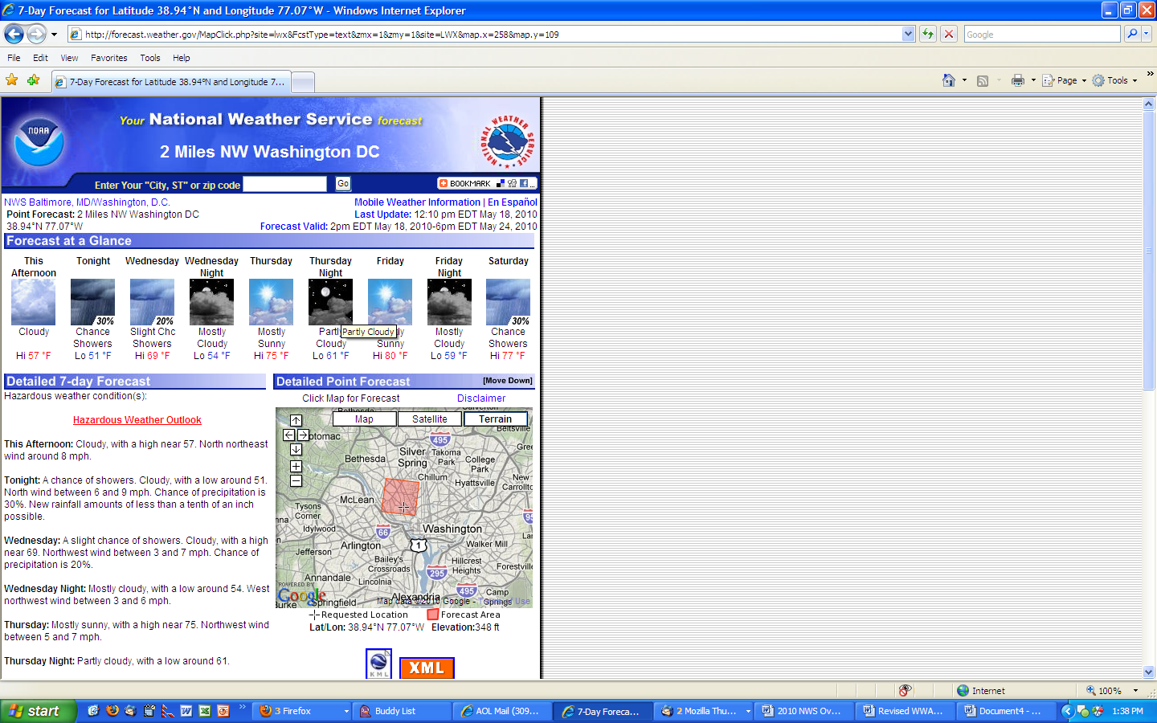

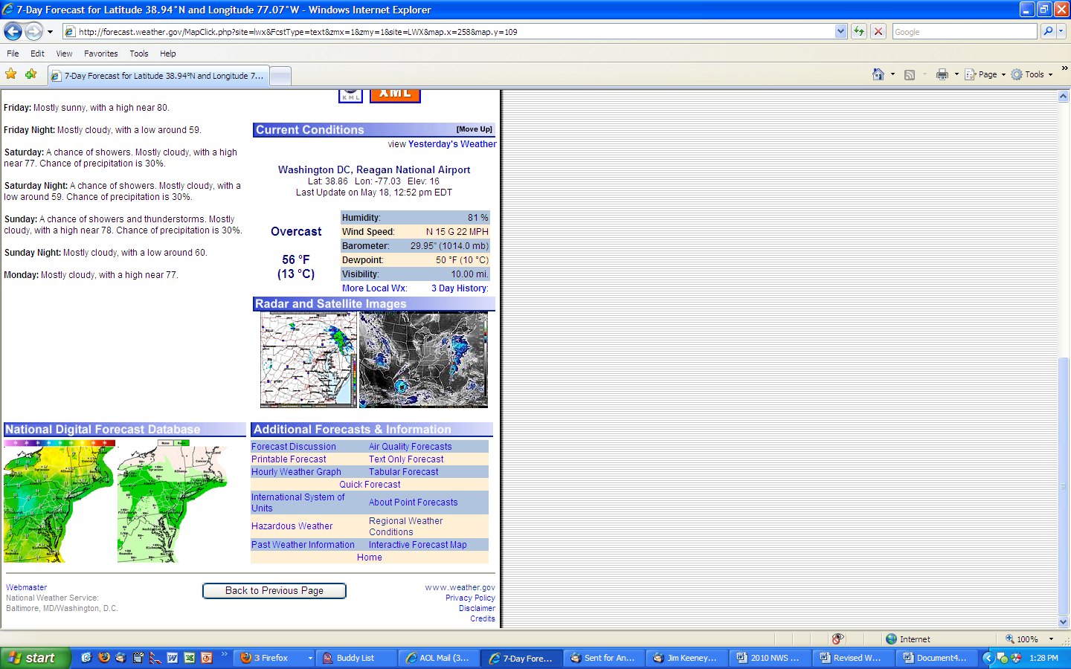

- What information in this example do you like? (capture open-ended)
- What information in this example do you not like? (capture open-ended)
- Is there information not provided in this example that would be useful for your needs? (capture open-ended)
- Do you have any other comments, suggestions or concerns regarding this Point & Click example? If so, please enter here (capture open-end)
When you receive each of the following longer-term NWS watches/warnings, please select the category that best represents the amount of time you need to plan/prepare for:
 | 12 hours –less than 1 day | 1- less than 2 days | 2- less than 3 days | 3 or more days | N/A
- River Flooding
- Winter Storms
- Hurricanes
- Heat Wave
- Extreme Cold Event
- Wildfire
- Drought
- Air Quality Alert (for high level of health concern – check definition)

