Form NMB-3 OMB No. 3140-0003 (Expiration Date 06/30/2009)
Revised June 2006

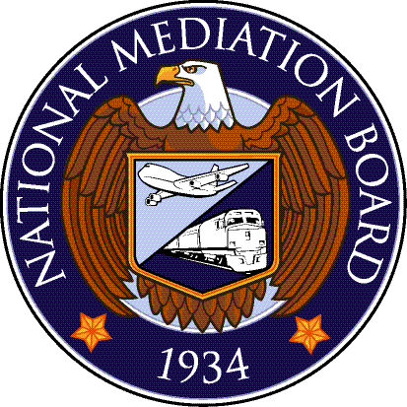

Request for Arbitration Panel for Airline System Boards of Adjustment

Date: ________________________________

TO: Arbitration Services
National Mediation Board
Washington, DC 20005 or
E-MAIL: ARB@NMB.GOV

Name of Carrier/Representative requesting the panel (please print or type):

Name of Carrier:
Name of Representative  to Receive Panel: |  | Address:
Telephone Number: |  | City, State, Zip Code:
Fax Number: |  | E-mail:

Name of Union:
Name of Representative  to Receive Panel: |  | Address:
Telephone Number: |  | City, State, Zip Code:
Fax Number: |  | E-mail:

Case Identification(s)
Per Panel

Panel –
A panel of seven (7) names per case is usually provided; if you desire a different number please indicate that number in the box. →

Special Requirements –
(Note special arbitrator qualifications, time limitations on hearing or decision, geographical restrictions, etc.)

Carrier Name and Signature:
Union Name and Signature:

Although the NMB prefers to act upon a joint request of the parties, a submission may be made based on the request of a single party if the relevant collective bargaining agreement so indicates. However, any submission of a panel should not be construed as anything more than compliance with a request and does not reflect on the substance or arbitrability of the issue in dispute.

