Project 173 |  |  | OMB No. 0535-0003: Approval Expires 12/31/2009
 | SHEEP & LAMB PRICES  __________, 200__  (Enter the current month and year) |  |  |  | 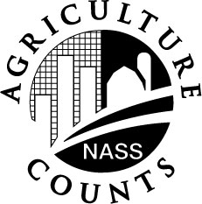 | NATIONAL  AGRICULTURAL STATISTICS  SERVICE
Idaho Field Office
P.O. Box 1699
2224 Old Penitentiary Road
Boise, Idaho 83701-1699
Phone 1-800-691-9987,Fax 208-334-1114
nass-id@nass.usda.gov

If necessary, please make any corrections to the name and address above.

INSTRUCTIONS:
- Exclude ewes over 205 pounds.
- Exclude sheep sold for breeding.

Enumerator: _________________________________________________________ Date: ___________________________________

Page No. _____ of _____ Firm Name: ________________________________________________

Line Number | Sheep |  |  | Lambs
Line Number | Head | Total Live Weight | Gross to Producers | Head | Total Live Weight | Gross to Producers
Line Number | Number | Pounds | Dollars | Number | Pounds | Dollars
1
2
3
4
5
6
7
8
9
10
11
12
13
14
15
16
17
18
19
20
21
22
23
24
25
According to the Paperwork Reduction Act of 1995, an agency may not conduct or sponsor, and a person is not required to respond to, a collection of information unless it displays a valid OMB control number. The valid OMB control number for this information collection is 0535-0039. The time required to complete this information collection is estimated to average 10 minutes per response, including the time for reviewing instructions, searching existing data sources, gathering and maintaining the data needed, and completing and reviewing the collection of information.

