Address Canvassing
Job Aid: Hard-to-Find Units In Small Multi-Unit Buildings
Topic 1: Overview
Introduction |  | To do an accurate 2010 Census we need to include every place where people could or do live. You will easily find most of the housing units in your assignment area. But some people live in housing units that are hard to see as you canvass your area. We refer to these units as hard-to-find units.  Some of these hard-to-find housing units are in small multi-unit buildings, like private homes or small buildings expanded into more housing units. The term “small multi-unit building” describes a building containing between 2 and 19 housing units. They come in all shapes and sizes, ranging from what looks like a one-family private home to a building with several levels.  This job-aid will help you locate hard-to-find units that may be missing from our Address List in small multi-unit buildings. This job-aid is in addition to your regular Address Canvassing procedures and only applies to small multi-unit buildings.  These units might not receive a 2010 Census questionnaire unless you add them to the Address List. Here are some examples:  - Buildings that once only had a few housing units may now have additional apartments.  - Owners of large houses with full basements and attics may turn those spaces into rental apartments.  - Two or more separate housing units may exist in the main living space.  - Owners of convenience stores and other types of stores may use part of the building for housing units.  In many cases you will find these units, add them to the Address List, and move on to your next address. However, in some cases you may have to be persuasive and do a little detective work to account for the hard-to-find housing units.  - Building owners, managers and tenants are not always willing to disclose the existence of these additional units due to concerns about zoning violations or other potential infractions.  - Always maintain a polite, professional manner when asking about additional units at an address. Explain that you are just there to obtain address information.  - Never argue with anyone over the existence of additional units at an address.  - If the owner or tenant is reluctant to cooperate, try to find someone else who is knowledgeable about the address, such as a long-time neighbor or the mail carrier.  If you see evidence that additional units exist, keep them on the Address List or add them if they are not already on the Address List, even if you cannot find someone willing to confirm them.  Do not delete any units from the Address List. Explain the situation completely on an INFO-COMM. Do not take any other action on these units. A supervisor will make the final decision whether to delete any units. This only applies to small multi-unit buildings. You may delete nonexistent or duplicate units in other situations, as described in your regular Address Canvassing procedures.  If you are unsure how to handle a situation, explain the situation fully on an INFO-COMM before taking any action. An office supervisor will decide how to handle the situation.
Why Are We Concerned About Hard-To-Find Units? |  | The 2010 Census could miss some housing units in small multi-unit buildings unless you account for them on the Address List.  Be alert for the clues described in Topic 2. If you see any clues, confirm the situation with the owner or an occupant if the owner is not available. Tell them that laws keep you from sharing their information with city agencies or with anyone else. Give them a copy of the Confidentiality Notice shown in Appendix 1.  If the owner or occupant is reluctant to provide information, look for another respondent such as a neighbor or the mail carrier.  Our goal is to count all housing units. This helps ensure that your community gets the federally funded services it needs.
Only Add Housing Units To The List  Door to bsmt apt. |  | Only add missing housing units to the Address List. This means the occupants of the missing units must:  - live separately from any other occupants in the building, and  - have direct access, that is, the entrance to the living quarters is directly from the outside of the building or through a common hall.  If more than one family shares the same housing unit the Census treats it as one household.  Be sure to follow all the procedures in your Address Canvassing manual for adding or correcting information on the Address List. Keep in mind these special procedures only apply to small multi-unit buildings, and the regular Address Canvassing procedures apply in all other buildings.  The Census Bureau has no interest whatsoever in knowing the legal status of any housing unit. Do not ask about the legal status of any housing unit. The information you obtain about housing units at an address is strictly confidential.  Example:  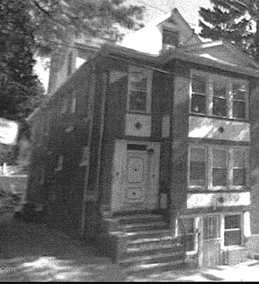  This house has a basement apartment, a main unit, a 2nd floor apartment, and a driveway leading to a rear apartment. The Address List shows it as a single-family house. You need to assign it multi-unit status and add the missing units. If the current occupant or owner is reluctant to cooperate, find someone else to verify the existence of each housing unit, or add them to the Address List based on your observation using the procedures in Topic 4.
Topic 2: Clues for Finding Housing Units
Overview |  | This Topic provides guidelines to help you locate all the housing units in small multi-unit buildings. Always work from “ground to the list”, that is, confirm what is on the ground and then see if it exists on the Address List, not the other way around. This is the same procedure you use for all your Address Canvassing work.  - Owners often remodel large private homes into rental apartments. The address list may show only one unit there.  - The building may have additional housing units since its original construction. Some or all of the units might not have posted unit numbers or letters.  - The occupants may all get their mail at one mailbox and then sort it out later. The building may actually have more units than the doorbells and mailboxes show.  - You need to account for all the separate housing units in these buildings so they are included in the 2010 Census.
Signs of Additional Units In Buildings |  | The following clues may alert you to the presence of additional units in a building. See also Appendix 2 for illustrations of buildings that may contain more housing units than are shown on the Address List for the address.  Keep in mind that these clues by themselves are not always indicators that the building has hard to find units. One clue is often not enough evidence, but a combination of clues offers more evidence. However, if you think the building has more units than are shown on the Address List, always confirm it with the owner. If the owner is not available or unwilling to answer your questions, talk to an occupant or someone else who is knowledgeable about the building.  Here are some examples of clues that a building has more than one housing unit. This is not an exhaustive list, so there may be other clues that are more common in your assignment area.  Multiple doorbells  The house has two house numbers.  - two or more house numbers or a range of house numbers,  - multiple mailboxes or buzzers, particularly two sets of doorbells,  - several gas or electric meters,  - many garbage cans or several newspapers,  - “For Rent” signs,  - curtains or bars on a basement window,  - a house number on a garage,  - many vehicles parked around the house,  - side or rear walkways,  - outside or basement doors leading to housing units,  Outside door leading to basement apt.  Side door leading to a housing unit.  Satellite dishes.  - 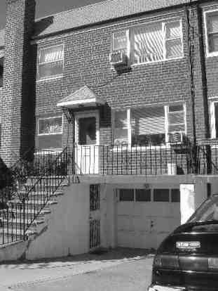  - outside stairs,  - large sheds behind or beside the building,  - unmarked doors possibly leading to housing units,  - 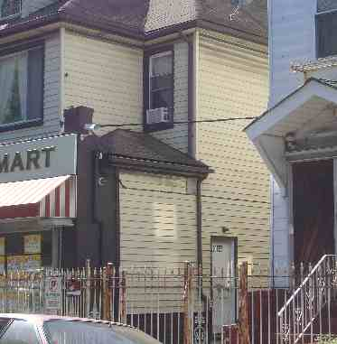  - several television satellite dishes on the roof,  - 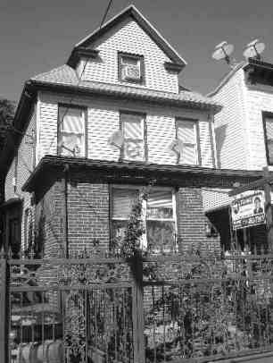  - signs of habitation in storage areas,  - outside stairs leading to the attic,  - fire escapes to additional units.  - 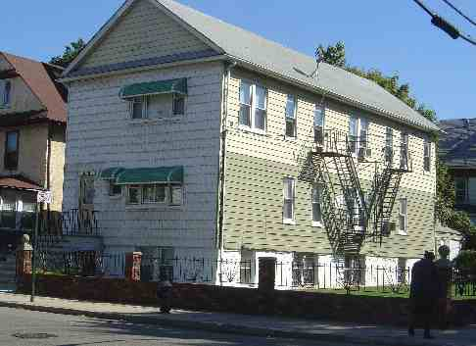
Under Renovation  When To Inquire  Fire escapes |  | Renovation may be ongoing, or planned, in the building. Only add missing units for which you see evidence of construction.  If you see any of the signs of additional housing units in a building, or the Address List shows more or fewer units that you find at an address, first ask an owner for information. If the owner is not available ask a resident.  - Owners or residents may be reluctant to tell you about all the units at the address. Do not confront anyone or insist upon cooperation. In this situation, try to find a knowledgeable long-time resident of the neighborhood and ask them about the units at the address. As a last resort, add the units based on observation and use the unit descriptors in Topic 4.  If you are unsure how to handle a situation, explain it fully on an INFO-COMM so a supervisor can make the final decision.
Housing Units In Commercial Buildings |  | Commercial space may contain housing units. If you see several mailboxes or utility meters near commercial buildings, or other signs of people living there, stop and inquire. Look for the clues described earlier in this topic.
Clearly Identify The Added Units |  | While it is very important to add any missing housing units to the Address List, it is just as important to clearly identify each added housing unit so they will receive a 2010 Census questionnaire. Topic 4 provides help for identifying each added unit.  In the illustration below, the owner previously had only storage space on the entire 1st floor, so the Address List shows only a 2nd floor apartment. You find four housing units on the 1st floor with no unit identifications. You would add all of the 1st floor units and clearly identify each of them.
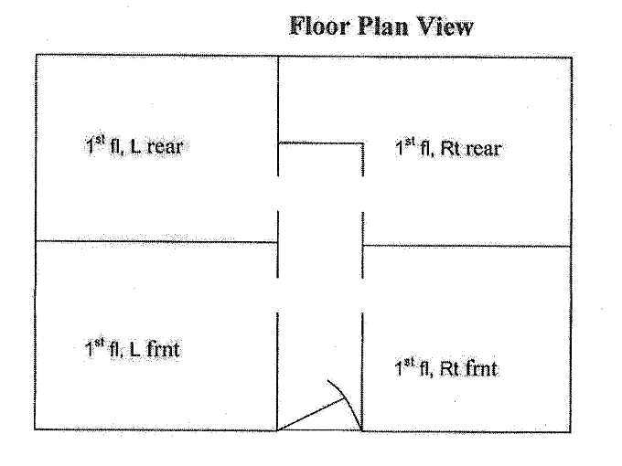

Front Door

Topic 3: Situations Involving Small Multi-Unit Buildings

Overview |  | Some or all of the units in small multi-unit buildings may not have posted unit numbers or letters. For some of these places the Address List shows the basic address with an incorrect number of units or missing unit designations because the building has expanded to include more housing units.  This topic provides rules for handling various types of situations. Please see Appendix 3 on page 18 for a diagram.
(Case 1)--The Address List shows only one unit for the address but you find evidence that more units exist at the address. |  | If the Address List shows only one unit for the address but you find more units there:  - Try to confirm with the owner, tenant or another knowledgeable respondent, the number of housing units in the building.  - If the owner or resident is reluctant to cooperate, maintain a professional and polite demeanor at all times. Then try to find someone else who is knowledgeable about the housing units at the address.  - If the respondent confirms the additional units, add each missing housing unit to the Address List.  - Ask the respondent to clearly identify each unit. Use the posted unit designations.  - See Topic 4 if any units do not have posted designations.  If you cannot find anyone to confirm the units at the address, do your best to list them by observation, but be sure to follow the rules in Topic 4. For example, list the units as 1st fl left, 1st fl right, 2nd fl left, and 2nd fl right.
(Case 2)—There are multiple units on the Address List for the building, and you find multiple units there, but they do not have unit designations posted. |  | If there is more than one unit shown on the Address List for the building, and you do find multiple units there, but they do not have unit designations posted:  - Try to confirm the exact number of units with the owner, tenant or another knowledgeable respondent.  - Add any missing housing units to the Address List.  - Follow the instructions in Topic 4 to properly identify the location of each unit.  If the respondent tells you that the address only has one unit, ask the reason for the additional mailboxes, doorbells or other signs of multiple units. Do not argue with the respondent. Do not delete any units from the Address List. Do not take any other action on these units. Explain the situation on an INFO-COMM.
(Case 3)—There are multiple units on the Address List for the building, and you find multiple units there, but the unit designations posted on the building do not match the unit designations on the Address List. |  | If there is more than one unit shown for the address on the Address List, and you find multiple units there, but the unit designations posted on the building do not match the unit designations on the Address List:  - Try to confirm with a knowledgeable respondent the exact number of units in the building, and their exact unit designations.  - Make additions and corrections to the Address List to reflect the correct posted unit designation for each housing unit at the address.  If the Address List shows more units than the respondent says exist at the address, do not delete any units from the Address List. Do not take any other action on these units.  - Make corrections to the Address List as necessary to reflect the posted unit designations of the units you were able to confirm with the respondent.  - Fill out an INFO-COMM showing to whom you spoke, and which units you were not able to confirm with the respondent. An office supervisor will tell you what to enter on your HHC.  If you are unable to confirm the unit designations at the address, list them and explain what you did on an INFO-COMM.
(Case 4)—There are multiple units on the Address List for the building, but you find only one housing unit. |  | If there are multiple units on the Address List for the building, but you find only one housing unit there:  - Try to confirm with a knowledgeable respondent whether this building has one or more housing units.  - If it has more than one housing unit, confirm with the respondent the exact number of units at the address.  - Add any missing units to the Address List.  - Use the posted unit designations, if there are any, to identify each unit. Otherwise, follow the guidelines in Topic 4.  If the respondent confirms that the building has only one housing unit, and you do not see any evidence to suggest otherwise, explain the situation fully on an INFO-COMM. An office supervisor will resolve the situation with you.
Other Situations |  | If you find any other situations in small multi-unit buildings that do not fall into one of the four cases discussed above, document the situation on an INFO-COMM and discuss it with your supervisor at your next daily meeting.
 |  | Topic 4: Assigning Unit Designations To Adds
Overview |  | We must be able to clearly identify each housing unit at an address in order to mail it a 2010 Census questionnaire.  - If you add any units to the Address List, you must clearly identify each housing unit. Also, you must make sure the unit designations already shown on the Address List are accurate and complete. By unit designations, we mean letters or numbers or a combination, such as “Apt 1” or “Apt A” or “2B” or “4 L”.  - Use the guidelines in this Topic to assign and/or correct the unit designations in the Address List.
All The Units Have Posted Unit Designations |  | If there are posted unit designations for all the housing units, you must use those identifiers to update the Address List. Use them even if they are out of order or non-consecutive.
The Units Do Not All Have Posted Designations |  | If there are no posted unit designations for some or all of the units, rely on the respondent or your observation to identify the location of each housing unit in the building. Use the Unit Identifier field. Correct any unit designations that are incorrect on the Address List and add any that are missing. Use the standard abbreviations shown in Appendix 4 and in your Listers Manual.  - Do not make up your own apartment letters or numbers.  - Always list from the lowest floor to the highest floor. List any basement apartments first, and any attic apartments last.  - Consider the level where you enter the building as the first floor.  - Always list from left to right. For example: Bsmt L, Bsmt R, 1st Fl Frnt L, 1st Fl rear L, etc.  - Always show the position of the housing unit in relation to others in the building, such as “frnt”, “back”, etc.  - Here are some examples of how to clearly identify units which do not have posted designations:  - 1st Fl Front, 1st Fl Middle, 1st Flr Rear,  - Lowr, Uppr,  - Bsmt, L, R, Atc,  - Frnt L, Rear L, Rear R, Frnt R,  - Guesthouse, Grg, side or rear shed,  - Frnt porch, rear porch, or side porch.
Problem Situations |  | If you are not sure how to handle a case, explain it on an INFO-COMM. Discuss it with your crew leader at your daily meeting.
Examples |  | In this example, the Address List shows one unit at 18-186th Street, but when you get there you see four buzzers on the front door. The units do not have posted designations. All the units are on the same floor. The respondent says the units are located as shown below:  Apt. Owner’s Apt.  Apt.  Apt.  Front door  List these housing units as “Frnt L ”, “Middle L”, “Rear L” and then “Frnt R” because you always list from left to right. Put the unit information into the Unit Identifier field on the Address List.  In this example, the house is a one-story house with an attic and a basement. The Address List shows only two apartments but you find two on the main level (1st floor) and two in the basement. They use the attic for storage.  Front  Door  Attic  1st Fl Apt 1st Fl Apt  Bsmt Apt Bsmt Apt  In this house, you would add the basement apartments (“Bsmt L, Bsmt R”) to the Address List. Then make sure the Address List correctly shows the designations for the units on the main floor (“1st Fl L, 1st Fl R”).  The goal is to clearly identify each housing unit so we can mail a 2010 Census questionnaire to each unit. We also need to be able to identify the units in case other Census Bureau staff need to visit the address in the future.  IMPORTANT: In situations where there are no posted unit designations, always enter the unit information in the unit identifier field as described in Table 5-4 of your Address Canvassing Listers Manual.  If you think you have found a place that qualifies as an “Other Living Quarters”, explain the situation on an INFO-COMM and discuss it with your supervisor before taking any action in regards to the place.
Appendix 1. D-31, Confidentiality Notice

Appendix 2. Illustrations of Small Multi-Units
Figure 1. This building has multiple door buzzers with names, but no unit designations.

Figure 2. This house has two house numbers (not shown), but only one mail slot and one doorbell.
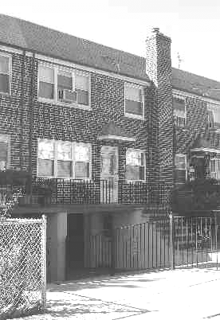
Figure 3. Railing leads to a basement apartment that may have been a garage at one time.
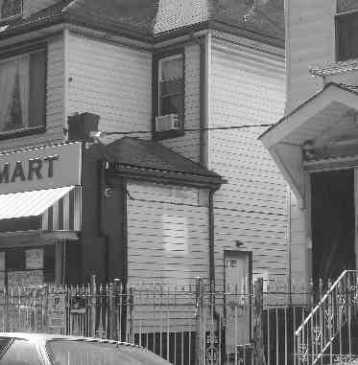
Figure 4. This store has a side door leading to an apartment and indications of possible housing units above the store.

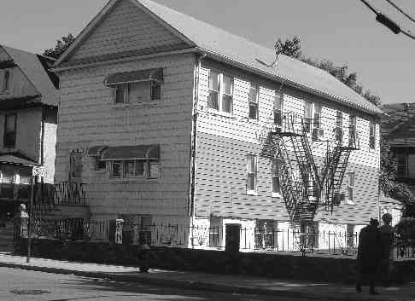
Figure 5. The fire escapes suggest several housing units. There are also signs of basement apartments.

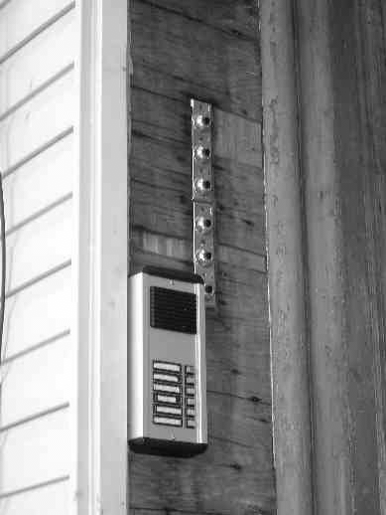

Figure 6. This is a house with a set of old doorbells and a set of new doorbells. There could be 6 units here or 12 units here, so you need to inquire to confirm the number of housing units. Always inquire about any building with two sets of doorbells.

Appendix 3. Diagram of Various Situations
This chart shows the general procedures for handling various situations you might encounter at small multi-unit buildings. Refer to Topic 3 for the detailed procedures. This diagram only provides a general overview. Follow the detailed procedures in Topic 3 on page 9 for each small multi-unit situation.

Appendix 4. Standard Abbreviations
For a full list refer to Appendix B in your Lister’s Manual.
Attic -- Atc
Basement -- Bsmt
Building -- Bldg
Downstairs -- Dwnstr
Floor -- Fl
Front -- Frnt
Garage -- Grg
House -- Hse
Left -- L
Lower -- Lowr
Penthouse -- PH
Porch -- Prch
Right -- R
Room Rm
Suite -- Ste
Trailer (mobile home) -- Trlr
Upper -- Uppr

Appendix 5. Practice Exercises
You will use the illustrations below during your classroom lesson.
Exercise 1.
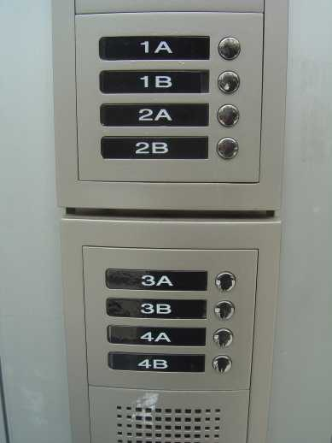

Exercise 2.
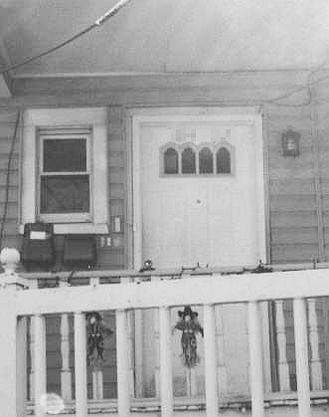
NOTES

