“Evaluation of Pharmacy Syringe Access Linked to HIV Testing for Injection Drug Users in New York City (Pharm-HIV)”

Pharmacy Staff Consent

_____________________________________________________________________________________
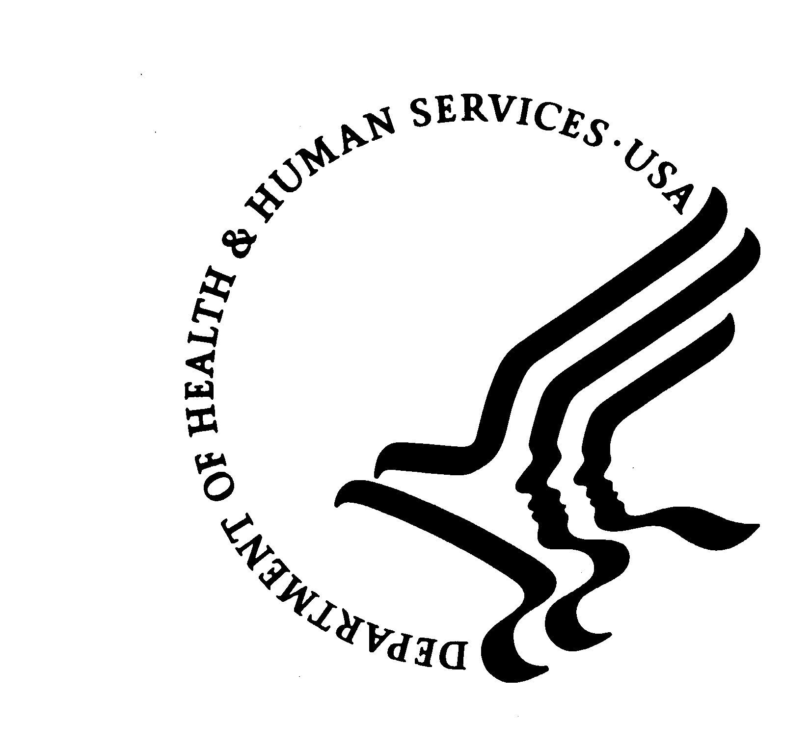
U.S. DEPARTMENT OF HEALTH AND HUMAN SERVICES
Public Health Service
Centers for Disease Control and Prevention
Atlanta, Georgia 30333

New York Academy of Medicine
Consent to Participate in
Pharm-HIV Study:
Pharmacy Staff Consent Form

Purpose
The New York Academy of Medicine (NYAM) and the U.S Centers for Disease Control and Prevention are looking at the impact of non-prescription syringes sales at pharmacies. In this research study, we want to find out how well this program is working. We also want to learn if this program can include more services, like referring syringe customers to HIV testing. We are asking you to take part because you work in a pharmacy involved in our research study. Pharmacy staff that attend the training, sell syringes, and log those sales may be interviewed during the research study.

Procedures
This is what will happen if you agree to join this research study:
- A NYAM researcher will train you at your pharmacy. This will focus on two things. The first is filling out the syringe sale log sheet. The second is how to refer IDU syringe customers to NYAM’s research study. In some cases more training may be needed. We also require you to come to 2 other trainings. They are the Pharmacy Training Seminar (2 hours) and the Injection Safety and Overdose Prevention Seminar (2 hours). These trainings will focus on talking to drug users about HIV testing.
- Each month during the research study, a NYAM researcher will visit your pharmacy. They will pick up log sheets and do a brief survey (5-10 minutes) with one technician or pharmacist who has time. Every six months, a NYAM researcher will call your pharmacy to do a longer survey by telephone (15-20 minutes). This longer survey will be the same as the one you took at baseline. Your answers to all surveys are private. They will not be shared with other pharmacy staff or with corporate management.
- You will be expected to talk to your regular IDU customers about information they may need. This includes referrals to HIV testing, syringe disposal, and safety information. Regular IDU customers are IDUs who have bought syringes from your pharmacy at least twice and with whom you have spoken.
- At HIV testing referral pharmacies, pharmacists and technicians will give HIV testing referrals. This person will tell IDU syringe customers that the pharmacy is part of an “HIV testing campaign.” Staff will say that they’re offering referrals to all who buy syringes. This will be done discretely. Referrals will be given to nearby HIV testing sites. NYAM and if possible the pharmacy will have a relationship with these sites. Finally, the pharmacy staff will explain that the pharmacy is part of a community survey. The customer will be told that a researcher will be at the pharmacy on a particular day to run surveys. Customers will be told that they will be paid for taking the survey.
- At HIV testing pharmacies, HIV testing will be offered to IDU syringe customers in the pharmacy. This will happen one day a week. Pharmacy staff will tell IDU customers about this. Pharmacy staff will ask them to come back on the HIV testing day to be tested. Staff will also mention a brief survey for which customers will be paid. The pharmacy staff will make clear that HIV testing is done privately and confidentially. Staff will also explain that being tested is not required take survey.
- Either you or other staff will write the customer’s first name or initials on the research study sign-up sheet. You/they will provide the customer with a card with the appointment written on it. You will tell the customer that they should bring the card with them to the testing center if they decide to go. They should also to bring the card with them to the pharmacy on the day of their appointment. You or other staff will tell NYAM researchers of appointments via phone or fax.
- If you are an HIV testing pharmacy, you will also allow NYAM to provide free, confidential HIV testing in your pharmacy. This will happen 1-2 days per week. Research staff will test on the same days they come to run surveys. NYAM will provide HIV counselors and testers, testing kits, and all other testing supplies. Dr. Silvia Amesty, M.D. MPH, Principal Investigator, will consult on-site in the case that people test positive..
- During the research study NYAM will conduct syringe “test-buys” at your pharmacy. These test-buys are to help you improve how your pharmacy provides services to syringe customers. You will not know the NYAM staff that performs the test-buys. They will not identify themselves. They will simply purchase a syringe like any other customer. Based the test-buys, we change training at your pharmacy. We may also work with you to address any special needs at your pharmacy. Staff at your pharmacy will not be singled out due to the test-buys. Nothing from them will be shared with pharmacy management.
- You will receive $50 per training session you come to (up to 2) and up to $100 in gifts for every 12 months that we collect data based on your participation in the study. It will be paid every quarter, stating three months after data collection begins. Collection will last no more than 24 months. It will start after on-site training and the Training Seminars finish.
- Taking part in this research study is voluntary. It will in no way impact your employment. You may choose to quit this research study at any time. If your pharmacy chooses to stop selling ESAP syringes, it will no longer be eligible for the research study. Also, during the first 6 months your pharmacy may fail to meet the eligibility criteria. If this happens, the pharmacy will be removed from the research study.

Risks/Discomforts
NYAM staff will do everything possible to protect your privacy as much as the law allows. But sterile syringe access is a sensitive issue. So there is a possible social risk from a breach of confidentiality. Nothing that links you or your pharmacy to data from this research study will be released or published in any way. Your name and your pharmacy’s name will not be written on surveys. Instead, a research study number will be used. We will store this in a computer database with a password. No personal data will be linked to the database. All paper records will be destroyed at the end of the research study. The federal government requires this. Your answers to surveys will not be shared with other pharmacy staff, or pharmacy or corporate management.

For pharmacies with on-site HIV testing, this testing may have some risks. Customers may become emotional upon learning they may be HIV positive. NYAM will make every effort to make sure no problems result from this. NYAM’s HIV counselors and testers are highly trained. They are skilled in talking with people about how to cope with an HIV diagnosis. They will link IDU participants immediately to medical services for confirmatory testing. They will also refer to social services. Dr. Silvia Amesty, M.D. MPH will consult at pharmacies in the case that people test positive.

Benefits
You may not directly benefit from taking part in this research study. Future state programs may change. This may affect pharmacies. If we find this research study works, pharmacy services could be expanded like this on a larger scale. This would reach people without access to care.

Costs
There will be no cost to you for taking part in this research study except your time.

Questions
If you have any questions or problems, you can call Silvia Amesty, MD, MPH, Principal Investigator at 212-822-7391 or Natalie Crawford, MPH, Project Director at 212-822-7274.

If you have any questions about your rights in this research study, you may call or write the Institutional Review Board (IRB). The IRB protects the safety of people in research projects. You may reach the New York Academy of Medicine IRB office between 9:00 and 5:00, Monday through Friday. You can call Kristine Gebbie, DrPH, RN at 212-822-7287. You may also write them: The Institutional Review Board, New York Academy of Medicine, 1216 Fifth Avenue – 6th Floor, New York, NY 10029.
Consent
I have talked to ________________ about this research study and my questions have been answered. Taking part in this research study is voluntary, and will not impact my employment at this pharmacy. I am free to not join this research study, or to stop being in this research study at any point. I have been given a copy of this consent form to keep. If I agree to be in the research study, I should sign below.

___________________________ _____
Participant's Signature Date

___________________________ _____
Additional Participant's Signature Date
(if applicable)*
_____________
Pharmacy ID # (provided by NYAM staff)

______________________ _____

Person Obtaining Consent Date

______________________ _____
Witness Signature Date

* If an additional signature is required by someone operating outside of your pharmacy.

