“Evaluation of Pharmacy Syringe Access Linked to HIV Testing for Injection Drug Users in New York City (Pharm-HIV)”

Syringe Customer Participant Referral Consent

_____________________________________________________________________________________
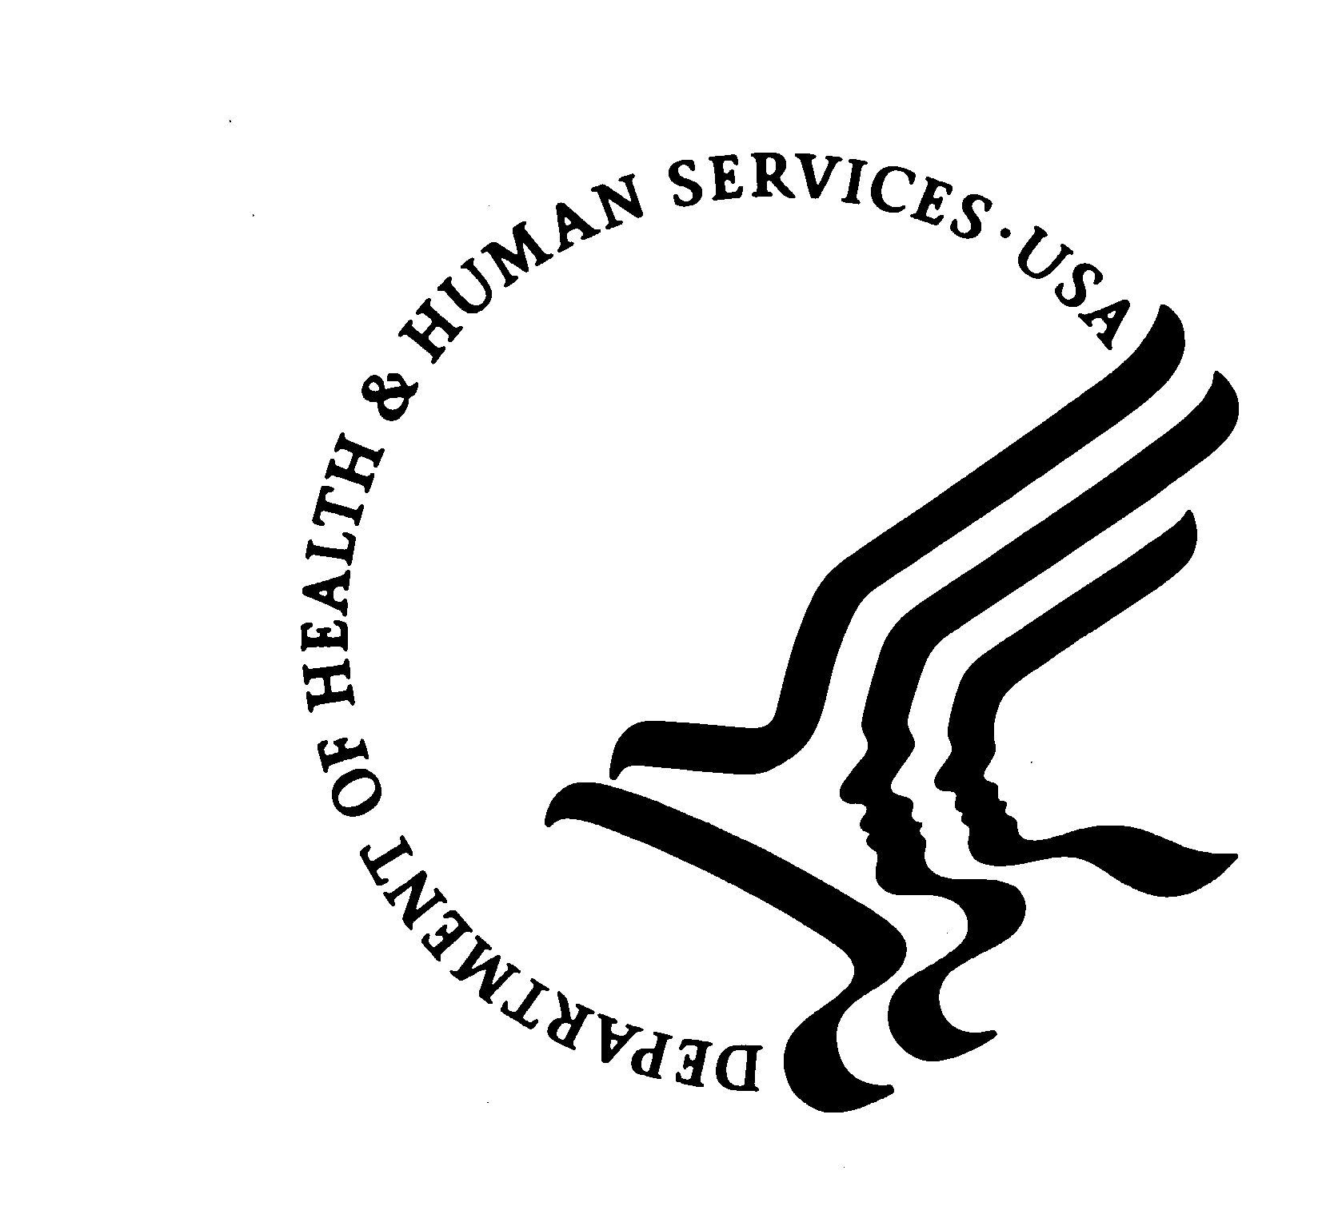
U.S. DEPARTMENT OF HEALTH AND HUMAN SERVICES
Public Health Service
Centers for Disease Control and Prevention
Atlanta, Georgia 30333

New York Academy of Medicine
Syringe Customer Consent to Participate in
Pharm-HIV Study with HIV referral: Consent Form

Purpose
The New York Academy of Medicine (NYAM) and the U.S. Centers for Disease Control and Prevention are looking at the impact of non-prescription syringes sales in pharmacies. In this research study, we want to find out how well this program is working.
We also want to learn if this program can include more services, like referring syringe customers to HIV testing.

Procedures
This is what will happen if you agree to join this research study:

- We will ask for a valid ID and give you a unique number so that your name will be confidential and will not be used to identify you with any personal information you tell us.
- You will take part in a survey that will take about 30 minutes. The survey has questions about your drug use and experience with HIV testing and buying syringes at pharmacies. We will also ask about other things that affect your health, such as sexual practices.
- If you decide to join, you will be offered a $10 incentive to volunteer. Your survey will be destroyed after the research study is over. Your survey will not be linked to your responses. You will receive an extra $5 if you brought your appointment card with you today.
- You may choose to quit being a part of this research study at any time.

Confidentiality
We will do everything to protect your answers in this research study. All answers that we collect will be kept private by law: Section 301(d) of the Public Health Service act [42 U.S.C. 241 (d).] This is so because this study has been given a Certificate of Confidentiality. This means anything you tell us will not have to be given out to anyone, even if a court orders us to do so, unless you say it’s okay. But under law, we must report to the state suspected cases of child abuse or if you tell us you are planning to cause serious harm to yourself or others. This protection lasts forever (even after death) for anyone who took part in the research study. The Certificate of Confidentiality will serve as additional protection, but because its limitations have not been challenged in court, absolute protection can not be guaranteed. The research team has been trained to keep your data private. All team members have signed a statement saying they agree to keep your data confidential.

We will protect your privacy in these ways:
- Your name will not be put on your answers to the interview. We will label your answers with a number.
- We will destroy your name and any identifying answers at the end of the research study.
- The project has no link to the police or criminal justice system. We will not pass data about drug use or sexual behavior to the police or justice system.
- Your name will not be used in any reports or publications taken from this research study.
- Pharmacy staff will not have access to any survey data or test results that you give to us or the testing center. We will not ask testing centers for your test results.

Risks/Discomforts
We will make every effort to protect your confidentiality. There is a possibility that your confidentiality may not be kept. Your name will not be put on your survey responses or on any test results. We will use a number that will label your answers. No data linking your name to data collected in this research study will be released or published in any form. However, if you would like to join future studies, we will ask you where we can reach you in the future and store it for up to seven years.

There may also be some discomfort when answering questions about your drug use or sexual behaviors. You may not want to answer any question that makes you feel uncomfortable. Since you are taking this survey in a public space, we have given you head phones and a computer with a privacy screen. These will prevent anyone from hearing the survey questions or see your responses. Again, we will make every effort to protect your confidentiality.

Benefits
There may be no direct benefit to you for taking part in this research study. We can refer you to HIV testing services if you are want to get HIV testing. We can also refer you to testing and vaccinations for Hepatitis B and C. This research study may affect you indirectly. Future state programs may change. Your answers may also help guide drug and HIV prevention and treatment programs that you may help you.

Costs
There will be no cost to you as a result of joining part in this research study except your time.

Questions
If you have any questions or problems, you can call Silvia Amesty, M.D., MPH, Principal Investigator at 212-822-7391 or Natalie Crawford, MPH, Project Director at 212-822-7274.

If you have any questions about your rights in this research study, you may call or write the Institutional Review Board (IRB). The IRB protects the safety of people in research projects. You may reach the New York Academy of Medicine IRB office between 9:00 and 5:00, Monday through Friday. You can call Kristine Gebbie, DrPH, RN at 212-822-7287. You may also write them: The Institutional Review Board, New York Academy of Medicine, 1216 Fifth Avenue – 6th Floor, New York, NY 10029.
Consent
I have talked to ________________ about this research study and my questions have been answered. Taking part in this research study is voluntary. I am free to not join this research study, or to stop being in this research study at any point. I have been given a copy of this consent form to keep. If I agree to be in the research study, I should sign below.

Signature: _____________________________________ Date: __________

Signature of Research Project member obtaining consent:

_____________________________________ Date: __________

