Consent Form

NATIONAL INSTITUTE FOR OCCUPATIONAL SAFETY AND HEALTH (NIOSH)
CENTERS FOR DISEASE CONTROL
U.S. PUBLIC HEALTH SERVICE
U.S. DEPARTMENT OF HEALTH AND HUMAN SERVICES

CONSENT TO PARTICIPATE IN A RESEARCH STUDY

-------------------------------------------------------------
You have been asked to participate in a NIOSH research study. We explain here the nature of your participation, describe your rights, and specify how NIOSH will treat your records.
-------------------------------------------------------------

I. DESCRIPTION

1. Title: Postural Analyses of Coal Mining in Low Working Heights: Effect of Working Height and Job Type

2. Sponsor and/or Project Officer:

Susan Moore
NIOSH
Pittsburgh Research Laboratory
626 Cochrans Mill Road
PO Box 18070
Pittsburgh, PA 15236-0070
(412) 386-6613

Jonisha Pollard
NIOSH
Pittsburgh Research Laboratory
626 Cochrans Mill Road
PO Box 18070
Pittsburgh, PA 15236-0070
(412)386-5220

3. Purpose and Benefits: In this study we will observe the postures you use when doing your job. Kneeling and crawling are examples of postures. The types of postures used and how often you use them will be recorded. The effect of other factors such as height, weight, and age will also be observed. This study is part of a larger project where improvements to knee pads and interventions will be made. Results from this larger project will be used to write suggestions for the design of knee pads and interventions. These suggestions will be given to the mining community. The overall goal of this project is to decrease the risk of knee injuries in low-seam mines.

II. CONDITIONS OF THE STUDY

1. Procedure

The following procedure will be followed:

- You will first fill out this consent form. Please feel free to ask the researchers questions at any time. (approximately 15 minutes)
- The researchers will then collect some basic demographics information. This includes your: 1) job type (e.g. roof bolter operator); 2) age; 3) weight; 4) height; 5) years of experience mining in low working heights (≤48”); and 6) years of experience in your current job type. (approximately 10 minutes)
- How the researchers observe you will depend upon your job type. Please read the information below for your job type.
  - Roof bolter operator (observation time: approximately 1 hour at the beginning and end of your shift)
    - The researchers will position themselves so you will be visible while installing roof bolts at the working face. You will determine if their position is safe and does not interfere with your work. The researchers will talk to you before entering or leaving your work area. Please point out safety concerns at any time.
    - The researchers will record the different postures you use as you perform your tasks (Figures 1 and 2). The researchers will record this information using a handheld system. Before collecting data, the researchers will show you this handheld system and explain how it works. The researchers will observe you as you install approximately 6 rows of bolts. No data will be collected for the first 3 rows. The researchers will simply familiarize themselves with the postures you utilize. For the remaining rows of bolts, the researchers will record data.
    - With approval from the mine, the researchers may choose to record any unique postures by taking pictures while you are in the posture(s).
    - Once the researchers are done observing you, they may ask you some questions about your postures. For example, they may notice that you have a unique way of doing a task.
    - The events described above will be performed at the beginning (within first 3 hours) and end (within last 3 hours) of your shift.
  - Continuous miner operator (observation time: approximately 1½ hour at the beginning and end of your shift)
    - The researchers will position themselves so you will be visible while doing a cut sequence. You will determine if their position is safe and does not interfere with your work. The researchers will talk to you before entering or leaving your work area. Please point out safety concerns at any time.
    - The researchers will record the different postures you use as you perform your tasks (Figures 1 and 2). The researchers will record this information using a handheld system. Before collecting data, the researchers will show you this handheld system and explain how it works. The researchers will initially observe you for a few minutes to familiarize themselves with the postures you utilize. Then, the researchers will observe you through your 3 entire cut sequences and record data.
    - With approval of the mine, the researchers may document any unique postures by taking pictures while you are in the posture(s).
    - Once the researchers are done observing you, they may ask you some questions about your postures. For example, they may notice that you have a unique way of doing a task.
    - The events described above will be performed at the beginning (within first 3 hours) and end (within last 3 hours) of your shift.
  - Scoop operator (observation time: approximately 15 minutes to 1 hour and 15 minutes depending on the type of observations that are permitted by your mine)
    - The researchers will show you a list of postures (Figure 1). Then they will ask you to identify which postures you use when scooping the face, loading and unloading supplies, building stoppings, rock dusting, advancing power load center, hanging curtain, hanging cable, and extending tubing. If you do not perform some of these tasks at your mine, you will not be asked to identify any postures for it.
    - The researchers will then ask you to estimate the amount of time you are in each posture while performing the tasks listed above.
    - The researchers will also ask you to estimate the amount of time you spend performing each of the tasks throughout your shift.
    - The researchers may observe you as you perform your tasks or as you simulate them outby if permission from your mine is given. The researchers will position themselves so you will be visible while doing the tasks. You will determine if their observation location is safe and does not interfere with your work. The researchers will talk to you before entering or leaving your work area. Please point out safety concerns at any time
    - The researchers will observe when you use the postures you identified from Figure 1 as you perform your tasks.
    - If performed outby, the researchers will note your postures by taking pictures.
    - The researchers may ask you some questions about your postures. For example, they may notice that you have a unique way of doing a task.
  - Foreman (observation time: approximately 15 minutes to 1 hour and 15 minutes depending on the type of observations that are permitted by your mine)
    - The researchers will show you a list of postures (Figure 1). Then they will ask you to identify which postures you use when moving about the mine, operating the continuous miner, loading and unloading supplies, building stoppings, rock dusting, advancing power of the load center, hanging curtain, hanging cable, and extending tubing. You will not be asked to identify any postures for tasks you do not perform.
    - The researchers will then ask you to estimate the amount of time you are in each posture while performing the tasks listed above.
    - The researchers will also ask you to estimate the amount of time you spend performing each of the tasks throughout your shift.
    - If permission from your mine is given, the researchers may observe you as you perform these tasks or as you simulate them outby. The researchers will position themselves such that you will be visible while doing the tasks. You will determine if their observation location is safe and does not interfere with your work. The researchers will talk to you before entering or leaving your work area. Please point out safety concerns at any time.
    - The researchers will observe when you use the postures you identified from Figure 1 as you perform your tasks.
    - If performed outby, the researchers will note your postures by taking pictures.
    - The researchers may ask you some questions about your postures. For example, they may notice that you have a unique way of doing a task.
  - Maintenance shift worker (observation time: approximately 45 minutes to 1 hour and 15 minutes depending on the type of observations that are permitted by your mine)
    - The researchers will show you a list of postures (Figure 1). Then they will ask you to identify which postures you use when building stoppings, rock dusting, scooping or doing clean up activities, bolting unfinished areas, advancing power of the load center, hanging curtain, and hanging cable. You will not be asked to identify any postures for tasks you do not perform.
    - The researchers will then ask you to estimate the amount of time you are in each posture while performing the tasks listed above.
    - The researchers will also ask you to estimate the amount of time you spend performing each of the tasks throughout your shift.
    - The researchers may observe you as you perform your tasks or as you simulate them outby if permission from your mine is given. The researchers will position themselves so you will be visible while doing the tasks. You will determine if their observation location is safe and does not interfere with your work. The researchers will talk to you before entering or leaving your work area. Please point out safety concerns at any time.
    - The researchers will observe when you use the postures you identified from Figure 1 as you perform your tasks.
    - If performed outby, the researchers will note your postures by taking pictures.
    - The researchers may ask you some questions about your postures. For example, they may notice that you have a unique way of doing a task.
  - Shuttle car operator (observation time: approximately 10 to 30 minutes depending on the type of observations that are permitted by your mine)
    - The researchers will ask you to describe the position of your knees while riding in the shuttle car.
    - The researchers may observe you as you perform your tasks or as you simulate them outby if permission from your mine is given.
    - If performed outby, the researchers will note your postures by taking pictures.
    - The researchers may ask you some questions about your postures. For example, they may notice that you use a unique posture when sitting in the vehicle. They may ask questions to understand why you have chosen this posture.
  - Mobile bridge operator (observation time: approximately 10 to 30 minutes depending on the type of observations that are permitted by your mine)
    - The researchers will ask you to describe the position of your knees while riding in the mobile bridge.
    - The researchers may observe you as you perform your tasks or as you simulate them outby if permission from your mine is given.
    - If performed outby, the researchers will note your postures by taking pictures.
    - The researchers may ask you some questions about your postures. For example, they may notice that you use a unique posture when sitting in the vehicle. They may ask questions to understand why you have chosen this posture.

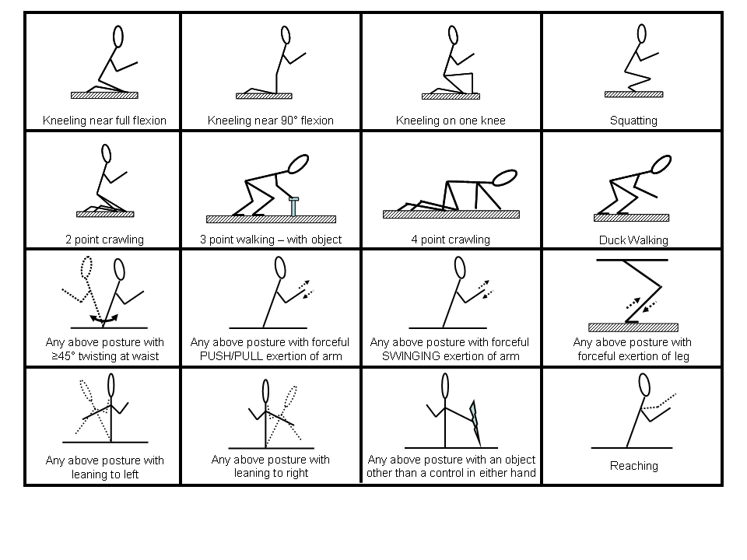
Figure 1. Postures the researchers will use when watching you perform your

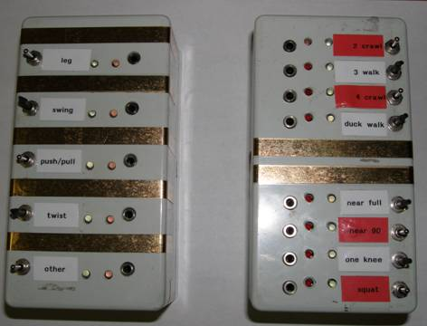

Figure 2. Handheld ONLI Task Analysis System

Risks and Discomfort

You will only perform your normal job tasks for this study. The position of the researchers may be an additional risk. This risk is small since you, the researchers, and your health and safety representative will pick their position. In the event of any problems/concerns after the observations take place, you should contact:

Vijia Karra, PhD
Chief, NIOSH-PRL Mining Injury Prevention Branch
(412) 386-6648

Susan Moore, PhD
NIOSH-PRL Mining Injury Prevention Branch
(412) 386-6613

3. No alternative test procedures are available.

Injury or harm from this project is unlikely. But if it results, only emergency treatment will be provided. If you are injured through carelessness of a NIOSH worker you may be able to obtain compensation under Federal Law. If you want to file a claim against the Federal government your contact point is: Public Health Service Claims Office: (301) 443-1904. If you are injured or harmed through the carelessness of a NIOSH contractor, your claim would be against the contractor, not the federal government. If an injury or harm should occur to you as the result of your participation, you also should contact:

Susan Moore, PhD
NIOSH-PRL Mining Injury Prevention Branch
(412) 386-6613

Michael J. Colligan, PhD
Chairman, Human Subjects Review Board, NIOSH
(513) 533-8222

5. Contact Susan Moore at 412-386-6613 if you have any questions. Contact Michael Colligan at 513-533-8222 if you have questions about your rights.

6. Your participation is voluntary. You may withdraw from the study at any time without penalty or loss of benefits to which you are otherwise entitled. Please note that there will be no reimbursement for your participation.

- The results of this study will be published and made available to you at your request. The publication process may take months or years depending on the type of publication. For a copy of any published results, please contact Susan Moore at 412-386-6613 or via email SMMoore@cdc.gov.
III. USE OF INFORMATION

This study is being done by The National Institute for Occupational Safety and Health (NIOSH). NIOSH is part of the Centers for Disease Control (CDC), a government agency in the Department of Health and Human Services. We collect this information in order to learn about various kinds of work hazards that may influence the health of the American worker.

NIOSH is allowed to collect and keep information about you, including your results from this study, along with your social security number (if applicable), because of three laws passed by Congress. These laws are:

- The Public Health Service Act (42 U.S.C 241)
- The Occupational Safety and Health Act (29 U.S.C. 669)
- The Federal Mine Safety and Health Act of 1977 (30 U.S.C. 951)

You will decide whether you want to provide us with this information by being in this study. You are free to choose not to be in this study. It is up to you. If the information we are collecting is maintained and retrieved by personal identifiers, such as your name and social security number, it will become part of the CDC record system and we will protect it to extent allowed by law. You should know, however, that there are conditions under the Privacy Act when we could be authorized to release this information to outside sources. These conditions under which we might release this information are listed in Appendix A (the Privacy Act).

IV. SIGNATURES

I have read this consent form and received a copy of the conditions for data release under the Privacy Act (Appendix A). I agree to participate in this study.

PARTICIPANT Age (signature)

(and Guardian, if required) Date

I, the NIOSH representative, have accurately described this study to the participant.

REPRESENTATIVE Date
(signature)

Appendix A

The Information you provide will become part of the CDC Privacy Act System, 09-20-0147, “Occupational Health Epidemiological Studies and EEOICPA Program Records” and may be disclosed to

- Appropriate state or local heath departments to report communicable diseases;

- A State Cancer Registry to report cases of cancer where the state has a legal reporting program providing for confidentiality;

- Private contractors assisting NIOSH;

- Collaborating researchers under certain circumstances to conduct further investigations;

- One or more potential sources of vital statistics to make determinations of death, health status or to find last known address;

- The Department of Justice or the Department of Labor in the event of litigation;

- Congressional offices assisting an individual in locating his or her records;

- The Department of Justice to assist in determining the eligibility for compensation to uranium workers or their survivors [optional but must be used if study pertains to uranium workers]

You may request an accounting of the disclosures made by NIOSH.
Except for these and other permissible disclosures authorized by the Privacy Act, or in limited circumstances required by the Freedom of Information Act, no other disclosures may be made without your written consent.

