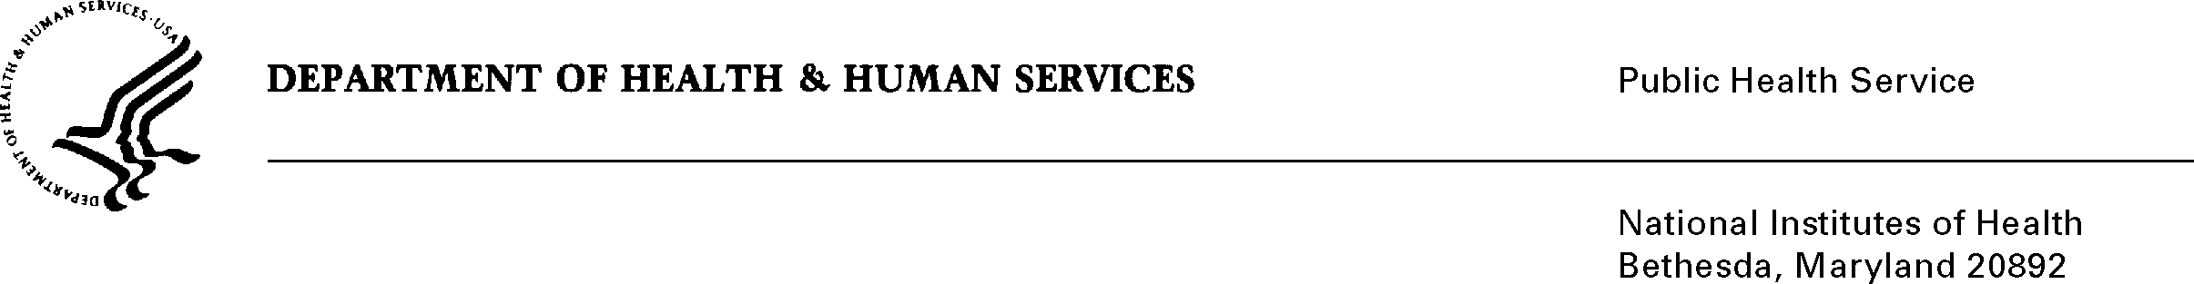

DATE: July 31, 2009

TO: Christy Thomsen
Director, Office of Communications and Public Liaison, NCCAM

FROM: NIH Privacy Act Officer

SUBJECT: Applicability of the Privacy Act: NCCAM Customer Service Data Collection

I have reviewed the NCCAM submission to OMB requesting approval for the use of the “NCCAM Customer Service Data Collection”.

I have determined that the Privacy Act will not apply to this data collection. Although the survey respondents will be asked to provide personally identifiable information such as name, age, gender and education level, the system is not designed to retrieve the survey information by a personal identifier. The information will be presented in aggregate form.

If the system of records was designed to retrieve information by a personal identifier linked to the survey respondents, it would be covered by NIH Privacy Act Systems of Record 09-25-0156, “Records of Participants in Programs and Respondents in Surveys Used to Evaluate Programs of the Public Health Service, HHS/PHS/NIH/OD.”

If you have any questions, please contact my office at (301) 496-2832.

Karen M. Plá

