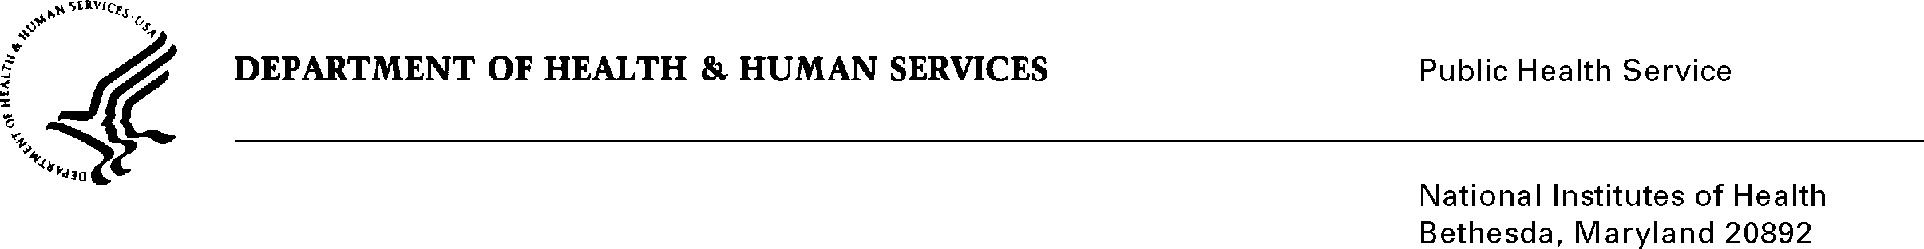

DATE: May 20, 2009

TO: Charles L. Hall, RPh. M.S.
Pharmaceutical Management Branch
Cancer Therapy Evaluation Program
Division of Cancer Treatment and Diagnosis
National Cancer Institute

FROM: NIH Privacy Act Officer

SUBJECT: Applicability of the Privacy Act: “Investigator Registration and Financial Disclosure for Investigational Trials in Cancer Treatment (NCI)”

I have reviewed the NCI/DCTD submission to OMB requesting approval to keep records on investigators to track compliance and to allow investigators to receive, and continue to receive NCI-sponsored drugs. I have determined that the Privacy Act will apply to this data collection which involves the collection of education, date of birth and financial disclosure information.

At the completion of the data collection, data will be recorded and stored in an investigator registration database. A UPIN number will be assigned and used to establish the identity of the investigator and to ensure the investigator has completed required training and is licensed and practicing in the field of expertise in which the research is conducted. The data collection is covered by NIH Privacy Act Systems of Record 09-25-0200, “Clinical, Basic and Population-based Research Studies of the National Institutes of Health (NIH), HHS/NIH/OD”.

If you have any questions, please contact my office at (301) 402-6201.

Karen M. Plá

Attachment

cc: V. Horovitch-Kelley, NCI OMB Project Clearance Liaison Office

