DEPARTMENT OF HEALTH AND HUMAN SERVICES  PUBLIC HEALTH SERVICE  FOOD AND DRUG ADMINISTRATION  STATEMENT OF INVESTIGATOR  (TITLE 21, CODE OF FEDERAL REGULATIONS (CFR) PART 312)  (See instructions on reverse side.) | Form Approved: OMB No. 0925-xxxx  Expiration Date: xx/xx/xxxx
NOTE: No investigator may participate in an
investigation until he/she provides the sponsor with
a completed, signed Statement of Investigator,
Form FDA 1572 (21 CFR 312.53(c)).
Public reporting burden for this collection of information is estimated to average 15 minutes per response, including the time for reviewing instructions, searching existing data sources, gathering and maintaining the data needed, and completing and reviewing the collection of information. An agency may not conduct or sponsor, and a person is not required to respond to, a collection of information unless it displays a currently valid OMB control number. Send comments regarding this burden estimate or any other aspect of this collection of information, including suggestions for reducing this burden, to: NIH, Project Clearance Branch, 6705 Rockledge Drive, MSC 7974, Bethesda, MD 20892-7974, ATTN: PRA (0925-xxxx). Do not return the completed form to this address.
- NAME AND ADDRESS OF INVESTIGATOR.

- EDUCATION, TRAINING, AND EXPERIENCE THAT QUALIFIES THE INVESTIGATOR AS AN EXPERT IN THE CLINICAL INVESTIGATION OF THE DRUG FOR THE USE UNDER INVESTIGATION. ONE OF THE FOLLOWING IS ATTACHED.

CURRICULUM VITAE OTHER STATEMENT OF QUALIFICATIONS

- NAME AND ADDRESS OF ANY MEDICAL SCHOOL, HOSPITAL, OR OTHER RESEARCH FACILITY WHERE THE CLINICAL INVESTIGATION(S) WILL BE CONDUCTED.

- NAME AND ADDRESS OF ANY CLINICAL LABORATORY FACILITIES TO BE USED IN THE STUDY.

- NAME AND ADDRESS OF THE INSTITUTIONAL REVIEW BOARD (IRB) THAT IS RESPONSIBLE FOR REVIEW AND APPROVAL OF THE STUDY(IES).

- NAMES OF THE SUBINVESTIGATORS (e.g., research fellows, residents, and associates) WHO WILL BE ASSISTING THE INVESTIGATOR IN THE CONDUCT OF THE INVESTIGATION(S).
N/A – The Cancer Therapy Evaluation Program, National Cancer Institute requires each investigator to submit a separate FDA Form 1572,
CV, Supplemental Investigator Data Form, and Financial Disclosure Form. Information entered in this section will NOT be entered in the CTEP
NCI database.

- NAME AND CODE NUMBER, IF ANY, OF THE PROTOCOL(S) IN THE IND FOR THE STUDY(IES) TO BE CONDUCTED BY THE INVESTIGATOR.
I am participating in Cancer Therapy Evaluation Program (CTEP), National Cancer Institute-sponsored clinical trials. I understand that this
single FDA Form 1572 will cover my participation in all (one or more) clinical trials under CTEP sponsorship (IND and/or funding). I also
understand that I am responsible for meeting all the requirements for clinical trials specified by this signed FDA Form 1572 for EACH CTEP
clinical trial in which I participate.

FORM FDA 1572 (5/09) PREVIOUS EDITION IS OBSOLETE. PAGE 1 OF 2
Created by Electronic Document Services/USDHHS: (301) 443-2454

- ATTACH THE FOLLOWING CLINICAL PROTOCOL INFORMATION: * * 1. Check one or both boxes as appropriate.
2. Protocol(s) should not be attached.
FOR PHASE 1 INVESTIGATIONS, A GENERAL OUTLINE OF THE PLANNED INVESTIGATION INCLUDING THE ESTIMATED DURATION OF THE STUDY AND THE MAXIMUM NUMBER OF SUBJECTS THAT WILL BE INVOLVED. * *
FOR PHASE 2 OR 3 INVESTIGATIONS, AN OUTLINE OF THE STUDY PROTOCOL INCLUDING AN APPROXIMATION OF THE NUMBER OF SUBJECTS TO BE TREATED WITH THE DRUG AND THE NUMBER TO BE EMPLOYED AS THE CONTROLS, IF ANY; THE CLINICAL USES TO BE INVESTIGATED; CHARACTERISTICS OF SUBJECTS BY AGE, SEX, AND CONDITION; THE KIND OF CLINICAL OBSERVATIONS AND LABORATORY TESTS TO BE CONDUCTED; THE ESTIMATED DURATION OF THE STUDY; AND COPIES OR A DESCRIPTION OF CASE REPORT FORMS TO BE USED. * *
* * Refer to item number 7 and the NCI Drug Master File #2803 at FDA for a general outline of planned investigation.
- COMMITMENTS:
I agree to conduct the study(ies) in accordance with the relevant, current protocol(s) and will only make changes in a protocol after notifying the sponsor, except when necessary to protect the safety, rights, or welfare of subjects.
I agree to personally conduct or supervise the described investigation(s).
I agree to inform any patients, or any persons used as controls, that the drugs are being used for investigational purposes and I will ensure that the requirements relating to obtaining informed consent in 21 CFR Part 50 and institutional review board (IRB) review and approval in 21 CFR Part 56 are met.
I agree to report to the sponsor adverse experiences that occur in the course of the investigation(s) in accordance with 21 CFR 312.64.
I have read and understand the information in the investigator's brochure, including the potential risks and side effects of the drug.
I agree to ensure that all associates, colleagues, and employees assisting in the conduct of the study(ies) are informed about their obligations in meeting the above commitments.
I agree to maintain adequate and accurate records in accordance with 21 CFR 312.62 and to make those records available for inspection in accordance with 21 CFR 312.68.
I will ensure that an IRB that complies with the requirements of 21 CFR Part 56 will be responsible for the initial and continuing review and approval of the clinical investigation. I also agree to promptly report to the IRB all changes in the research activity and all unanticipated problems involving risks to human subjects or others. Additionally, I will not make any changes in the research without IRB approval, except where necessary to eliminate apparent immediate hazards to human subjects.
I agree to comply with all other requirements regarding the obligations of clinical investigators and all other pertinent requirements in 21 CFR Part 312.

INSTRUCTIONS FOR COMPLETING FORM FDA 1572
STATEMENT OF INVESTIGATOR:
- Complete all sections. Attach a separate page if additional space is needed.
- Attach curriculum vitae or other statement of qualifications as described in Section 2.
- Attach protocol outline as described in Section 8.
- Sign and date below.
- FORWARD THE COMPLETED FORM AND ATTACHMENTS TO THE SPONSOR. The sponsor will incorporate this information along with other technical data into an investigational New Drug Application (IND).

- SIGNATURE OF INVESTIGATOR | - DATE

(WARNING: A willfully false statement is a criminal offense. U.S.C. Title 18, Sec. 1001.)

FORM FDA 1572 (5/09) |  | PAGE 2 OF 2
 | Return Form to: Pharmaceutical Management Branch
 | Cancer Therapy Evaluation Program
 | Division of Cancer Treatment and Diagnosis, NCI
 | Executive Plaza North, Room 7149
 | 9000 Rockville Pike, Bethesda, MD 20892-7422

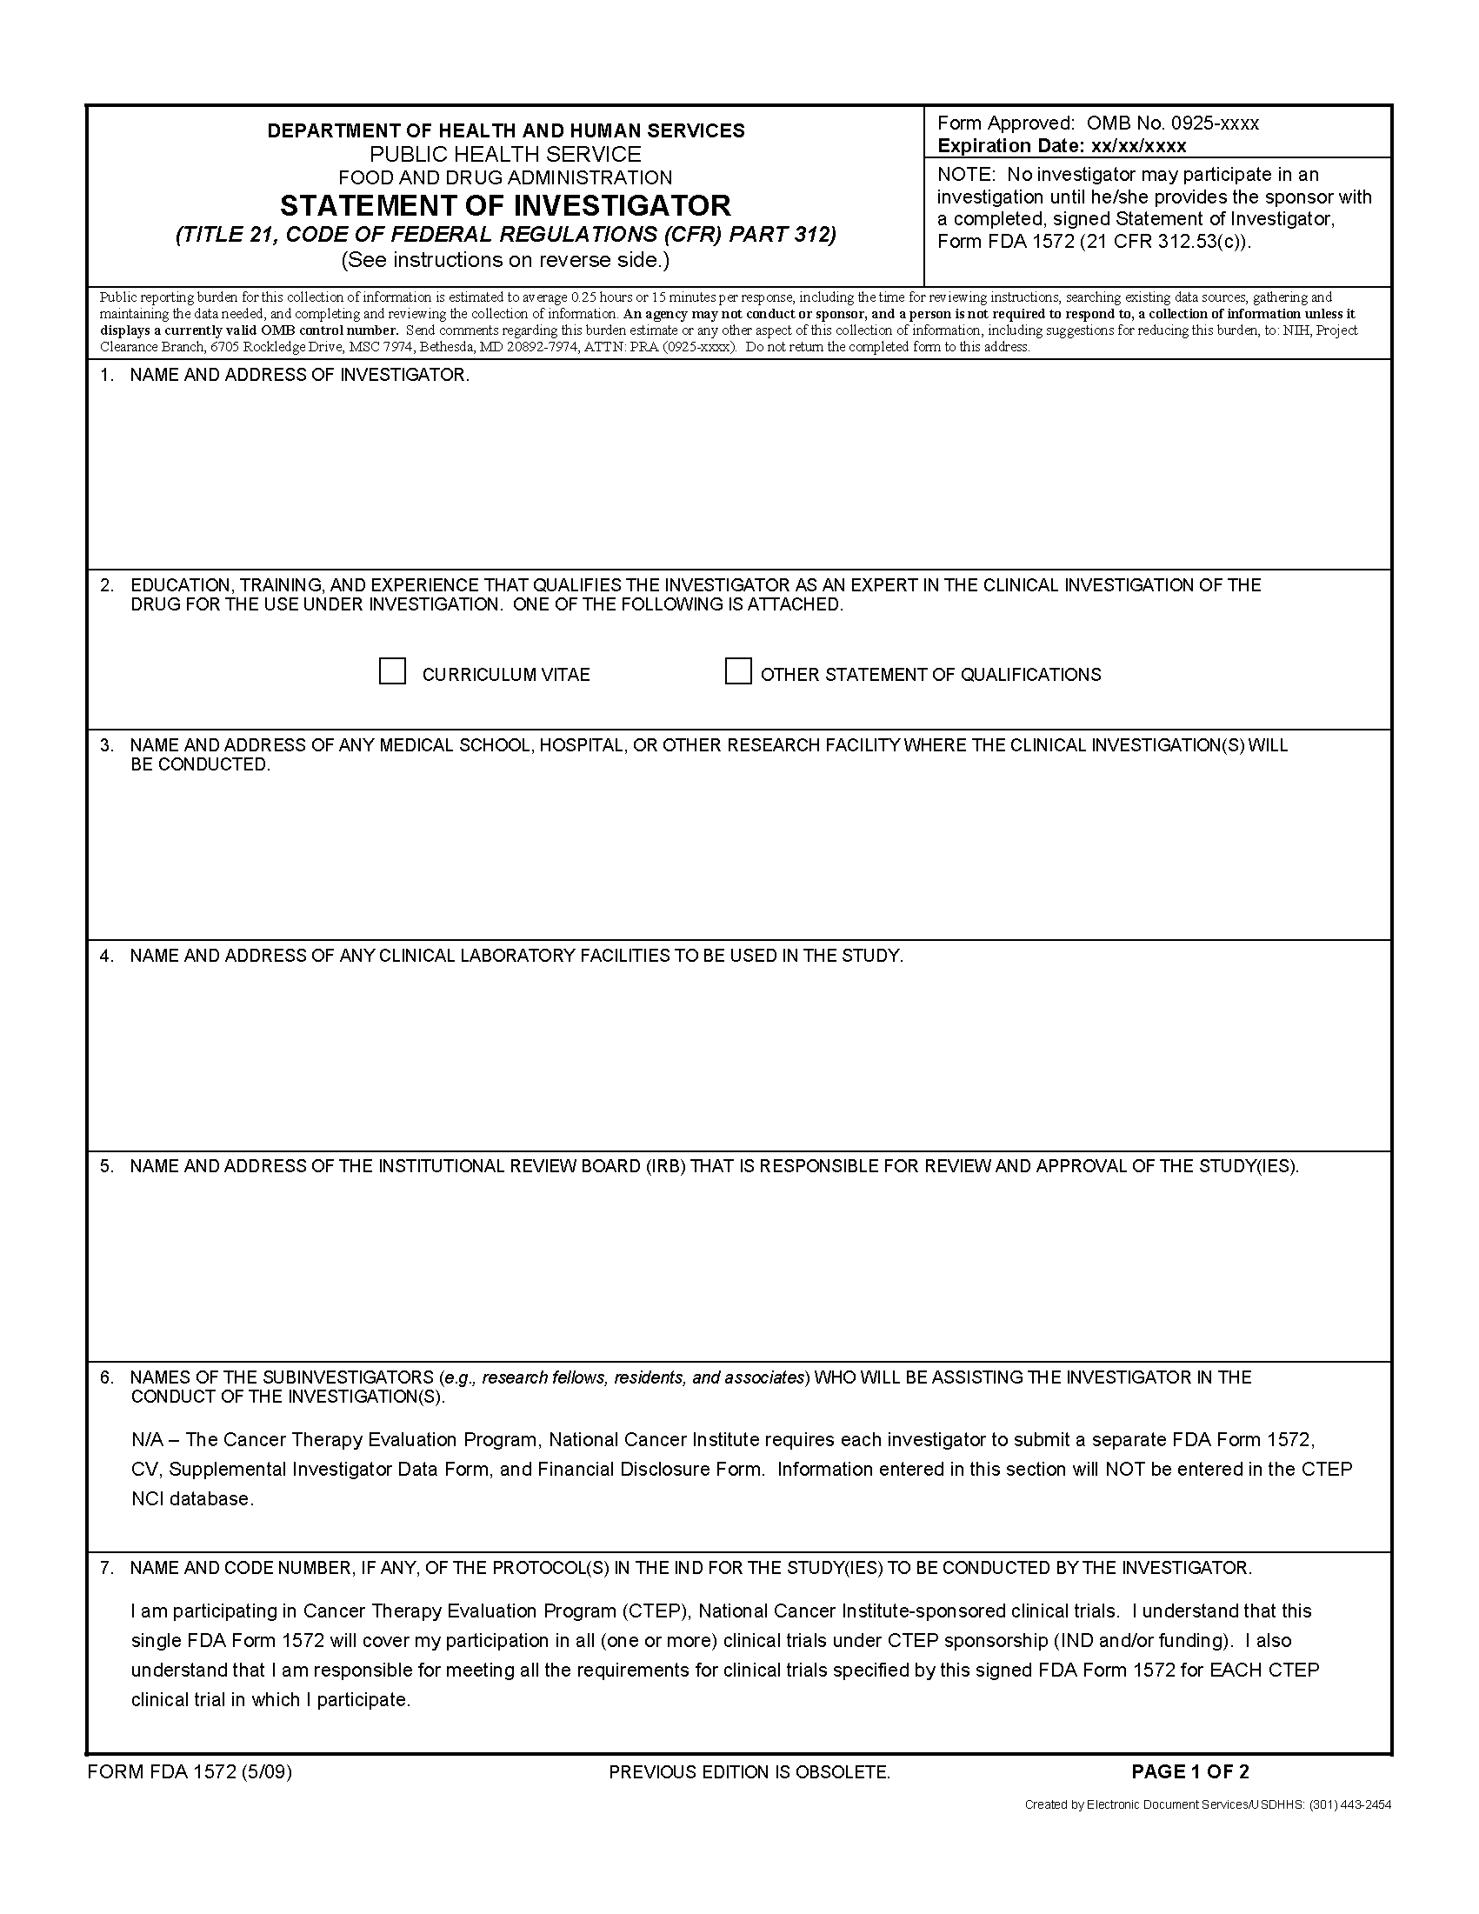
Check one box. Attach your CV (preferred) or other statement of qualifications.
Provide all relevant information for items 3, 4, and 5. Attach separate pages if necessary.
Provide Investi-gator name and office mailing address.

Items 6 and 7 have already been completed.
S
A
M
P
L
E

Check one or both boxes as appropriate.

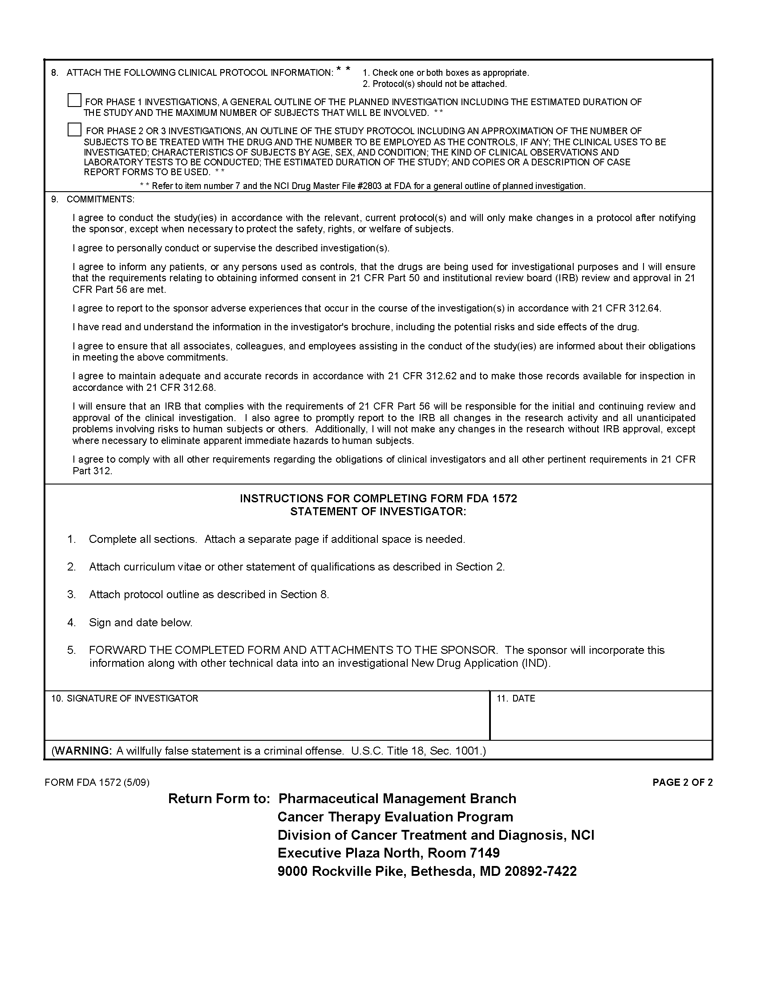
An original signature is required here. Submit the original of this form, do not send a photocopy.
The date of the signature.
Read item 9 carefully. You do not have to complete any information.
S
A
M
P
L
E

