Attachment D: Invitation Letter – Pharmacy

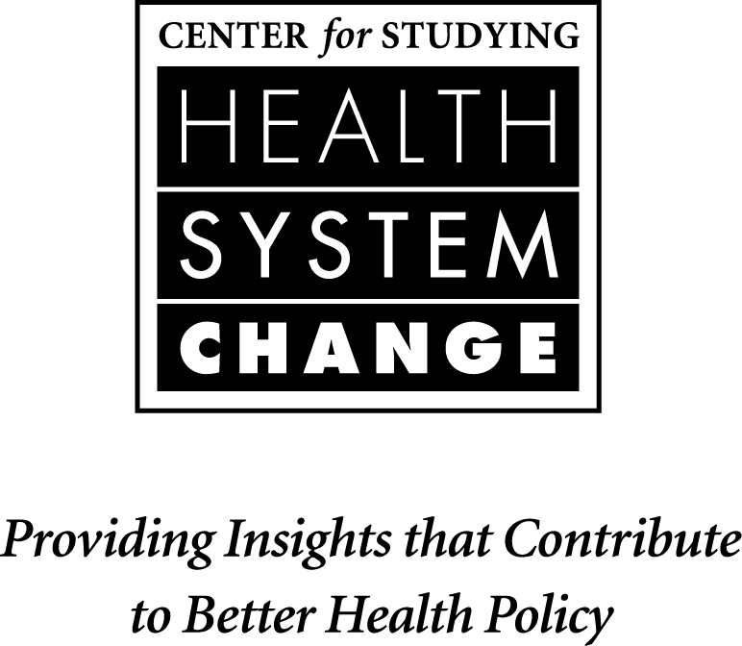

January 14, 2010

Dear ___________:

We would like to invite you to participate in a one-time telephone interview as part of a study exploring the effective use of electronic prescribing (“e-prescribing”) in pharmacies and physician practices. This study, funded by the Agency for Healthcare Research and Quality, is being conducted by the Center for Studying Health System Change, a non-partisan health policy research organization in Washington, DC.

For this study, to better understand how e-prescribing is affecting communications between pharmacies and physician practices, we would like to interview pharmacies that receive at least some prescriptions electronically from physician practices, instead of by fax. This is often referred to as electronic data interchange.

To participate:
- Your pharmacy should be using e-prescribing software currently, and,
- Your pharmacy should receive at least some prescriptions electronically from physician practices, instead of by fax.

If your pharmacy is able to participate, we would appreciate the opportunity to conduct one 60-minute telephone interview with you or another pharmacist on staff familiar with e-prescribing. The discussion will explore in-depth how e-prescribing is used by pharmacy staff as well as how e-prescribing affects communication between pharmacies and physician practices.

If your pharmacy cannot participate, we would appreciate your referral to a pharmacy in the community that receives prescriptions electronically.

The study will be published and we will provide participants with a copy. The results will be disseminated widely to help policy makers and the health care community advance the use of health information technology. Please note that we will not disclose the names of participating organizations or individual respondents in any publications.

If you would like to schedule an interview, or if you have any questions or concerns, please contact <<Scheduler>>, by phone, <<Phone>>, or by e-mail, <<Email>>.

Sincerely,

Joy M. Grossman, Ph.D.
Project Director and Senior Health Researcher
Phone: (202) 484-3298
Fax: (202) 484-9258
Email: JGrossman@hschange.org
www.hschange.org

