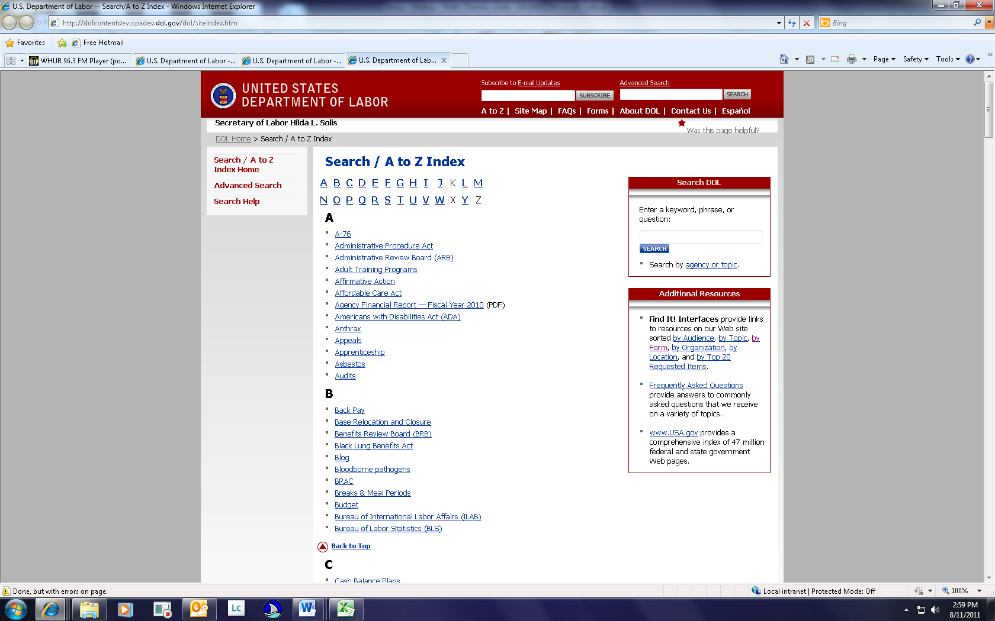
Was this page helpful?

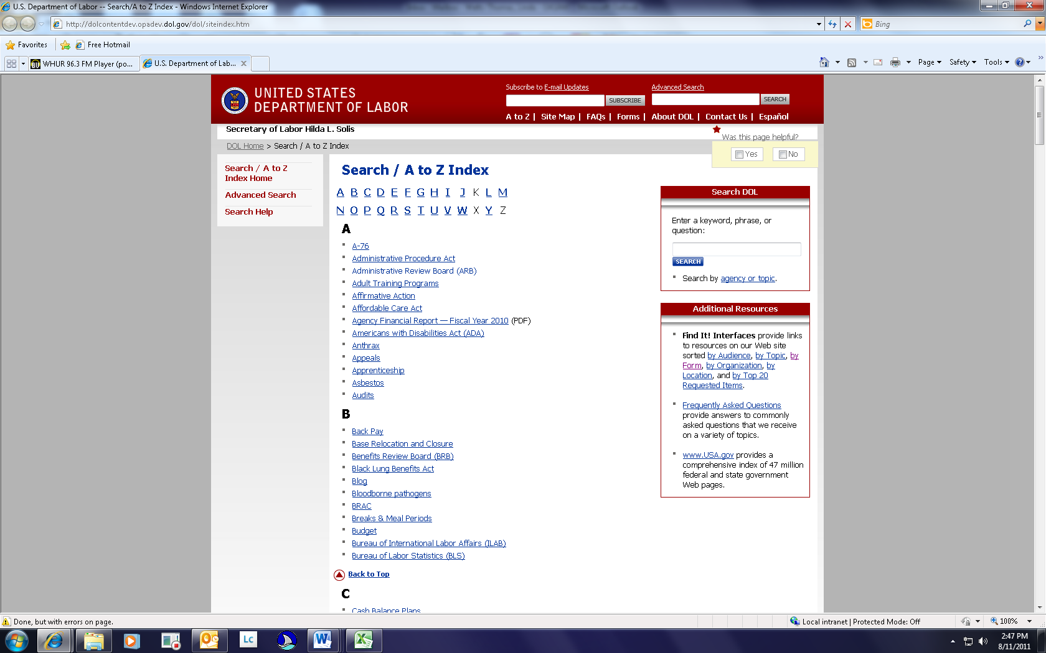
You can select Yes or No.

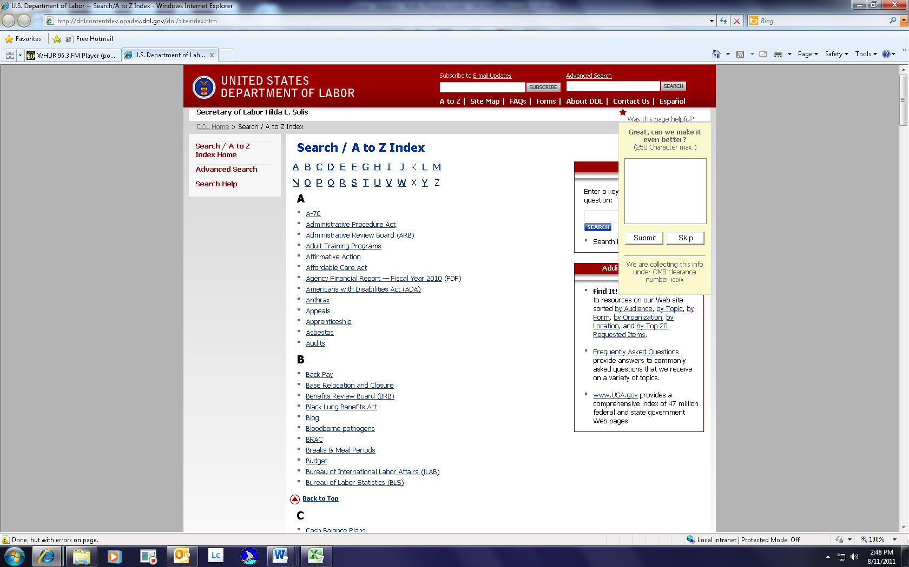
We are collecting this information under OMB clearance no. XXXX
If you select “Yes,” this message appears. “Great, can we make it even better?”

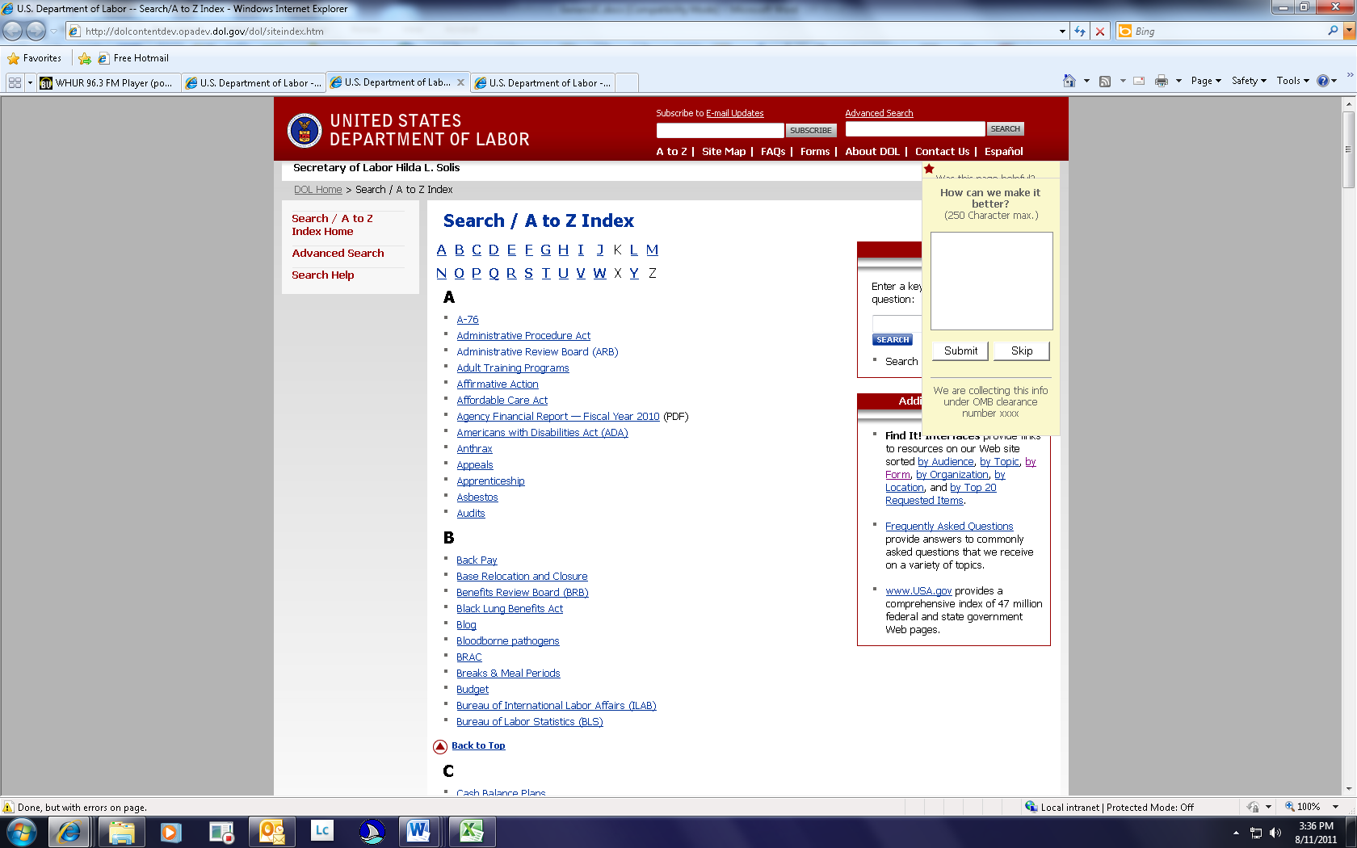
If you select “No,” this message appears. “How can we make it better?”
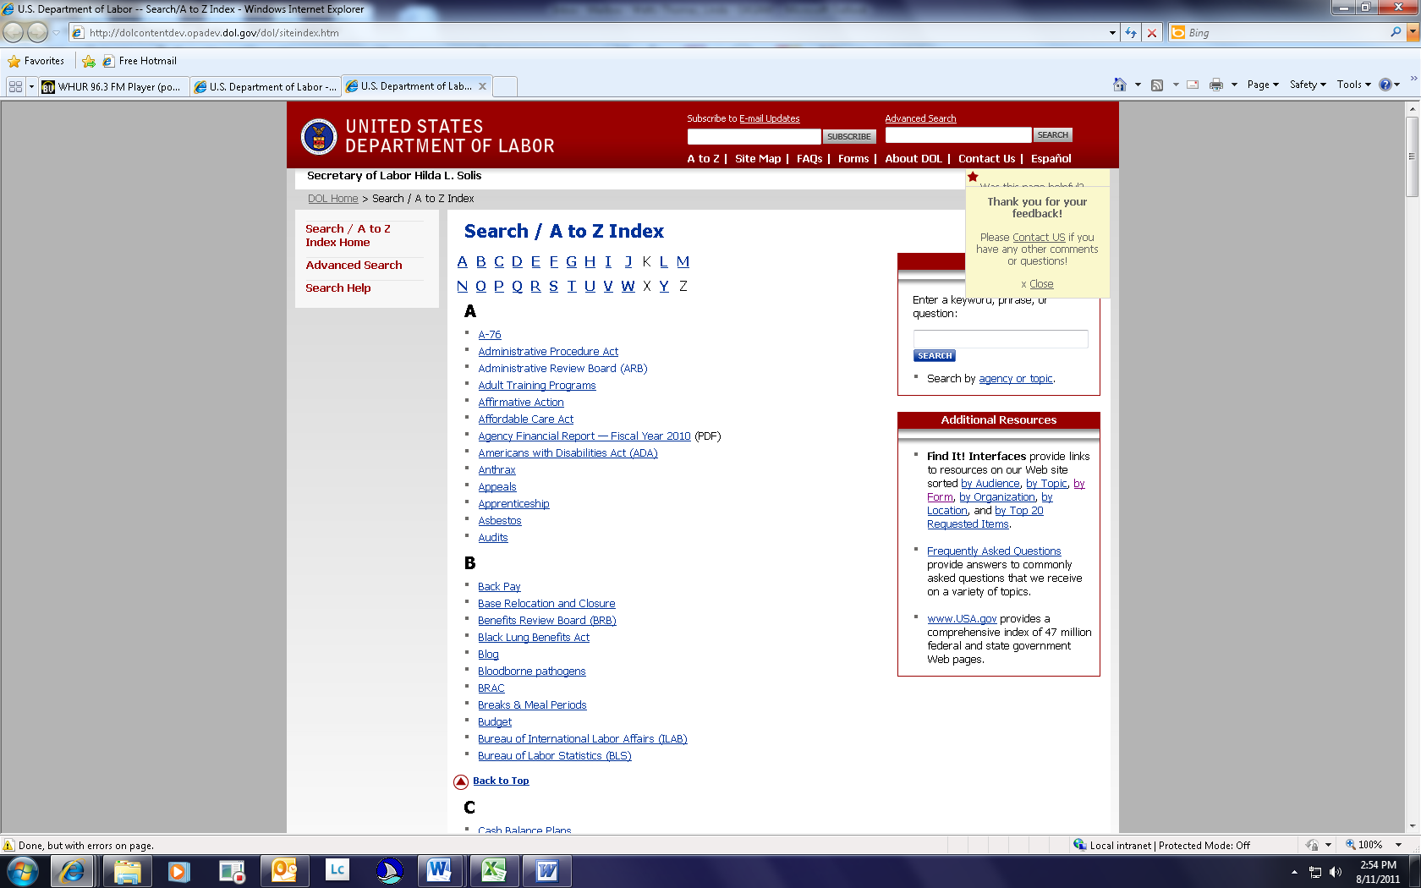
Thank you for your feedback!

