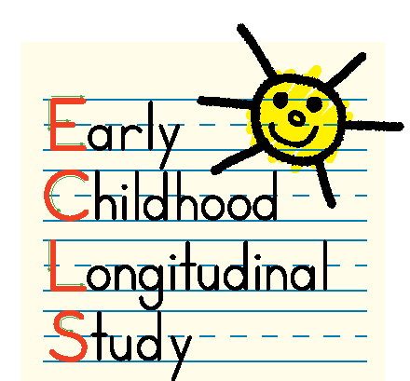
Early Childhood Longitudinal Study, Kindergarten Class 2010-11 (ECLS-K:2011)

Parent Permission for Child to Participate

Your child is being asked to take part in Phase I of an important continuing study, the Early Childhood Longitudinal Study, Kindergarten Class of 2010-11 (ECLS-K:2011). The ECLS-K:2011 is sponsored by the National Center for Education Statistics (NCES) of the U.S. Department of Education’s Institute of Education Sciences and is being conducted on behalf of NCES by Westat. In fall 2009, children in kindergarten through third grade in your child's school and other schools across the nation will be administered an assessment designed to measure basic skills in reading. The Phase I assessment will help researchers select the best items to use in the ECLS-K:2011 assessments next year in Phase II. The assessments will be administered individually to each child.
The collection of information in this study is authorized by Public Law 107-279 Education Sciences Reform Act of 2002, Title I, Part C, Sec. 151(b) and Sec. 153(a). The valid OMB control number for this information collection is 1850-0750. Participation in the ECLS-K:2011 is voluntary. Children may skip questions they do not wish to answer; however, we hope that they will answer as many questions as they can. Children's responses are protected from disclosure by federal statute (PL 107-279 Title I, Part C, Sec. 183). All responses that relate to or describe identifiable characteristics of individuals may be used only for statistical purposes and may not be disclosed, or used, in identifiable form for any other purpose, unless otherwise compelled by law. Data from multiple individuals will be combined to produce statistical reports. No individual data that links names, addresses, telephone numbers, or identification numbers with responses will be included in the statistical reports.
If you have any questions or concerns about the protection of the information you provide or your rights in this research study, contact Gail Mulligan at the National Center for Education Statistics at 1-202-502-7491 or Gail.Mulligan@ed.gov.
PARTICIPATION AGREEMENT

I have read the letter and the information above. I freely agree to allow my child to participate in the ECLS-K:2011 Phase I assessment.

❒ I consent to my child’s participation in the ECLS-K:2011 assessment tasks.

Please complete, sign, and return this form in the enclosed envelope to your child’s school.

CHILD NAME:
First and last name

Sign your name:
Signature of parent/guardian Date

Print your name:
First Middle Last

