Paperwork Reduction Act Submission

Please read the instruction before completing this form. For additional forms or assistance in completing this forms, contact your agency’s Paperwork Reduction Officer. Send two copies of this form, the collection instrument to be reviewed, the Supporting Statement, and any additional documentation to: Office of Information and Regulatory Affairs, Office of Management and Budget, Docket Library, Room 10102, 725 Seventeenth St. NW, Washington, DC 20503.

|  |  |  |  |
| --- | --- | --- | --- |
| 1. Agency/Subagency Originating Request:  **U.S. Department of Housing and Urban Development**  Office of Healthy Homes and Lead Hazard Control | | 2. OMB Control Number:  a. **2539-0008** | b.  None |
| 3. Type of information collection: (check one)   1. New Collection 2. Revision of a currently approved collection 3. Extension of a currently approved collection 4. Reinstatement, **without change**, of previously approved   collection for which approval has expired   1. Reinstatement, **with change**, of previously approved collection   for which approval has expired   1. Existing collection in use without an OMB control number   For b-f, note item A2 of Supporting Statement instructions. | 4. Type of review requested: (check one)   1. Regular 2. Emergency - Approval requested by 3. Delegated   5. Small entities: Will this information collection have a significant economic impact on a substantial number of small entities?  Yes  No  6. Requested expiration date:  a.  Three years from approval date b.  Other (specify) | | |

7. Title:

**Healthy Home and Lead Hazard Control Grant Programs Data Collection – Progress Reporting**

8. Agency form number(s): (if applicable)

HUD-96006

9. Keywords:

Housing, Lead-based paint, Hazard Control, Healthy homes

10. Abstract:

This data collection is designed to provide HUD timely information on progress of all OHHLHC grant programs, including Healthy Homes Demonstration Program, Healthy Homes Technical Studies Program, Lead Based Paint Hazard Control Program, Lead Hazard Reduction Demonstration Program, Lead Outreach Program, Lead Technical Studies Program, Operation Lead Elimination Action Program, Green Healthy Housing Technical Studies Program, and Lead Hazard Control Capacity Building Program grant activities,. HUD will provide Congress with status reports as required by statute.

|  |  |  |
| --- | --- | --- |
| 11. Affected public: (mark primary with “P” and all others that apply with “X”)  a. Individuals or households e. Farms  b. **X** Business or other for-profit f. Federal Government  c. **X** Not-for-profit institutions g. **P** State, Local or Tribal Government | | 12. Obligation to respond: (mark primary with “P” and all others that apply with “X”)  a.  Voluntary  b.  Required to obtain or retain benefits  c. **X** Mandatory |
| 13. Annual reporting and recordkeeping hour burden:  a. Number of respondents 300  b. Total annual responses 1,200  Percentage of these responses collected electronically  100%  c. Total annual hours requested 10,800  d. Current OMB inventory 8,160  e. Difference (+,-) +2,640  f. Explanation of difference:  1. Program change: +2,640  2. Adjustment: | | 14. Annual reporting and recordkeeping cost burden: (in thousands of dollars)  a. Total annualized capital/startup costs  00  b. Total annual costs (O&M)  00  c. Total annualized cost requested  00  d. Current OMB inventory  00  e. Difference  00  f. Explanation of difference:  1. Program change:  00  2. Adjustment:  00 |
| 15. Purpose of Information collection: (mark primary with “P” and all others that apply with “X”)  a. Application for benefits e. **X** Program planning or management  b. **P** Program evaluation f. Research  c. General purpose statistics g. **X** Regulatory or compliance  d. Audit | | 16. Frequency of recordkeeping or reporting: (check all that apply)  a.  Recordkeeping b. Third party disclosure  c. Reporting:  1.  On occasion 2.  Weekly 3.  Monthly  4.  Quarterly 5.  Semi-annually 6.  Annually  7.  Biennially 8.  Other (describe) |
| 17. Statistical methods:  Does this information collection employ statistical methods?  Yes  No | 18. Agency contact: (person who can best answer questions regarding the content of this submission)  Name: Michelle Miller  Phone: (202) 402-5769 | |

**19.** **Certification for Paperwork Reduction Act Submissions**

On behalf of this Federal Agency, I certify that the collection of information encompassed by this request complies with 5 CFR 1320.9.

**Note:** The text of 5 CFR 1320.9, and the related provisions of 5 CFR 1320/8(b)(3). Appear at the end of the instructions. The certification is to be made with reference to those regulatory provisions as set forth in the instructions.

The following is a summary of the topics, regarding the proposed collections of information, that the certification covers:

1. It is necessary for the proper performance of agency functions;
2. It avoids unnecessary duplication;
3. It reduces burden on small entities;
4. It uses plain, coherent, and unambiguous terminology that is understandable to respondents;
5. Its implementation will be consistent and compatible with current reporting and recordkeeping practices;
6. It indicates the retention periods for recordkeeping requirements;
7. It informs respondents of the information called for under 5 CFR 1320.8(b)(3):
8. Why the information is being collected;
9. Use of the information;
10. burden estimate;
11. Nature of response (voluntary, required for a benefit, or mandatory);
12. Nature and extent of confidentiality; and
13. Need to display currently valid OMB control number;
14. It was developed by an office that has planned and allocated resources for the efficient and effective management and use of the information to collected (see note in item 19 of the instructions);
15. It uses effective and efficient statistical survey methodology; and
16. It makes appropriate use of information technology.

If you are unable to certify compliance with any of these provisions, identify the item below and explain the reason in item 18 of the Supporting Statement.

|  |  |
| --- | --- |
| Signature of Program Official:  X | Date: |

SUPPORTING STATEMENT FOR

HUD OFFICE OF HEALTHY HOMES AND LEAD HAZARD CONTROL GRANT PROGRAMS DATA COLLECTION - PROGRESS REPORTING

September 2009

A. JUSTIFICATION

1. Circumstances making information collection necessary.

This is a request by the Department of Housing and Urban Development (HUD) for a revision of OMB approved data collection instruments (OMB Approval No. 2539-0008) for existing grant programs of the Office of Healthy Homes and Lead Hazard Control (OHHLHC). The purpose of this revision is to include Federal Financial Accountability and Transparency Act (FFATA, Public Law 109-282), reporting requirements (currently imposed by the American Recovery and Reinvestment Act of 2009 (ARRA, Public Law 111-5)in quarterly performance reports for the Healthy Homes Demonstration, Healthy Homes Technical Studies, Lead Hazard Control, Lead Hazard Reduction Demonstration, Lead Hazard Control Capacity Building, and Green Healthy Housing Technical Studies grant programs, and updated quarterly performance reports for the Lead Technical Studies, Lead Outreach, and Lead Elimination Action Program grant programs. This revision will allow 100% of OHHLHC grantees to report their performance electronically using our web-based Quarterly Performance Reporting System.

Section 1011 of the Housing and Community Development Act of 1992 (Public Law 102-550) authorizes grant programs for State and local governments for the evaluation and reduction of lead-based paint hazards in privately owned housing built before 1978 and occupied by low-income families. This program is a continuation of a similar program that was mandated by the HUD Appropriations Act of FY 1992. Sections 1051 and 1052 of P.L. 102-550 require HUD to conduct research on developing improved methods for evaluating lead in paint and lead‑based paint hazards in housing, and on controlling lead-based paint hazards and lead exposure from other sources.

The authority for the Healthy Homes Initiative is sections 501 and 502 of the Housing and Urban Development Act of 1970, and annual appropriations, most recently, the Omnibus Appropriations Act, 2009 (Pub. L. 111-8), 119 Stat. 2396, approved November 30, 2005.)

This data collection is designed to provide timely information to HUD on progress of the grantees on carrying out the Healthy Homes Demonstration, Healthy Homes Technical Studies Program, Green Healthy Housing Technical Studies Program, Lead Hazard Control Capacity Building, Lead Hazard Control Program, Lead Hazard Reduction Demonstration, Lead Outreach Program, Lead Technical Studies, and Operation Lead Elimination Action Program (LEAP) and to provide the Congress with status reports as required by statute - Title X of the Housing and Community Development Act of 1992 (P.L. 102-550).

Most of the FFATA reporting requirements are static information that is provided in forms required for the grant application phase (SF-424, SF-424-CBW, and HUD Form-96010 Logic Model). The information will simply be consolidated by HUD staff in the Grantee Information section of QPRS.

2. Uses of the data.

The Department will use this information to report to Congress on the progress of lead hazard reduction work and to determine the relative cost and effectiveness of various kinds of treatments. Data collected from the grantees are used to support HUD’s Strategic Goal objective of addressing housing conditions that threaten health. In particular, data from lead grantees are used to identify the number of housing units made lead safe as a result of lead hazard control grant activities. (For Fiscal Year 2009, the target is 11,800 housing units.) Data from healthy homes grantees are used to identify the number of housing units with reduced allergen (allergy-inducing substances) levels as a result of healthy homes interventions, a measure associated with the reduction in asthmatic episodes of children in these units. (For Fiscal Year 2009qq, the target is 880 housing units.) Additional data on the types, locations and costs of hazard evaluation and control activities are required in order to measure the cost-effectiveness of the grants.

The data collection instruments for the several grant programs used a standardized approach for data collection across the programs, with the specific data collected tailored to program goals.

3. Data automation.

The data from all of the OHHLHC grantees is collected through an on-line Quarterly Performance Reporting System (QPRS, pronounced "Kyoo-purz"). QPRS allows the Office to report all grant performance for the annual performance plan targets more accurately than would manual or partially automated reporting. The vast majority of the data will be collected in the field at grantee sites (or at the grantee's finance offices) and will be entered into electronic versions of the data collection forms.

Grantees are provided a username, password, and instruction guide on how to access QPRS, and troubleshooting tips. OHHLHC provides a Help Desk to assist grantees with accessing the system and entering data.

See sample QPRS screen shots for the Lead-Based Paint Control Program, below. These screen shots demonstrate the automated collection of housing units completed and cleared in a quarter by one grantee (Figure 1), and the automated calculation of quarterly and cumulative housing unit totals (Figure 2). As noted in answer 2, above, these data are used as the performance indicator of housing made lead safe through HUD's lead hazard control grants, in HUD’s Strategic Goal objective of addressing housing conditions that threaten health.

4. Duplication.

OHHLHC grantees are providing performance data on progress toward meeting their established grant benchmarks and/or milestones. This information collection effort does not duplicate any other effort and will not cause any information duplication.

5. Small businesses.

Small businesses (not-for-profit institutions, and for-profit firms who are not earning a profit or fee from the grant) may receive funding from five OHHLHC grant programs: Lead Technical Studies, Operation LEAP, Lead Outreach, Healthy Homes Technical Studies, and Healthy Homes Demonstration grant programs. These small businesses would be required to report to HUD on a quarterly basis, just as other OHHLHC grantees would. As of September 2009, 50 of the 384 active grants are to a total of 45 small businesses (three of these small business have two grants apiece, and one has three grants).

In order to reduce the burden on small businesses, the quarterly reporting is being conducted electronically using standardized forms, and, during the application phase, the NOFAs include comprehensive guidance, electronic forms, and ready-to-fill tables to facilitate submitting applications. Grants.gov, used by HUD for grant submissions, provides a toll-free telephone help line at 800‑518‑GRANTS and support@grants.gov. HUD operates its toll-free NOFA Information Center at 800-HUD–8929 and via teletype, at 800-HUD–2209. The toll-free Federal Relay Service at 1-800-877-8339 may also be used for teletype access by hearing- or speech-challenged individuals. These contact points for assistance are included in the Department's SuperNOFA and individual program NOFAs.

6. Federal Policy Notice.

If the requested information is not collected for the OHHLHC grant programs, HUD will not be able to evaluate the performance of OHHLHC grantees in achieving the Department's goal of addressing housing conditions that threaten health and the enhanced monitoring requirements of ARRA .

In particular, if the proposed information is not collected for the lead programs, HUD will not be able to determine and make known the progress of the grantees in carrying out their responsibilities of reducing the exposure of young children to lead-based paint and other residential hazards. In particular, not collecting data on lead evaluation and control activities will reduce the precision and accuracy of estimates of the effectiveness and relative cost of different strategies for reducing lead in house dust and blood of young children.

In particular, if the proposed information is not collected for the Healthy Homes programs, HUD will not be able to determine and make known the progress of the grantees in reducing levels of allergens (mold and allergens from pests and/or pets) in residences and the corresponding reduction in asthma episodes of children living in these units that are constructed or rehabilitated using healthy homes principles. The OHHLHC requires both pre-intervention and post-intervention data to quantity the change in allergen levels and reported asthma episodes.

In particular, if the proposed information is not collected for the ARRA grants, HUD will not be able to report on the information required by ARRA in a timely manner.

7. Special Circumstances.

There are no special circumstances that would require the collection to be conducted in a manner inconsistent with the general information collection guidelines in 5 CFR 1320.6.

8. Federal Register Notice.

HUD published a notice (74 *Federal Register* page 36243; July 22, 2009) soliciting public comment regarding this request to OMB to renew its approval of the revised data collection forms for the Office of Healthy Homes and Lead Hazard Control. Comments are due by September 21, 2009. No comments have been received.

9. Respondent remuneration.

No payments or gifts are provided to respondents.

10. Confidentially.

This collection does not require the collection or retention of confidential material.

11. Sensitive questions.

There are no sensitive questions being asked.

12. Respondent burden.

Reporting Burden:

HUD 96006

|  |  |  |  |
| --- | --- | --- | --- |
| Number of Responses | Frequency of Responses | Hours per Response | Burden Hours |
| 300 | 4 | 9 | 10,800 |

The respondents' expenses will be covered by grant funds.

13. Cost burden to respondents.

There are no other costs to the respondents (other than those shown in item 12 above).

14. Annualized cost to the Federal government.

Approximately 300 grantees respond via the electronic Quarterly Performance Reporting Systems four times a year. Each grantee quarterly report is reviewed by one Government Technical Representative (GTR; GS-13 equivalent, $41.65 per hour). Each quarterly report review requires approximately three labor hours. The annual cost to the Federal government for reviewing the reports is:

|  |  |  |  |  |
| --- | --- | --- | --- | --- |
| Number of Respondents | Review hours per quarterly report | GS–13 labor rate per hour | Number of quarters per year | Annual Cost to the Government |
| 300 | 3 | $38.40 | 4 | $117,504 |

The Federal cost has increased from previous years because of the increased number of grant programs covered, and the increased labor rate for the GS-13 grade level.

15. Program Changes.

The form has been changed to include quarterly performance reports for the Green Healthy Housing Technical Studies and Lead Hazard Control Capacity Building grant programs, in addition to updating the quarterly performance reports for the Lead-Based Paint Hazard Control, and Lead Hazard Reduction Demonstration, Healthy Homes Initiative, Lead Technical Studies and Lead Outreach grant programs. This change increases the number of respondents.

The total number of hours has increased, as indicated in Items 12 and 14, as a result of:

1. Increased number (from 255 to 300) of grantees reporting on-line;
2. Increased number (from 70 to 100) of grant awards;
3. More precise description of grantee activities;
4. Consolidation of static information provided in the grant application process to improve transparency and accountability reporting;
5. Additional information on job creation and income of people receiving government support; and
6. Improved estimates of time required to satisfy requirements.

16. Publication of information.

The Office will use the data collected to evaluate grantee performance. The Office will post a summary rating of grantee performance on a quarterly basis to its website, www.hud.gov/offices/lead. Annually, the Office will use these data to perform an overall grant risk assessment in accordance with HUD grant monitoring requirements; this report will be available from the Office.

The Office includes specific summary performance results in reporting results for its Management Plan, and as part of the Department's Annual Performance Plan. These performance results include:

- The number of housing units made lead safe as a result of lead hazard control grant activities; and

- The number of housing units with reduced allergen (allergy-inducing substances) levels as a result of healthy homes interventions.

The results for each grantee and the overall results for the grant portfolio will be made available to grantees, including state and local officials and other interested parties. There are no plans at this time to publish these results in peer-reviewed technical journals.

Healthy Homes Technical Studies grantees, Lead Technical Studies grantees, and sometimes other grantees, may publish results in peer-reviewed technical journals. In addition, Healthy Homes grantees are providing programmatic results to HUD as a part of the evaluation of the Healthy Homes Program.

17. Display of expiration date.

The expiration date of the form will be displayed in the right footer.

18. Exceptions to certification statement.

There are no exceptions to the certification statement.

Figure 1. Quarterly Performance Reporting System (QPRS) screen shot for the automated collection of housing units completed and cleared in a quarter by one grantee under the Lead-Based Paint Control Program.

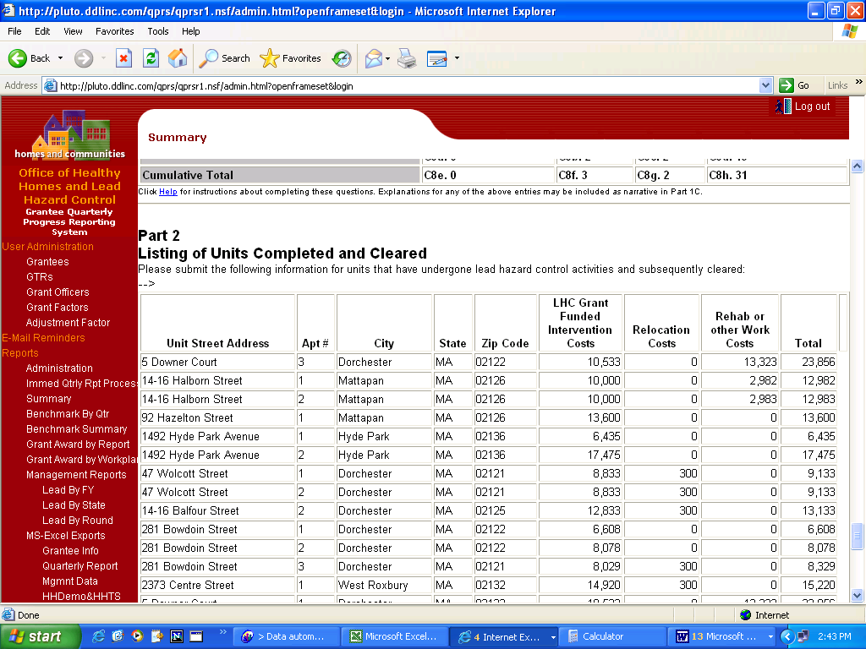

Figure 2. Quarterly Performance Reporting System (QPRS) screen shot for the automated calculation of the quarterly and cumulative housing unit totals of housing units completed and cleared in a quarter by one grantee under the Lead-Based Paint Control Program.

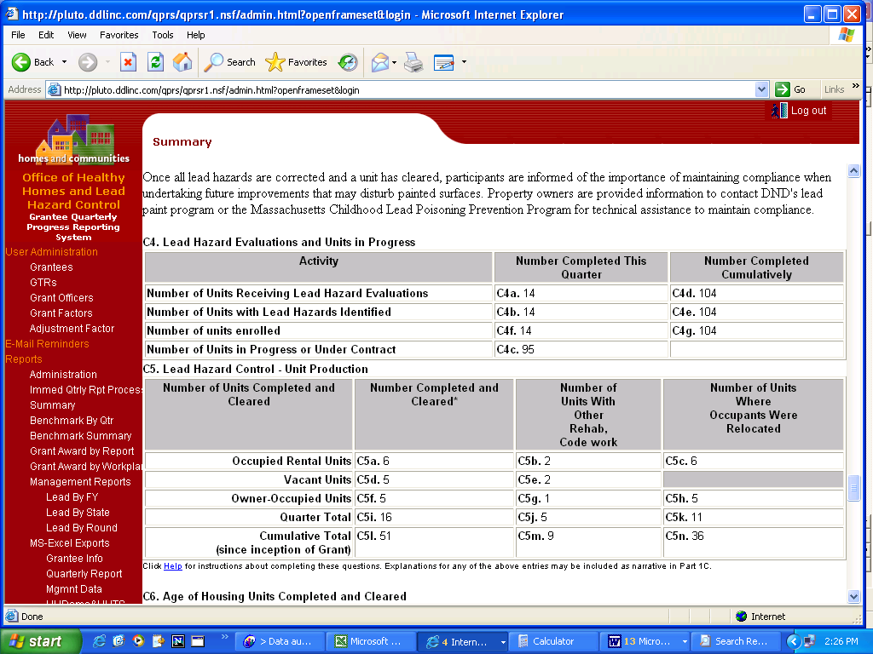p